Epilogue

Landscapes and architecture: the Cork & Bandon railway today

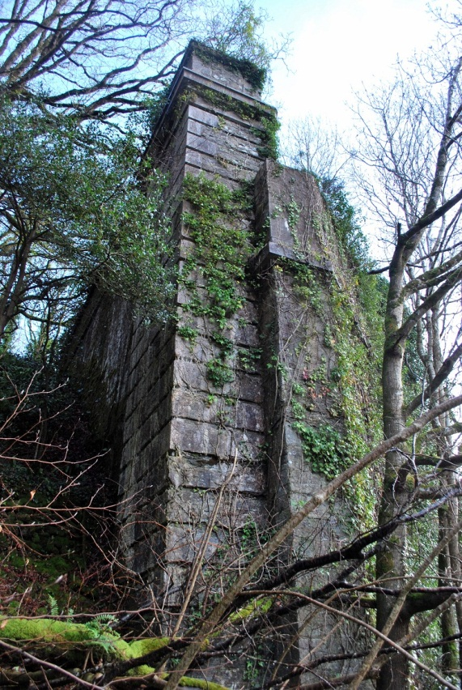
1 Inishannon viaduct, east abutment (January 2012)

It is a truism that before humans set foot in Ireland there was land, water, and nature. In a similar way, before railways were planned and built in the nineteenth century, there were hills and valleys, rivers, forests, as well as the hallmarks of centuries of human activity: roads small and large, villages, and towns, woven together by centuries-old economic and social ties. This human activity was at every stage affected by the landscape: rivers dictated settlement patterns, and mountains separated communities. In time this relationship was inverted as the landscape was in turn altered by streams diverted to power mills, forests felled and cut up, estates planned, and so on. The railways continued this process of reforming the rural landscape, and the new specifications so characteristic of the engineering of the period – gradient and curvature – necessitated bolder and more magnificent disturbances of the natural environment.

The county of Cork is defined by the three great rivers – the Blackwater, the Lee, and the Bandon – which run from mountains in the west, through long valleys to the sea in the east, as well as the hilly ridges which separate them. The mountainous peninsulas, most notably Beara, are extensions of this same geological arrangement. In the popular mind-set, west Cork is roughly that part of the county which lies south of the Lee. It encompasses a wealth of different natural environments, from undulating pasture land in the east, especially around Bandon, to old and difficult bogs further west near Skibbereen, and to rocky outcrops along the coast and in the mountainous regions. Within west Cork, the Bandon is undoubtedly king. Rising in the Shehy mountains and in the desolate and sparsely inhabited regions near Nowen hill (cnoc na hAbhann, hill of the rivers), it flows for over forty miles through the towns of Dunmanway (sometimes translated as Dún abhainn bhuí, castle by the yellow river), Ballineen, Enniskean, Bandon (formerly Bandon-Bridge, droichead na bandan), Inishannon, and enters the sea at the historic port of Kinsale. Those who take to the road between Cork and Bantry today might only notice they are in the Bandon valley for the short stretch between Inishannon and Bandon, so wide and flat is it further upstream. An alert eye would notice the mountains west of Dunmanway which signify the end of the valley – the main road passes, as the railway once did, through the steep Glounda glen. Apart from the coastal settlements, for example Skibbereen and Clonakilty, much of west Cork’s population is concentrated within the Bandon valley. Many of the villages and hamlets in the hills north of the river are virtually unknown, even to those who live in west Cork: while Béal na mBláth and Kilmichael are famous on account of their military history, it is safe to say that few locals (and even fewer tourists) know much of Newcestown, Castletown Kinneigh, Teerelton, or Derrynacaheragh. In the early nineteenth century these settlements were even more isolated from the centre of trade and agriculture in the Bandon valley.

However, the Bandon is not the only river of importance in west Cork. Parallel to it, about six miles further south, is the Argideen (an t-Airgidín, the little silver river), which enters the sea at Timoleague. Further to the west, the vast tract of land stretching from Dunmanway in the east to Bantry in the west, and from Castledonovan in the north to Baltimore in the south is drained by the Ilen (aighlinn, a female name). The other principal rivers of the area, the Mealagh, Coomhola and Owenboy, play a less significant role in the shaping of the railways. The central importance of the river system is apparent if we consider the proposed route of the original Cork & Bandon railway, drawn up by the engineer Edmund Leahy (1814-1888) around 1843. He faced two obstacles: first, to bring the railway out of the Lee valley around Cork city and up onto the plateau drained by the Owenboy, i.e. to the villages of Ballinhassig, Half-Way, and Crossbarry. This necessitated the viaducts at Chetwynd and Half-Way, and the long tunnel near Ballinhassig. Secondly, he had to bring the railway back down again, into the Bandon valley. He did this by means of two rock cuttings near Upton, the large bridges over the Brinny and Bandon rivers, and, perhaps most beautifully, at the picturesque tunnel at Kilpatrick.

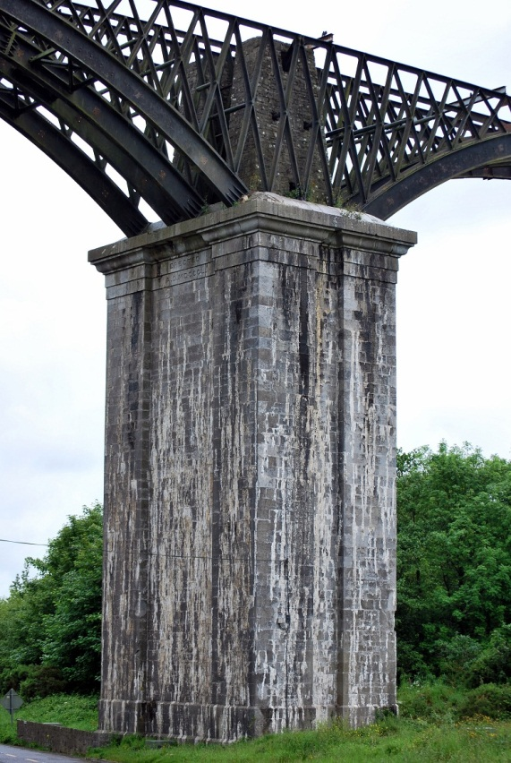
2 Chetwynd viaduct (June 2012)

It was no different for Leahy’s successors in the small independent railway companies which later built the extensions to Kinsale, Courtmacsherry, Clonakilty, Baltimore, and Bantry. In the case of Clonakilty, the principal engineering work was to bridge the Argideen; for Courtmacsherry it was to follow this river and make use of its falling gradient all the way to the sea. The line to Skibbereen and Baltimore followed the valley formed by the Ilen, crossing it twice; the main challenge facing the line to Bantry was to come out of the Ilen valley and then descend rapidly to the sea, which entailed a circuitous route all the way around the town. Today it is impossible to trace the route of west Cork’s abandoned railways without being at all times cognisant of the natural features presented by the landscape. In an era when one can instantly ascertain one’s exact location with a GPS phone or sat-nav., it is becoming more and more unusual to have the skills necessary to visualise the landscape and to be guided by its natural features. The extra constraints attached to a railway – gradient and curvature – help to focus one’s attention even more on the subtleties of the land.

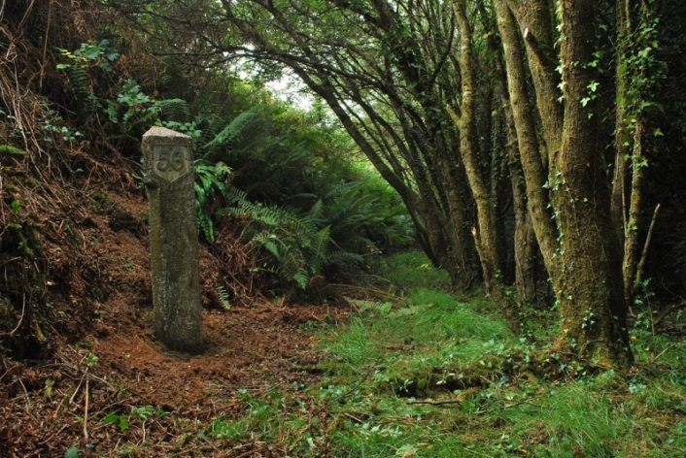
3 ‘56’ milepost and cutting, Dromleigh North, near Bantry (September 2010)

Today there is much popular interest in the role of the nineteenth-century railway engineer, his work romanticised alongside that of the cartographer, inventor or explorer. Brunel is deservedly the most famous. It is easy to understand their appeal – they planned works on a scale never before seen in human history, using ‘real’ materials like stone, wood, and iron, and often formed one-man enterprises; they could not be more different to the large modern engineering office made slothful by the unlimited potential of reinforced concrete. But despite the romantic attachment these were, fundamentally, ordinary people attempting to solve a particular problem in the cheapest and most efficient manner. Take for example Charles Vignoles and his 1836-37 plan for a major trunk railway from Dublin to Castletown Berehaven. He proposed that it should branch off the main Dublin-Cork route at Blarney, follow the course of the Lee, tear through the wild cliffs of Conigar mountain near the beautiful lake of Gougane Barra with a 2000yd tunnel (the summit, at 1 in 132), and emerge onto a 200ft-high viaduct over the sparsely inhabited Coomhola valley. From there it would cross the famous coastal village of Glengarriff by a viaduct over the sea to Garnish Island and run by the coast, with the aid of another tunnel and sea viaduct, all the way down the Beara peninsula. It is easy to think of his plan as pure fantasy – as nothing more than an engineer’s dream – but as Vignoles made clear in his government report, he came to settle on this route after many weeks spent surveying the region during the bitter winter of 1836. The route was not only possible, he claimed, but was in fact the cheapest way of bringing a major trunk railway to this important navy port. Tunnels of that length were not extraordinary, and viaducts of that scale were soon to be built in Germany. Vignoles described the line as ‘formidable, and in one or two of the points gigantic.’ However, an engineer today, faced with the use of only iron, stone and wood, and constrained in terms of certain gradients and curvatures, would surely proceed in much the same way.

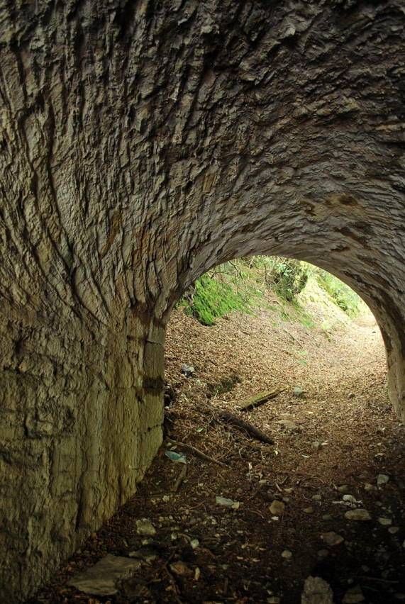
4 Curranure farm road underbridge, near Bandon (May 2012)

The route was, of course, never built. It was turned down not for the impossibility of its engineering but for the lack of political will to fund the project from the public purse. Somewhat less gigantic, though arguably formidable in places, was the route as built between Cork and Bandon. It opened in stages: Bandon to Ballinhassig in 1849, and Ballinhassig to Cork in 1851. While not wishing to overly romanticise the efforts of Leahy, the engineer Charles Nixon and others, their achievements were awesome: the Illustrated London News remarked that ‘few railways have had such a hard struggle for existence as this Bandon line’. One of the largest engineering works was the 906yd tunnel at Ballinhassig. We know from old company records that 300 men were employed at the site around 1850-51, working day and night. Six shafts were dug, allowing work to proceed at a total of 14 different faces. But we do not know the names of any of these men, nor where exactly they came from. A whole village of huts must have been built to house them and we can imagine that a local industry developed, providing sustenance, repairing clothing and tending to injuries sustained in the dark, damp, and dangerous excavation sites. Perhaps we simply cannot understand the sheer brutality of their work; there is hardly any activity we could engage in today which would give us a comparable experience.

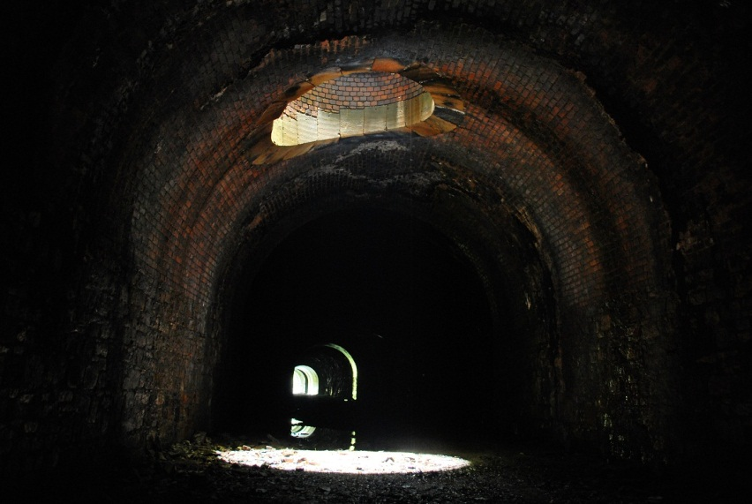
5 Ballinhassig tunnel, looking north

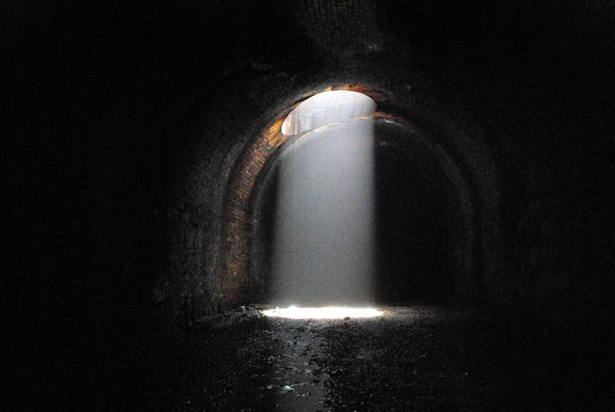
6 Ballinhassig tunnel, shaft

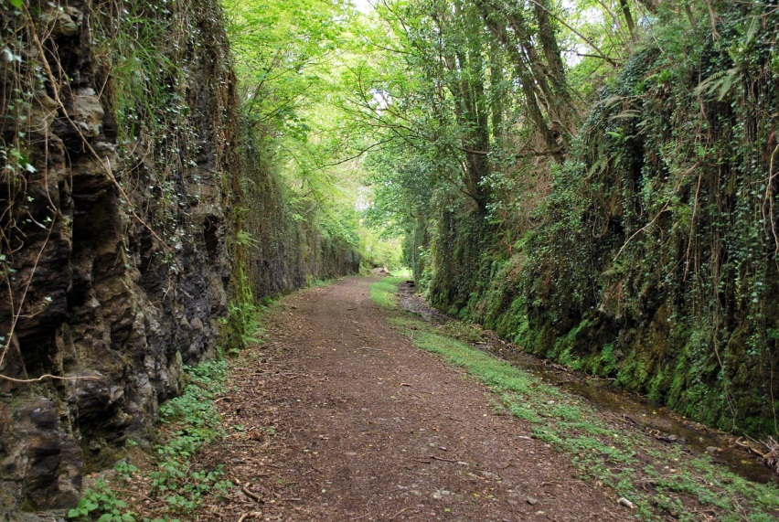
7 Brinny rock cutting no. 1 (north) (May 2012)

In order for the railway to enter the Bandon valley, from the Cork side, two large rock cuttings forming an S-bend, each around 30-40ft deep were required near the Brinny river. One pictures the rolling hills which Leahy would have surveyed before any work was done, the wooden stakes put in to mark the proposed route, and then the slow gradual work of excavation (without the help of dynamite) and the moving of spoil to form embankments in the adjoining ravines. Presumably huts were set up in the valley and trees felled for firewood. As these cuttings were dug during the Great Famine, it is likely many of the men were only too grateful for employment of any kind, no matter how difficult the work. For us today, these cuttings can tell us much about Ireland on the eve of this human disaster. Their width, just enough to accommodate two tracks, says much about the optimism of the railway’s promoters in the future economic growth and industrial development of the Bandon valley. Their way of thinking was nurtured long before the Famine, in the Bandon of the 1820s, when the town was alive with the spinning and weaving of cotton, marking it out as an unusually industrialised town for the south of Ireland. The Cork & Bandon was to be a major trunk railway, delivering a return of 13½ per cent to its investors. In reality they could not have been more mistaken: after the Famine the population of Bandon shrunk almost by half, nascent hopes for industry and manufacturing were dashed, and rural life was changed forever in the surrounding hinterland. These cuttings never saw a second track, and the Cork & Bandon never became a trunk railway. If the exposed rock of these cuttings speaks for the human labour which excavated them in a time of great suffering, their dimensions hints at the hopes and aspirations of the years beforehand.

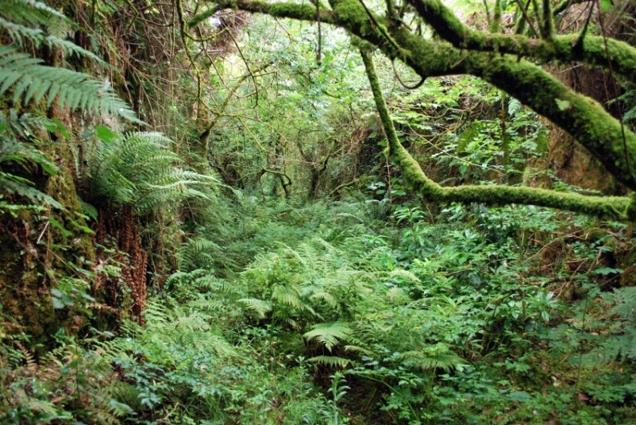
8 Rock cutting, Keilnascarta, near Bantry (July 2011)

During 2010-12 I was fortunate to have the time to conduct an archaeological survey of the entire Cork, Bandon & South Coast railway, with the help of countless 25-inch Ordnance Survey maps (c. 1888-1913). Part of the reason for doing this has been to see what is left after fifty years of neglect (2011 being, of course, the fiftieth anniversary of the closure). The tracks no longer remain in situ, and neither do the signal posts, or most of the telegraph poles, but the engineering works are generally still intact. It has been fascinating to explore the area by foot, bicycle, canoe, and car, and see how the remaining fragments of such an intricate system have fallen into decay. As the land of the permanent way was sold back to local landowners soon after 1961, the majority of the railway infrastructure was simply handed back to nature. In fifty years’ time there will be even less than there is now, and one day there may even be nothing left whatsoever. The ‘soft days’ of mild, misty weather contribute to the jungle-like feeling of many of the overgrown rock cuttings, particularly in the western districts, with their host of straggly sally trees, ferns, gorse, ivy, moss, and insects. We could apply E.M. Forster’s remark on tropical climates (in A Passage to India) without any incongruity, when he wrote that ‘the inarticulate world is closer at hand and readier to resume control as soon as men are tired.’

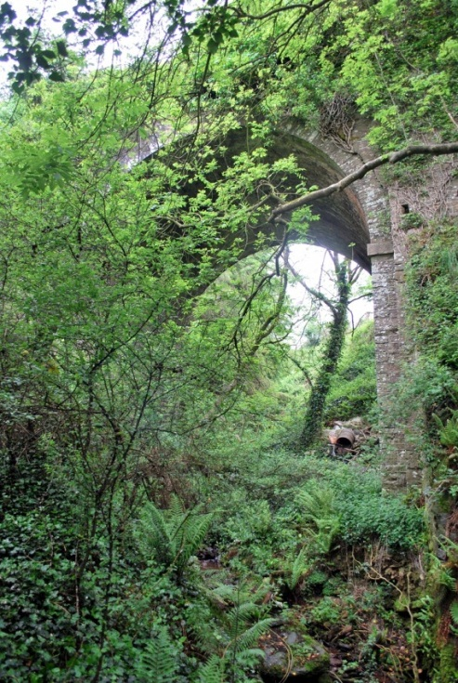
9 Gortnaclogh Bridge, near Half-Way (May 2012)

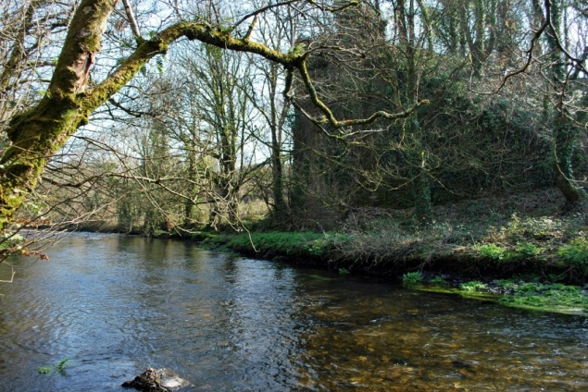
10 Argideen viaduct, south abutment (March 2011)

During the course of my work, I have had the opportunity to visit many relatively inaccessible corners of west Cork, terrains where people have seldom traversed since the railway closed. It is always a particular pleasure to identify a structure – say a culvert, a bridge, or a cutting – on an old map and then attempt to find it. Occasionally, it has been very affecting to see the degree to which a landscape can be altered in just fifty years, a miniscule period in natural history. I do not have enough pages here to describe all of these sights, so I have selected only a few.

We begin with Shannonvale mill, around two miles north of Clonakilty. I visited during a dry spell in the early spring, when the land was cold and dry, the sky clear, the shadows long, and the previous summer’s growth reduced to a flaxen blanket at the edges of the rolling fields. The mill, which drew its power from the nearby Argideen river, was situated around half a mile west of where the Clonakilty railway crossed the valley. Many of the mill buildings remain, most spectacularly the grain tower, with its darkened concrete and old corrugated iron. The course of the siding which served the mill, horse-powered for its entire existence, can still be seen just a stone’s throw north of the old viaduct, whose piers and spans have vanished, leaving just one abutment. The eager explorer might be tempted to wade across the river, only a foot or so deep in dry weather, and climb up this abutment, a triangle of stone, at the far side, but the best view is undoubtedly from afar. A short distance away, in the oddly-named townland of Beanhill (cnoc an phonaire, hill of the beans), there is a high embankment pierced by a small road under-bridge. Though the spans are missing, the owners of a nearby house have placed some modern track over the abutments (without any supporting substructure), and relocated a nearby milepost down by the side of the local public road. The whole ensemble – track, valley, mill – is as good an essay as any in proto-industrial development in rural Ireland.

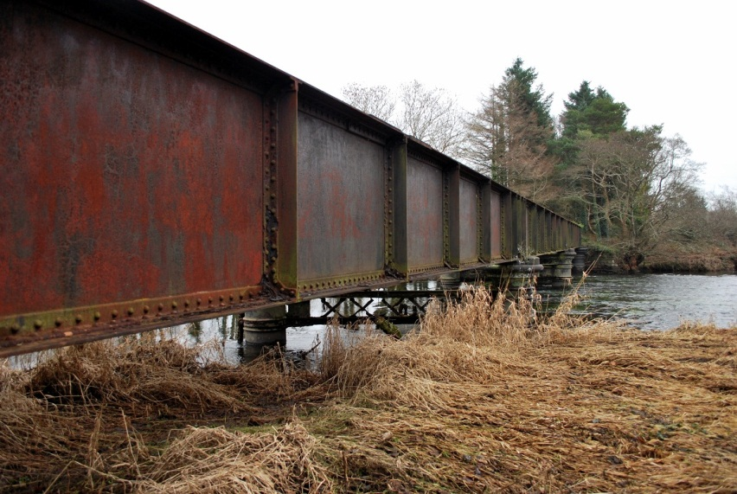
11 Milleenanannig viaduct, near Dunmanway (January 2011)

A very different landscape is to be found a little east of Dunmanway, where the 1866-built extension of the railway to that town crossed the Bandon river for the final time in the townland of Milleenanannig (millín an eanaig, little hillock of the marsh). I have visited many times, but the most memorable occasion was on New Year’s Day one year, when the river was in flood. The viaduct, unusual in still being completely intact (including sleepers and rails), is of metal caissons and spans. In low water, some rotten timber, pieces of the original trestle bridge, emerge out of the water like shards of glass and catch logs swept down from the mountains (as well as the keels of kayaks). To reach the viaduct by land one wanders down a small dirt-track road and into a dense concoction of briars, nettles, and rushes, all the more boggy in high water (and indeed completely submerged in full flood). Apart from a few fording points and the low concrete bridge at Bealaboy, there are no crossings of the Bandon between Dunmanway and Manch bridge except for this old railway viaduct, which, it is said, was left intact to allow anglers to fish off it. Only the brave would cross the viaduct by standing in the centre of the rotten sleepers; it is safer to walk along the edge, on the track, or on the metal girders of the bridge. None are perfect though, and viewing the water rushing by just six or seven feet below, it is best to be cautious and proceed slowly. The track is very overgrown at the far end, with briars up to shoulder height, and fir trees on both sides. At the right time of day one can distinguish a few remaining telegraph poles from the similar-looking trees. The flat, boggy bit of land to the east of the bridge is effectively an island, as there is another river to the north which joins the Bandon further downstream. Here the landscape looks like part of the New Orleans delta, and it is never clear whether one is standing on land which could in a few hours’ time be completely inundated. In the middle of this ‘island’ is a ruined level-crossing cottage, the roof and floors of which have collapsed, but the paint on the inside walls, different in each room, has survived. One is left wondering why the railway company would ever have built a manned level-crossing here, as the only traffic would have to ford the Bandon en route. On a winter’s day with the river in flood, one imagines the family in this house would have little occasion to operate their gates. I have had the story told to me by a man whose family worked for the railway that the people who lived in this house used to return home at night from Dunmanway to their ‘island’ home by crossing the small metal bridge over the stream to the east with the help of an oil lamp, making sure not to fall between the girders.

Other relics of the former railway appear throughout the county. Farrangalway station, on the former Kinsale branch, has been renovated and cared for unlike any other in the area. Down by the sea in Timoleague, it is striking to see how close the former tramway to Courtmacsherry passed by the beautiful medieval friary, something which heritage guidelines would surely never allow today. West of Dunmanway, in land now owned by the state forestry company Coillte, one can walk the route of the Ilen Valley railway to Drimoleague and Skibbereen as it passed through a narrow gap in the mountains (the aforementioned Glounda glen). Just beyond a boggy rock cutting now shaded by mature trees, a stream cascades down the rock-face and passes under the track by a small neat culvert to join the Brewery river at the other side. One imagines that if this culvert were to be blocked during a storm, a great lake would develop, fed by the waterfall, possibly overflowing the whole embankment. Further on, in the village and former junction of Drimoleague, one can still stand on the raised platforms and look up at the 1950s concrete Roman Catholic church on the hill behind, a strange contrast with an antiquated and decaying railway station.
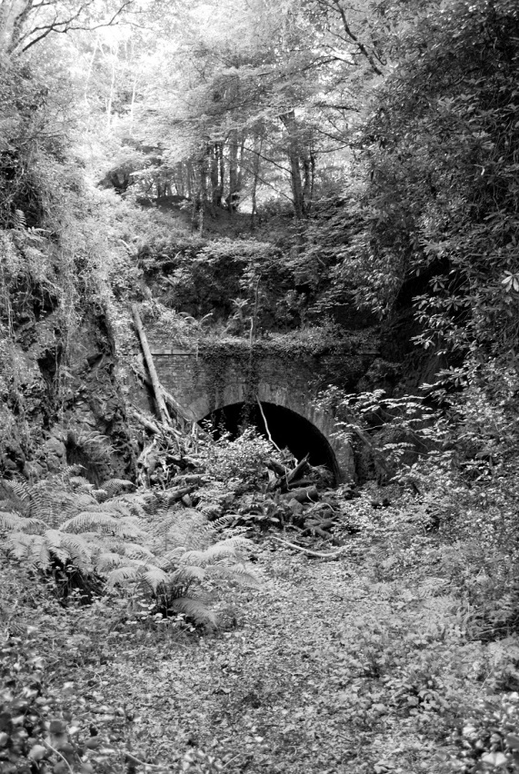
12 Kilpatrick tunnel, west portal (August 2011)

All of these sites offer their own rewards to the curious visitor. The glory of the entire system, however, is the mile of track around the Kilpatrick tunnel. I have discovered that the best time to visit is in the early afternoon on a clear winter’s day, when the bare trees expose as much as possible of the remaining structures. As previously noted, the task facing the Cork & Bandon’s engineer was, from the Bandon side, to bring the railway out of the Bandon valley and onto the flat plateau of the Owenboy river. The viaduct over the Bandon, known as Inishannon viaduct, was a metal lattice structure of two spans. These are now gone, as is the central pier, but both abutments survive. One does not get a sense of their scale unless looking up from below at the courses of ashlar stonework, now covered with the long fingers of ivy. Both abutments are rusticated like the best neo-classical prison or fort, a motif often used by architects to convey a sense of strength and impregnability. It is not known if the central pier was taken down, or simply undermined in some great flood, but its remains lie scattered in a heap of well-cut blocks of limestone in the centre of the river. Many birds, animals, and insects live in the various nooks and crannies of these abutments; wherever the lime mortar has failed, a plant or small tree has been sure to grab a foothold and thrive.

No sooner does the embankment vanish into the steep wooded hill than we are in a deep rock cutting, with the portal of the tunnel in view. Old photos show the hill was once covered in flowering gorse, but now a forest reigns supreme, and every so often trees make the perilous mistake of setting up root too close to the edge of the cutting. Once they are high enough to be caught by a strong gale, they fall in, blocking the cutting on both sides like crossed swords. The west portal is now more than half blocked with old trees, making the edifice look like some kind of lost Aztec ruin. The tunnel is dry and the floor of railway ballast remains untouched. It is 110yds long, and curves gently to the north as it works its way through Kilpatrick hill. At the far end the pattern of rock cutting and forest is repeated, until just as quickly as before the track is on a high embankment which becomes a wide stone-arch bridge over the Brinny river. On the Bandon side it is easy to be distracted by the noise of the busy N71 road nearby; on the Brinny side there is silence, except for the wind in the old trees, the river below, and perhaps some cattle in the lush fields at the base of the valley. Ahead are the aforementioned rock cuttings; beyond them the magic is diminished. What makes Kilpatrick unique in west Cork is the combination of bridge, tunnel, bridge, and cutting – a trio of topography, nature, and engineering, all in a picturesque rural setting.

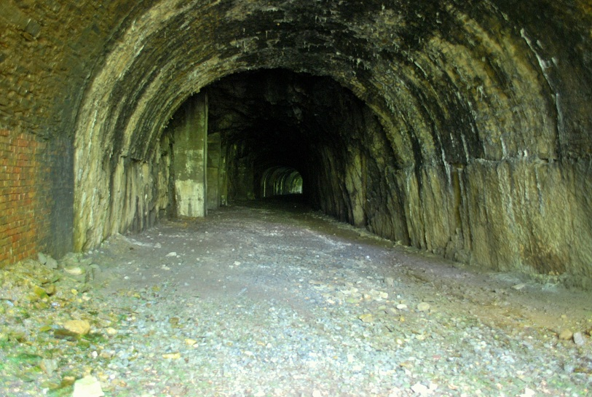
13 Kilpatrick tunnel, looking west (August 2011)

If one can see in these sites much history, especially the toil of their construction, and at the same time see their present state of decay and the unrelenting encroachment of nature, perhaps it is possible to imagine something of the future in them. The sense of calmness and integration with nature that, for example, the Kilpatrick area provides is completely at odds with our current environmental, ecological, economic, and political turmoil. One is reminded of something Yeats wrote in a time of much greater crisis, the first stanza of The Stare’s Nest by My Window, from Meditations in Time of Civil War (1928):

The bees build in the crevices
Of loosening masonry, and there
The mother birds bring grubs and flies.
My wall is loosening; honey-bees,
Come build in the empty house of the stare.

The ruined structures in Kilpatrick represent everything left unrepresented by life increasingly focused on virtual experience, electronic communication, and globalised trade and commerce. These bridges and tunnels were, of course, built for freight first and passengers second, but the directors of the Cork & Bandon could never have imagined the goods now transported between their two original termini: oil from West Africa, toys from Chinese factories, vegetables from South America. In effect their hopes rested on the successes of the proto-industrial society in which they lived, that of cottage industries working carefully alongside agriculture. In Irish terms, this model proved effective only in the north-east, with the rapid industrialisation of Belfast in the nineteenth century. In the south and especially in west Cork, where the first green shoots of industrialisation had been evident before 1820, the reverse happened, and the area was significantly de-industrialised by the time the Cork & Bandon started a full service in 1851. As is apparent from watching the excellent DVDs recently released with hours of footage of the last years of the west Cork railway, the region had still not experienced any kind of meaningful industrialisation by the early 1960s. Most historians now agree that much of southern Ireland only underwent a process of industrialisation in the late 1960s and 70s, becoming the last European country to do so. As a young person who does not remember these years, the video footage often suggests a landscape which was more ordered and cared for than ours today, with tidy hedgerows, quiet roads, and an attitude untainted by concerns over health and safety. I am conscious that this is a deliberately romanticised viewpoint, one that ignores the social problems, unemployment, and emigration of the time. Nevertheless, if anything has been demonstrated during the last few years of economic gloom in Ireland, it is that people now have found the time again to care for their plot of land, to complete that job left half-done, and to take the time to enjoy the landscape. This is a slow process, and it will take many years to erase the many scars imposed on the countryside during the ‘Celtic Tiger’. Coupled with this is an ever-increasing market for home-made products and ‘natural’ foodstuffs, with the growth of a modern kind of cottage industry. Perhaps the last time there was such a growth was in the early nineteenth century. In all this, there may still be a role for a system of collectivised transport, despite the dominance of car and trunk, and an individualised way of thinking. Our methods of transport today depend upon cheap and readily available raw materials like oil. Even the electric car relies on coal-, oil-, and gas-burning power plants. No-one quite knows how the world would react to a sudden unavailability of these resources, but it seems likely the inherent inefficiency of individualised transport, which has been the mainstay of communication for nearly a century, would become apparent. Could, then, there be a future for the decaying remnants of Ireland’s closed railways? Perhaps. But would we wish to take back from nature those works of previous generations in which it has now so beautifully staked out its claim of ownership?

Richard Butler is a doctoral student and supervisor at St John’s College, Cambridge, where he is writing a history of public architecture in Ireland, 1800-1860. He is a native of west Cork and has completed a survey of the Cork, Bandon & South Coast railway, the highlights of which can be seen on http://beneathesummergrowth.wordpress.com.

