“The radicals in these Reform times”: politics, grand juries,
and Ireland’s unbuilt assize courthouses, 1800–50

12,471 (9,291) words

Richard J. Butler

By their nature, courthouses were built in Ireland as throughout Europe by ‘the state’. They demarcate the visible and tangible presence of both the law and state-sanctioned justice in the Irish urban landscape. Laws passed by the Irish Parliament, and after its abolition in 1800, by Westminster, were enforced in assize courthouses by travelling judges on established ‘circuits’, visiting each county town or city twice a year – in the spring and summer. These judges travelled with great splendour through the countryside, and were welcomed by each high sheriff at the county border and escorted with military pageantry, ritual, and procession to the county towns. Assize courthouses, then, were temporary pauses in a near-continuous flow of judicial displays of power and authority, emanating from the superior courts in Dublin to the provincial urban nuclei. Persons accused of serious crimes, arrested and imprisoned, had to wait in some cases many months for the next assizes: those arrested, for example, in September, had to languish in gaol till the following March for the spring assizes. They would then be tried and if found guilty immediately given their punishments – often transportation or hanging – unless pardoned. In times of acute agrarian unrest or rebellion, as marked so much of early nineteenth-century Ireland, assizes could be extraordinarily busy occasions with, by modern standards, exceptionally brief trials. Much of this was also true in mainland Britain: what made Ireland unique in this period was the contested nature of government itself, and in particular the validity of the country’s status within the United Kingdom. The Rev. Michael Collins, addressing a House of Commons parliamentary inquiry in 1825, highlighted the lack of respect shown by ordinary people in his parish for the established system of justice, seeing it as both foreign and corrupt. David Fitzpatrick has argued that Ireland in the nineteenth-century was in all but name a ‘colony’. The de-legitimization of the Irish legal system at this time is an unavoidable aspect of any study of Irish courthouses, and one that is not shared with the study of similar buildings elsewhere in the United Kingdom. Nowhere is this decoupling more evident than in the subsequent history of the Irish courthouse during the revolutionary period of 1913–23, or in the Troubles in Northern Ireland, when so many were burned or destroyed in what one modern historian has argued was a legible sequence of contested claims of ownership and possession over the judicial and political power these buildings embodied.

Yet ‘the state’ is a problematic term for describing how government worked in Ireland in the early nineteenth century, as is familiar to historians of the period. Westminster did not build a single assize courthouse in Ireland in the pre-famine years, the ‘imperial power’ never surveyed a site nor laid a cornerstone, nor did they make contracts with carpenters or dictate the shape or design or size of any such building. All these powers rested instead with local government, and here we must establish a clear break between the activities and agendas of central government – Dublin Castle, Westminster, and Whitehall – and those of local government. The latter was controlled, for the most part, by county grand juries – loose groupings of twenty-three of the largest landholders (and therefore cess payers) in a county, assembled by the high sheriff at the beginning of each assizes and dismissed afterwards. Once sworn in by visiting assize judges, these groups of men (and they were all men) like their name-sakes in the present-day United States decided whether criminal cases were strong enough to proceed to a full trial. This was their historic role, but throughout the eighteenth century grand juries in Ireland developed into proto-county councils (which indeed they formally became in 1898), and as well as hearing criminal indictments they made ‘presentments’ (proposed county expenditure) that had to be approved by the judges. These presentments paid for the upkeep of roads, bridges, gaols, and infirmaries, and occasionally lunatic asylums and schools. They were also the avenue by which all planned expenditure on courthouses, big or small, had to be initiated and approved.

Irish grand juries came under sustained criticism in the early nineteenth century, both from radicals and reformers, and from politicians and civil servants in Dublin Castle and Westminster. Such an unaccountable system of taxation and governance was always bound to generate a wave of accusations of jobbery, waste, or political bias. In a corporate sense, many grand juries, as far apart as Monaghan in the north, Dublin and Carlow in the east, and Cork in the south shared a common sectarian political ideology marked by its high-church Protestant ‘Orangeism’, and these bodies were delighted when the Roman Catholic Emancipation bill of 1817 failed in the House of Commons, and were distraught by its eventual passage in 1829. Some were fatalistic and decried the unravelling of their political supremacy; many looked back to the eighteenth century as their golden era of Ascendancy. Catholic supporters, both inside and outside government, were often critical of the inflammatory proclamations made by some outspoken grand jury members, and popular leaders such as Daniel O’Connell targeted known ‘Orange’ assize judges who condoned or encouraged these activities. Grand juries made all their decisions – judicial, political, and architectural – in the resplendent ‘grand jury room’ of their county courthouses. These buildings, then, were more than visible instruments of justice: they were also centres of local administration and the visible presence of the authority, political inclinations, scandals, and pretensions of key local elites.

Yet it would be a mistake to think that central government, with its nucleus in Westminster, was as supportive as some assize judges were of these excesses, which often served merely to draw unfavourable attention to the distinctly irksome elements of the ancien régime, largely church-and-state, Protestant Irish landed elite. While Westminster depended upon this plutocracy to govern the country, to act as magistrates in the lesser courts, to ensure law and order, and to support the wider military and political stability of the union, they also sought to rectify the worst abuses of the grand jury system. Westminster politicians understood it was damaging to the economic prospects and political stability of a country as poor and troubled as Ireland. Through enquiries and legislation, they forced better governance on the grand juries, made them seek greater cess-payer support for their proposed expenditure, and limited their power to commit to large and often indulgent displays of architectural material culture. In this manner the relationship between central and local government, in terms of how it affected the building of assize courthouses, needs to be understood as an uneasy one, where at different periods central government moved to restrict the ability of grand juries to spend (or waste) great sums of cess-payer funds on new and often unnecessary courthouses. In 1828 the Freeman’s Journal called attention to the ‘caprice’ of grand juries, arguing that old courthouses were being ‘pulled down, which, if altered or enlarged, would have perfectly answered the purpose […] at great expense and taxation to the people.’

The placing of courthouse design within a broader context of social, cultural, and legal shifts is a relatively recent pursuit, and the literature on the subject is still quite limited. From the late seventeenth century, borough governments in England funded the construction of splendid new courthouses in their towns in attempts to reap the financial dividends from staging assizes and other court sittings. Martha McNamara has shown similar dynamics in county courthouse building in Massachusetts from the eighteenth century onwards, and Judith Resnik and Denny Curtis, in their international survey, suggest courthouse building tracked ‘political hopes or confidence intersecting with economic capacity.’ The increasing sophistication of plans and segregation of spaces has been linked to the professionalization of lawyers, judges, and clerks, and the re-creation of wider class divisions and expressions of social and moral propriety within judicial settings, especially in limiting interactions between the public, defendants, and legal professionals. McNamara credits the growing political power of lawyers in Massachusetts with reshaping court rituals in that commonwealth, and in creating ‘a judicial landscape’ that they could monopolise and use to highlight their importance. For Linda Mulcahy, changing perceptions towards the actual and moral dangers of defendants and the public led to strict divisions within courtrooms, and also segregated entranceways and corridors. She questions in particular the design and location of the defendant’s dock, and how it can preclude fair hearings to accused persons. Patrick Polden emphasizes the many benefits legal reform brought to the emerging middle classes in his study of the post-1846 county courts for debt recovery in England, and how this contributed to support from tax-payers for the building and operation of increasingly expensive and complex courthouses.

McNamara’s focus on the power of legal professionals has been questioned by other scholars. Their direct influence over decisions to build or rebuild courthouses is unclear, and, as one reviewer noted, in Virginia the control of courthouse architecture remained firmly and exclusively with the local landed and mercantile elite, a group often suspicious of the aspirational legal profession. While McNamara points to an insightful correlation, her analysis downplays the role of judges and local government officials in actually instigating courthouse-building projects and choosing designs. In the case of one Irish project, the decision to rebuild lay with an assize judge embarrassed by undignified and inadequate facilities, and a cabal of local landlords who felt out-done by the splendour and sophistication of the new courthouses in neighbouring counties. Lawyers and clerks, though slowly professionalizing in Ireland as in other Western societies, had very little impact on the design of courthouses at this time, where the unusual and antiquated structure of Irish local government meant that spending powers remained almost exclusively with the county grand juries. Ireland’s slowly-emerging and to a certain extent politically-circumscribed middle class had even less control over county taxation than in Britain, and until the 1830s there was little cess-payers could do to stop the rebuilding plans of grand juries.

The grand juries, then, must be the focus of this article. C.E.B. Brett and Christine Casey have emphasized the extent to which new courthouses were vanity projects for the most influential of their members. In England in the eighteenth century, Graham has documented many shire halls and assembly rooms built to stage balls and concerts, as well as court sittings. At Newark, the private and social rooms in the Town Hall occupied almost as much space as those with a judicial function. This other use of courthouses – as pleasure palaces for polite society – became less pronounced in the nineteenth century as distinct architectural typologies developed, and legal reform led to an increasingly professionalized courtroom environment. However, buildings such as St George’s Hall, Liverpool, show how these functions were still occasionally combined. The tardiness of comparable municipal reform in Ireland meant that the assize courthouse continued to serve its social function, akin to a club for local elites, well into the second half of the nineteenth century. In the four case studies presented in this article, we see, in a manner analogous to what was happening in many other countries, the increasing sophistication and segregation of planning in courtrooms; in this regard Irish buildings are not exceptional, and in any case the most influential designs tended to be derived from foreign, primarily British, precedents. However this article will build on Graham’s work on the private functions of eighteenth century shire halls by seeing conspicuous consumption as the primary driving force behind grand juries’ building projects, and so analysing the factors that either allowed or hindered these courthouses to come to fruition. In none of the four schemes discussed here were new courthouses strictly necessary (there were no fires or collapses, for example), and existing buildings could well have continued to serve each county’s needs. In many new British courthouses an increasing population and swelling urban crime rate could justify, in purely practical terms, the need for more courtroom space. The same was less true in Ireland, where we find that neighbouring counties, faced with broadly similar fluctuations in crime levels, reacted in different ways and only certain grand juries moved to renovate or rebuild their courthouses. Indeed in the four schemes analysed in this article the level of crime was either steady or falling in each county at the time when the grand jury decided there was a need for a new courthouse. The decision, then, of when and what to build is clearly more complicated than simply an equation of supply and demand.

By looking at unbuilt schemes we can see some of these dynamics at work. Architectural historians often put emphasis on unbuilt designs in making their arguments, for they are every inch as revealing and instructive as those that made it to completion. The unbuilt can often say more, as necessarily there must have been some reasons for its rejection or adaptation, and thereby we can gleam insights into political, economic, and cultural questions of the time. For an eighteenth-century example of an unbuilt Irish courthouse, whose full analysis is beyond the scope of this article, we can look at the two known designs for a new courthouse in Roscommon, both dated c. 1762. The unsuccessful design is little more than an arcaded markethouse in the recognisable European arrangement, with plenty of shelter at ground level for the trading and housing of goods, and a piano nobile meeting room above. In Ireland there were precedents for this plan in Dublin, Kilkenny, and elsewhere. In this particular iteration of the design, the court room occupies only a very small proportion of the overall building, with the entire ground floor given over to a colonnaded market place with flanking store rooms. A small court room occupies three of the five bays on the piano nobile. From the main elevation, one would hardly recognise the building as a courthouse. The impression created by the arcade is unmistakeably that of a markethouse and the judicial function is concealed. Very different is the design by George Ensor (Fig. 1), ultimately successful in the competition. As Edward McParland has remarked, the ‘accommodation for the market [is] reduced so that the judicial nature of the building is emphasized’. Ensor provided for two court rooms instead of one, and placed a much smaller market space to the rear of the building (a space later requisitioned to expand the court rooms); the main façade was less like a markethouse than any courthouse by this time built in Ireland (except perhaps Michael Priestley’s 1746 design for Lifford in county Donegal), with two large astylar doors in the Burlington tradition crowned by thermal windows that lit the court rooms, and the central focus emphasized by a Serliana window motif. The main façade provided no arcaded shelter for the traders or their goods, and its symmetrical doorways at either end suggest the internal divisions of the building are more complicated than a single open market space. Ensor’s design gave expression to a new kind of building where the judicial function was brought to the fore, and by contrasting these two designs we can see a working out of a broader European trend of increasing typological division and expression familiar to historians of the period.

Yet if Roscommon provides us with evidence of a changing architectural typology, the four case-studies that form the basis for this article are all later, from the fifty years before the famine of the 1840s, and tell a different story of architectural and corporate ambition. By this time, James Gandon’s design for Waterford (1784–86), similar to his Shire Hall at Nottingham, had firmly broken the link in Ireland between markethouses and courthouses, and his and Thomas Cooley’s Dublin Four Courts (1776–1802) dramatically raised the standard throughout the United Kingdom for architectural sophistication in a judicial setting. In these four case-studies we find an increasingly formal layout to the court room itself and new restrictions on movement; this is similar to new courthouses throughout Europe at this time. But the four unexecuted design – for Armagh, Kilmainham, Tullamore, and Limerick – are also emblematic of distinctly Irish political, economic and cultural shifts: each is a straw-in-the-wind that represents a particular moment in the longue durée narrative of alliance and enmity that characterizes relations between central and local government – between Dublin Castle and Westminster, and the grand juries. They are all unusual in that so many original drawings have survived, and Kilmainham and Limerick have thus far escaped any scholarly analysis. It will be argued that in times of economic plenty and lax oversight from central government, grand juries could embellish their architectural plans, skimming the cream of prosperity to beautify their county towns and provide ample private social spaces. In more straitened times such aspirations had to be scaled back, but loans from central government (to alleviate unemployment and distress) could provide an alternative means for appropriating architectural material culture. In certain cases an influx of central government money permitted a level of architectural sophistication that local elites could scarcely otherwise have hoped to achieve. In the late 1820s and early 1830s a raft of disruptive changes to local government – Roman Catholic emancipation, reforms to parliament and municipal corporations, new cess-payer rights and further central government encroachment through the reformed Board of Words – made life much more difficult for grand juries. They could not commit to building as they had done in the ‘good years’ of the late 1810s and 1820s. In some cases local elites cut their cloth accordingly, and scaled back their ambitions, but elsewhere we find unbuilt designs that suggest wildly ambitious schemes that would have been white elephants in the Ireland of the 1830s, with all the boldness of the preceding decade but little of the financial wherewithal to realise them.

I

The first fifteen years after the act of union were marked by the Napoleonic wars and an economic boom caused by sustained high commodity prices. An often newly-titled generation of landed elite, many of whom had earned peerages through their loyalism during the rebellion of 1798, consolidated their position with new public buildings and country houses throughout Ireland. Between the rebellion and Waterloo some fifteen new assize courthouses were built or planned all around the country. In fact there was so much building going that in 1808 the Disused Public Buildings Act was needed to allow grand juries to sell off old courthouses that they no longer required. This was an act for an ‘age of affluence’, and what is so remarkable about the entire period is the lack of any substantive legislative reform to curb the spending powers of the grand juries. Though Maurice Fitzgerald and some other Irish whigs called attention to ‘the enormous sum of half a million,’ taxed annually by the grand juries, attempts at introducing reform did not succeed in the tory-controlled House of Commons. Back in 1796 the old Irish Parliament passed an act limiting the commission that grand juries were allowed to pay overseers of new courthouses to one-shilling-in-the-pound (five per-cent), and along with other provisions this act caused complications for the more scrupulous grand jury members of the early nineteenth century, careful like John Leslie Foster in Louth to follow the letter of the law in their interactions with architects. Others were less concerned and simply ignored the measure altogether: Foster wrote to Robert Peel, Irish chief secretary, in 1813 saying ‘I am not aware how this difficulty has been got over (consistent with Law) in the Cases of the New Court houses lately constructed throughout Ireland’. One of these new courthouses was in Foster’s neighbouring county Armagh.

Armagh is an unusually well-documented assize courthouse of the time, for we have drawings showing some four main designs – three unexecuted and one as built – all by Francis Johnston, from the period 1805–08. Johnston, who had lived in Armagh, was sent by Archbishop Richard Robinson to work with Thomas Cooley in Dublin in the late 1770s, and there he built up a reputation as a major Irish architect, converting the old Parliament buildings in Dublin for the Bank of Ireland, and later designing the General Post Office. Before his Armagh commission he had built smaller rather undistinguished courthouses at Dunshaughlin (1799–1802) and Kells (1802) in county Meath. From 1805 he was architect to the Irish Board of Works, and Armagh was his first large commission after taking on this new busy role. Armagh’s old courthouse was at the foot of Market Street and had previously held the county gaol in its basement; the replacement was to be situated at the north end of a recently laid-out and generously-proportioned green known as ‘the Mall’. In his four designs, Johnston moves from a simple and rather plain building to a much more elaborate and architecturally rich one. We can deduce from this that the Armagh grand jurors were willing to consider increasing their projected budget, and sent Johnston away each time with orders to further embellish his proposal. The three unexecuted schemes were, like the unbuilt design for Roscommon, less distinguished than what was eventually built, and it is a testament to the economic prosperity and political freedom of the time that this was possible.

The first scheme (here called A) (Fig. 2), of February–March 1805, is a rather simple building: the plan shows two court rooms to the right, inconveniently opening onto each other in a perpendicular manner. The superior importance of the crown court is signified by its colonnaded entrance (much like Gandon’s Waterford design). It is hard to imagine how both courts could have functioned simultaneously without unbearable amounts of noise carrying through the vestibule – the record court, in particular, would have been a highly undesirable space in which to hear cases with the regular passage of persons between the external door to one side and the larger crown court to the other. Its placing seems almost an afterthought, wedged into one side of the entrance hall. Surrounding the court rooms would be smaller spaces for the grand jury and their secretary, laid out in a manner that gave ample space but little emphasis to the importance of the grand jury. Enclosing the rear of the building would be a large yard with access provided through a wooden arched doorway to the right of the main façade. One storey in height (Fig. 3) (though on varying levels in places, and with a basement), the façade is five bays – four large windows and an even larger door – all arched, with nothing to mark the skyline but lion, crown, and unicorn, and chimney stacks. For such an architecturally distinguished city, this design was found wanting. Johnston came back with his second proposal (B) (Fig. 4), in January 1807. This is much more elaborate, and though no elevation drawing has survived, we can tell from the paper flap attached to the plan, which can be lifted to show either the ground or first floor arrangements, that he proposed a full tetrastyle portico, and that the height of the building was to be more emphatically two stories. The plan owes much to Gandon’s design for Nottingham’s Shire Hall (published in Vitruvius Brittanicus in 1771) with two large double-height court rooms separated by a vestibule and an impressive staircase that would have led upstairs to more extensive grand jury rooms and offices. Perhaps his second design was seemed too ambitious in early 1807 as a third scheme (C) (Fig. 5) followed that May that used the advanced plan of scheme B with the more simple elevation of scheme A: the pediment is preserved, but the full portico was reduced to an astylar projecting central block. Not content with this permutation, the grand jurors settled eventually on a scheme more elaborate than any before, D (Fig. 6) (watermark 1808), that brought back the full Doric portico and, though in general faithful to the plan developed in scheme B, gave more importance and dignity to the vestibule by Romanising it in a neo-classical manner with a circular plan and inset niches (similar to Robert Adam’s saloon at Kedleston of c. 1761), and with the addition of a ribbed dome above. The building, as executed (Fig. 7), is very similar to scheme D, except for aspects of the vestibule, the proposed dome, and (to Johnston’s great annoyance in later years) the dimensions of the portico columns. Here the grand jury’s pretentions did not match the depth of their wallets, no matter how ambitious they showed themselves to be: the diameters of the limestone columns were reduced. Johnston later speculated to the travel-writer James Brewer that ‘for the greater convenience of getting the stones of which they are composed,’ they had cut down his original design, adding ruefully, ‘they have ruined the portico.’ Johnston was at the time too busy in Dublin to closely supervise the building. Armagh courthouse could otherwise claim, when finished in c. 1810, to be the most elaborate yet built in the north of Ireland, and stood in contrast to the much plainer building of the 1770s for the neighbouring county of Antrim at Carrickfergus.

II

In 1812–13 the grand juries of counties Louth and Derry successfully outmanoeuvred the commissioning restrictions of the aforementioned 1796 law with new legislation that allowed them to build courthouses in their county cities and towns of Derry and Dundalk. It appeared grand juries had more freedom than ever to commit to such expensive projects, but by 1815 reform had re-emerged as an issue at Westminster. A select committee proposed County Surveyors should be attached to each grand jury, whose role would be to oversee and manage all public works projects. Peel, as chief secretary, helped draft the act that followed in 1817. His colleague Vesey Fitzgerald thought the measure would do ‘more good to Ireland than [any other] since the Union.’ In spite of objections from prominent grand jury figures such as Sir George Hill in Derry, Peel’s act took effect in July 1817: not only were County Surveyors to be appointed before the end of the year, but grand juries could now only make presentments for new courthouses at their summer meeting.

In the end the act was an embarrassing failure for Vesey Fitzgerald and Peel: by January 1818 they had to introduce a bill to repeal its measures. The problem had been simply a lack of suitable recruits for the poorly-remunerated County Surveyor positions. Peel’s amending act that summer was quite a climb-down: gone in particular were the much-maligned County Surveyors, seen as unwanted intrusions by grand jurors, and also the inconvenient ban on making presentments for new courthouses at the spring assizes. Another bullet dodged for the Irish grand juries. By these years there were other problems on the horizon, not least the cessation of the Napoleonic wars, which led to a sudden collapse in staple prices and a prolonged period of economic depression throughout the United Kingdom. In 1817 poor crop yields aggravated the situation, and the tory government introduced the Public Works Loan Act, providing £1,750,000 to help alleviate unemployment; of this £250,000 was allocated for Ireland. Further emergency Irish legislation in the years that followed made it even easier for grand juries to obtain loans, for any kind of public work, with little oversight or scrutiny. In the House of Lords, the prime minister, Lord Liverpool, made it clear that though he found the general principle of these measures ‘objectionable,’ the severity of poverty and unemployment in Ireland created ‘special circumstances’. This quantity of ‘easy’ money completely overwhelmed any attempt at grand jury reform in the 1820s and opened new opportunities for large assize courthouse construction and re-construction, opportunities certainly not granted by the economic reality of the time. Many hundreds of large courthouses were also built in Britain but relatively few benefited from government loans: from 1817 to 1832 eight new assize courthouses (and nineteen smaller courthouses) were funded by way of these loans in Ireland. In Britain, obviously a much larger country, there were only two loans issued over the same period for any kind of courthouse – at the Old Bailey in London, and at Presteigne in Wales. Thus the funding of courthouses in Ireland and Britain follows different trajectories after 1817: in Britain much of the government loans fund went to collieries and canal companies. In Ireland the money was spent – perhaps unsurprisingly for a poorer country with far less industry – on roads, harbours, and public buildings. This new money allowed the spirit of ambitious war-time assize courthouse building such as at Armagh, Dundalk, and Derry to continue into the 1820s, and without the same scrutiny from landed and middle-class cess-payers who were becoming more powerful in other parts of the United Kingdom.

There is also a political dimension to 1817 that needs to be explored. Since 1813 the campaign for Catholic emancipation had been reignited, and many (if not all) grand juries opposed the measure. It came to a head in May 1817 with a vote in the House of Commons and the granting of emancipation was very narrowly defeated. The government victory, many thought, could be attributed to Peel’s interventions, and however inadvertently, he was thereafter branded by parts of the tabloid press as ‘Orange’ Peel. He found himself in political alliance with the grand juries – the same bodies he was criticising and attempting to reform. As Robert Saunders has recently remarked, in relation to a different reform campaign, the ‘alliance between Peel and the politics of Protestant defense would always be uneasy’. The failure of the Catholic Emancipation vote was an unexpected boost in an era when many were defeatist and fatalist and convinced that the measure would eventually, as a matter of course, be granted. Ten days after the vote, Peel wrote to the Lord Lieutenant commenting that he hoped the grand juries and the Orange press would not be too triumphalist in the wake of the vote. He urged the ‘utmost vigilance and circumspection,’ conscious always of ‘the impolicy of adding irritation to [the] disappointment’ of the Catholic side. But in this he was too optimistic: the Dublin city grand jury had already voted to publically thank him for his role in defeating the bill, roguishly praising ‘the glorious majority’ of the House of Commons. All the main Irish newspapers carried the city grand jury’s praise for Peel’s involvement in upholding what they termed the ‘Protestant Constitution in Church & State.’ For Dublin city, like many other grand juries, the years around 1820 were an encouraging time of lax regulation, easy money, and an unexpected political victory. The decision of the neighbouring grand jury of the county of Dublin to replace their assize courthouse at Kilmainham at this time must be seen in the light of all these events.

A set of unexecuted drawings for a new courthouse at Kilmainham, prepared by the Dublin firm Henry, Mullins & McMahon (hereafter HMM), who were at the time working on the new courthouse in Derry, are dated 5 October 1817, indicating that they were ordered by the Dublin county grand jury at the preceding summer assizes, or at the same time as the aforementioned political drama was playing out at Westminster. To be situated adjacent to the county gaol, the HMM design would have featured an impressive two-storey façade of five bays with two engaged temple-fronts of paired Ionic columns above a rusticated base (Fig. 8). To the side was a novel and important development for the time – a completely separate grand jury entrance (the first to survive that is explicitly marked as such), framed by a giant Ionic order in antis (in the Gandon tradition) (Fig. 9). This private entrance was clearly a mark of status and importance for the grand jurors and in the case of Kilmainham would have led to an imperial staircase and to the grand jury room. The courthouse keeper had to make do with a much less pretentious entrance to the rear that gave access to his quarters in the basement. Overall, the grand jury would have occupied more rooms (and thus more space), if one includes the central hall, than the court room and judges quarters combined (Fig. 10). The Dublin grand jury was to be provided with a private gallery space that communicated with their meeting room and would have allowed them to look down on the judge and the accused from on high. If the transition in Roscommon was from a market to a judicial building, then here the shift arguably would have been from judicial one to a palace for private entertainment. The court rooms appear to have been of secondary importance to the architects, as it was to John Carr in his Newark Town Hall of the 1770s.

Remarkably ambitious and revolutionary for its time, the design came to nothing. With no surviving minutes or presentment books, we will never know for sure why it was superseded, but the fire that destroyed half of the county’s adjacent gaol in December 1817 cannot have helped the grand jury’s finances. The plans for the new courthouse were scaled back and in December 1818, the grand jury became the first in Ireland to obtain a government loan under the new scheme (in total they were loaned £8,615 at the favourable rate of 5%). Around 1818-19 the prominent Dublin architect Henry Aaron Baker was associated with the project; he may have submitted a competing design or been employed to modify and reduce the HMM proposal. It is also possible that a more modest courthouse might have been a stipulation of the granting of a loan. Whatever the exact sequence of events was, the Dublin grand jury undoubtedly benefited hugely from this large source of relatively cheap capital. They even obtained an extra sum to purchase land for the new building, something that had little to do with the stated aim of the government scheme – to alleviate unemployment – and one that Dublin Castle ensured did not happen again.

The final executed design is in fact by William Farrell, who is likely to have worked with Johnston at the Board of Works in these years, and his courthouse opened in October 1820. Though Farrell kept certain features of the earlier scheme, such as the separate grand jury entrance to the east, he restored the primary importance of the judicial junction of the building by bringing the court room into the centre of the plan (Fig. 11), and raising it to nearly three stories in height, lit by a succession of clerestory windows and by a large thermal window to the rear. To make space for the large court room, the adjacent entrance hall projects forward, lending a central focus to the principal elevation where the earlier HMM scheme had put emphasis on the pedimented edges. The grand jury still maintained their gallery entrance to the court room, but their private function room was reduced in scale and importance. A more even balance between the judicial and social functions of the courthouse was established. Externally (Fig. 12), much of the architectural detailing of the earlier scheme was done away with, such as the attached Ionic columns. This is partly made up for by the central projecting bay that, with its pediment and ceremonial lion, shield and unicorn (the British crown having since been removed), made up for the plainness of much of the façade. Following his Dublin success, Farrell became one of the most sought-after courthouse architects of the 1820s and went on to build new assize courthouses at Cavan, Carrick-on-Shannon, and Enniskillen.

III

The availability of government loans and an intense inter-county grand jury rivalry led to the construction of some of Ireland’s most distinguished courthouses in the late 1820s, especially at Monaghan, Tralee, Carlow, and Cork. But with the passing of Catholic Emancipation in 1829 and the reforming measures of whig governments in the 1830s, the tide dramatically turned and the grand juries were reduced to a mere shadow of their former selves. In Parliament defenders had to admit that though grand juries were composed of ‘honourable’ men, they often did not act ‘virtuously’. With the reshaping of the Board of Works in 1831, giving it a better administrative structure and a strengthened in-house architect, the power of central government grew further. In 1833 the Grand Jury (Ireland) Act dealt the biggest blow, leading in the words of P.J. Meghen to a ‘drastic limitation on the powers of [a] hitherto all-powerful body’. County Surveyors re-entered the picture. Grand juries now were obliged to hold ‘Special Sessions’ in each barony where presentments could first be vetted before going to assizes. This gave cess-payers some say in the level of proposed expenditure, and allowed them to challenge self-aggrandising courthouse projects put forward by keen grand jurors. Other acts of the 1830s gave the Board of Works power to purchase sites and build courthouses and to then to charge the cost to grand juries. The result of all these changes was that it became much harder for grand juries to independently commit to new large public buildings, and there is correspondingly a dramatic fall-off in the rate of construction after around 1832.

One of the most recurring disputes of the 1830s was over the location for holding the assizes. There was an understandable wish, as Graham and McNamara have shown in other countries, to reap the economic benefits that assizes brought. This was all the more acute in Ireland in a period marked by economy malaise and significant de-industrialization outside of north-east Ulster. In King’s County (now Offaly), the dispute lay between Philipstown (now Daingean) and Tullamore and had been running since at least 1786, but was re-energized in the early 1820s with the decision to build a new county gaol in Tullamore, the hometown of Charles Bury, Lord Tullamore. After much wrangling, an 1832 act granted victory to the Tullamore interest, and Bury planned a new courthouse for his town to be built alongside the new gaol. A competition was held late that year with entrants advised that the site would be on land granted freely by the Bury family, and that architects should consider following ‘the plan of Gloucester (and Kerry [added later in pen]) Court House,’ both deemed ‘good models’. By this time William Vitruvius Morrison’s courthouse at Tralee, county Kerry (referenced above by Bury), was under construction, and had exerted a large influence on the plans for new courthouses throughout the country. The benefits of its spacious court rooms with clever circulatory spaces – semi-circular at Tralee and half-octagonal at Carlow (Fig. 13) – were widely known throughout Ireland. Judges, lawyers, and grand jurors were provided with larger and more convenience private rooms, and the austere Greek façade, dictated mostly by the shape of the court rooms, played to fashionable neo-classical and neo-Grec sensibilities of the time. As well as leading the Tullamore project, Bury was MP for Carlow and will have been aware of Morrison’s plans for the new courthouse in that town. Morrison himself submitted two entries to the Tullamore competition, one Greek, one Gothic, but neither was successful and none of his drawings have survived. Of the many entries to the competition only two exist today – by William Murray, who had trained with Johnston, and by John B. Keane, who had trained with Morrison.

The façade of Murray’s unexecuted scheme, prepared in December 1832, has been criticised by one historian as dull and heavy in its Italianate features, but in fact its architectural language is derived not only from Italy but also from Greece and France, and it has several noteworthy features. The principal façade (Fig. 14), of nine bays over two storeys, is Palladian in composition but the columns, paired at the ends and forming a tetrastyle portico in the centre, are Greek and free-standing – both significant departures from the standard Palladian form – and their severity contrasts with the Italianate balustrade above and the French haunched segmental windows and channelled rustication below. Murray’s detailing is problematic throughout, especially in the two blind windows on the ground floor (necessitated by the poor arrangement of rooms behind) and the unusual decision to reduce the importance of the central portico by inserting diminished arched windows where pedimented ones, flanking on both sides, would have better worked. Behind this palazzo-like façade, which tends to conceal the judicial nature of the building and instead suggests a municipal or domestic function, Murray hid the tricks of his plan (Fig. 15). Here the principle of having semicircular (or rather curved) court rooms was maintained, following Morrison in Kerry and specifically referred to by the competition’s overseers, but the arrangement of the two rooms, at either corner of the rear of the building, bulging out like squashed balloons, was a poorly conceived one. His other variation on the Morrison plan – providing circulation space in a curved corridor that surrounds the court – was not possible in this layout and instead Murray proposed a simple balcony for the public at the rear of each court room, and reused the concept of a circulation space in the half-octagon of corridors in the centre of the building, enveloping a unroofed courtyard. With the help of some creatively-placed staircases Murray was able to provide space for judges, grand and petty juries, barristers, clerks and even basement rooms for witnesses. Indeed the judges and the grand jury are amply provided for in the design, echoing Kilmainham some years before, with first-floor rooms that collectively are much larger than the two court rooms. To the side there are separate entrances for the judges and the public, with commensurate levels of architectural detailing. The crown court would have been placed nearer the gaol, allowing for the transportation of accused persons via an underground passage shown in Murray’s basement plan.

The awkward elements of the plan may well have been enough to discount the scheme, but is clear that Bury’s concern was more with finding a suitable elevation than a perfect plan. In a letter to his mother in January 1833 he stated

We have selected a capital plan of Court House as far as internal accommodation and convenience, but with Grecian elevation, which I fear will clash with the [Gothic] gaol, but I couldn’t get them to give a decent Saxon, Norman, rustic or Elizabethan plan and the democratic party runs so high that out of all the plans, all Grecian, we chose the plainest exterior, fearing a traverse at the assizes.

Keen to get ‘the most accommodation at the least cost,’ the plan adopted, he argued

accomplished that object and if an Elizabethan elevation had cost the same, the ignorant, the vicious, and the radicals in these Reform times, [would] say [Lord Tullamore] spent public money in ornamenting his town and squandered and frittered it away in pinnacles, carvings, to indulge in his taste regardless of the misery the poor endured in paying the tax for it […] The present plan […] is bold and simple.

Murray’s ostentatious proposal – a palace in the manner more identifiable with eighteenth-century precedents in Britain and America, or the Victorian town halls of the industrial north of England – was clearly too ornate for a poor county in the politically troublesome years of the 1830s. Charles Robert Cockerell had praised the ‘simplicity and cheapness’ of the Greek style, and here it provided Bury with a method of deflecting criticism of superfluous spending in a changed political environment where grand juries were under much greater scrutiny. The Greek style, especially as practised by the victor in the competition, John B. Keane, was de rigueur austere and sparse in ornamentation, but this had little to do with economy in the financial meaning of the word and, of course, arose from the nature and form of the ancient buildings themselves. Bury foresaw financial and political reasons for adopting this style for his new courthouse.

Keane’s design (Fig. 16), with ‘plainest exterior’ of all the entrants, was approved at the spring assizes in 1833, a loan followed later that year and assizes were held in the building for the first time in the summer of 1835. Keane had beaten his master Morrison with a design that was essentially a combination of Morrison’s own Tralee design with an elevation derived from a courthouse then building in Cork city. He provided for two semicircular court rooms with a surrounding corridor that connected them with the great entrance hall, the host of rooms in the centre and also offices to the rear. Instead of letting the shape of the court rooms dictate the exterior façade, as at Tralee and Carlow, Keane squared the curved rooms, using the little and awkward triangular spaces gained in each corner as rooms for witnesses and police (a late adjustment it would appear, as discussed below). The principal façade is broad and symmetrical, and dominated by a hexastyle Ionic portico with a blank attic behind the pediment, and a lion, shield, crown and unicorn (since removed). The flanking walls are sparsely articulated – as Bury intended to silence any opposition to the scale of the building, with shallow pilasters, pedimented windows (on the ground floor only) and a full entablature running the length of the façade.

It appears Keane had originally intended the façade of his courthouse to be more explicitly based on Morrison’s Tralee design than it eventually was as built. An elevation drawing labelled ‘County Courts for Tullamore’ (Fig. 17) and carrying Keane’s name (now in the possession of Mr Michael Byrne of Tullamore) shows a slightly different design, also unexecuted, in one key respect that has escaped the attention of scholars: the truncated appearance of the arched windows at both ends of the drawing clearly indicate this design was to have had semicircular wings, as at Tralee. Furthermore, the drawing shows three pairs of windows on either side, whereas as built there is only one pair as well as two pilasters (one of which is at the corner). Therefore the elevation drawing is not the building we see in Tullamore but instead a variant of it. This discrepancy also accounts for the problematic use of rustication in the central block of the courthouse as built – in the unexecuted elevation drawing Keane shows this rustication carrying onto the curved wings, binding the composition together, but in the final design the rustication is incomplete, an effect particularly obvious in the paired pilasters that cut into the rusticated stonework at either side of the central portico. Keane had clearly intended an appearance of impregnable continuous rustication that we find in buildings such as George Dance’s Newgate Gaol, but this did not appear in the façade as built. It is unclear if directives from the grand jury led to this last-minute adjustment, and if so, what their motives may have been.

IV

Our final case-study is the unbuilt courthouse for the grand jury of Limerick city, from the mid-1830s. Here it is not that a better designed was afterwards selected but simply that plans were abandoned altogether and nothing happened for some years afterwards. While the county grand jury had built a new courthouse in 1807–09, the city continued to use a 1760s building nearby (still standing) that had itself replaced an earlier tholsel. Why in the mid-1830s the city thought it was necessary to replace their perfectly practical building with a new courthouse is unclear (presentment books have not survived, but it was certainly not on account of any measured increase in crime – the newspapers are full of praise from assize judges for the relatively peaceful and settled state of the city in these years). However a scheme was presented to them by Henry Hill in 1834, at their request that had all the bravado and confidence of the glory years in Tralee and Carlow. If it had been proposed in the late 1820s it may well have been built but the fact that Hill’s scheme was never realized says much for the new and more constrained world in which grand juries operated after 1832. Hill was a Cork-based architect who had likely worked with George Richard Pain, architect of Cork’s new courthouse at this time. He undertook a short tour – mostly visiting ecclesiastical ruins – through the south of Ireland in 1831. His design for the Limerick city grand jury, dated June 1834, is one of his earliest known works, done when he was in his late twenties, which makes its confidence all the more extraordinary.

Hill envisaged that the new courthouse could be built on an extremely difficult site wedged between the existing county courthouse and the city gaol. Substantial land reclamation from the river Shannon behind, with appropriate embankments, would have been necessary. From the square formed by the existing courthouse and gaol, the new building would have made a very minimal presence (Fig. 18) – a screen of two arches, one blank, the other leading to a tight passageway that would grant access to the courthouse. Above this open arch would have been the only indicator of what lay behind – the words ‘CITY COURT’ inscribed above the entablature and a royal coat of arms above. The main façade (Fig. 19) of the building would only have been revealed on approach from the river side, which Hill presumably intended to make accessible with further reclamation to the rear of the existing county courthouse. The river facade – with an elaborate tetrastyle Greek Ionic portico in the centre (following John Bowden’s design for Derry courthouse perhaps), wings with three-light windows ending in paired pilasters (in the manner of William Wilkins), and diastyle unpedimented porticos around the corners – was clearly intended to impress those looking across the broad expanse of the Shannon from nearly bridges, ships, and the far shore. It would have been the first large Irish courthouse since Gandon’s Four Courts to have taken advantage of a river vista. Hill’s enthusiasm for this porticoed composition is clear from his re-use of it in another undated sketch in his collection, marked a design for a ‘Public Building’. He clearly intended this river entrance to be more than simply decorative, for in the design the doorway grants access to the grand jury staircase and meeting room, recalling the unexecuted Kilmainham HMM design. The awkwardness of having one of the two diastyle side porticos cramped up against the side wall of the county courthouse did not detract Hill from wishing the main façade to be symmetrical.

Behind this rigidly symmetrical and rectilinear façade – so modest in its contribution to the square yet so confident and full-bodied to the river – Hill concealed his indebtedness to Morrison’s Tralee and Carlow design: his court room would have been arranged in a semicircular fashion with a colonnaded public gallery surrounding it (Fig. 20), two-storeys in height, but where Morrison had placed two court rooms facing back to back, Hill used part of the space gained by the city only needing a single court room to provide a single-storey suite of rooms for the judge and petty jury. Evidently keen to reuse the general outline of the two-chamber Morrison plan, but only needing half of it, Hill was unsure of what to do with the surplus space, and so the second curved corridor simply takes visitors around a selection of yards, with no windows at all on the inside. Determined to square-off the façade, as Pain had done in Cork, and presumably in this case because of the existing rectilinear buildings on both sides, Hill suggested the four awkwardly-shaped corner spaces could be yards (at Tullamore Keane had found better uses for these spaces). For all its drawbacks, the design had several advantages: firstly, it provided easy communication with the city gaol nearby, and theoretically too with the county courthouse. Secondly, it would have given the Limerick city grand jury the ‘obvious and great’ advantages (to quote a Monaghan grand juror who wanted a copy of Morrison’s design in his own county) of the same plan that was eventually adopted in Tralee and Carlow. Thirdly, there were some attractive detailing, such as separating part of the public gallery for use by the grand jury only (following Kilmainham again), and providing very easy communication between this space and the grand jury staircase nearby. Finally, the river façade would undoubtedly have been one of the most important and beautiful additions to the city’s waterfront for many generations.

Nothing came of Hill’s design. The old courthouse continued to serve the city grand jury, and in 1840 played host to a series of trials for leaders of riots in the city. Nine years later, in 1843, James Pain, elder brother of George Richard Pain, drew up plans for a new courthouse for the city that necessitated the destruction of a portion of the existing city gaol. Though the prison inspectors protested at the loss of cells in what was then a crowded gaol, and won the support of the gaol’s Board of Superintendence, the grand jury pushed ahead and in 1845 sold their old courthouse to the Christian Brothers for the purposes of establishing a school, and a loan of £1,250 was obtained for a new courthouse – the last public works loan issued for an assize court in the period under study. Such a paltry amount could never have built Hill’s design, but was enough for their new modest courthouse. James Pain’s design for this building (demolished c. 1988) was little more than a shadow of Hill’s plan – a dull unpedimented five-bay façade over two storeys.

V

From studying the unbuilt designs for Irish assize courthouses we gain a valuable insight into the political and economic world in which grand juries worked. Maurice Craig’s often-quoted remark that the courthouses of Ireland are the ‘last, and perhaps [the] finest contribution in the sphere of public buildings’ built by ‘the old oligarchical system’ is certainly true, but it masks conflicting and shifting forces and desires within distinct periods of building. The means by which Armagh courthouse was built in 1805, or Kilmainham in 1817 actually had very little in common with Tullamore or Limerick a generation later, and they cannot be discussed as one and the same thing. Furthermore, a study of economic conditions, political reforms and the status and power of Protestant Ascendancy itself in the pre-famine period are essential precursors to our understanding of how and why courthouses came to be built. Unlike courthouses in England or America, it is unclear if lawyers or clerks had any real power to lobby for new courthouses. The financing of these buildings was controlled by the ever-changing balance of power between central government and the grand juries, and, as the Tullamore case shows, the sophistication of the main façade and the provision of private social spaces were dictated by grand juries’ ability to circumvent local opposition.

In contrast to Polden and Graham’s portrayal of courthouse-building in late nineteenth-century England as responses to a rapidly increasing and powerful middle class, urban expansion, and refinements in judicial practice, there was very little building activity in these years in Ireland. The grand juries were stripped of many of their spending powers at the same time as a falling population after the Famine reduced pressure on the judicial system. No new courthouses were built for more than twenty years after the Famine; instead the overwhelming bulk of Ireland’s courthouse-building dates to the early nineteenth century. This was a period marked by ancien regime grand jury power and shares more traits with earlier, eighteenth-century, trends of conspicuous consumption, elite-led town improvement, and private social function. By analysing unbuilt courthouse schemes we can see how the economic and political forces played out at the time, and gain an insight into how and why courthouse-building patronage was exercised by grand juries – a traditional role downplayed by other histories of the courthouse at this time.

ACKNOWLEDGEMENTS
I am grateful to Frank Salmon, James S. Donnelly Jr., David Watkin, Edward McParland, Christine Casey, Ian d’Alton, Frank Keohane, Karen Latimer, Anthony Malcolmson, Virginia Crossman, Tim Allen, Judith Hill, Michael Byrne, Damian Murphy, Colum O’Riordan, Charles Noble, Otto Saumarez-Smith, Tamela Maciel, Emily Mann, the two anonymous peer reviewers, and several of my students, for all their helpful comments and assistance. Quotations and drawings are reproduced with the kind permission of the National Library of Ireland, the National Archives of Ireland, the Irish Architectural Archive, the British Library, the University of Nottingham Library, Carlow County Library, Kent History and Library Centre, Michael Byrne, and the Hill family. My thanks too to Lorna and Elizabeth Farrelly, Martina and Dermot Hanna, Fintan Lyons, Peter Butler, and all my family for their hospitality during my fieldwork travels in Ireland. My research would not have been possible without the generous financial backing provided by the Gates Foundation, the Irish Fulbright Commission, the Department of History of Art (Kettle’s Yard Travel Fund), Cambridge, and St John’s College, Cambridge. An earlier draft of this article was the recipient of the 2014 Hawksmoor Medal of the Society of Architectural Historians of Great Britain.

ILLUSTRATIONS

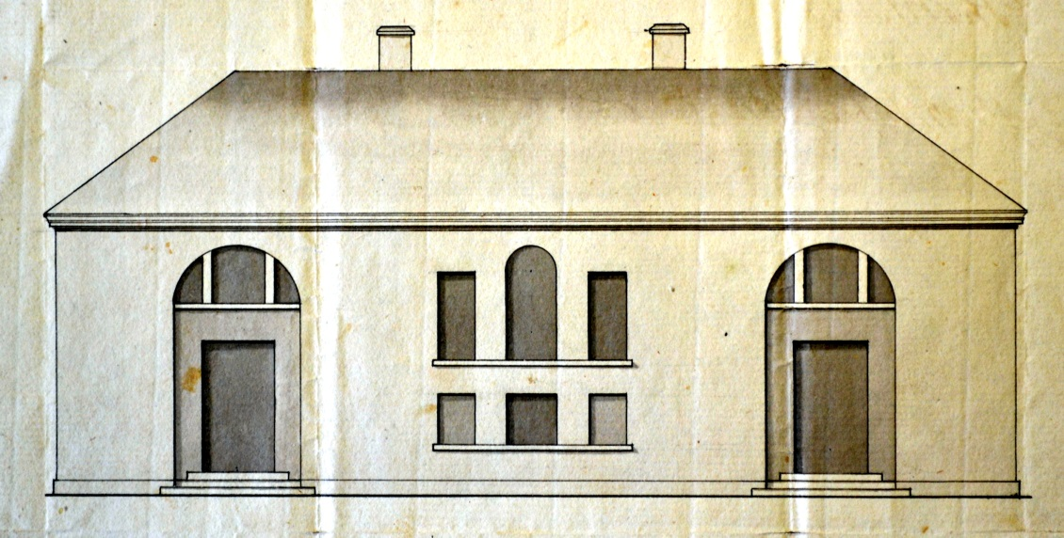
1. George Ensor, Roscommon Courthouse, sketch elevation, c. 1762. (This image is reproduced courtesy of the National Library of Ireland, Pakenham-Mahon Papers, MS 10,770 (3)).

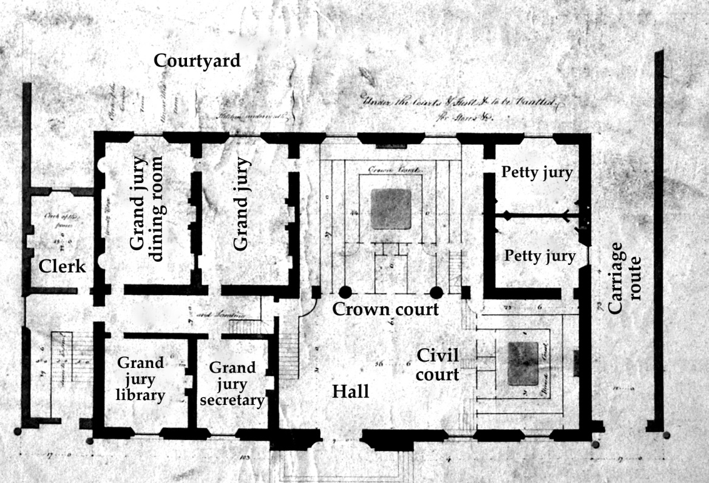
2. Francis Johnston, Armagh Courthouse, scheme ‘A’ plan, February–March 1805, unexecuted. (Irish Architectural Archive, RIAI Murray Collection, Acc. 92/46.4).

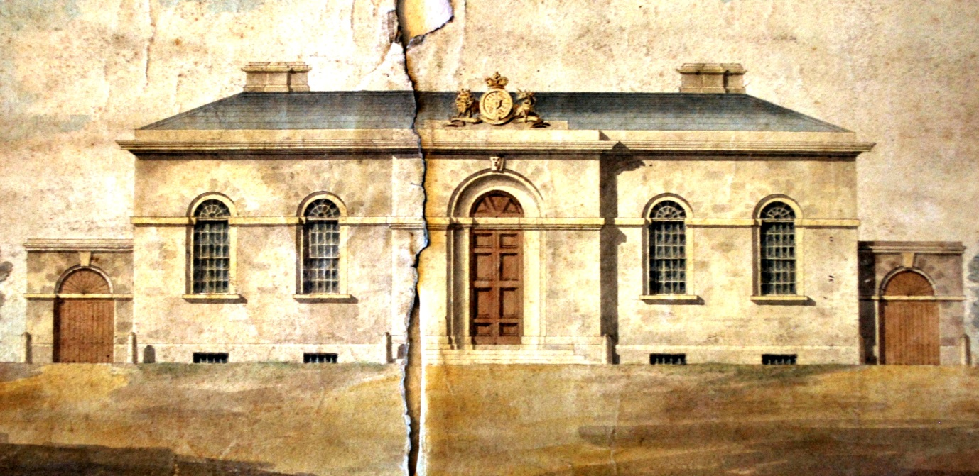
3. Francis Johnston, Armagh Courthouse, scheme ‘A’ elevation, February–March 1805, unexecuted. (Irish Architectural Archive, RIAI Murray Collection, Acc. 92/46.6).

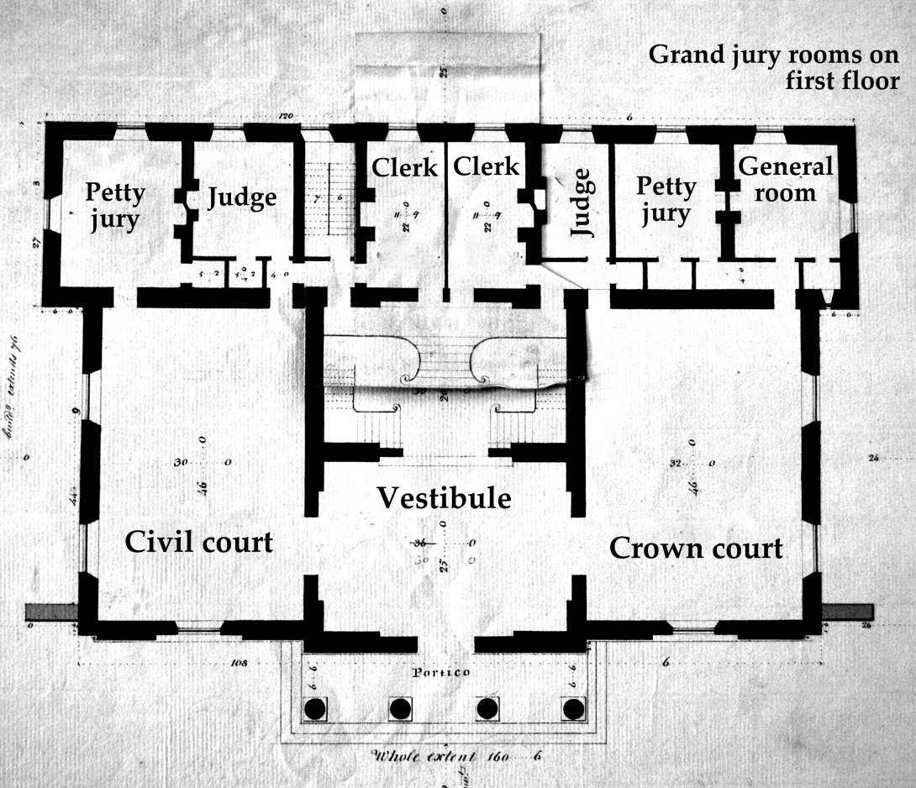
4. Francis Johnston, Armagh Courthouse, scheme ‘B’ plan, January 1807, unexecuted. (Irish Architectural Archive, RIAI Murray Collection, Acc. 92/46.13).
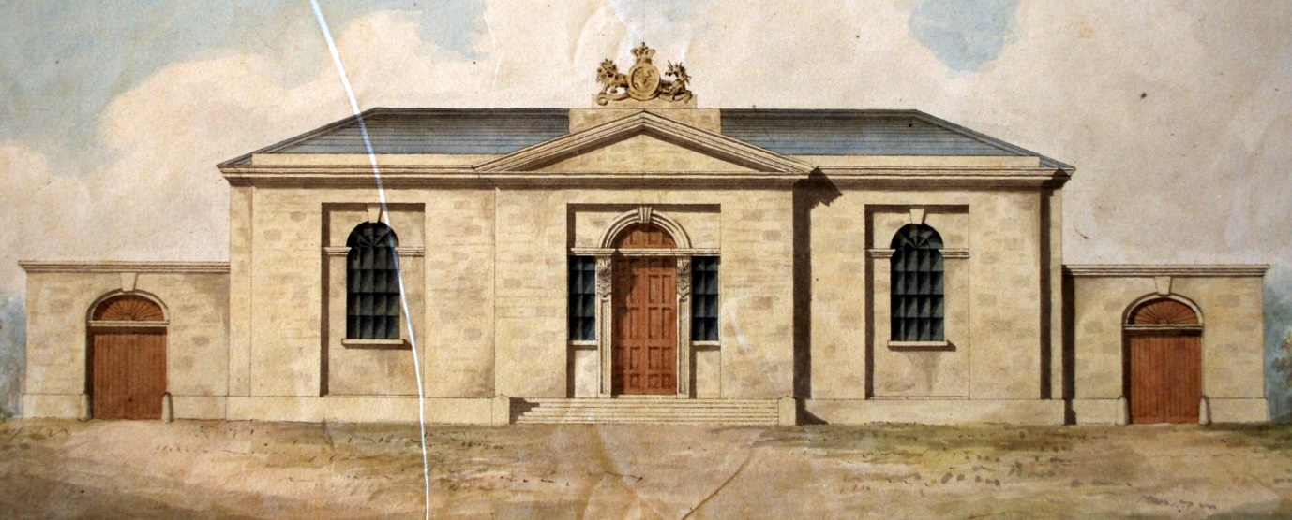
5. Francis Johnston, Armagh Courthouse, scheme ‘C’ elevation, May 1807, unexecuted. (Irish Architectural Archive, RIAI Murray Collection, Acc. 92/46.17).

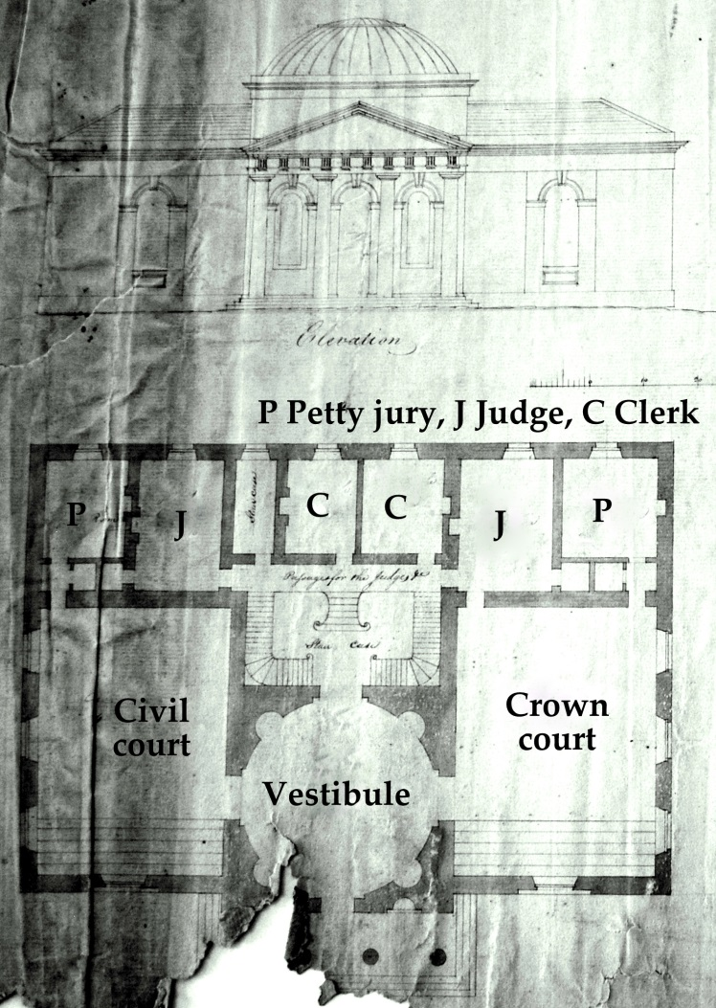
6. Francis Johnston, Armagh Courthouse, scheme ‘D’ plan and elevation, watermark 1808. (Irish Architectural Archive, RIAI Murray Collection, Acc. 92/46.18).
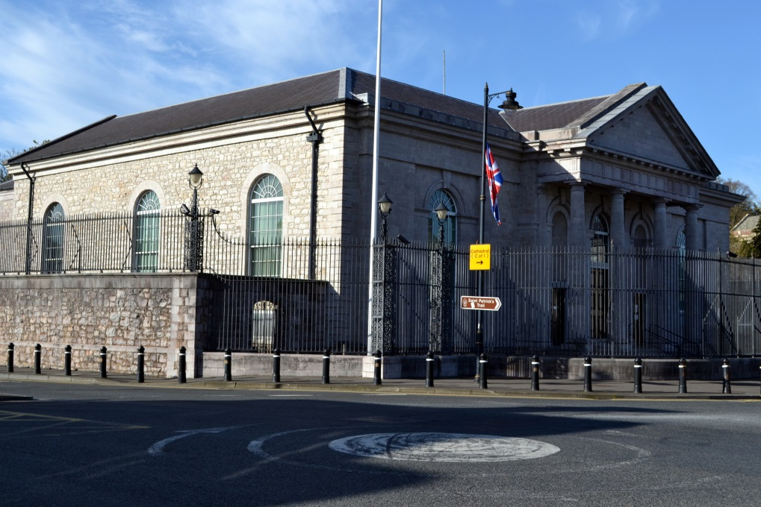
7. Armagh Courthouse, from the south-west. Photo by author, April 2014.

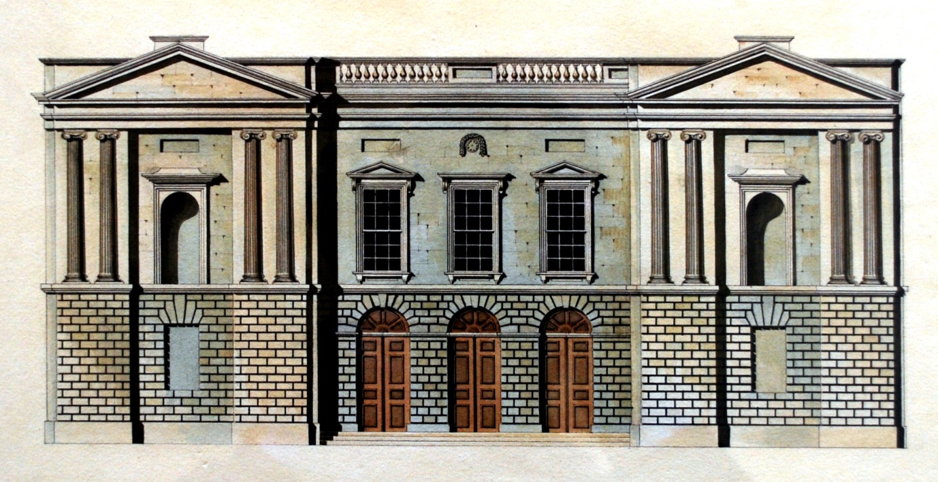
8. Henry, Mullins & McMahon, Kilmainham Courthouse, Dublin, elevation, 5 October 1817, unexecuted. (Irish Architectural Archive, Guinness Collection, Acc.96/68.5.1.3).

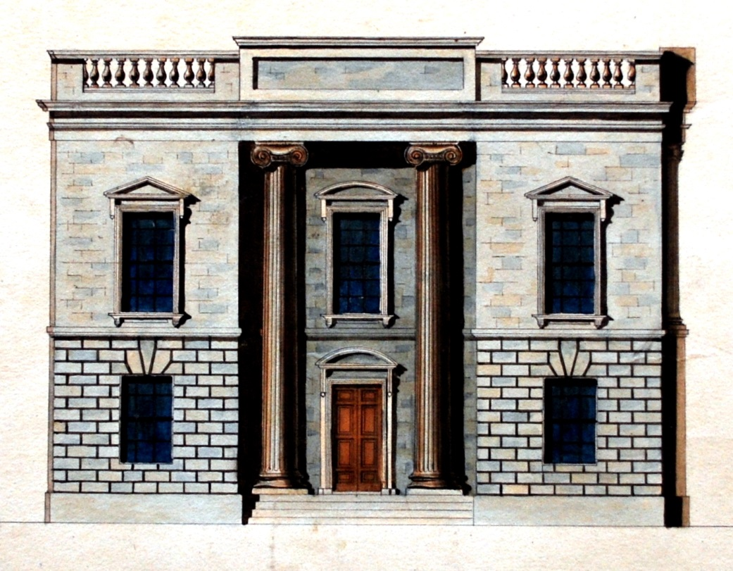
9. Henry, Mullins & McMahon, Kilmainham Courthouse, Dublin, side elevation (‘Grand Jury Entrance’), 5 October 1817, unexecuted. (Irish Architectural Archive, Guinness Collection, Acc.96/68.5.1.4).

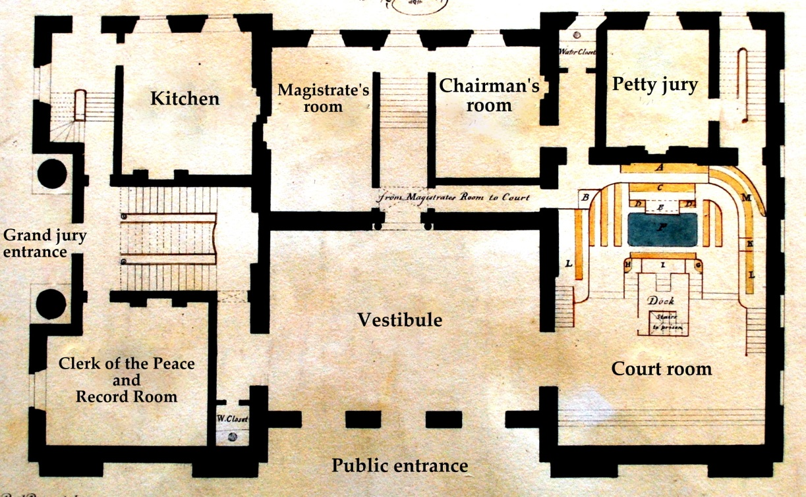
10. Henry, Mullins & McMahon, Kilmainham Courthouse, Dublin, ground floor plan, 5 October 1817, unexecuted. (Irish Architectural Archive, Guinness Collection, Acc.96/68.5.1.1).

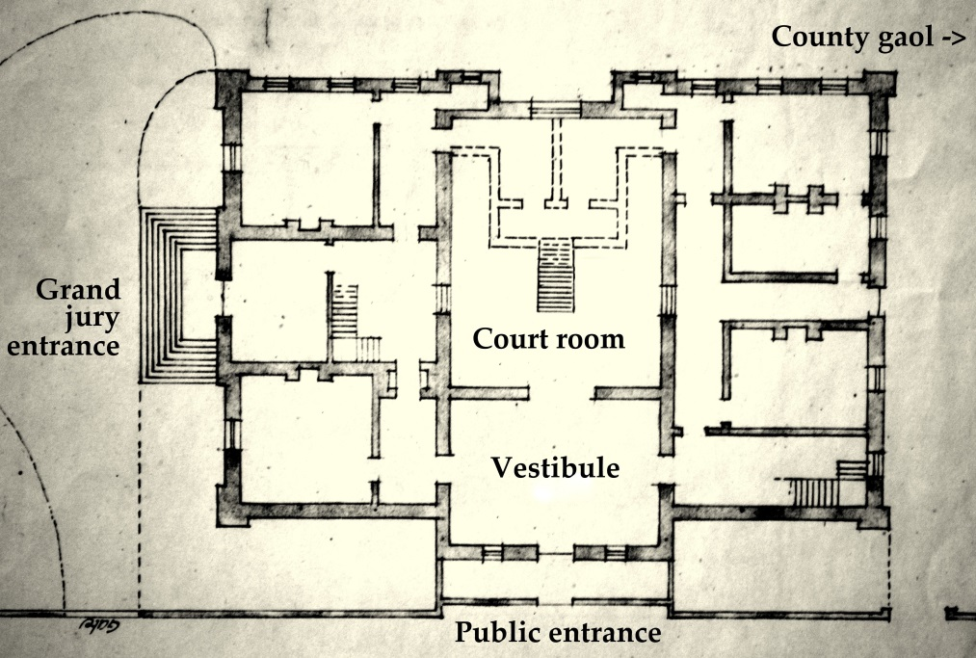
11. Office of Public Works, Ireland, Kilmainham Courthouse, Dublin, plan, 16 February 1920. (National Archives of Ireland, Office of Public Works drawings, OPW 5HC/4/400. Reproduced courtesy of the Director of the National Archives of Ireland).

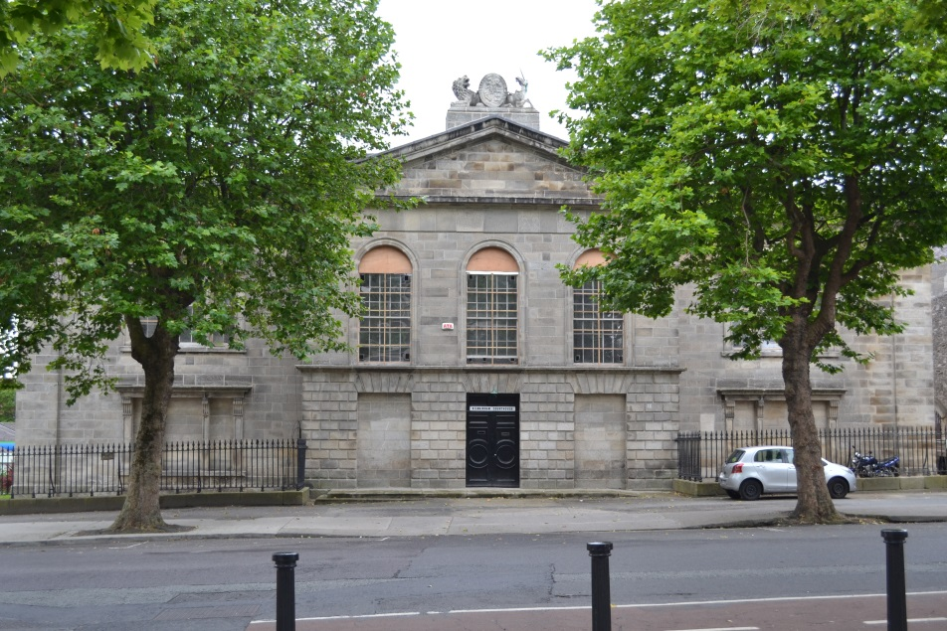
12. Kilmainham Courthouse, Dublin, from the north. Photo by author, June 2014.

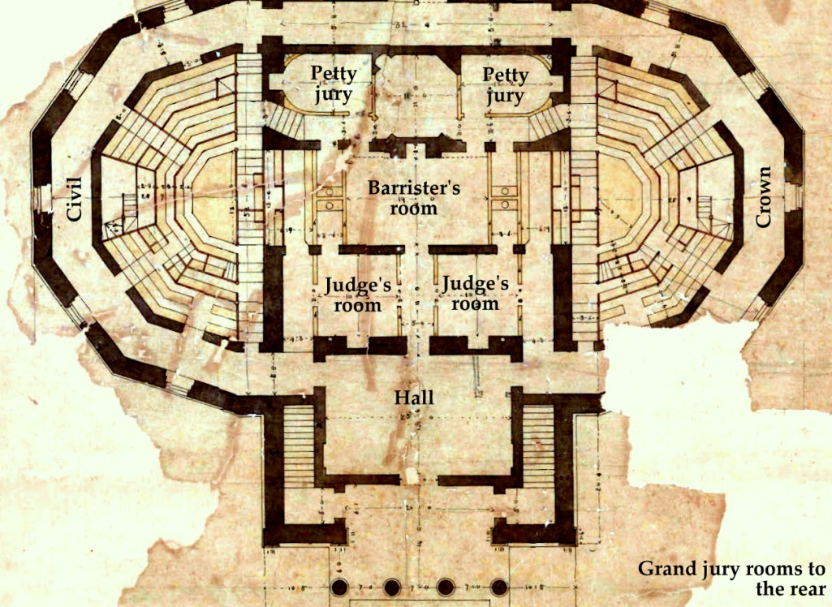
13. William Vitruvius Morrison, Carlow Courthouse, plan, c. 1828, executed instead with an octastyle portico and some other minor changes, 1832-34. (Carlow County Library).

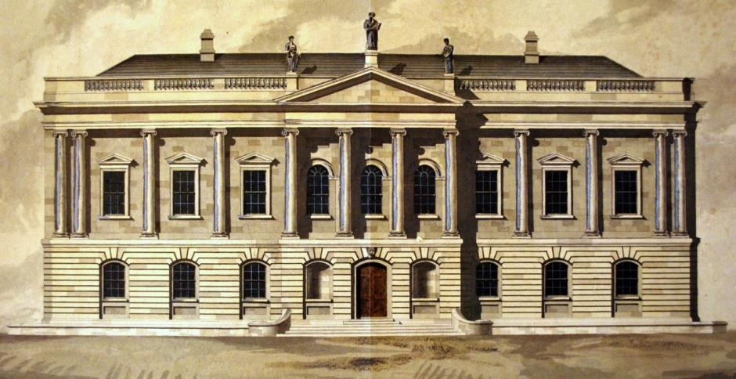
14. William Murray, Tullamore Courthouse, Co. Offaly, front elevation, December 1832, unexecuted. The piano nobile windows lit a series of large rooms for private entertainment by the grand jury. (Irish Architectural Archive, RIAI Murray Collection, Acc.92/46.1191).

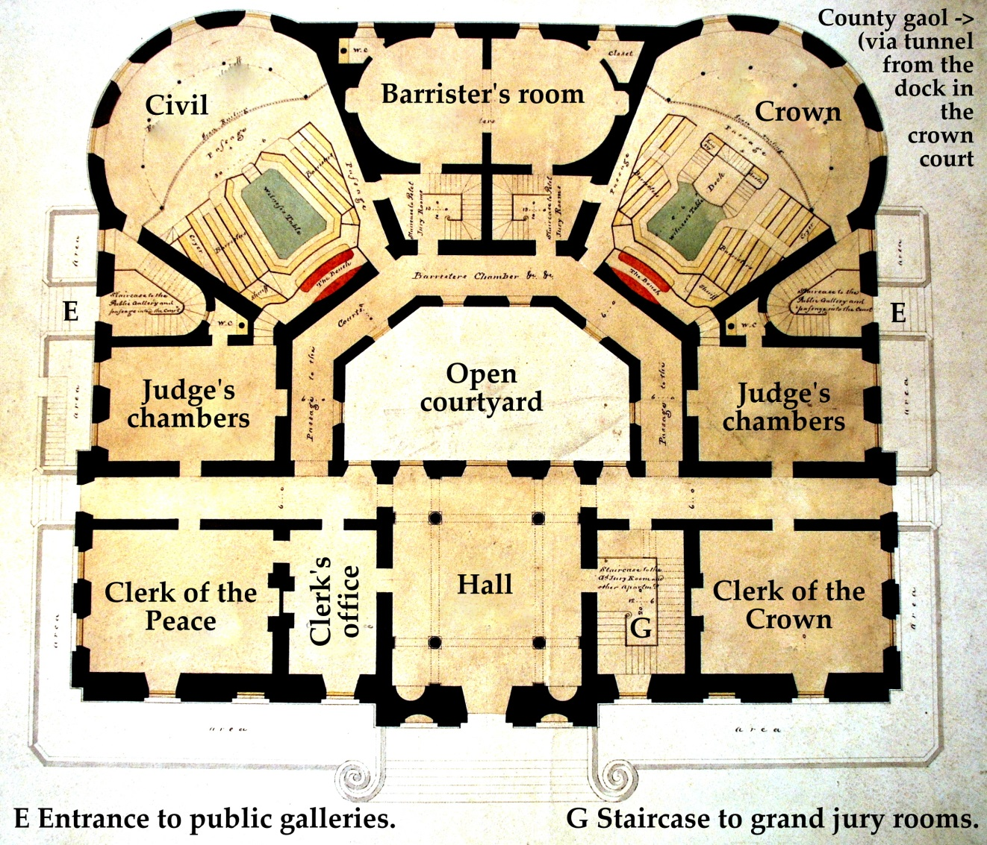
15. William Murray, Tullamore Courthouse, Co. Offaly, ground floor plan, December 1832, unexecuted. (Irish Architectural Archive, RIAI Murray Collection, Acc.92/46.1188).

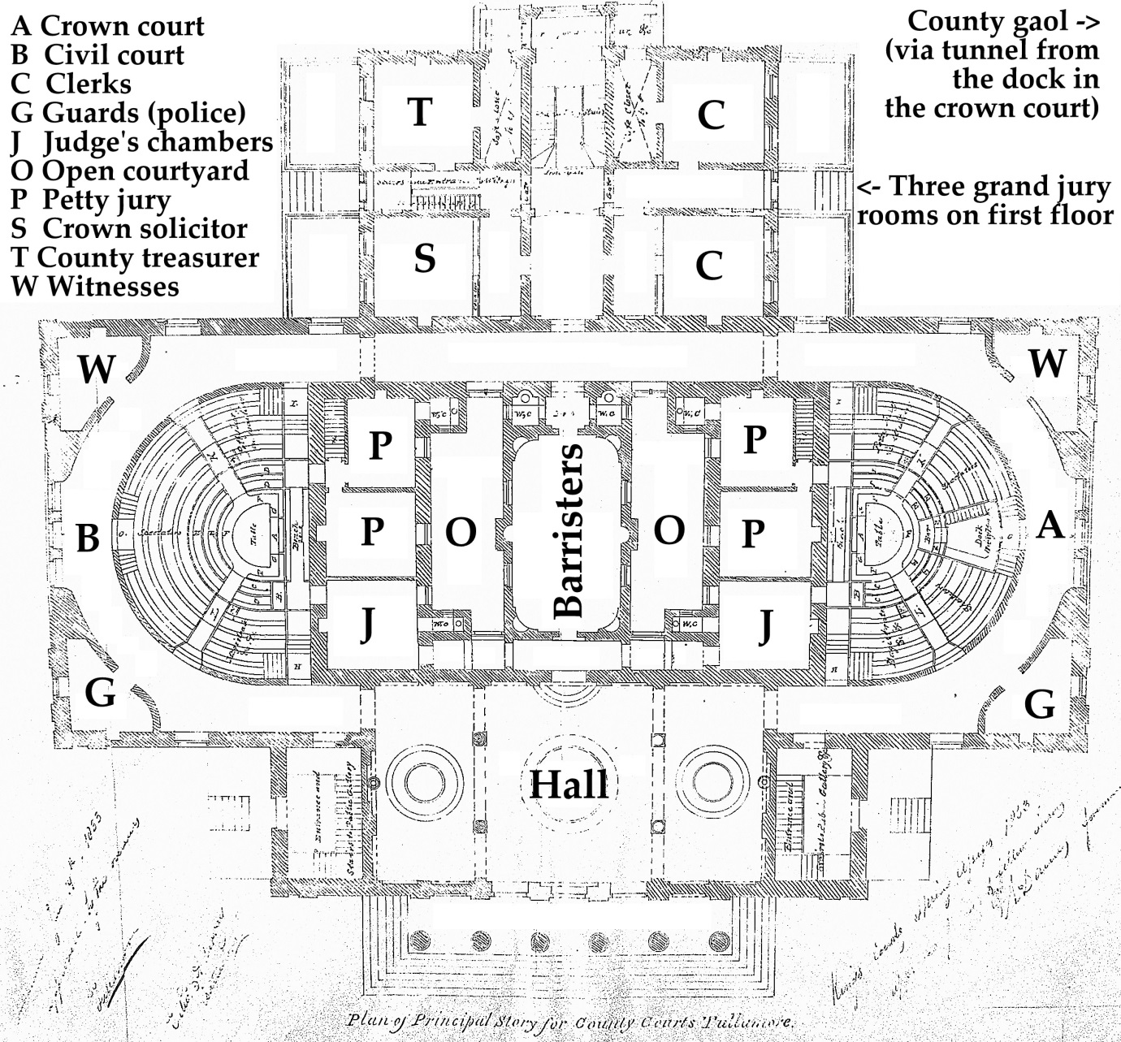
16. John B. Keane, Tullamore Courthouse, Co. Offaly, plan, 1833, as executed. (Irish Architectural Archive, Lismore Castle Collection, Acc.97/107.3.1).

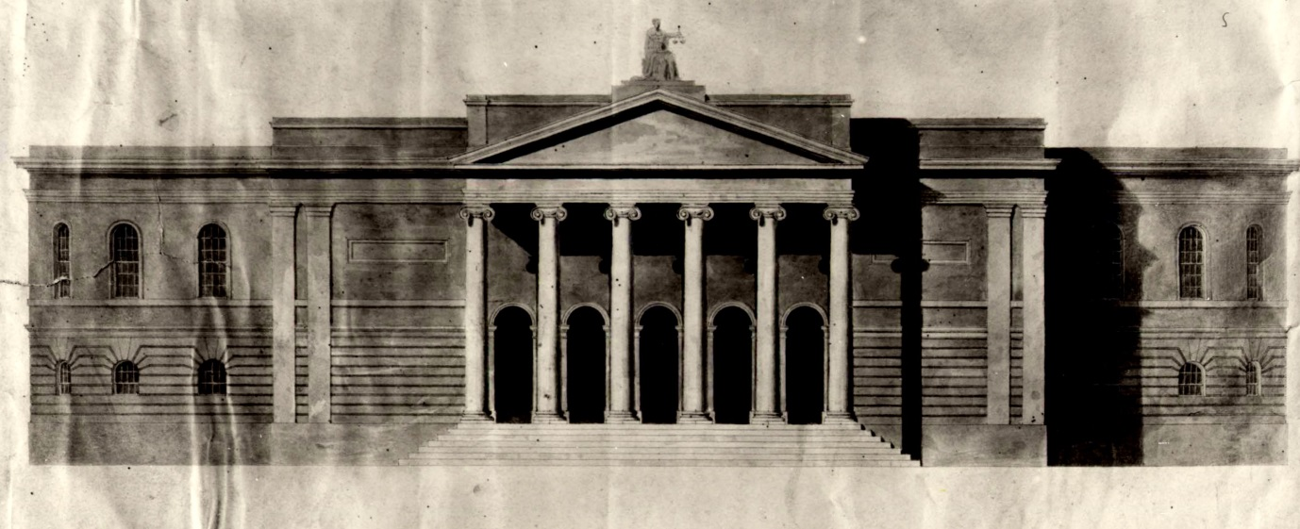
17. John B. Keane, Tullamore Courthouse, Co. Offaly, front elevation, c. 1833, unexecuted. The curved nature of the flanking elevations is clearly visible (contrast with Figs. 13 and 16) (reproduced courtesy of Mr Michael Byrne, Tullamore, Co. Offaly).

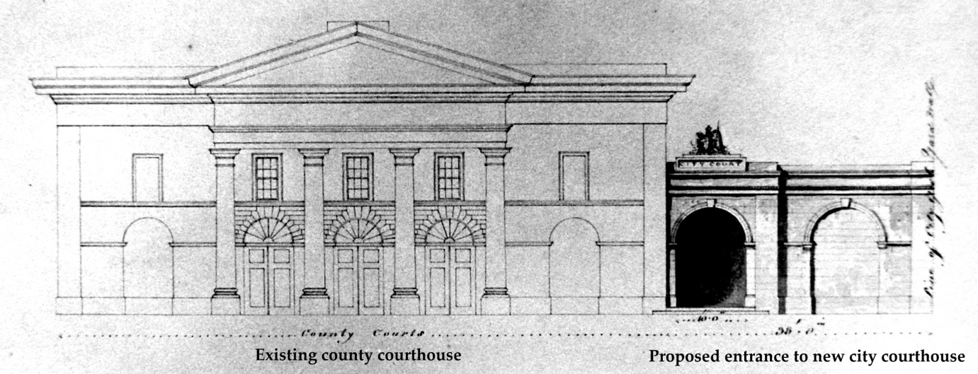
18. Henry Hill, Limerick City Courthouse, Co. Limerick, elevation of entrance porch (dark pen to right of existing County Courthouse), June 1834, unexecuted). (The Allen family, Shanagarry, Co. Cork).

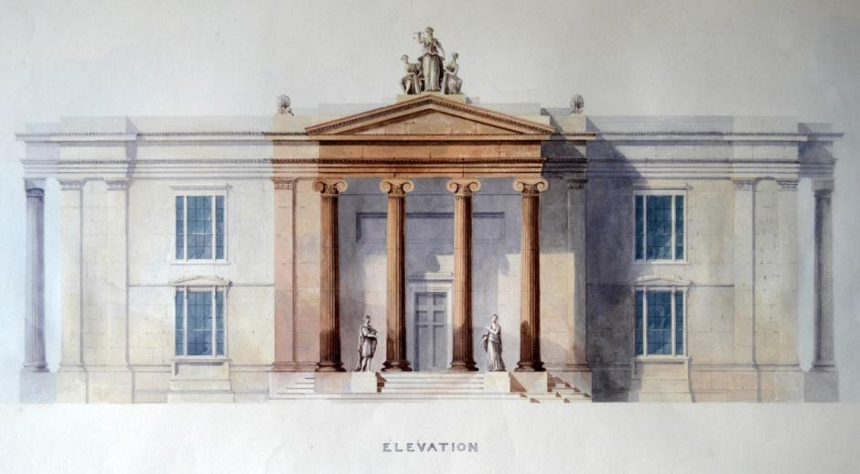
19. Henry Hill, Limerick City Courthouse, Co. Limerick, river elevation, June 1834, unexecuted. (The Allen family, Shanagarry, Co. Cork).

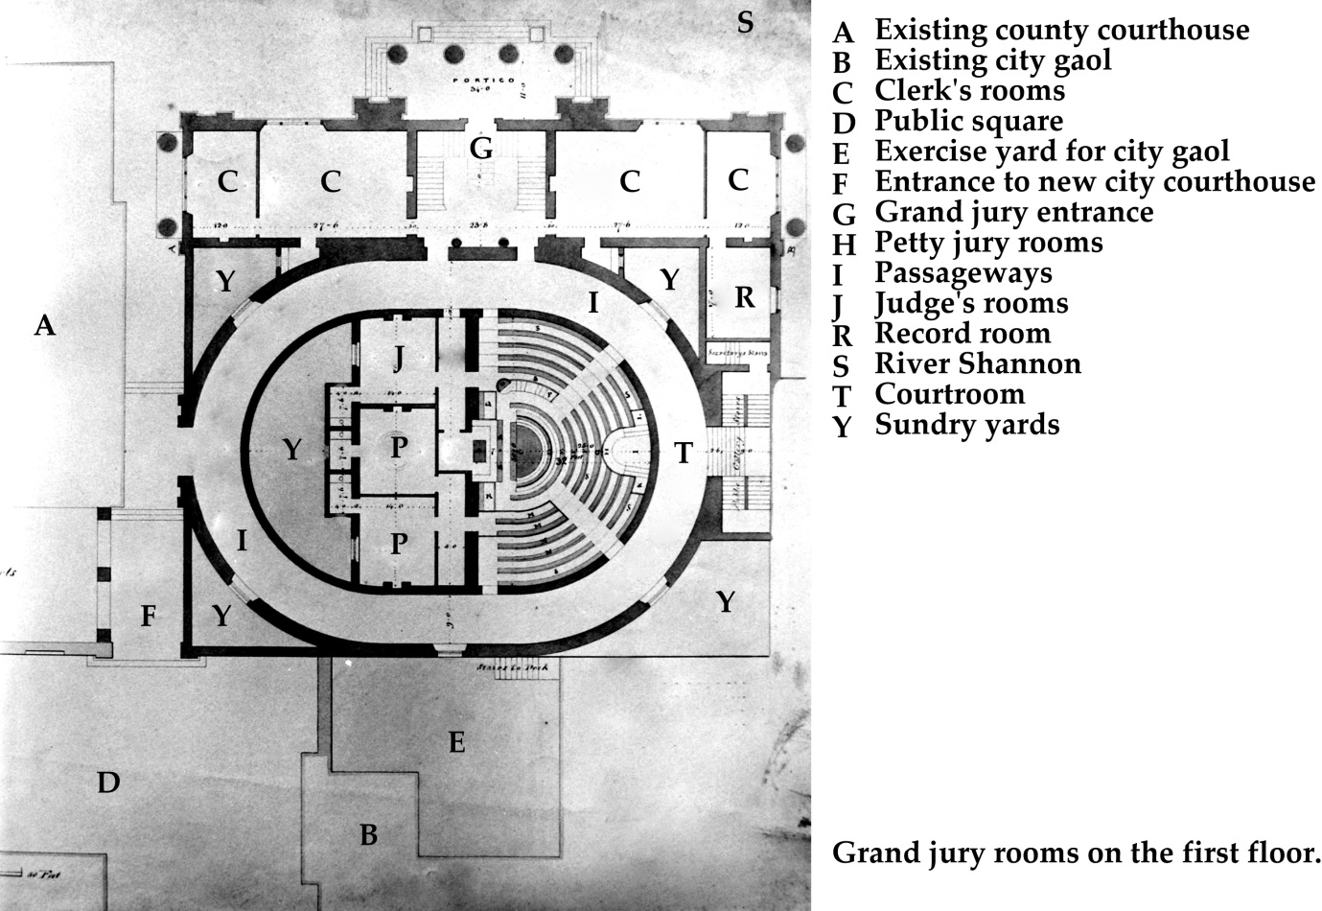
20. Henry Hill, Limerick City Courthouse, Co. Limerick, ground floor plan, June 1834, unexecuted. (The Allen family, Shanagarry, Co. Cork).

C.J. Woods, ‘Johann Friedrich Hering's description of Connacht, 1806–7’, Irish Historical Studies, 25, no. 99 (May 1987), pp. 315–21 (p. 320). See also Freeman’s Journal, 25 Mar. 1826.
Donal A. Murphy, The Two Tipperarys (Nenagh, Co. Tipperary, 1994), pp. 27–30, 57.
Third report from the select committee on the subject of the disturbed districts in Ireland, H.C. 1825 (36), xi, p. 335.
David Fitzpatrick, ‘Ireland in Empire’, in The Oxford History of the British Empire, 5 vols, ed. A. Porter (Oxford, 1999), III, pp. 494–521. See also G.A. Bremner, Imperial Gothic: Religious Architecture and High Anglican Culture in the British Empire, c. 1840–1870 (New Haven and London, 2013), pp. 350–63.
Jason Knirck, Afterimage of the Revolution: Cumann na nGaedheal and Irish Politics, 1922–1932 (Madison, Wisconsin, 2004), pp. 63–68. For broader approaches to this subject, see Charles Goodsell, The Social Meaning of Civic Space: Studying Political Authority through Architecture (Lawrence: University Press of Kansas, 1988); Robert Louis Rotenberg and Gary Wray McDonogh (eds.), The Cultural Meaning of Urban Space (Westport, Connecticut, 1993); Alistair Rowan, ‘The Irishness of Irish Architecture’, Architectural History, 40 (1997), pp. 1–23; Patrick Duffy, ‘Colonial spaces and sites of resistance: landed estates in nineteenth-century Ireland’, in (Dis)placing empire: renegotiating British colonial geographies, ed. Lindsay J. Proudfoot and Michael M. Roche (Aldershot, 2005), pp. 15–40; Gary A. Boyd, Dublin, 1745–1922: Hospitals, Spectacle and Vice (Dublin, 2006), pp. 144–201; and Gary A. Boyd and Denis Lenihan (eds.), Ordnance: War + Architecture & Space (Ashgate, 2013).
P.J. Meghen, ‘The Administrative Work of the Grand Jury’, Administration: Journal of the Institute of Public Administration of Ireland, 6, no. 3 (Autumn 1958), pp. 247–64. Virginia Crossman, Local Government in Nineteenth Century Ireland (Belfast, 1994).
Monaghan: D.R. Fisher, The History of Parliament: the House of Commons 1820–1832, 7 vols. (Cambridge, 2009), VII, pp. 696–700. Carlow: Freeman’s Journal, 3 Aug. 1831. Dublin: British Library, MS 40265, Peel Papers, f. 317, Resolution of the Dublin City Grand Jury, 14 May 1817. Cork: Ian d’Alton, ‘Remembering the future, imagining the past: how southern Irish Protestants survived’, in Librarians, Poets and scholars – a festschrift for Donall O Luanaigh, ed. F. M. Larkin (Dublin, 2007), pp. 212–30 (p. 217). For an overview, see Irene Whelan, The Bible War in Ireland: The “Second Reformation” and the Polarization of Protestant–Catholic Relations, 1800–1840 (Madison, WI., 2005).
Norman Gash, Mr Secretary Peel: The Life of Sir Robert Peel to 1830 (London, 1985), pp. 204–05.
Ronan Keane, ‘John Toler, first earl of Norbury’, in Oxford Dictionary of National Biography, ed. H.C.G. Matthew and Brian Harrison, 60 vols. (Oxford, 2004), LIV, p. 900. See also Journal of the House of Commons, 81 (5 May 1826), p. 328 and Freeman’s Journal, 4 June 1829.
Ian d’Alton, Protestant Society and Politics in Cork 1812–1844 (Cork, 1981), p. 123.
Hansard 9 (20 Apr. 1807), cc. 499–500, and 36 (30 June 1817), cc. 1270–75.
Freeman’s Journal, 23 Apr. 1828.
Clare Graham, Ordering Law: An Architectural and Social History of the English Law Court to 1914 (Ashgate, 2003), chapters 2–4.
Martha J. McNamara, From Tavern to Courthouse: Architecture and Ritual in American Law, 1658–1860 (Baltimore and London, 2004), pp. 81–102. Judith Resnik and Dennis E. Curtis, Representing Justice: Invention, Controversy, and Rights in City–States and Democratic Courtrooms (New Haven and London, 2011), chapters. 7–12 (quote at p. 226). See also Costas Douzinas and Lynda Nead (eds.), Law and the Image: The Authority of Art and the Aesthetics of Law (Chicago, 1999); Linda Mulcahy, Legal Architecture: Justice, Due Process and the place of Law (New York, 2011); and Yale Journal of Law & the Humanities, special issue (Winter 2012).
McNamara, From Tavern to Courthouse, p. 5.
Mulcahy, Legal Architecture, p. 83. See also Graham, Ordering Law, pp. 315–34; and Linda Mulcahy, ‘Putting the defendant in their place: why do we still use the dock in criminal proceedings?’, The British Journal of Criminology, 53, no. 6 (Nov. 2013), pp. 1139–56.
Patrick Polden, A History of the County Court, 1846–1971 (Cambridge, 1991). See also Graham, Ordering Law, pp. 157–315; and Jonathan Simon, Nicholas Temple, and Renée Tobe (eds.), Architecture and Justice: judicial meanings in the public realm (Ashgate, 2013).
Carl Lounsbury, ‘From Tavern to Courthouse: Architecture and Ritual in American Law, 1658–1860, by Martha J. McNamara (review)’, Journal of the Society of Architectural Historians, 64, no. 2 (June 2005), pp. 254–255.
Claire Priest, ‘From Tavern to Courthouse: Architecture and Ritual in American Law, 1658–1860, by Martha J. McNamara (review)’, Law and History Review, 25, no. 3 (Fall 2007), pp. 635–637.
Carlow courthouse. Finn’s Leinster Journal, 11 Apr. 1827, and 19 July 1828. National Archives of Ireland, CSORP 1828/556, Charles Burke to William Gregory, 19 July 1828.
C.E.B. Brett, Court Houses and Market Houses of the Province of Ulster (Belfast, 1973), pp. 15–20; and Christine Casey, ‘Courthouses, Markethouses and Townhalls of Leinster’ (master’s thesis, University College Dublin, 1982) pp. 15–22. For an overview of Irish courthouses, see Livia Hurley, ‘Courthouses’, in Art and Architecture of Ireland: Volume IV: Architecture 1600-2000, eds. Andrew Carpenter, Rolf Loeber, Hugh Campbell, Livia Hurley, John Montague, and Ellen Rowley (Dublin, New Haven and London, 2014), pp. 181–84.
Graham, Ordering Law, pp. 73–114 (pp. 91–93).
Figures for criminal indictments in Papers relating to the internal judicature of Ireland: return of the number of indictments, &c. entered for trial […] in the several counties of Ireland […] from 1786–1819, H.C. 1819–19 (15), iii, and from 1823 onwards in the appendices to the annual reports of the Inspectors General of Irish Prisons (H.C. papers).
Howard Colvin, Unbuilt Oxford (New Haven and London, 1983). See also Cees Nooteboom, Unbuilt Netherlands (London, 1985); Robert Harbison, The built, the unbuilt and the unbuildable: in pursuit of architectural meaning (London, 1991); T.P. Connor, Unbuilt Eton: an exhibition of architectural drawings (Eton, 1993); and Frank Salmon, Building on Ruins: The Rediscovery of Rome and English Architecture (Ashgate, 2000), pp. 153–226.
Edward McParland, ‘The public work of architects in Ireland during the neo-classical period’, 2 vols. (doctoral thesis, University of Cambridge, 1975), I, p. 12.
National Library of Ireland, MS 10,770, Pakenham–Mahon Papers, Roscommon Courthouse, elevation and plan drawings, undated. A clause in a 1796 act (36 Geo. III, c. 55, s. 97) allowed the County Roscommon grand jury to acquire the town’s market space ‘for the benefits of the court and the grand jury’. For Lifford, see Billy Patton, The Court Will Rise: A short history of the Old Courthouse, Lifford (Donegal, 2004).
For Gandon’s involvement in Waterford courthouse and the Four Courts, see Thomas J. Mulvany and James Gandon, The Life of James Gandon (Dublin, 1846), pp. 68–74, and Edward McParland, James Gandon: Vitruvius Hibernicus (London, 1985).
L.M. Cullen, An Economic History of Ireland since 1660 (London, 1972), pp. 100–11.
Maurice Craig, The Architecture of Ireland from the Earliest Times to 1880 (London, 1982), pp. 244–83.
From north to south: Derry, Omagh, Armagh, Dundalk, Trim, Athy, Naas, Portlaoise, Philipstown (now Daingean), Galway, Clonmel, Carlow, Wexford, Limerick and Cork.
Disused Public Buildings (Ireland) Act, 1808 (48 Geo. III, c. 113).
Hansard, 9 (20 Apr. 1807), cc. 499–502. Journal of the House of Commons, 64 (24 May 1809), p. 341. Hansard, 14 (24 May 1809), cc. 668–70. Journal of the House of Commons, 65 (21 Feb. 1810), p. 113. A Bill to amend the laws in Ireland respecting…grand juries, H.C. 1810 (118), i.
36 Geo. III c. 55. The problems with this act were first noted by Casey, ‘Courthouses, Markethouses and Townhalls of Leinster’, pp. 17–18.
British Library, MS 40223, Peel Papers, f. 121, John Leslie Foster to Robert Peel, 26 Feb. 1813.
Irish Architectural Archive [hereafter ‘IAA’], Acc. 92/46.4–18, RIAI Murray Collection, drawings by Francis Johnston (15 in total). See also Public Records Office of Northern Ireland, T1554, plans and elevations (mostly copies of the aforementioned Murray Collection drawings), 1805–07; and T636/46, County Armagh Grand Jury Presentments, 1800–1810, for Spring Assizes 1810. For other analyses of this building, and its early unexecuted designs, see Bernadette Goslin, ‘A History and Descriptive Catalogue of the Murray Collection of Architectural Drawings in the Collection of the Royal Institute of the Architects of Ireland’ (master’s thesis, University College Dublin, 1990), pp. 44–47; Robert McKinstry, Richard Oram, Roger Weatherup, and Primrose Wilson, The Buildings of Armagh (Belfast, 1992), pp. 153–54; C.E.B. Brett, Buildings of County Armagh (Belfast, 1999), pp. 219–20; and Kevin V. Mulligan, The Buildings of Ireland: South Ulster, the counties of Armagh, Cavan and Monaghan (New Haven and London, 2013), pp. 120–21.
Edward McParland, ‘Francis Johnston, Architect’, Irish Georgian Society Bulletin, 12, nos. 3–4 (1969), pp. 61–139.
James Stuart, Historical Memoirs of the City of Armagh (Newry, Co. Down, 1819), pp. 530–31.
IAA, Acc. 92/46.4–10, RIAI Murray Collection, Francis Johnston, elevations and plans for Scheme ‘A’, Feb.–Mar. 1805.
John Woolfe and James Gandon, Vitruvius Britannicus, Volume 5 (London, 1771), p. 8, plates 72–77. IAA, Acc. 92/46.11–15, RIAI Murray Collection, Francis Johnston, plans for Scheme ‘B’, Jan. 1807.
IAA, Acc. 92/46.16–17, RIAI Murray Collection, Francis Johnston, elevations and plans for Scheme ‘C’, May 1807.
IAA, Acc. 92/46.18, RIAI Murray Collection, Francis Johnston, plans for Scheme ‘D’, c. 1807
Francis Johnston to James Norris Brewer, 29 Feb. 1820, in Patrick Henchy, ‘Francis Johnston, Architect, 1760–1829’, Dublin Historical Record, 11, no. 1 (Dec. 1949–Feb. 1950), pp. 1–16 (pp. 12–13). McParland, ‘The public work of architects in Ireland during the neo-classical period’, I, p. 241.
Londonderry Court House Act (Local), 1812 (52 Geo. III, c. clxxxii). Court House (Ireland) Act, 1813 (53 Geo. III, c. 131).
Report from the Select Committee on Grand Jury Presentments of Ireland, minutes of evidence and appendix, H.C. 1814–15 (283), vi. Report from the Select Committee on Grand Jury Presentments, H.C. 1816 (374), ix. Second Report from the Select Committee on Grand Jury Presentments, H.C. 1816 (435), ix.
Journal of the House of Commons, 70 (28 Apr. 1815), pp. 253; 71 (29 Apr. 1816), p. 317; and 72 (23 May 1817), p. 306.
Hansard, 36 (30 June 1817), c. 1277. For a more detailed analysis see Brendan O'Donoghue, The Irish County Surveyors 1834–1944: A Biographical Dictionary (Dublin, 2007), pp. 6–9.
Hansard, 36 (30 June 1817), cc. 1270–75. Grand Jury Presentments (Ireland) Act, 1817 (57 Geo. III, c. 107).
Journal of the House of Commons, 73 (29 Jan. 1818), p. 13. Grand Jury Presentments (Ireland) Act, 1818 (58 Geo. III, c. 2). O’Donoghue, The Irish County Surveyors, pp. 8–9.
Grand Jury Presentments (Ireland) Act, 1818 (58 Geo. III, c. 67).
Gash, Mr Secretary Peel, pp. 135–37. Cullen, An Economic History of Ireland, pp. 100–20.
Public Works Loan Act, 1817 (57 Geo. III, c. 34). See also Ruth Heard, ‘Public Works in Ireland, 1800–1831’ (master’s thesis, Trinity College Dublin, 1977) and John Cunningham, ‘“Compelled to their bad acts by hunger”: Three Irish Urban Crowds, 1817–45’, Éire–Ireland, 45, nos. 1 & 2 (Spring–Summer 2010), pp. 128–51 (p. 140).
Public Works Loan (Ireland) Act, 1818 (58 Geo. III, c. 88). Employment of the Poor (Ireland) Act, 1822 (3 Geo. IV, c. 34). Public Works Loans (Ireland) Act, 1822 (3 Geo. IV, c. 112).
Hansard 7 (2nd series) (23 May 1822), c. 727. M. W. Flinn, ‘The Poor Employment Act of 1817’, Economic History Review, 14, no. 1 (1961), pp. 82–92.
Return of all sums of money…in aid of Public Works in Ireland, since the Union, H.C. 1839 (540), xxxxiv, pp. 12–13. An Account (since the Union) of all sums of money…for Public Works…in Ireland, H.C. 1847 (718), pp. liv, 3, 18–27.
Account (since the Union) of all sums of money…for Public Works…for England and Scotland, H.C. 1847 (718), pp. liv, 160–61.
Gash, Mr Secretary Peel, pp. 145–48. Gerard O’Brien, ‘Robert Peel and the Pursuit of Catholic Emancipation, 1813–17’, Archivium Hibernicum, 43 (1988), pp. 135–41.
Gash, Mr Secretary Peel, pp. 205–10. Richard A. Gaunt, Sir Robert Peel: the Life and Legacy (London, 2010), p. 24.
Robert Saunders, ‘God and the Great Reform Act: Preaching against Reform, 1831–32’, Journal of British Studies, 53, no. 2 (Apr. 2014), pp. 378–99 (p. 397).
Gash, Mr Secretary Peel, pp. 204–05.
Kent History and Library Centre, U269/022525, Sackville (Whitworth) Papers, Robert Peel to Lord Whitworth, 19 May 1817.
Gash, Mr Secretary Peel, p. 210. British Library, MS 40265, Peel Papers, f. 317, Resolution of the Dublin City Grand Jury, 14 May 1817.
A set of four drawings have survived – IAA, Acc. 96/68.5.1.1–4, Guinness Collection, Henry, Mullins & McMahon, Kilmainham Courthouse, Dublin, elevations and plans, 5 Oct. 1817, unexecuted. See also Brett, Court Houses and Market Houses of the Province of Ulster, p. 88.
Something similar, though not entirely analogous, appears in the Green Street courthouse (built 1792-97), built for the Dublin city grand jury. See Christine Casey, The Buildings of Ireland: Dublin (New Haven and London, 2005), pp. 99–100.
Casey notes the only surviving pre-famine Dublin grand jury presentment books are for 1841 and 1849. See Casey, ‘Courthouses, Markethouses and Townhalls of Leinster’, p. 15.
A.J. Nowlan, ‘Kilmainham Jail’, Dublin Historical Record, 15, no. 4 (Jan. 1960), pp. 105–15, at p. 110.
An Account (since the Union) of all sums of money…for Public Works…in Ireland, H.C. 1847 (718), liv, pp. 18–19.
Obtaining loans for purchasing land was explicitly prohibited in Public works loan (Ireland) Act 1820 (1 Geo IV c. 81), s. 13.
Baker exhibited drawings at the Royal Hibernian Academy in 1826 – nos. 245, 253, 259 and 265. See also Return of all sums of money…in aid of Public Works in Ireland, since the Union, H.C. 1839 (540), xxxxiv, p. 12. Plaque in grand jury room gives architect’s name and date of opening – 2 October 1820. A typo in Casey, The Buildings of Ireland: Dublin, p. 686, incorrectly gives the architect as Isaac Farrell, William Farrell’s brother (clarified in correspondence with Christine Casey). Harvard University, Houghton Library, RAN 1/N/4, William Farrell Album, Kilmainham Courthouse, Dublin, undated elevation (a photograph copy exists in the IAA).
National Archives of Ireland, OPW 5HC/4/400, Office of Public Works drawings, Kilmainham Courthouse, Dublin, ground floor plans, 16 Feb. 1920.
Hansard, 1 (3rd series) (9 Dec. 1830), cc. 909–32.
Public Works (Ireland) Act, 1831 (1 & 2 Will. IV, c. 33). Frederick O’Dwyer, ‘The architecture of the Board of Works 1829–1923’ (doctoral thesis, Trinity College Dublin, 1996).
Grand Jury (Ireland) Act, 1833 (3 & 4 Will. IV, c. 78). Meghen, ‘The Administrative Work of the Grand Jury’, p. 261.
Civil Bill Courts (Ireland) Act, 1836 (6 & 7 Will. IV, c. 75). Grand Jury (Ireland) Act, 1836 (6 & 7 Will. IV, c. 116). Public Works (Ireland) Act, 1839 (2 & 3 Vict., c. 50).
Cullen, An Economic History of Ireland, pp. 105–12, 119–22.
Hansard, 13 (3rd series) (30 May 1832), cc. 209–10. Cambridge University Library, King’s County Grand Jury Presentment Book, 1820, Thomas Bernard to Charles Grant, 15 Mar. 1820. For a full account of this dispute, see Michael Byrne, Legal Offaly: the county courthouse at Tullamore and the legal profession in County Offaly from the 1820s to the present day (Tullamore, 2008). There were also disputes in Tipperary and Waterford – see Murphy, The Two Tipperarys.
King’s County Assizes Act, 1832 (2 Will. IV, c. 60).
IAA, Acc.92/46.1174, RIAI Murray Collection, Letter from the overseers of the competition to select a design for the new courthouse at Tullamore to William Murray, 15 Nov. 1832. Bury had earlier communicated with Robert Smirke (architect of the Gloucester courthouse) about his plans, but it appears this came to nothing, see Byrne, Legal Offaly, p. 32.
Goslin, ‘A History and Descriptive Catalogue of the Murray Collection’, p. 338. IAA, Acc.92/46.1174–1193, RIAI Murray Collection, Tullamore Courthouse, Co. Offaly, plans, elevations, and sections, unexecuted, Dec. 1832.
French haunched segmental windows were used by C.R. Cockerell around this time – see David Watkin, The Life and Work of C.R. Cockerell (London, 1974), p. 228.
An objection from a cess-payer to a proposed item of expenditure (a presentment) by the grand jury.
University of Nottingham, Manuscripts and Special Collections, My 454/1–4, Charles Brinsley Marlay Papers, Charles Bury to Catherine Bury, 17 Jan. 1833; and My 463/1–3, Charles Brinsley Marlay Letters, Charles Bury to Catherine Bury, 3 Sept. 1833.
Quoted in J. Mordaunt Crook, The Greek Revival: neo-classical attitudes in British architecture (London, 1995), p. 133.
IAA, Acc.97/107.3.1–4, Lismore Castle Collection, John B. Keane, Tullamore Courthouse, plans and section, 1833, photocopy. An Account (since the Union) of all sums of money…for Public Works…in Ireland, H.C. 1847 (718), liv, p. 3.
Collection of Mr Michael Byrne, Tullamore, Co. Offaly, John B. Keane, Tullamore Courthouse, elevation, undated, c. 1833 (a photograph copy exists in the IAA).
Judith Hill, The Building of Limerick (Dublin, 1991), pp. 51–52. Samuel Lewis, A Topographical Dictionary of Ireland, 2 vols. (London, 1837), II, p. 272.
For crime figures, see the appendices to the annual reports of the Inspectors General of Irish Prisons (H.C. papers). Freeman’s Journal, 8 Mar. 1833; 2 Aug. 1833; 17 July 1834; and 12 July 1836.
Henry H. Hill (ed.), ‘Diary of a tour in Cos. Waterford, Kilkenny and Tipperary, 29 Aug–6 Sep 1831’, Journal of the Cork Historical and Archaeological Society, 38 (1933), pp. 30–37. Dagmar Ó Riain-Raedel, ‘“Rambles throughout the south of Ireland”: an antiquarian’s journey’, Journal of the Cork Historical and Archaeological Society, 113 (2008), pp. 40–52.
Collection of the Allen family, Shanagarry, Co. Cork, Henry Hill, Limerick City Courthouse, plan and elevations, June 1834, unexecuted (photograph copies exist in the IAA).
Collection of the Allen family, Shanagarry, Co. Cork, Henry Hill, ‘Design for a Public Building’, undated (a photograph copy exists in the IAA).
National Archives of Ireland, CSORP 1827/1453, Henry Westenra to William Gregory, 25 July 1827.
Cunningham, ‘“Compelled to their bad acts by hunger”: Three Irish Urban Crowds’, pp. 136–37.
Limerick Chronicle, 26 July 1843. Twenty-third report of the inspectors general on…the Prisons of Ireland, H.C. 1845 (620) xxv, pp. 69–70. The Board of Superintendence minute refers to an ‘original plan, alongside the county court-house’, likely Hill’s scheme. An Account (since the Union) of all sums of money…for Public Works…in Ireland, H.C. 1847 (718), liv, pp. 40–41.
Craig, The Architecture of Ireland, p. 266.
One study omitted from this article is Charles Lanyon’s courthouse at Crumlin Road, Belfast, from the late 1840s, for which an unexecuted scheme exists, with an elevation altered in a later design (as built) in a manner very similar to Keane’s revisions at Tullamore. After the long stasis of the famine we find courthouses at Sligo (in the 1870s) and after a fire at Roscommon (in the 1880s). An unbuilt scheme survives for the latter. For Belfast, see Brett, Court Houses and Market Houses of the Province of Ulster, p. 49. For Sligo, see Lynda Mulvin, ‘Administering justice in Gothic revival Ireland: a study of the Sligo assizes courthouse’, in Studies in the Gothic Revival, ed. Michael McCarthy and Karina O'Neill (Dublin, 2008), pp. 180–194; and Irish Builder, 16, no. 349 (1 July 1874), p. 189. For Roscommon, see Irish Builder, 25, no. 569 (1 Sept. 1883), pp. 270, 275.

