What is the Process Window for Semi-Solid Processing?
Duyao Zhang,¹ Hongbiao Dong,¹ Helen Atkinson^{1,*}
(1) Department of Engineering, University of Leicester, University Road, Leicester, LE1 7RH, UK,
*Email: hva2@le.ac.uk, Tel: +44(0)1162231019

Abstract.
In semi-solid processing, the liquid fraction versus temperature is commonly used to define the process window. Conventionally it is assumed a freezing range is required for semi-solid processing but recently both high-purity aluminium and binary Al-Si eutectic alloy have been rheo-processed. Here, the kinetics during melting and solidification of pure metal are analyzed and a comparison between the liquid fraction versus temperature and the liquid fraction versus time presented. It is found that liquid fraction versus time is a significant criterion for semi-solid processing.

Keywords: Process window; Aluminium; DSC; Semi-solid processing

Process window is defined as a collection of process parameters that allow materials to be manufactured and to operate under desired specifications [1]. In semi-solid processing, the process window is related to a stage between the solidus and the liquidus of a metallic alloy. Semi-solid processing from a solid state starting point (thixoforming) is normally carried out with between 30% and 50% liquid as it leads to an optimum slurry viscosity and a good die filling property [2, 3, 4]. Kazakov [5] examined the processability from a thermodynamic prediction and Differential Scanning Calorimetry (DSC) view point focusing on the slope of the liquid fraction versus temperature. He defined several critical parameters including that the slope ($df_{L}/dT$) of the liquid fraction versus temperature curve and noted that at 50% fraction liquid this should be relatively low. Atkinson et al. [6] identified that it is the slope of the liquid fraction versus temperature curve in the region of 30-50% liquid which is the key parameter. More recently, Liu et al. [7] using the MTDATA thermodynamic package and DSC predicted the liquid fraction sensitivity ${(df_{L}/dT)}_{f_{L=0.4}}$ at 40% fraction liquid (mid-way through the process range of 30-50% liquid) and argued that it should not change too rapidly with temperature in the process window. As pure metals and the eutectic alloys do not have a freezing (or melting) range, it has been conventionally expected that it is not possible for them to be semi-solid processed because$(df_{L}/dT$) is ∞. Based on Liu et al.’s theory [7], recent studies have been focused on the evaluation the thixoformability through processing temperature and modifying alloy elements [8-10].
Surprisingly Curle et al. [11, 12] recently demonstrated that both high-purity aluminium and binary Al-Si eutectic alloy can be rheocast. Rheocasting involves cooling from the liquid state into the semi-solid range and forming at about 60% liquid or higher. This is a different approach from thixoforming but the principles that will be drawn out in this paper are applicable in both cases. Curle et al. [11, 12] identify that the processing in the semi-solid state is achievable because of the solidification kinetics during the thermo-arrest i.e. solidification is not instantaneous. It seems, therefore, that time can be a critical factor during processing and not just temperature. In addition, this will be relevant not only with pure metals, and binaries at the eutectic point, but also with other alloys where there is a freezing range. Those who carry out the process in industry understand that time is a factor because isothermal holds are introduced during the heating process for the billet for thixoforming but the role of time in determining the process window has not previously been articulated fully scientifically.
The aim of this paper is to isolate the role of time for high-purity aluminium metal and hence to illustrate an analysis which can be applied to alloys in due course. In this paper, the liquid fraction sensitivity to temperature ${(df_{L}/dT)}_{f_{L=0.4}}$ and the liquid fraction sensitivity to time ($df_{L}/dt$) will be evaluated for the processing route. The thixoforming route will be focused on (where it is the range between 30% and 50% liquid which is of concern) but the analysis has parallels for other semisolid processing routes such as rheocasting.
A high accuracy single-pan scanning calorimeter (SPSC) developed by Dong and Hunt [13, 14] has been used to measure the liquid fraction change during solidification. The SPSC can eliminate the smearing effect in a conventional DSC. In SPSC the sample is in a uniform temperature enclosure and there is a large thermal resistance between the sample and its surroundings. In this study the liquid fraction change versus time will be measured for high purity (99.999%) aluminium using a conventional DSC and a new SPSC.
In experiments, Differential Scanning Calorimetry (DSC) was performed on a NETZSCH 404 DSC in an argon-controlled environment. A high-purity aluminium (99.999%) and sapphire were used to calibrate the temperature and enthalpy measurements of the instrument. Samples of high purity aluminium were prepared 3mm in diameter and about 20mg in weight. The standard heating rates in the DSC are 3K/min and 10K/min. The samples were heated to 993K (720ºC) at 3K/min (or 10K/min) and then cooled to 303K (30ºC) at the same rate. Argon was fed through the system at a flow rate of 35ml/min to minimize oxidation of the samples. Three repetitions were carried out for each sample (two samples) under each condition. A high reproducibility was obtained. The evaluation of the liquid phase fraction is carried out by the application of peak partial area integration [15].
To overcome the smearing effect [16] in DSC experiments, a Single-Pan Scanning Calorimeter (SPSC) was used to measure enthalpy data with higher accuracy. High-purity aluminium (99.999%) and sapphire were used to calibrate the temperature and enthalpy measurements in SPSC. In experiments a constant heat flux mode was used [13, 14] by controlling the temperature difference between the inner and outer crucible at ± 6K and ± 12K. These temperature differences correspond to heating and cooling rate of 3.0±0.1 K/min and 8.5±0.1K/min respectively before any melting and solidification occurs. The cylindrical samples in the SPSC were 2.10g in weight.
The DSC traces for melting and solidification of high-purity aluminium are shown in Figure 1(a,c). Although high-purity aluminium has a fixed melting point at 933.49K (660.34ºC), the measured DSC signal shows that melting and freezing occur over a range of temperature, a 10K range for 3K/min and a 20K range for 10K/min. This was termed as the “smearing” effect by Höhne et al. [16]. The smearing effect was further quantitatively analyzed by Dong and Hunt [13, 14] and they revealed that during melting and freezing, a large temperature difference occurs between the sample and the sample thermocouple, i.e. the sample thermocouple doesn’t measure the sample temperature correctly during melting and freezing. This is particularly true for metals and alloys because extremely high solidification interface velocities (of the order of mm/s) were measured even with temperature differences from the melting point of a few hundredths of a degree [17, 18]. The “smeared” DSC signals have commonly been used to study solidification kinetics and ironically the “smeared” signals provide better-looking but wrong figures in kinetic analysis as discussed later.
The SPSC overcomes the “smearing” effect and the measured raw data (temperature vs. time) with the temperature difference between the inner and outer crucible at ± 6K and ±12K is shown in Figure 1(b). The temperature variation during melting and solidification was very small. Steady state temperature differences have been obtained through melting and solidification for high accuracy enthalpy measurement, as shown in Figure 1(d).
The enthalpy data was calculated from the measured raw data. As the calorimeter is heated in the time period $dt$, the temperature of the (empty) inner crucible increases$dT_{E}$, the (calibrant + empty) increases $dT_{C}$ and the (sample + empty) increases by $dT_{S}$. The equivalent temperature differences between the inner and outer crucible for the three cases are $∆T_{DE}$, $∆T_{DC}$, and $∆T_{DS}$. The change in heat substance per degree (i.e. heat capacity times mass) of the calibrant $C_{C}$ is a function of temperature. Similarly $C_{E}$ and $C_{S}$ are those of the empty crucible and sample. It should be distinguished that $C_{S}$ contains any latent heat and is thus a valuable heat capacity. The heat transfer coefficient between the inner and outer crucible is defined as $α$. $α$ is a function of temperature.
The equations for the heat transfer between the inner and outer crucibles and enthalpy change within the inner crucible can be written as follows:
For the empty crucible: $α$ΔT_{DE}dt = C_{E}dT_{S}
For the calibrant + empty: $α$ΔT_{DC}dt = (C_{C} + C_{E}) dT_{C}
For the sample + empty: $α$ΔT_{DS}dt = (C_{S} + C_{E}) dT_{S}
Eliminating $α$and multiplying by $dT_{S}$ gives a general expression for the rise in enthalpy of the sample $dH_{S}$.
$C_{C }\left(\frac{∆T_{DS}-\frac{∆T_{DE}}{dT_{E}}dT_{S}}{\frac{∆T_{DC}}{dT_{C}}-\frac{∆T_{DE}}{dT_{E}}}\right)=C_{S}dT_{S}=dH_{S}$ (1)
The equation is valid as $dT_{S}$ → 0 and $C_{S}$→∞. Thus, it can handle the latent heat of a pure material. The ratios $\frac{∆T_{DE}}{dT_{E}}$ and $\frac{∆T_{DC}}{dT_{C}}$ are evaluated from the (empty) and (calibrant + empty) run at the relevant temperature using the same time interval. The implication of these terms is best visualized by noting that the first is the inverse of $\frac{dT_{E}}{dt}\frac{1}{ΔT_{DE}}$ which is the rate of rise of the empty pan divided by the difference in temperature between the inner and outer crucible. The equation and the use of a central thermocouple inherently handle the de-smearing process.
The obtained enthalpy was used to determine the fraction of liquid $f_{L}$. Assuming the true heat capacity $C_{p}$ is the same in the solid and liquid phases and the latent heat $L$is constant, $f_{L}$in the equation $H=C_{p}T+f_{L}L$ can be determined by [19]:
$f_{L}(T)=\left[\frac{\left(H-H_{solidus}\right)-C_{P}∙(T-T_{solidus})}{\left(H_{liquidus}-H_{solidus}\right)-C_{P}∙(T_{liquidus}-T_{solidus})}\right]$ (2)
where $H$ is enthalpy, $T$ is the temperature.
The measured enthalpy changes during melting and solidification for high-purity aluminium obtained by DSC and SPSC is shown in Figure 2. It can be seen that there is very little differences among these enthalpy curves for the different rates for SPSC, except for a small difference in the enthalpy step at the beginning of solidification. This is because the as expected undercooling occurs during freezing. However, the enthalpy measured by DSC shows large differences between different scan rates, which is not correct.
The liquid fraction versus temperature curves calculated from the DSC and SPSC results are shown in Figure 3. As can be seen in Figure 3(a), the DSC curves vary significantly with changes in heating rate. However, this is not a proper reflection of reality because the measured temperature is the reference pan temperature rather than the sample temperature. The SPSC (Figure 3(b)), in contrast, gives a constant temperature line when high-purity aluminium is melting or solidifying because it is measuring exactly the sample’s temperature. Liquid fraction sensitivity to temperature can be defined from the slope (Figure 3(a)) of the liquid fraction versus temperature curve as ${(df_{L}/dT)}_{f_{L}}$.
When taking time into consideration, the calculated liquid fraction as a function of time for high-purity aluminium with SPSC for the temperature differences at ±6K and ±12K are shown in Figure 4. It can be seen that the vertical curves in Figure 3(b) becomes curves with slopes about ±12 seconds per % liquid fraction for ±6K condition (±5 seconds per % liquid fraction for ±12K condition). The results indicated 2.10g high-purity aluminium needs about 1200 seconds to be totally melted under the ±6K condition (~240s to transition the 30%-50% liquid temperature range). The melting time decreased to 500 seconds under the ±12K condition (~±8.5K/min).
The liquid fraction sensitivity to temperature ${(df_{L}/dT)}_{f_{L=0.4}}$.and the liquid fraction sensitivity to time ${(df_{L}/dt)}_{f_{L=0.4}}$ for both DSC and SPSC are listed in Table 1. The sensitivity declines with an increase of the heating/cooling rate for DSC. However, the liquid fraction sensitivity to temperature for the SPSC result is infinity because the melting/solidification temperature variation for high-purity aluminium is almost zero.
As DSC is controlled to a constant heating/cooling rate, the time is proportional to the temperature during melting and solidification. As a result, the sensitivity to time ${(df_{L}/dt)}_{f_{L=0.4}}$ equals the sensitivity to temperature ${(df_{L}/dT)}_{f_{L=0.4}}$ times the heating/cooling rate. For SPSC, the liquid fraction sensitivity to time with 3K/min heating/cooling rate (Figure 4(a)) is ~±0.05min⁻¹ (~±0.12min⁻¹ for 8.5K/min heating/cooling rate, Figure 4(b)) rather than ∞ for sensitivity to temperature. The decreased liquid fraction sensitivity to time can open a process window with time for semi-solid processing (as demonstrated experimentally by Curle et al. [11, 12]).
In practice in semi-solid processing, it is impossible to heat/cool a billet at a constant rate when melting or solidification occurs. Instead, there is a holding time in the semi-solid state [20], where the thermo-arrest occurs. As Figure 4 shows, the melting or solidification does not happen instantaneously. The diffusion time during phase transformations is dependent on the amount of heat flux. Therefore, the liquid fraction sensitivity to time can be controlled through the heat flux. The process window can be enlarged when a lower heat flux ratio is applied. Thus the liquid fraction sensitivity to time at 40% liquid fraction must be analyzed, and is a substantive criterion for identifying the process window for semi-solid processing. In thixoforming or rheocasting, the time sensitivity should be calculated strictly according to sample mass, heat flux and phase transformation temperature. In addition, time sensitivity of liquid fraction for alloys is important is determining the extent to which defects such as hot tears occur and hence potentially in making the process cost effective.
DSC and SPSC have been used to investigate the liquid fraction versus temperature and time for high-purity aluminium. The DSC results are sensitive to the ramp rate and sample mass because the measured temperature is the reference pan temperature rather than the sample temperature. It is concluded that the time sensitivity of liquid fraction can be a significant criterion for identifying the process window for semi-solid processing. Semi-solid processing can occur even for materials lacking a temperature interval between the solidus and the liquidus (e.g. pure binary eutectics and pure metals) because of the kinetics of melting/solidification. In practice in semi-solid processing, the heating/cooling route must be analyzed to determine the melting/solidification in the various parts of the billet and hence predict the liquid content variation across the billet at stages in the processing. The next stage is to investigate the time sensitivity of liquid fraction of high performance alloys, which have great potential to be applied in practical semi-solid processing.
The authors would like to acknowledge the University of Leicester for financial support.

References
[1] P. Gupta: ACM SIGDA Newsletter, 2010, vol. 40, pp.1-1.
[2] D. Kirkwood: Int. Mater. Rev., 1994, vol. 39, pp. 173-189.
[3] H.V. Atkinson: Prog. Mater. Sci., 2005, vol. 50, pp. 341-412.
[4] O. Lashkari and R. Ghomashchi: Mater. Sci. Eng., A, 2008, vol. 486, pp. 333-340.
[5] A.A. Kazakov: Adv. Mater. Process., 2000, vol. 157, pp. 31-34.
[6] H.V. Atkinson, P. Kapranos, D. Kirkwood: in: Proceedings of the 6th International Conference “Semi-solid Processing of Alloys and Composites”, Turin, 2000, pp. 445-446.
[7] D. Liu, H.V. Atkinson, H. Jones: Acta Mater., 2005, vol. 53, pp. 3807-3819.
[8] E.J. Zoqui, M.A. Naldi: J. Mater. Sci., 2011, vol. 46, pp. 7558-7566.
[9] M.S. Salleh, M.Z. Omar, J. Syarif, M.N. Mohammed. Adv. Sci. Lett., 2013, vol. 19, pp. 3503-3507.
[10] D.M. Benati, E.J. Zoqui, J. Mater. Eng. Perf., 2014, vol. 23, pp. 3156-3179.
[11] U. Curle, H. Möller, J. Wilkins: Scripta Mater., 2011, vol. 64, pp. 479-482.
[12] U. Curle, H. Möller, J. Wilkins: Mater. Lett., 2011, vol. 65, pp. 1469-1472.
[13] H.B. Dong and J.D. Hunt, J. Therm: Anal. Calorim., 2001, vol. 64, pp. 341-350.
[14] H.B. Dong, M. Shin, E. Kurum, H. Cama, J.D. Hunt: Fluid Phase Equilibr., 2003, vol. 212, pp. 199-208.
[15] D. Larouche, C. Laroche, M. Bouchard: Acta Mater., 2003, vol. 51, pp. 2161-2170.
[16] G. Höhne, W.F. Hemminger, H. J. Flammersheim: Differential Scanning Calorimetry, 2nd edition, Springer, 2003.
[17] G.H. Rodway and J.D. Hunt: J. Cryst. Growth, 1991, vol. 112, pp. 554.
[18] G.H. Rodway and J.D. Hunt: J. Cryst. Growth, 1991, vol. 155, pp. 563.
[19] H.B. Dong and R. Brooks: Mater. Sci. Eng., A, 2005, vol. 413-414, pp. 480-484.
[20] H.V. Atkinson: Current Status of Semi-Solid Processing of Metallic Materials, in: Advances in Material Forming, Springer Paris, 2007, pp. 81-98.

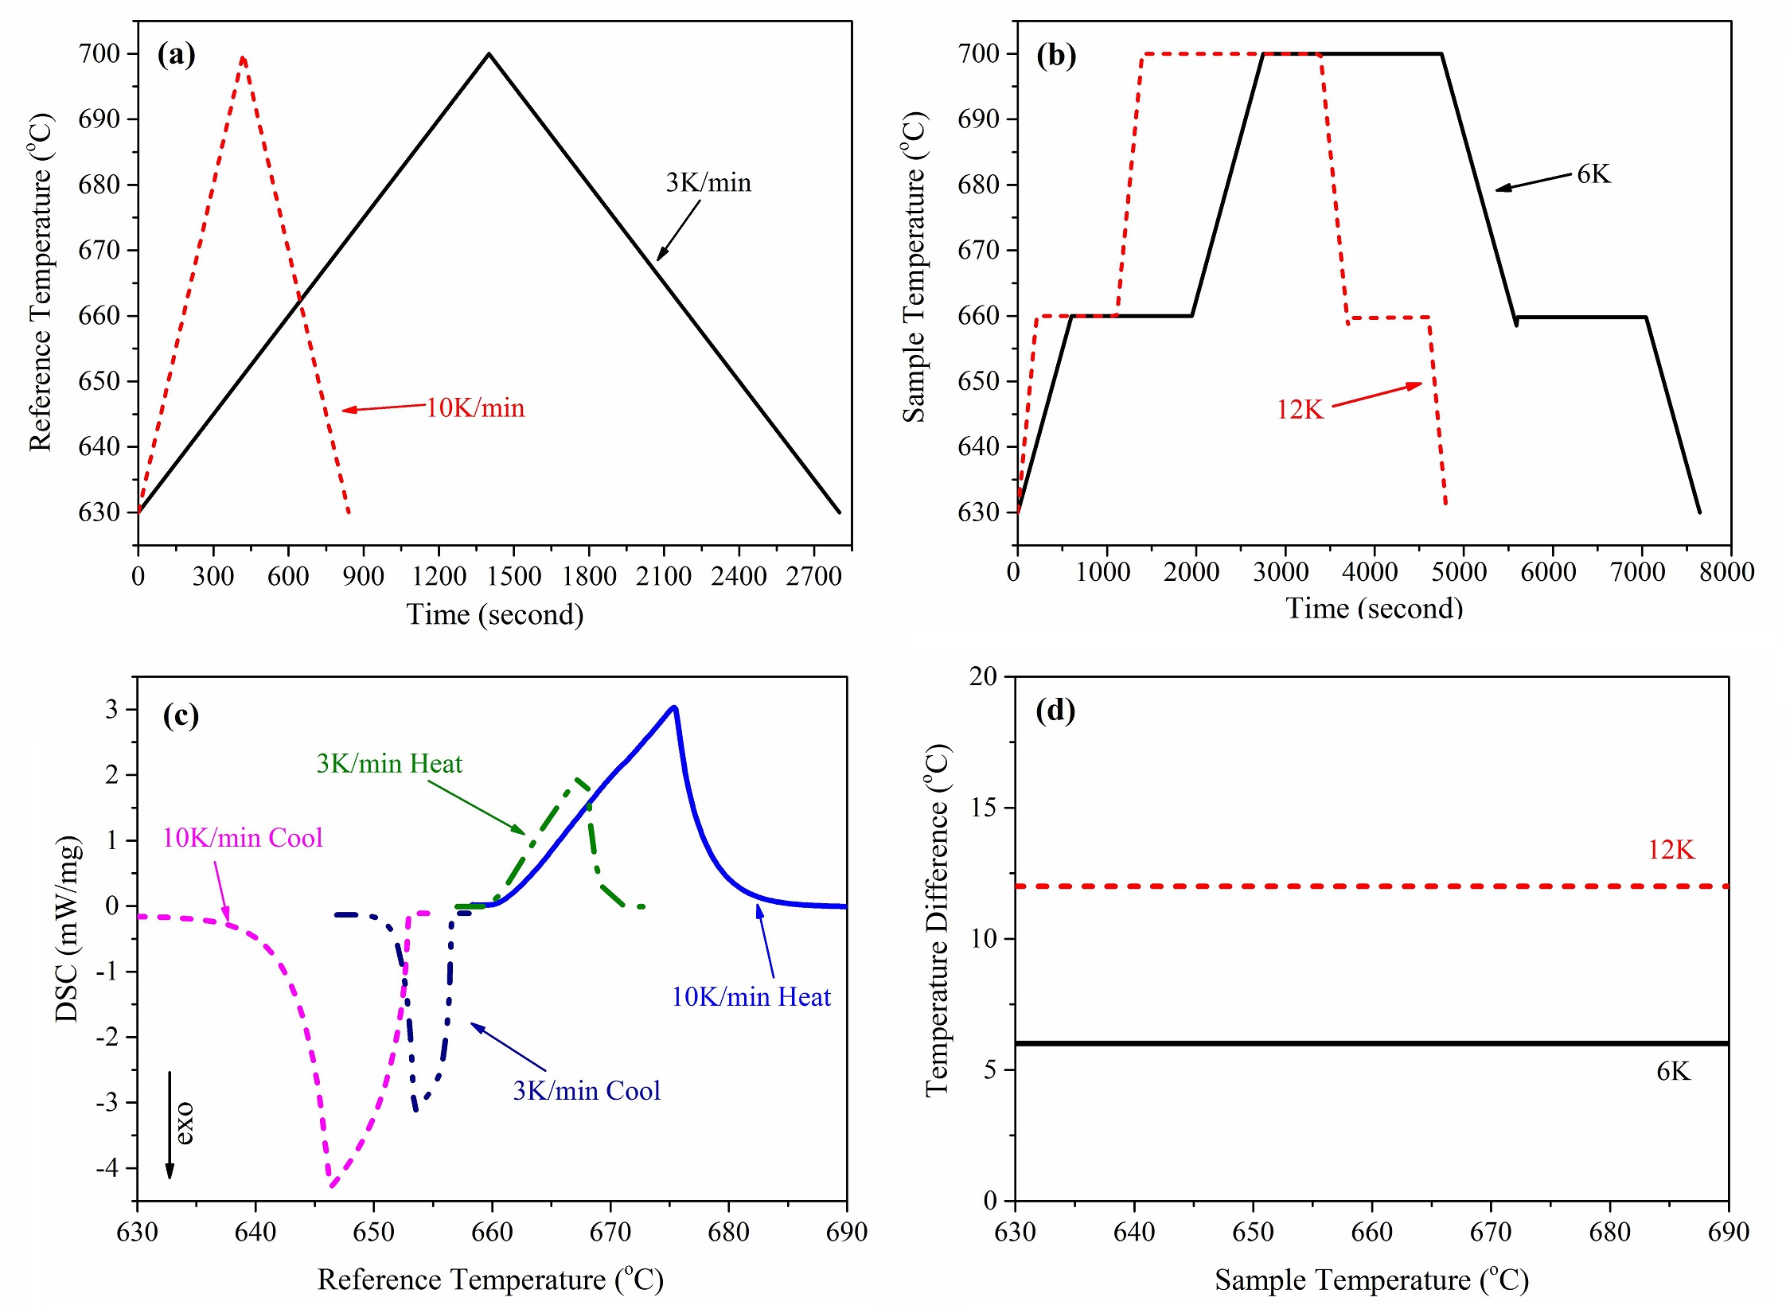
Fig. 1: (a) Measured reference temperature versus time for high-purity Al with DSC (b) Measured sample temperature versus time for high-purity Al with SPSC, (c) Measured DSC signal (heat flow) versus reference temperature for high-purity Al, (d) Measured temperature difference (heat flow) versus sample temperature for high-purity Al with SPSC, showing maintenance of steady-state condition during melting and solidification to ensure the high accuracy in enthalpy measurement in SPSC
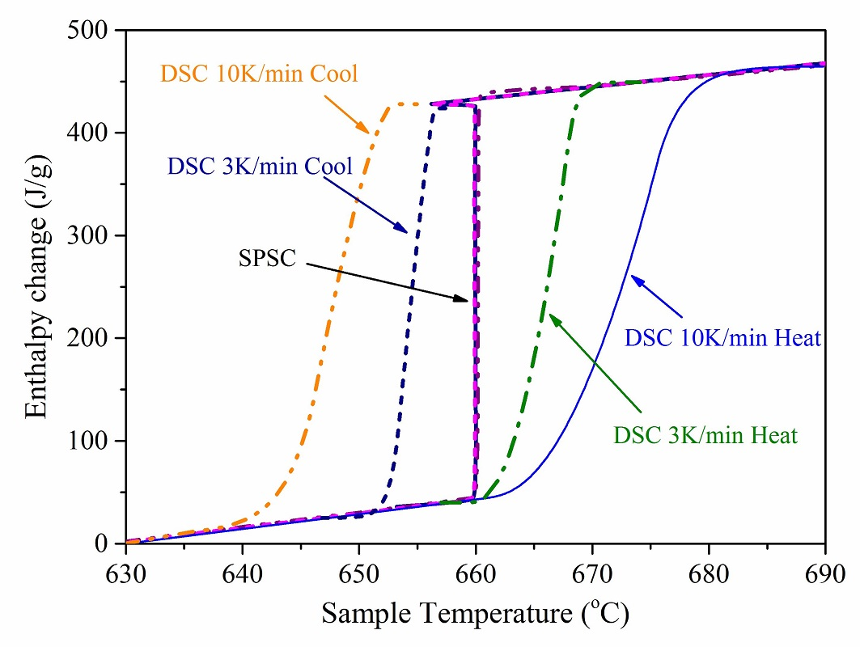
Fig. 2: Measured enthalpy changes versus temperature by DSC and SPSC for high-purity Al
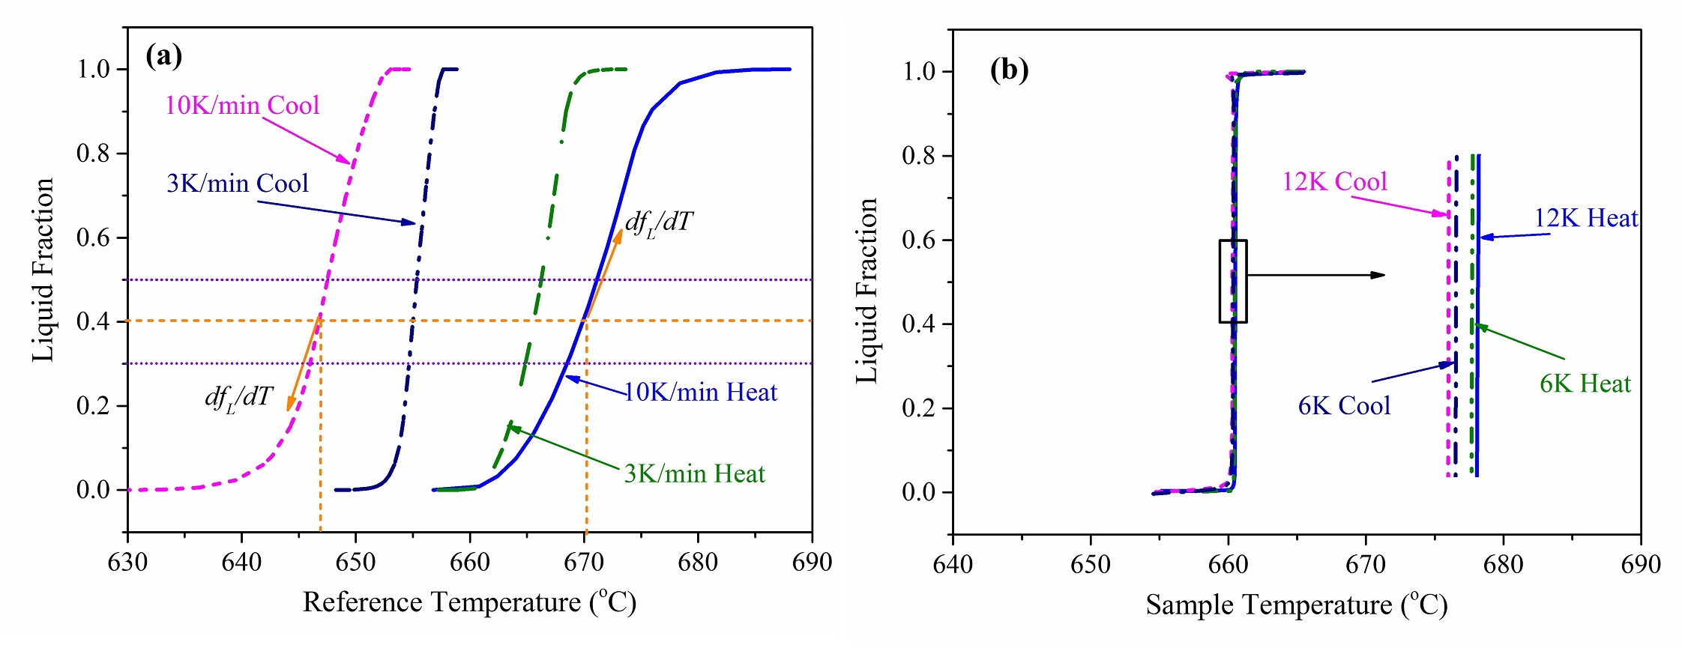
Fig. 3: Calculated liquid fraction as a function of temperature (a) DSC, (b) SPSC, for high-purity Al; ‘12K Heat/Cool’ and ‘6K Heat/Cool’ refer to the temperature difference between the inner and outer crucible in constant heat flux mode.

Fig. 4: Process window calculated using liquid fraction as a function of time for high-purity Al with SPSC for the temperature difference between the outer and inner crucible at (a) ±6K, (b) ±12K
Table 1: Calculated liquid fraction sensitivity to temperature/time for DSC and SPSC
Sensitivity | DSC |  |  |  | SPSC
 | 10K/min Heat | 10K/min Cool | 3K/min Heat | 3K/min Cool | 3K/min Heat | 3K/min Cool | 8.5K/min  Heat | 8.5K/min  Cool
${(\frac{df_{L}}{dT})}_{f_{L=0.4}}$.(K⁻¹) | 0.11 | -0.12 | 0.26 | -0.28 | +∞ | -∞ | +∞ | -∞
${(\frac{df_{L}}{dt})}_{f_{L=0.4}}$. (min⁻¹) | 1.10 | -1.20 | 0.78 | -0.84 | +0.05 | -0.05 | +0.12 | -0.12

