British Journal of Anaesthesia

223 words in abstract

3289 words excluding abstract, refs & legends

2 Figures and 2 Tables

22 Refs

**Evidence for Nociceptin/Orphanin FQ (NOP) but *not* µ (MOP), δ (DOP) or κ (KOP) opioid receptor mRNA in whole human blood.**

M Al-Hashimi, J McDonald, JP Thompson and DG Lambert.

Department of Cardiovascular Sciences, University of Leicester, Division of Anaesthesia, Critical Care and Pain Management, Leicester Royal Infirmary, Leicester, LE2 7LX. UK.

Address correspondence and reprint requests to Prof D.G. Lambert at the above address. Tel: (+44) 0116 252 3161. E.mail [DGL3@le.ac.uk](mailto:DGL3@le.ac.uk)

JPT and DGL are joint senior authors

**COI statement**

DGL is administration director and board member of BJA. JPT is an Editor and board member of BJA.

**Author Contributions**

M. Al-H and J.McD performed experiments, analysed data and wrote the manuscript. J.P.T and D.G.L conceived study, analysed data and co-wrote the manuscript. All authors approved the final version.

**Abstract**

***Background:*** Whilst it is well known that opioids depress the immune system, the site(s) of action for this depression is highly controversial. Immune modulation could occur directly at the immune cell or centrally via the hypothalamic-pituitary-adrenal axis. In a number of studies using individual enriched immune cell populations we have failed to detect classical MOP (µ), DOP (δ) and KOP (κ) receptors. The non-classical nociceptin/orphanin FQ (N/OFQ) receptor, NOP is expressed on all cells so far examined. Our hypothesis was that immune cells do not express classical opioid receptors and that using whole blood would definitively answer this question.

***Methods:*** Whole blood (containing all immune cell types) was incubated with opioids (morphine and fentanyl) commonly encountered in anaesthesia and with agents mimicking sepsis (lipopolysaccharide (LPS) and peptidoglycan G (PepG)). Opioid receptor mRNA expression was assessed by end point PCR with gel visualisation and quantitative PCR.

***Results:*** Classical MOP, DOP and KOP receptors were not detected in any of the samples tested either at rest or when challenged with opioids, LPS or PepG. Commercial primers for DOP did not perform well in quantitative PCR so absence of expression was confirmed using a traditional gel-based approach. NOP receptors were detected in all samples; expression was unaffected by opioids and reduced by LPS/PepG combinations.

***Conclusions:*** Classical opioid receptors are *not* expressed on circulating immune cells.

**Running head:** Opioid receptors and immune cells

**Key Words:** Opioid receptors, Morphine, Nociceptin, Immune cells, PCR.

**Introduction**

Opioid receptors are classified as both classical - MOP (µ), DOP (δ) and KOP (κ) - and non-classical NOP (nociceptin/orphanin FQ peptide) receptors. A causal link between opioids and immune function has been historically presumed, based on observations of opioid addicts having an increased incidence and severity of infections.12 More recent evidence highlights how opioids can have an effect on endocrine and immune function.3 However, the immunomodulatory effects of opioids have not been determined precisely, with various opioid drugs having different effects on immune function, despite targeting a single receptor subtype, the MOP receptor.4-6 Moreover, elucidating the mechanism(s) by which opioids modulate immune function is confounded by interspecies differences in their immunomodulatory effects. Hence opioid immunological interactions are both drug and species dependent. In MOP receptor knockout animal studies, no opioid immune modulation is seen, providing robust evidence that this receptor is the biological target.78

One of proposed mechanisms for the immune modulatory action of opioids is a direct action on immunocytes; however there is huge controversy as to whether or not classical opioid receptors are expressed on these cells. Whilst there is still a strong belief that peripherally-mediated immune modulatory effects of opioids are facilitated through receptors expressed on immunocytes, and several studies have determined the presence of opioid receptors on peripheral blood mononuclear cells (PBMCs), our group has been unable to detect classical opioid receptor expression on immunocytes in several settings and using a series of detection methodologies: fluorescent/immunofluorescent labelling, quantitative PCR and Western blotting.9-13 Previous studies have focused on individual populations of immune cell types, in one study NOP receptor mRNA and mRNA for the precursor protein of N/OFQ (ppNOC) was differentially detected in granulocytes, monocytes and lymphocytes; MOP receptor mRNA was not detected in any cell type.11-15 We therefore aimed to take a more systematic approach using several PCR methodologies to investigate opioid receptor expression in unstimulated blood from healthy volunteers. It is possible that opioid treatment or the presence of sepsis might upregulate expression so we additionally treated whole blood with supraclinical concentrations of morphine and fentanyl and lipopolysaccharide (LPS) and peptidoglycan G (PepG), agents commonly used to mimic sepsis.

Our hypothesis was that immune cells do not express classical opioid receptors and that using whole blood would definitively answer this question.

**General Methodology**

**Blood collection**

Venous blood was collected from 10 healthy volunteers from the University Deptartment of Cardiovascular Sciences, Division of Anaesthesia, Critical Care and Pain Management, with approval from the University of Leicester (volunteer) research ethics committee and with informed consent. Up to 30mls of venous blood was collected using EDTA-monovette® tubes and divided into sterile 2ml tubes to which Lipopolysaccharide from Escherichia coli 0111:B4  (Sigma, UK) (LPS) 5µg/ml, Staphylococcus Aureus Peptidoglycan (Sigma, UK) (PEPG), 20µg ml-1, fentanyl 10µM (Tocris, UK), morphine 10µM (Sigma, UK), were added separately and in combinations as indicated in results. Samples were incubated for 24hrs at 37.0°C in 5% CO2 humidified air.

**Tissue culture**

Positive control samples were prepared using Chinese Hamster ovary cells (CHO) expressing human KOP, DOP, NOP receptors and Human Embryonic Kidney (HEK) cells expressing human MOP. CHOhKOP/DOP cells were cultured in Hams F12, CHOhNOP in DMEM/Hams F12 (1:1) and HEKhMOP cells in MEM, all media were supplemented with 10% FCS, Penicillin (100IU/ml), Fungizone (2.5µg/ml), and streptomycin (100µg ml-1). For maintaining expression of inserted genes, stock cultures of cells were additionally supplemented with 200µg ml-1 of G418for classical opioid receptors MOP/KOP/DOP, and 200µg ml-1 of G418 and Hygromycin B for CHOhNOP. Raji cells (lymphoblast-like cell) were used as an additional cell expressing DOP and cultured in RMPI 1640 supplemented with 10% FCS, Penicillin (100IU/ml), Fungizone (2.5µg ml-1), streptomycin (100µg ml-1) and Glutamine (2mM). All cells were cultured at 37.0°C and 5% CO2 humidified air. All tissue culture media were from Sigma (UK) and supplements were from Invitrogen Invitrogen – Thermo Fisher Scientific (UK).

**RNA Extraction, cDNA synthesis and QPCR**

Total RNA was purified from whole blood samples using a RiboPure™ RNA Purification Kit (Thermo Fisher Scientific, UK) as per the manufacturer’s instructions and from Chinese hamster ovary (CHO) cells and Raji cells using a preparatory RNA isolation kit (*mir*Vana, Thermo Fisher Scientific) in which 1ml of *mir*Vana lysis buffer was used for extraction of RNA from confluent 25cm2 flasks for adherent cells or 1x10­7 for non-adherent cells. In all cases final RNA samples were resuspended in PCR grade water, the mass of RNA determined using a NanoDrop 2000 (LabTech) and purity assessed from the 260/280 nm ratio which was >1.8. Isolated RNA was processed using a Turbo DNA-*free*® kit for the removal of possible genomic DNA (gDNA) contamination before reverse transcription and production of copy DNA (cDNA) using the High Capacity cDNA Reverse Transcription Kit (Thermo Fisher Scientific, UK). For some samples additional production of cDNA using the Quantitect Reverse Transcription Kit (Qiagen,UK), which included an additional genomic DNA elimination reaction, took place. For all samples a non-template control (in which the reverse transcriptase enzyme was omitted from reverse transcription reactions), was included during PCR/qPCR reactions.

**Statistical analysis**

qPCR experimental data are expressed as cycle threshold (Ct; one cycle representing a doubling of starting material) relative to the geometric mean of two housekeeper gene Ct values; human beta-2-microglobulin (B2M) and human glyceraldehyde-3-phosphate dehydrogenase (GAPDH) represents the ΔCt. The effect of treatments on mRNA expression was determined by normalizing target gene expression level using the equation 2(‐ΔΔCt), where ΔΔCt = ΔCt (treated) –ΔCt (control). Data were analysed using Kruskal-Wallis Analysis of Variance (ANOVA) with Dunn’s multiple comparison test. P values <0.05 were considered statistically significant.

**Methods and Results**

Volunteer characteristics were 4 females and 6 males, mean age 40.6 years (range 32-54 years), mean weight 86.4kg (range 55-110kg) and mean height 174.9 cm (range 153-196 cm).

**MOP/KOP**

Whole blood was collected and incubated overnight with the inflammatory mediators LPS and PepG in the absence and presence of clinical MOP receptor agonists morphine and fentanyl (supraclinical concentrations) as noted above. Additional untreated (plain) and media (vehicle) treated controls were included. cDNA from whole blood samples and cell lines were probed for gene transcripts using; quantitative PCR (qPCR) with commercially available TaqMan probes (Thermo Fisher Scientific, UK), SYBR Green and predesigned, target-validated primer pairs (Qiagen and Sigma, UK) (Table 1). Relative gene expression quantification was determined using TaqMan endogenous control probes, human beta-2-microglobulin (B2M) and human glyceraldehyde-3-phosphate dehydrogenase (GAPDH), and assays run in a duplex format. QPCR reactions were run on a StepOne instrument (applied Biosystems, UK), the thermal profile for reactions with TM-MOP1, TM-KOP1, TM-NOP1, TM-DOP1&2 and endogenous control probes was 2min at 50˚C, 10min at 95˚C followed by 40 cycles of 15s at 95˚C and 1min at 60˚C, for TM-DOP3 probes 3min at 95˚C followed by 40 cycles of 3s at 95˚C and 30s at 60˚C.

In qPCR experiments with mRNA extracted from whole blood samples, probing for KOP and MOP expression, no amplification of these receptor transcripts could be detected. In the same samples there was robust amplification of endogenous controls B2M and GAPDH which was consistent across the various blood treatments with Ct values not varying significantly from one another (Kruskal-Wallis and Dunn’s multiple comparison p>0.05) (Table 2). Positive control cDNA from CHOhKOP and CHOhMOP cells verified the probes with Ct values of 22.55 and 24.07 respectively. This absence of KOP and MOP receptor expression is similar to our previous studies in more discrete populations of white blood cells; PBMCs and polymorphonuclear cells.10121415

**NOP**

Relative gene expression quantification for NOP receptor transcripts was determined using two TaqMan endogenous control probes, human B2M and human GAPDH in a duplex assay format with NOP TaqMan probes. NOP expression was detected in untreated whole blood samples, median ∆Ct of 10.40 (range 8.56-11.24), and in all treated samples (Table 2).

The effect of LPS, PepG or a combination of the two on NOP mRNA were determined by normalized target gene expression level using the equation 2(‐ΔΔCt), where ΔΔCt = ΔCt (treated) –ΔCt (control; media). The calculated fold-change (2(‐ΔΔCt)) of NOP mRNA levels decreased significantly relative to vehicle treated control samples after treatment with LPS, PepG or the two combined (Figure 2).

**DOP**

In qPCR experiments with TaqMan probes designed and validated for the human DOP receptor, TM-DOP1-3, amplification in both positive control cDNA from CHO cells transfected with the human DOP receptor and in cDNA from whole blood samples was detected. Moreover, amplification of DOP receptor transcripts was also detected in non-template controls (NTCs) from whole blood samples for all those TaqMan probes (Table 1). NTC represent a negative control run in parallel for each sample for which the reverse transcriptase enzyme, which converts mRNA to cDNA, is removed and therefore amplification in these samples represents genomic DNA contamination and not mRNA expression which is the precursor for protein (receptor) expression. Amplification in NTCs suggests the amplification measured in sample cDNA could represent a false positive. The high Ct values seen with TM-DOP1-3 and those similarly measured Ct values between sample cDNA and the related NTC data also suggest this (Figure 1).

Alternative commercially available primer pairs where sourced and used in SYBR green experiments, using a Quantifast SYBR green PCR master mix (Qiagen, UK), the thermal profile of reactions with SBG-DOP1&2 primer pairs was 5min at 95˚C followed by 40 cycles of 10s at 95˚C and 30s at 60˚C. Melt curve analysis was carried out by a final melting of 15s at 95˚C followed by dissociation curve construction comprising increasing temperature by 0.3˚C increments from 60˚C. Amplification of DOP receptor transcripts was detected in cDNA and NTCs from whole blood samples and CHOhDOP controls using both primer pairs (Figure 1).

To determine whether there was a difference in the PCR products amplified from sample wells and NTCs wells, melt curve analysis was performed to determine the dissociation temperature (Tm) of PCR product. In a preliminary experiment (n=1) using whole blood RNA, expected differences were determined in the measured Tm values of PCR products amplified by different primer-pairs; 77.67˚C (TM-DOP1), 81.29˚C (TM-DOP3), 85˚C (SBG-1) and 87.25˚C (SBG-2). However when using a single TaqMan probes or primer pair no differences in measured Tm values was determined between cDNA samples and NTCs, 77.67˚C and 77.67˚C for TM-DOP1, 81.29˚C and 81.44˚C for TM-DOP3, 85˚C and 85.3˚C for SBG-1and 87.25˚C and 87.25˚C for SBG-2. This suggests the PCR product in cDNA samples and NTCs to be the same, and imaging of PCR products using gel electrophoresis for TM-DOP1 confirms these findings with all products ~100bp (Figure 1).

In an effort to reduce gDNA contamination beyond that removed by DNase treatment alone a test was performed using Raji cells which were reverse transcribed using the Quantitect reverse transcription kit, which incorporates an additional genomic DNA elimination reaction (Qiagen, UK). Using mRNA extracted from Raji cells a reverse transcription reaction which incorporated an extra genomic DNA elimination reaction had no effect. The Ct values determined using TM-DOP1 probes, relative to the standard reverse transcription reaction, were 36.17˚C and 36.13˚C in cDNA samples and 36.59˚C and 36.38˚C for NTC, respectively. Overall the extra genomic DNA elimination reaction was deemed ineffective and not used in the processing of volunteer sample bloods.

In an effort to distinguish cDNA from gDNA primers were designed which span an exon/exon boundary using primer-BLAST against the NCBI Reference Sequence NM_000911.3 for the Homo sapiens opioid receptor, delta 1 (OPRD1) mRNA. These primers designated STD-DOP-1 were used in end-point PCR using AmpliTaq Gold® 360 Master Mix (Thermo Fisher Scientific, UK) on an Eppendorf Mastercycler with an initial 95°C 10 min denaturing step followed by 40 cycles of 30s at 95°C, annealing for 30s between at temperatures 51˚C -71.5˚C and extension at 72˚C for 60s with a final extension for 10min at 72˚C. PCR products were run on a 3% agarose gel stained with ethidium bromide and imaged under UV illumination.

STD-DOP-1 primers where initially used at a concentration of 0.4µM and with an annealing temperature of 59˚C and were determined to amplify a product of predicted size ~700bp in cDNA from CHOhNOP. In NTC wells from whole blood samples the STD-DOP 1 primer pair was seen to amplify a product of ~700bp and another ~200bp, although this was not consistent for all NTC samples tested. In order to improve the stringency of the STD-DOP 1 primer pair, temperature and concentration gradients were performed leading to the determination of an optimum annealing temperature at 56.5˚C and primer pair concentration of 40nM. Under these conditions, in cDNA from CHOhDOP cells, amplification was of a product of predicted size, ~700bp, and no product could be detected in NTCs. STD-DOP 1 primers were subsequently used under the same experimental conditions to probe samples for expression of the DOP in whole blood samples and no expression could be detected (Figure 1).

**Discussion**

Our main finding using qPCR is that mRNA encoding for either the MOP or KOP receptor could not be detected in peripheral whole human blood under resting conditions or after incubation with a variety of inflammatory mediators and opioids. A false positive DOP receptor mRNA signal was initially detected, since a variety of the commercially available TaqMan probes for this receptor transcript did not differentiate genomic from copy DNA. The presence of DOP receptor transcript was subsequently disproved through the development of a primer pair utilised in end-point PCR experiments. These data further underscore the need for carefully controlled PCR protocols. Transcripts encoding for the NOP receptor were consistently detected in whole blood samples and these decreased in the presence inflammatory stimuli (LPS and PepG).

In this study, the full complement of cell populations in whole blood, comprising red blood cells, white blood cells and platelets, were utilised with a range of experimental conditions, to include the effects of inflammatory stimuli (alone and in combination) and a number of clinically used MOP receptor agonists. This approach was used in conjunction with a comprehensive series of opioid receptor primers to fully establish expression, and to allow for measuring changes in expression of both classical and non-classical opioid receptor subtypes, in the mRNA from whole blood. Expression of classical opioid receptors on immune cells is hugely controversial and has profound consequences for studies into and clinical modulation of immune function by opioid drugs.3101516-18 A comprehensive and carefully controlled (methodologically) study such as this is needed where the entire circulating immune cell population is present.

The physiological and cellular mechanisms that result in the immunosuppressant effect of opioid drugs seen in humans and whole animal studies is hypothesised to be mediated either through a direct action on immunocytes, altering sympathetic activity or modulation of the hypothalamic-pituitary-axis.17 In addition, there is evidence for further central effects at glia. Findings from our laboratory have shown that peripheral blood mononuclear leukocytes (PBMCs) do not express classical opiate receptors and therefore the functional action of opioid drugs on immune functioning is unlikely to be through opioid receptors expressed on these cells.1014-16 This finding is disputed by some studies which have identified the presence of MOP receptors on PBMCs. 5, 11, 15, 17, 18 In order to explore the hypothesis that opioid drugs can have a direct action on immunocytes, the expression of opioid receptor subtypes was determined using total RNA extracted from whole blood. It was believed that this approach could allow for detection of opioid receptor transcripts that may have been missed in discrete cell types. Consistent with the data of Williams *et al*. both MOP and KOP receptor transcripts could not be detected in RNA from whole blood.10

MOP knock-out species implicate the receptor as central to the immunomodulatory effects of opioids and whilst MOP receptor expression could not be detected under “basal” conditions it has been considered that expression on immunocytes occurs only after their exposure to pro-inflammatory mediators and cytokines. To determine if the immunomodulatory role of opioids could be influenced, or even established, a number of regulators of the immune system where tested to see if they would have an impact on opioid receptor expression in whole blood. 24hr incubation of whole blood samples with the pro-inflammatory mediators lipopolysaccharide and peptidoglycan had no effect on the expression of either MOP, DOP or KOP receptor transcripts. Other authors have shown that administration of TNF-α to immune cells up-regulates the MOP receptor, which may suggest that the type, concentration and exposure time of the pro-inflammatory mediators used in this study were not optimal.1419 It is worthy of mention that the Kraus study did use multiple rounds of PCR to detect MOP receptor transcripts which suggest an extremely low quantity of transcript.14

cDNA from whole blood RNA was initially probed for presence of human DOP receptor transcripts using TaqMan probes, Hs00538331_m1 (Thermo Fisher Scientific, UK), which revealed amplification of product, i.e. presence of the human DOP receptor. However this was a false positive with amplification measured in parallel non-template control samples, in which the reverse transcriptase enzyme had been removed in the conversion of whole blood RNA to cDNA, suggesting the amplification in both samples to be genomic DNA. The same false positive amplification was seen with further commercially available TaqMan probes for the DOP receptor, Hs00357182_mh (Thermo Fisher Scientific, UK) and Hs_OPRD1_QF_1 (Qiagen, UK). Such gDNA amplification was despite RNA samples being processed with a DNase enzyme, designed to remove DNA contaminates, provides a cautionary tale and the need for using the correct negative controls. To distinguish cDNA from gDNA primers were designed that span an exon/exon boundary on the Homo sapiens opioid receptor, delta 1 (OPRD1) mRNA sequence. While these primers initially yielded amplification in some NTC samples, through a series of validating experiments the stringency with which they amplified specifically cDNA for the DOP receptor was increased. Using the STD-DOP-1 primer pair, under the correct experimental conditions, no amplification of the DOP receptor transcript could be detected, whilst a robust and consistent amplification was determined in positive control samples, cDNA from CHOhDOP cells. Again this highlights the importance and possibility of detecting a false positive if the correct experimental conditions are not defined.

Recent studies have indicated that the nociceptin system has a role in inflammation and sepsis.20 21 Clinical evidence from ICU patients diagnosed with sepsis has shown how there is a decrease in mRNA encoding for the NOP receptor in septic patients when compared with a matched control volunteer. Previously we have demonstrated that while PBMCs lack expression of classical opioid receptors (MOP, DOP, KOP), they do express NOP receptor transcripts and further studies have revealed differential expression on different white cell types, ∆Ct of 6.43 in monocytes, ∆Ct 8.05 in lymphocytes and ∆Ct of 7.73 in granulocytes.15 In mRNA extracted from whole untreated blood, expression of the NOP was further detected with a ∆Ct 10.40. In the presence of LPS and PepG the calculated fold-change (2(‐ΔΔCt)) for NOP mRNA levels decreased (Figure 2). These findings are similar to the decrease in NOP mRNA measured in ICU patients diagnosed with sepsis.20

**Limitations.**

One obvious limitation of this study is the fact that we did not show the presence or absence of opioid receptor protein. There are two points of note in this regards. First without the presence of a transcribed gene; i.e., no receptor mRNA there can be no translated protein. Secondly and despite considerable efforts in looking (see22) there are no antibodies with proven selectivity for a particular member of the opioid receptor family.

In summary, using whole blood from healthy volunteers that should contain the full range of circulating immune cells, we failed to detect transcripts for MOP, DOP or KOP receptors, but NOP mRNA was present. We therefore conclude that immune modulation produced by MOP agonists in clinical practice (morphine and fentanyl) cannot occur at the level of the circulating immune cell as there is no target for interaction.

**References**

1 Risdahl JM, Khanna KV, Peterson PK, Molitor TW. Opiates and infection. *J Neuroimmunol* 1998; **83**: 4-18

2 Hussey HH, Katz S. Infections resulting from narcotic addiction; report of 102 cases. *Am J Med* 1950; **9**: 186-93

3 Al-Hashimi M, Scott SW, Thompson JP, Lambert DG. Opioids and immune modulation: more questions than answers. *Br J Anaesth* 2013; **111**: 80-8

4 Sacerdote P. Opioids and the immune system. *Palliat Med* 2006; **20 Suppl 1**: s9-15

5 Sacerdote P, Limiroli E, Gaspani L. Experimental evidence for immunomodulatory effects of opioids. *Adv Exp Med Biol* 2003; **521**: 106-16

6 Sacerdote P, Manfredi B, Mantegazza P, Panerai AE. Antinociceptive and immunosuppressive effects of opiate drugs: a structure-related activity study. *Br J Pharmacol* 1997; **121**: 834-40

7 Roy S, Barke RA, Loh HH. MU-opioid receptor-knockout mice: role of mu-opioid receptor in morphine mediated immune functions. *Brain Res Mol Brain Res* 1998; **61**: 190-4

8 Nelson CJ, Schneider GM, Lysle DT. Involvement of central mu- but not delta- or kappa-opioid receptors in immunomodulation. *Brain Behav Immun* 2000; **14**: 170-84

9 Stefano GB, Melchiorri P, Negri L, Hughes TK, Jr., Scharrer B. [D-Ala2]deltorphin I binding and pharmacological evidence for a special subtype of delta opioid receptor on human and invertebrate immune cells. *Proc Natl Acad Sci U S A* 1992; **89**: 9316-20

10 Williams JP, Thompson JP, McDonald J, et al. Human peripheral blood mononuclear cells express nociceptin/orphanin FQ, but not mu, delta, or kappa opioid receptors. *Anesth Analg* 2007; **105**: 998-1005

11 Gaveriaux C, Peluso J, Simonin F, Laforet J, Kieffer B. Identification of kappa- and delta-opioid receptor transcripts in immune cells. *FEBS Lett* 1995; **369**: 272-6

12 McDonald J, Howells LM, Brown K, Thompson JP, Lambert DG. Use of preparative fluorescence-activated cell sorting (FACS) to profile opioid receptor and peptide mRNA expression on human granulocytes, lymphocytes, and monocytes. *Br J Anaesth* 2010; **105**: 707-8P

13 Ninkovic J, Roy S. Role of the mu-opioid receptor in opioid modulation of immune function. *Amino Acids* 2013; **45**: 9-24

14 Kraus J, Borner C, Giannini E, Hollt V. The role of nuclear factor kappaB in tumor necrosis factor-regulated transcription of the human mu-opioid receptor gene. *Mol Pharmacol* 2003; **64**: 876-84

15 Suzuki S, Miyagi T, Chuang TK, Chuang LF, Doi RH, Chuang RY. Morphine upregulates mu opioid receptors of human and monkey lymphocytes. *Biochem Biophys Res Commun* 2000; **279**: 621-8

16 Al-Hashimi M, McDonald J, Thompson JP, Lambert DG. Classical opioid receptor mRNA is not present in whole human blood. *Br J Anaesth* 2013; **110**: 860P-85P

17 Caldiroli E, Leoni O, Cattaneo S, et al. Neutrophil function and opioid receptor expression on leucocytes during chronic naltrexone treatment in humans. *Pharmacological research : the official journal of the Italian Pharmacological Society* 1999; **40**: 153-8

18 Chuang TK, Killam KF, Jr., Chuang LF, et al. Mu opioid receptor gene expression in immune cells. *Biochem Biophys Res Commun* 1995; **216**: 922-30

19 Kraus J, Borner C, Giannini E, et al. Regulation of mu-opioid receptor gene transcription by interleukin-4 and influence of an allelic variation within a STAT6 transcription factor binding site. *J Biol Chem* 2001; **276**: 43901-8

20 Thompson JP, Serrano-Gomez A, McDonald J, Ladak N, Bowrey S, Lambert DG. The Nociceptin/Orphanin FQ system is modulated in patients admitted to ICU with sepsis and after cardiopulmonary bypass. *PloS one* 2013; **8**: e76682

21 Lambert DG. The nociceptin/orphanin FQ receptor: a target with broad therapeutic potential. *Nature reviews Drug discovery* 2008; **7**: 694-710

22 Niwa H, Rowbotham DJ, Lambert DG. Evaluation of primary opioid receptor antibodies for use in western blotting. *Br J Anaesth*. 2012;**108(3)**:530-2

|  |  |  |  |
| --- | --- | --- | --- |
| **Target** | **Type** | **Sequence/ Assay ID (supplier)** | **Abbreviation** |
| KOP (OPRK1) | TaqMan assay | Hs00175127_m1 (Life Technologies) | TM-KOP1 |
| MOP (OPRM1) | TaqMan assay | Hs01053957_m1 (Life Technologies) | TM-MOP1 |
| NOP (OPRL1) | TaqMan assay | Hs00173471_m1 (Life Technologies) | TM-NOP1 |
| DOP (OPRD1) | TaqMan assay | Hs00538331_m1 (Life Technologies) | TM-DOP1 |
| DOP (OPRD1) | TaqMan assay | Hs00357182_mh (Life Technologies) | TM-DOP2 |
| DOP (OPRD1) | QuantiFast Probe Assay | Hs_OPRD1_QF_1 (Qiagen) | TM-DOP3 |
| DOP (OPRD1) | QuantiTect Primer Assay (SYBR Green) | Hs_OPRD1_1_SG (Qiagen) | SBG-DOP1 |
| DOP (OPRD1) | KiCqStart™ Primers H_OPRD1_1 | FH1(Sigma)  RH1(Sigma) | SBG-DOP2 |
| DOP (OPRD1) set4 | Oligonucleotide primer pairs | Forward  GGCATCGTCCGGTACACTA  Reverse  GTCGAGGAAAGCGTAGAGCA | STD-DOP-1 |

**Table 1.** Assay IDs and sequences for the different TaqMan probes and primer pairs used throughout the study.

|  |  |  |  |  |  |  |  |
| --- | --- | --- | --- | --- | --- | --- | --- |
|  | **Classical Opioid Receptors** | | | | **Nociceptin/Orphanin FQ Receptor (NOP)** | | |
| **Whole blood treatment** | **Ct GAPDH** | **Ct B2M** | **Ct MOP** | **Ct KOP** | **Geometric Mean Ct**  **(GAPDH / B2M)** | **NOP Ct** | **∆Ct** |
| Plain (n=10) | 24.16  (22.93-24.93) | 21.89  (20.58-22.18) | ND | ND | 23.17  (21.49-23.58) | 32.75  (31.75-34.17) | 10.40  (8.56-11.24) |
| Media (n=10) | 23.88 (22.54-25.09) | 21.07  (20.00-22.01) | ND | ND | 22.88  (21.15-23.47) | 32.82  (31.89-34.29) | 10.71  (8.41-11.64) |
| Morphine (n=10) | 24.23  (22.68-24.89) | 21.29  (20.67-21.87) | ND | ND | 22.93  (22.29-23.48) | 34.07  (32.19-34.47) | 10.68  (9.21-11.70) |
| Fentanyl (n=10) | 24.11  (23.24-24.90) | 21.52  (20.98-21.73) | ND | ND | 23.17  (22.34-23.30) | 33.45  (31.92-34.61) | 10.67  (8.21-11.48) |
| LPS (n=10) | 25.75  (25.02-27.27) | 21.19  (19.77-22.09) | ND | ND | 23.37  (22.54-24.37) | 35.19  (34.11-35.66) | 11.40  (11.21-12.98) |
| LPS + M (n=10) | 25.35  (24.79-26.63) | 20.05  (19.44-21.46) | ND | ND | 22.82  (21.93-23.58) | 35.08  (34.58-36.04) | 11.93  (10.74-13.12) |
| LPS + F (n=10) | 25.46  (24.94-26.83) | 20.72  (19.82-22.57) | ND | ND | 23.20  (22.57-24.70) | 35.66  (34.34-36.27) | 11.75  (10.79-13.18) |
| PepG (n=5) | 24.71  (22.82-28.18) | 20.74  (19.49-23.26) | ND | ND | 22.84  (21.57-25.40) | 33.91  (31.21-36.35) | 10.75  (8.54-12.19) |
| PepG + M (n=5) | 26.00  (24.32-26.92) | 20.76  (20.11-22.14) | ND | ND | 23.22  (22.24-24.75) | 34.71  (32.31-35.70) | 11.52  (8.41-13.08) |
| PepG + F (n=5) | 24.43  (22.43-26.81) | 20.54  (19.43-22.51) | ND | ND | 22.41  (21.43-24.48) | 34.10  (30.51-36.24) | 11.02  (8.26-12.90) |
| PepG + LPS  (n=5) | 25.01  (23.12-26.34) | 20.33  (19.76-21.17) | ND | ND | 22.70  (21.94-23.57) | 35.61  (31.33-36.00) | 12.36  (8.99-13.54) |
| PepG + LPS + M + F (n=5) | 25.59  (22.99-27.66) | 20.23  (19.15-22.89) | ND | ND | 22.38  (21.66-25.15) | 35.29  (32.94-36.47) | 12.28  (9.33-13.58) |

**Table 2.** Expression of classical and non-classical opioid receptor transcripts in mRNA extracted from whole blood samples treated with lipopolysaccharide (LPS) 5µg/ml, Staphylococcus Aureus Peptidoglycan (PepG) 20µg/ml, fentanyl (F) 10µM, morphine (M) 10µM in the combinations shown. Data presented are expressed as median (interquartile range) cycle threshold values (Ct) for endogenous controls (B2M and GAPDH) and genes of interest (MOP, KOP, NOP), consistent with previous data MOP and KOP transcripts could not be detected. Positive control cDNA from CHOhNOP, CHOhKOP, CHOhDOP and HEKhMOP cells verified the probes with respective Ct values of 17.95, 21.95, 24.72 and 24.06. The geometric mean of Ct values derived from B2M and GAPDH were used to determine ∆Ct values for expression NOP receptor transcripts. Data are for n=5-10 volunteers.

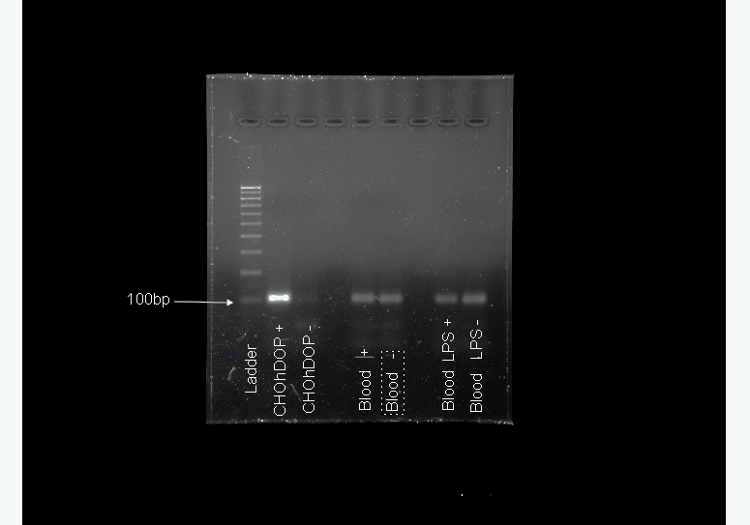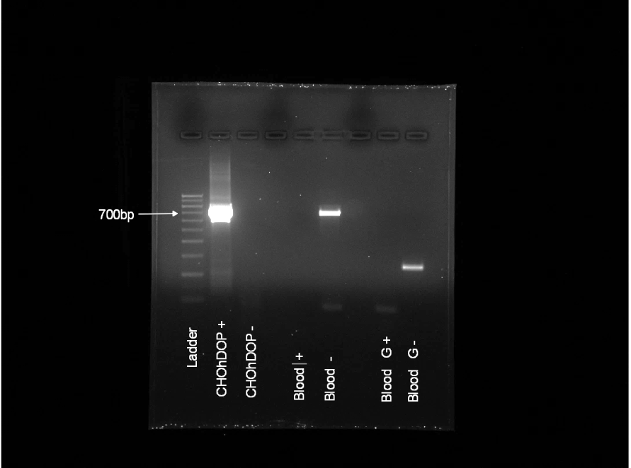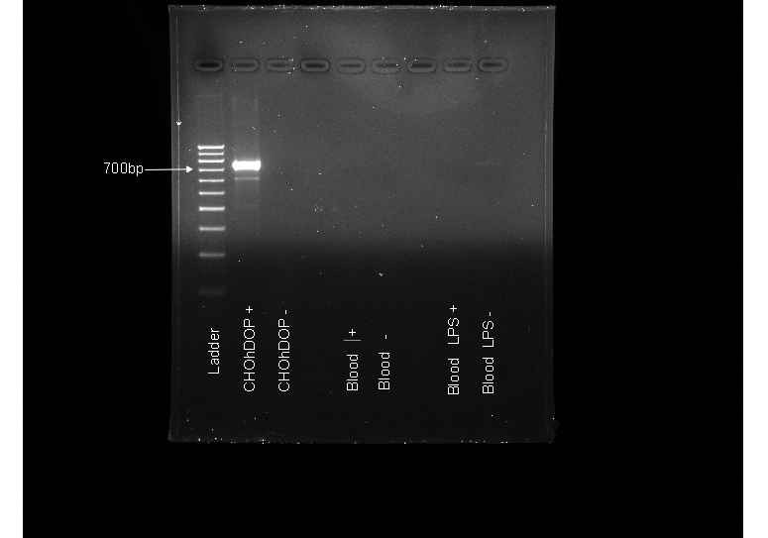

TaqMan Probe



STD-1 Primer Pair

(pre-validated)

STD-1 Primer Pair

(validated)

End-point PCR

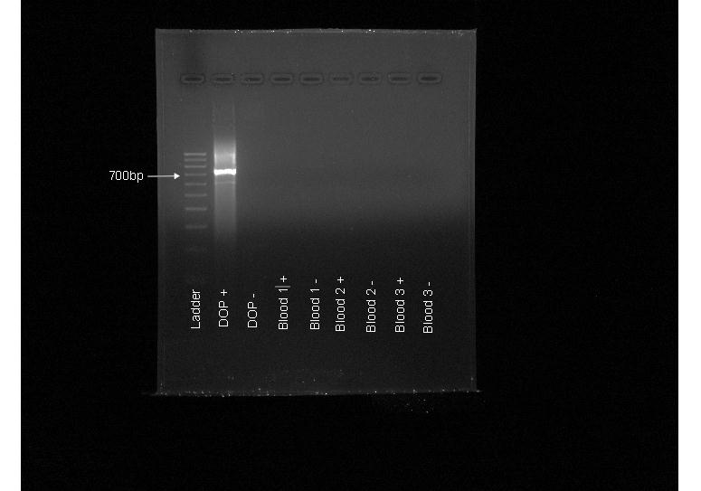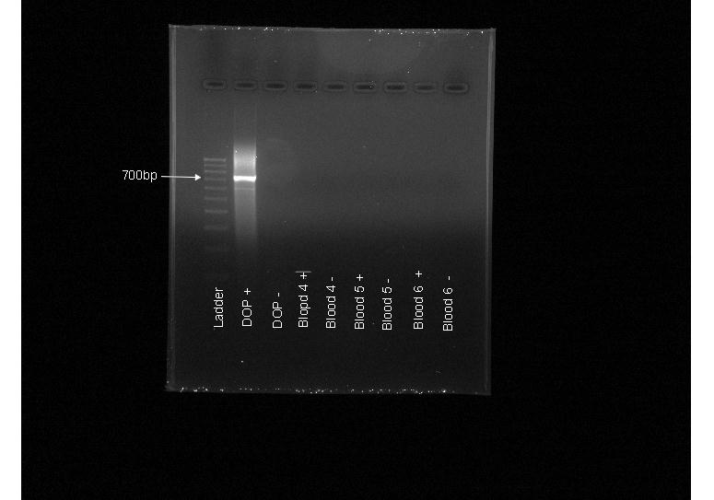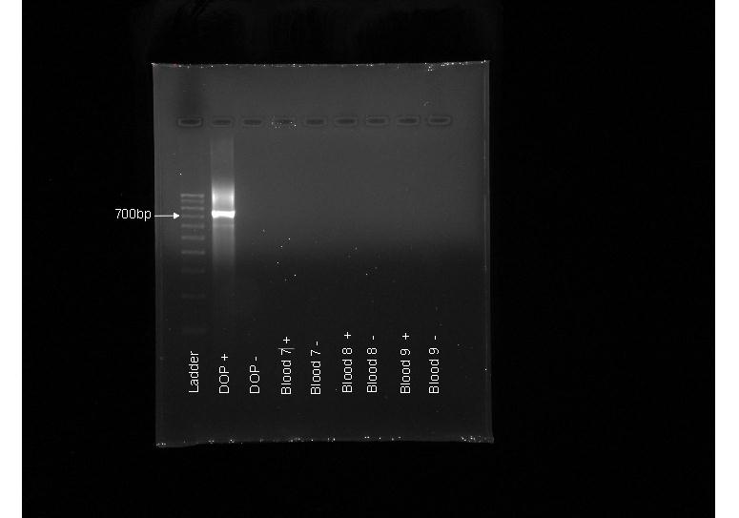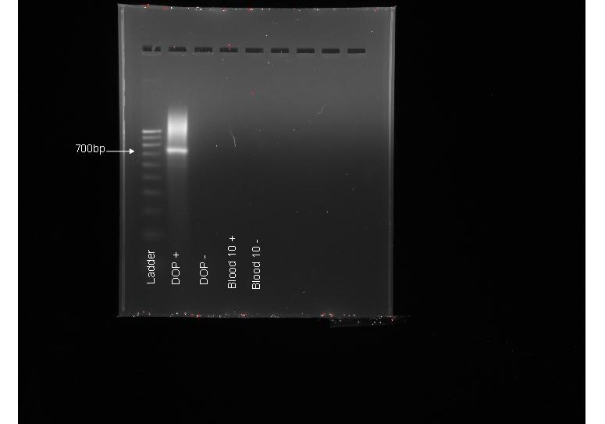

A

B

C

End-point PCR STD-1 Primer Pair - Bloods

**Figure 1.** Panel A displays the QPCR amplification plot in whole blood RNA using TaqMan probes targeting the DOP receptor, amplification in both reverse transcribed (RT) and non-RT samples can be seen, and the equivalent gel confirms both product presence and size. Panel B displays gel electrophoresis for the PCR products from end-point PCR using STD-1 primers-pairs pre and post-validation, in which annealing temperatures and primer concentrations were optimised. Panel C displays gel electrophoresis of PCR reactions using STD-1 primer pairs under authenticated conditions in RNA from whole blood samples.

Figure 2. Expression of NOP receptor transcripts in mRNA extracted from whole blood samples treated with lipopolysaccharide (LPS) 5µg/ml, Staphylococcus Aureus Peptidoglycan (PepG) 20µg/ml, fentanyl (F) 10µM, morphine (M) 10µM in the combinations shown. Data presented are present as the fold change relative to “plain” samples treated with a vehicle control (media). *Samples are statistically different to plain sample using a Kruskal-Wallis test with Dunn’s multiple comparisons test.