Supplemental Information
The external PASTA domain of the essential serine/threonine protein kinase PknB regulates mycobacterial growth
Obolbek Turapov¹, Jessica Loraine^{1$}, Christopher H. Jenkins¹, Philippe Barthe^{2, 3}, Daniel McFeely^{1&}, Francesca Forti⁴, Daniela Ghisotti⁴, Dusan Hesek⁵, Mijoon Lee⁵, Andrew R. Bottrill¹, Waldemar Vollmer⁶, Shahriar Mobashery⁵, Martin Cohen-Gonsaud ^{2, 3} and Galina V. Mukamolova¹*
¹Department of Infection, Immunity and Inflammation, University of Leicester, Leicester, LE1 9HN, UK; ²Centre de Biochimie Structurale, CNRS UMR 5048, 29, rue de Navacelles 34090 Montpellier, France; ³INSERM U1054, Université Montpellier I et II, Montpellier, France; ⁴Dipartimento di BioScienze, Università degli Studi di Milano, Italy; ⁵Department of Chemistry and Biochemistry, 423 Nieuwland Science Center, University of Notre Dame, Notre Dame, IN 46556 USA; ⁶ Centre for Bacterial Cell Biology, Institute for Cell and Molecular Biosciences, Newcastle University, Newcastle upon Tyne, NE2 4AX, United Kingdom.
Content
Table S1. Plasmids and strains generated for over-expression studies.
Table S2. Primers used in the study.
Table S3.Growth of M. smegmatis strains over-expressing pknB variants.
Table S4. Muropeptides and sugars tested in TMP growth assays.
Table S5. List of proteins differently present in the membrane fractions of TMP and MIND (submitted as a separate excel file). Peptides from the TMP and MIND samples were labelled with different tandem mass tags. During MS/MS fragmentation each tag generates a reporter-ion with a different m/z value. The peaks areas of the reporter-ion can thus be compared to give a relative quantitative value. The data were normalized separately within each acquisition run. Intensities for each peptide identification were normalized within the assigned protein. The reference channel (MIND) was normalized to produce a 1:1 fold change. All normalization calculations were performed using medians to multiplicatively normalize data. The values shown thus correspond to the log₂ fold change for the TMP sample normalized against the MIND (reference) sample.

Figure S1.
Figure S2.
Figure S3.

Figure S1. Growth of M. smegmatis MIND and TMP strains in Sauton’s medium supplemented with hygromycin and tetracycline after in vitro passage. Mycobacteria were grown in Sauton’s medium to stationary phase and used for inoculation of microtitre plates as described in Materials and Methods.
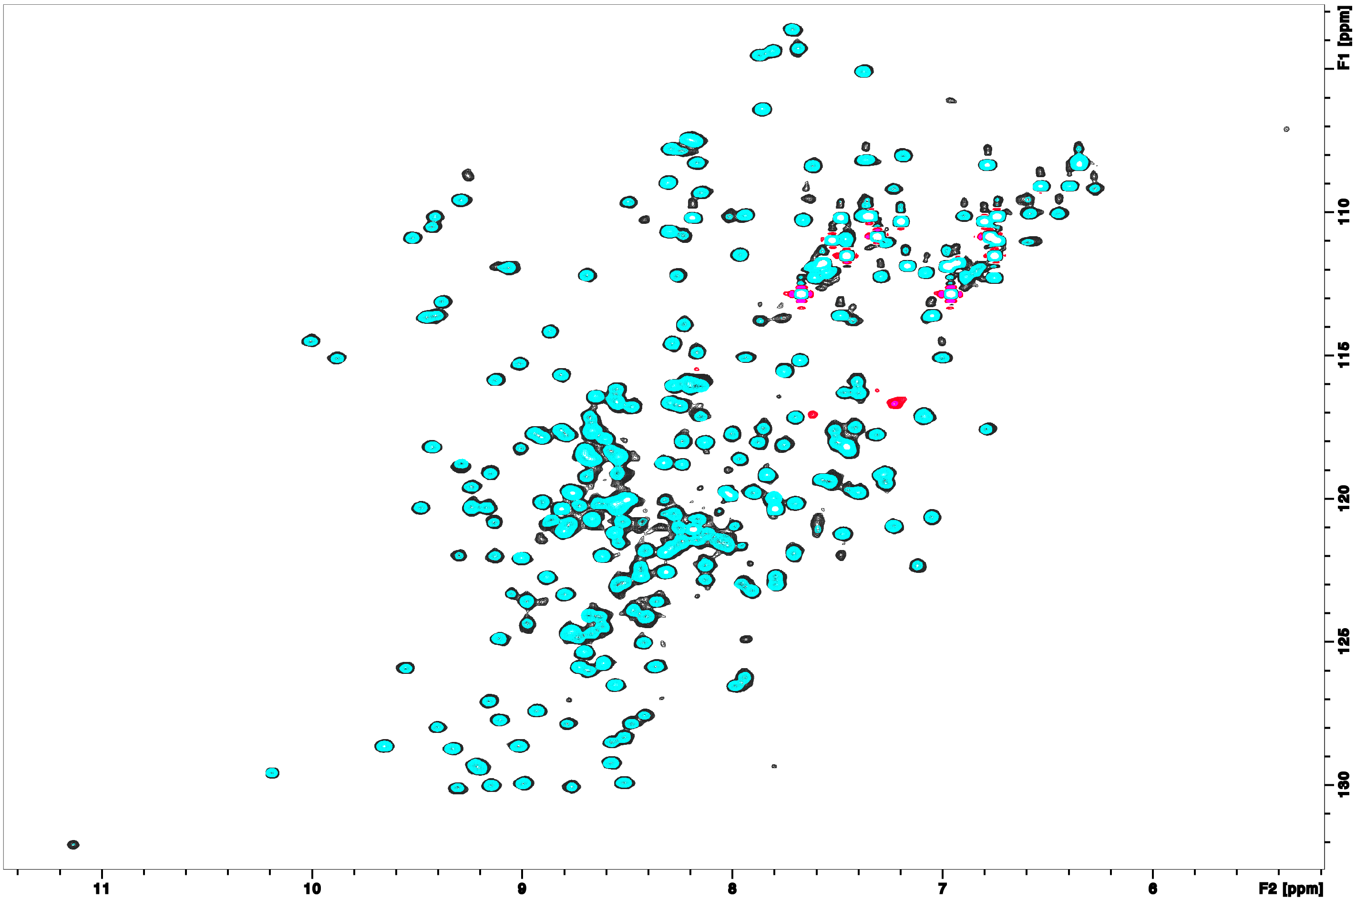
Figure S2. Superimposition of [¹H, ¹⁵N] HSQC spectra from PknB_PASTA in 25 mM sodium acetate pH 4.6 in the presence (black) or absence (blue) of 25 mM MgCl₂, recorded at 37°C.

Figure S3. Analytical gel filtration chromatograms of PknB_PASTA (50 µl at 50 µM) with (blue) or without (red) 25 mM MgSO₄. Both profile are almost identical indicating that the protein is not subject to any major conformational changes or oligomerization in presence of a large excess of MgSO₄.

Table S1. Plasmids and strains generated for over-expression studies
Plasmid Name | Strain Name | Insert Size (bp) | Primers | Description
pMind-pknB1 | PknB1 | 1881 | PknBF1 & PknBR1 | Full length gene
pMind pknB5 | PknB5 | 1062 | PknBF1 & PknBR5-TM | ΔPASTA 1-4
pMind pknB7 | TMP | 888 | PknBF2 & PknBR1 | TM-PASTA1-4
pMind pknB9 | PknB9 | 72 | PknBF2 & PknBR5-TM | TM only
pMind pknB10 | PknB10 | 276 | PknBF2 & PknBR4-P | TM-PASTA1
pMind pknB11 | PknB11 | 480 | PknBF2 & PknBR3-2P | TM-PASTA1-2
pMind pknB12 | PknB12 | 684 | PknBF2 & PknBR3-3P | TM-PASTA1-3
pMind pknB13 | PknB13 | 819 | PknBF3 & PknBR1 | PASTA 1-4
pMind pknB14 | PknB14 | 879 | PknBF3 &MycHisR | PASTA 1-4-MycHis-tag
pMind pknB15 | TMPH | 951 | PknBF1 & PknBHR2 | TM-PASTA1-4- Myc-His-tag
pMind | MIND | N/A | N/A | Empty plasmid control

Table S2. Primers used in the study
N | Primer | Sequence 5’-3’ | Description
1. | PknBF1 | gatGGATCCatgaccaccccttcccacctgtcc | Cloning of pknB in pMind plasmid
2. | PknBF2 | GacGGATCCatgcgttgggttgcggtggtc | Cloning of pknB8 in pMind plasmid
3. | PknBF3 | GcaGGATCCatgggc ggcatcacccgcgacgttcaa | Amplification pknB10
4. | PknBR1 | cggACTAGTctactg gcc gaa cct cag cgt gat | Cloning of pknB in pMind plasmid
5. | PknBR4-P | ttgACTAGTctatcc ggt gga cac gtt gac tgt | Cloning of pknB in pMind plasmid
6. | PknBR5-TM | ggtACTAGTctagcc gaa cgt gtt gat ggc gat | Cloning of pknB in pMind plasmid
7. | PknBHR2 | cggACTAGTcta ACG CGT ctg gcc gaa cct cag cgt | Cloning of pknB in pMind plasmid
8. | Myc-HisF | Gca ACG CGT gaa caa aaa ctc atc tca | Amplification of 6XHis-Myc tag
9. | Myc-HisR | Gcg ACT AGT Taa tct gta tca ggc gaa | Amplification of 6XHis-Myc tag
10. | MindF2 | tgagtcatagttgcactttatcat | Sequencing of pMind constructs
11. | MindR3 | TCCGAATCAATACGGTCGAGA | Sequencing of pMind constructs
12. | PknBR2-3P | cggACTAGT cta ctcttggacacctgtagttc | Cloning of pknB12 in in pMind plasmid
13. | PknBR3-2P | cggACTAGTcta gccaacgatgatgat | Cloning of pknB11 in in pMind plasmid
14. | RT-PknBF1 | TCAGAACGGAATCATCCACCGTGA | qRT-PCR
15. | RT-PknBR1 | GCGATGCCGAAATCCATCACCTTT | qRT-PCR
16. | RT-PknBF2 | AGAACCTCAACGTCTACGGCTTCA | qRT-PCR
17. | RT-PknBR2 | ATGACGAATTGGTTGCCCTTGGAC | qRT-PCR

Table S3.Growth of M. smegmatis strains over-expressing pknB variants
Sauton’s medium |  |  |  | Lysogeny broth |  |  | Middlebrook 7H9 medium
Strain | Maximum growth  rate (h-¹) | Lag-phase (h) | OD_{600nm} | Maximum growth  rate (h-¹) | Lag-phase (h) | OD_{600nm} | Maximum growth  rate (h-¹) | Lag-phase (h) | OD_{600nm}
Mind | 0.12±0.010 | 22±2.2 | 1.46±0.10 | 0.28±0.015 | 21±2.2 | 1.14±0.15 | 0.12±0.010 | 16±1.7 | 0.75±0.12
PknB1 | 0.11±0.010 | 52±4.0 | 1.10±0.12 | 0.09±0.002 | 55±4.4 | 0.98±0.16 | 0.06±0.005 | 32±2.7 | 0.54±0.15
PknB5 | 0.12±0.010 | 46±4.0 | 1.50±0.15 | 0.11±0.008 | 47±4.2 | 1.04±0.18 | 0.09±0.020 | 21±2.0 | 0.61±0.15
TMP | 0.11±0.010 | 50±2.0 | 1.60±0.16 | 0.24±0.020 | 29±2.0 | 1.05±0.10 | 0.10±0.030 | 17±1.5 | 0.73±0.11
Experiments were done in the Bioscreen Growth Analyser as described above. Presented data are mean ± SD from three independent experiments. The apparent lag phase was calculated as a time period from the inoculation of the culture until the OD (600 nm) was 0.1.

Table S4. Muropeptides and sugars tested in TMP growth assays.
Substance | Source | Concentration | Effect
D-glucose | Sigma | Up to 5 mM | No effect
N-acetylglucosamine (GlcNAc) | Sigma | Up to 5 mM | No effect
N-acetylmuramic acid (MurNAc) | Sigma | Up to 5 mM | No effect
GlcNAc-MurNAc disaccharide | Sigma | Up to 100 μM | No effect
MurNAc--dipeptide | Sigma | Up to 100 μM | No effect
MurNAc-pentapeptide | Synthesised in laboratory | Up to 75 μM | No effect
GlcNAc-MurNAc--pentapeptide | Synthesised in laboratory | Up to 75 μM | No effect
GlcNAc-1,6 anhydroMurNAc- pentapeptide | Synthesised in laboratory | Up to 75 μM | No effect
Tetrasaccharide- pentapeptide | Synthesised in laboratory | Up to 75 μM | No effect
Sonicated Mtb PG | Isolated in laboratory | Up to 1 mg/ml | 20% reduction of lag-phase at 0.5 mg/ml
E. coli PG | Isolated in laboratory | Up to 1 mg/ml | 20% reduction of lag-phase at 0.5 mg/ml
Lysozyme-digested E. coli PG | Isolated in laboratory | Up to 1 mg/ml | 20% reduction of lag-phase at 0.5 mg/ml
Mutanolysin-digested E. coli PG | Isolated in laboratory | Up to 1 mg/ml | 20% reduction of lag-phase at 0.5 mg/ml
MltA-digested E. coli PG | Isolated in laboratory | Up to 0.2 mg/ml | No effect
RpfB-digested E. coli PG | Isolated in laboratory | Up to 1 mg/ml | 20% reduction of lag-phase at 0.5 mg/ml
Sonicated M. smegmatis PG | Isolated in laboratory | Up to 1 mg/ml | 20% reduction of lag-phase at 0.5 mg/ml
RpfB-digested M. smegmatis PG | Isolated in laboratory | Up to 1 mg/ml | 20% reduction of lag-phase at 0.5 mg/ml
Culture supernatant (Sauton’s medium) | Prepared in laboratory | Up to 5xfold concentrated | Complete elimination of inhibition
Culture supernatant (7H9 supplemented medium) | Prepared in laboratory | Up to 5xfold concentrated | Complete elimination of inhibition
PG – peptidoglycan

