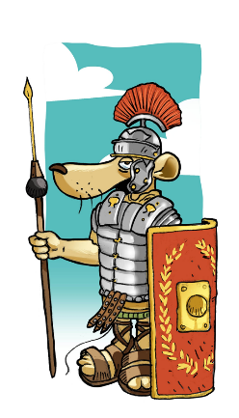
Object: tile
Material: clay
Function: part of the heating system of a bath house
Found: near the forum
Inscription: PRIMUS FECIT X
Extra information: ‘FECIT’ means ‘made’
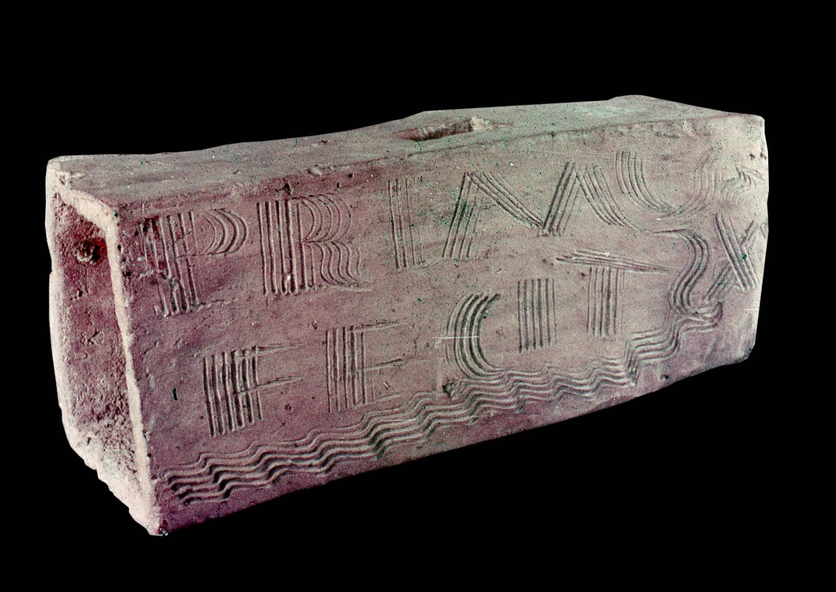
X is the Roman numeral for 10

Object: seal
Material: local limestone
Function: the mark of a seal confirmed that a citizen agreed to a deal, like a pin number today
Found: near the forum
Inscription: C. PAL. GRACILIS
Extra information: dots after a letter show that a word has been shortened (abbreviated).
Most Roman citizens had three names.
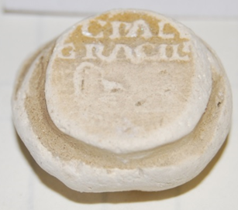

Object: part of a necklace
Material: pottery
Function: love token
Found: town centre
Inscription: VERECUNDA
LYDIA LUC
IUS GLADIA
TOR
Extra information:
- there is a hole for a piece of cord in the pottery.
- Lydia is a type of dancing girl.
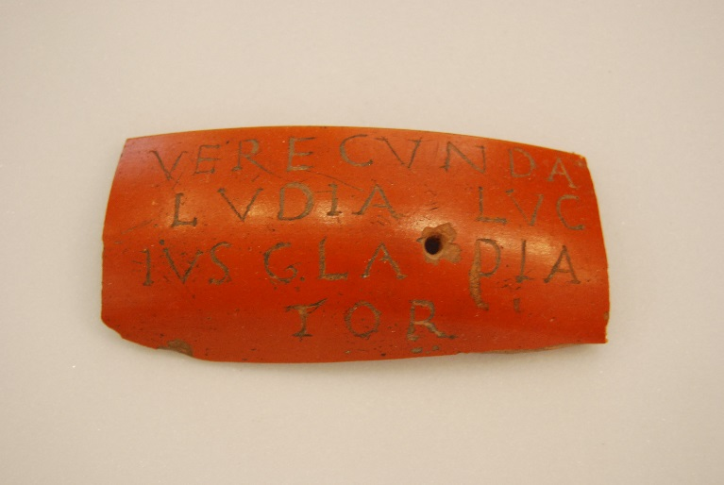

Object: mark of a seal
Material: lead
Function: the mark of a seal confirmed that a citizen agreed to a deal, like a pin number today
Found: a house in Vine Street, now under the High Cross carpark
Inscription: M. V. C.
LEG VI
Extra information: dots after a letter show that a word has been shortened (abbreviated).
Most Roman citizens had three names.
A legion was a unit of the Roman army.
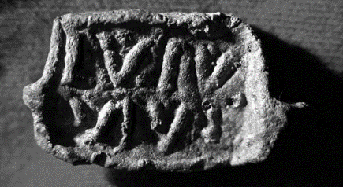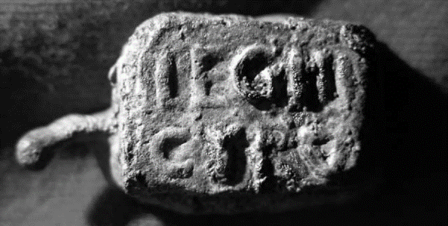

Object: tablet
Material: lead
Function: curse
Found: a house in Vine Street, now under the High Cross carpark
Inscription:
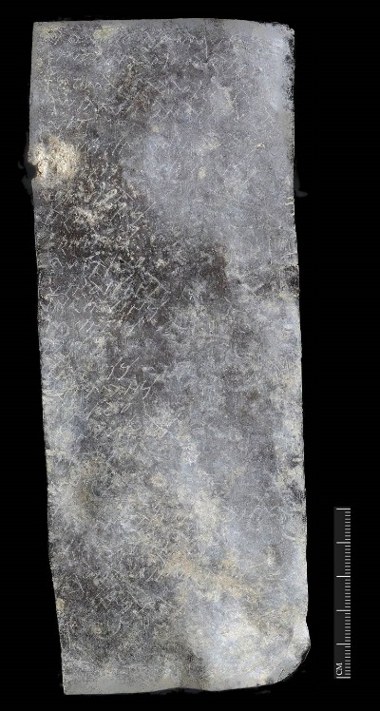
‘I give to the god Maglus him who did wrong from the slave-quarters; I give him who (did) theft <the cloak> from the slave-quarters; who stole the cloak of Servandus. Silvester, Ri(g)omandus, Senilis, Venustinus, Vorvena, Calaminus, Felicianus, Ruf<a>edo, Vendicina, Ingenuinus, Iuventius, Alocus, Cennosus, Germanus, Senedo, Cunovendus, Regalis, Ni(g)ella, Senicianus (deleted). I give (that the god Maglus) before the ninth day take away him who stole the cloak of Servandus.’

