Patchy vs. linear non-cropped habitats in farmland. What is better for nesting success of Red-backed Shrike Lanius collurio?
Joanna T. Wozna¹, Martin Hromada², Nicola F. Reeve³, Paweł Szymański⁴, Katarzyna M. Zolnierowicz¹, Marcin Tobolka¹*

¹Institute of Zoology, Poznań University of Life Sciences, Wojska Polskiego 71C, 60-625 Poznań, Poland
²Laboratory and Museum of Evolutionary Ecology, Department of Ecology, Faculty of Humanities and Natural Sciences, University of Prešov, Slovakia
³Sigma Mathematics and Statistics Support, Coventry University, Gosford Street, Coventry
CV1 5DD, UK
⁴Department of Behavioral Ecology, Adam Mickiewicz University, Umultowska 89, 61-614 Poznań, Poland
*corresponding author

Capsule
In the present study, the nesting success of Red-backed Shrike Lanius collurio in Western Poland during the years 2008-2011 was examined. No differences in nesting success between thorny and thornless bushes were found. Broods located in patchy bush aggregations had higher survival rate than broods from linear structures, in terms of both survival of eggs and survival of nestlings. Hence creating irregular, patchy non-cropped areas may represent a better solution for farmland birds than traditional linear structures.

Keywords: Red-backed Shrike, habitat structure, predation, brood survival, farmland
The influence of predation on breeding success as an evolutionary force was underestimated for a long time (Martin 1993). This seems incomprehensible because predation is the main cause of brood losses for most bird species (Ricklefs 1969, Fontaine & Martin 2006; Cox et al. 2013; Ibáñez-Álamo et al. 2015) and Martin (1993) argues that habitat selection can be explained better by predation than food limitation and competition.
A convincing hypothesis exists that mammalian and avian predators forage along linear features (Bider 1968), but there has been little attempt to prove it (Larivière 2003). Several studies have shown that the closer nests are to forest edges or roads, the higher the rates of predation, and the lower the nesting success (Gates & Gysel 1985, Marini et al. 1995) but there is still a lack of detailed analysis of the influence of bush aggregation shape on bird breeding success.
In nest site selection, the importance of bush type in relation to the impact of nest predation on breeding success has been demonstrated (e.g. Gawlik & Bildstein 1990). In open-cup nesting passerine birds, nest predation is considered to be the primary source of nestling mortality (Martin 1993), and in Red-backed Shrike Lanius collurio, a small, shrub-nesting passerine bird, this was found to be the case (Ash 1970, Farkas et al. 1997, Horvath et al. 2000 Tryjanowski et al. 2000, Goławski 2006, Martyniak 2011). Hence shrikes are thought to select less vulnerable nest sites, i.e. in thorny bushes, as an anti-predator strategy (Tryjanowski et al. 2000). Matyjasiak (1995) showed that nesting success of Red-backed Shrike is significantly lower in nests situated close to the forest edge than in those further away. It was also shown that sites occupied by Red-backed Shrikes abound with small shrub patches (Brambilla et al. 2007, Ceresa et al. 2012, Morelli et al. 2012) and are generally more heterogeneous landscapes, which reduces predation risk and also provides adequate food resources and perches for hunting (Morelli 2012).
In this study we analyse the relationship between bush aggregation structure, nesting sites (bush type) and breeding success in Red-backed Shrike. For nesting bushes, it chooses mainly Elder Sambucus nigra, Dog-rose Rosa canina, Hawthorn Crataegus sp., Dewberry Rubus sp, Blackthorn Prunus spinosa or Pine Pinus silvestris (Tryjanowski et al. 2000) and is considered to inhabit extensively rather than intensively cultivated lands (e.g. Verhulst et al. 2004). Its number has seen a decrease in Western and Northern Europe (Yosef 1994, Lefranc & Worfolk 1997) but in Poland the population is stable with a moderate increasing trend (Chodkiewicz et al. 2013). In this paper we focus on differences in clutch size, number of nestlings and fledglings, and overall nesting success between individual patches of shrubs and shrubs in apparent linear structures, and between thorny and thornless shrubs. We put forward two hypotheses: 1) survival rate is determined by landscape configuration, i.e. linear or patchy 2) survival rate is determined by nesting-bush species, i.e. thorny or thornless. Based upon research cited earlier in the paper, we expect that survival rate would be higher in patchy than linear landscape configuration, and higher in thorny than thornless nesting bush species.
The study was conducted in the agricultural landscape of Western Poland, near Odolanów (51°34'N, 17°40'E). The area is an extensively used farmland comprised of a mosaic of meadows and pastures (44%) and arable fields (42%) interspersed by small rivers, water bodies and ditches (details in Jankowiak et al. 2015). The nesting success of Red-backed Shrike was surveyed on two study plots (2.42 and 2.33 km²) with non-cropped patchy and linear habitats, mainly mixed rows of trees and bushes. Mean density was 8.74 pairs/km² (range: 6.44 - 12.40).
The study was carried out during four consecutive breeding seasons from 2008 to 2011. Detailed observations of birds started at the beginning of May, when Red-backed Shrikes arrive. The number of breeding territories was assessed using the combined version of
the mapping method (Tomiałojć 1980). Every pair’s behaviour was observed to reliably assess a breeding stage (mating, collecting of nest material and nest building) and to locate a nest. For timid and shy pairs, we searched for the nests directly by looking for all potential sites. Nests were visited at 2-5 day intervals to record clutch size, hatching success (if any of the eggs had hatched), number of hatchlings, and finally number of fledglings (older than 10 days). The cause of brood failure was determined according to Pietz & Granfors (2000), and Schaefer (2004) (i.e. when eggs were broken, eggs were taken out, nestlings were killed with visible remains or nesting material was deformed), and for the analyses, only predated nests were taken into account. For each nest, the nesting bush/tree species and a type of nesting site (patchy vs. linear) was recorded. The bush or tree species in which the nest was found was then assigned to one of two groups: thorny or thornless. The nesting site was considered as patchy if they were approximately round in shape and separated from any other site at a distance of at least 50m. We defined sections of continuous rows of bushes and/or trees as linear habitats if they were twice as long (up to 310 m, minimum length was 5 m) as their width. They were mainly found as field boundaries along ditches and field roads.
To avoid pseudoreplication only the first broods of particular pairs were analysed. Repeated and doubtful broods and broods failed due to abiotic factors were excluded from further consideration. Breeding success was coded on a binominal scale (1 - succeeded, 0 - failed) for hatchling and for fledglings.
A chi-squared test was used to test for differences in survival rate at the nestling stage and the egg stage. To test differences in brood size and number of hatchlings and number of fledglings between thorny and thornless nest bush species and linear and patchy habitats, a linear mixed model was used, including the brood size, number of hatchlings or number of fledglings as the dependent variable, year and patch ID as random effects to account for variation between years and patches, and first-egg laying date (FED), thorny/thornless, patchy/linear and the interaction between thorny/thornless and patchy/linear as fixed factors. To test differences in hatching and fledging success, a generalised linear mixed model with a binomial response and a logit link function was used, with hatching or fledging success as the dependent variable. Due to the amount of data available, it was not possible to include FED or the interaction between thorny/thornless and patchy/linear in this model. Examination of the model residuals showed that model fit was adequate.
All analyses were conducted using R version 3.1.1 with the lme4 library.
Out of 109 nests, 66 (61%) were found in thornless shrubs and 43 nests (39%) in thorny shrubs. Thornless were mainly Elder (35%), Willow Salix sp. (17%), Hop Humulus lupulus (14%) and Black Cherry Padus serotina (6%), and thorny were Dewberry Rubus caesius (58%), Wild Pear Pyrus sp. (14%), Dog-rose (12%), and Hawthorn (7%) (Table 1).
The mean number of eggs laid was 4.75 per nest, of hatchlings 3.12 and fledglings 2.25. Nesting success was determined separately for hatching 66% (N = 91), and for fledging 87% (N = 60) (Table 2). Survival rate was higher at the nestling stage than the egg stage (χ² = 8.11, p = 0.004, n = 151).
We did not find significant differences in clutch size between nests in thorny and thornless shrubs (n = 53), or in the number of hatchlings (n = 42) or number of fledglings (n = 37) (Table 3). We also found no significant differences in nesting success between thorny and thornless shrubs for hatching (n = 81) or for fledging (n = 67) (Table 4). Nests were significantly more successful when placed in patchy than in linear habitats both for hatching (p = 0.005, n = 81, Figure 1a) and fledging (p = 0.032, n = 67, Figure 1b). Clutch size, number of hatchlings and number of fledglings were not significantly different between patchy and linear habitats (n = 53; n = 42; n = 37 respectively) (Table 3).
In this study we have shown that the predation rate of Red-backed Shrike nests differed between patchy and linear non-cropped habitats. Pairs nesting in patchy sites had significantly higher nesting success than those in linear habitats. A potential explanation of this could be that predators travel and forage along linear landscape elements (Bider 1968) and bird nests located in these structures are more prone to predation. Lack of significant differences in number of hatchlings and fledglings is also consistent with this hypothesis as predators destroy the entire brood rather than part of it (Martin 1993). We found that nesting success in patchy habitat is significantly higher than success in linear habitats at both egg and nestling stages but we did not find significant differences in number of hatchlings and number of fledglings. This may suggest that parents' anti-predator behaviour is not being facilitated by the spatial structure of bushes, as active nest defense appears in the nestling stage and not the egg stage (Gotzman 1967). Similarly to other studies (Farkas et al. 1997; Müller et al. 2005; Martyniak 2011), we failed to show a relationship between nesting success and nest-bush type (thorny/thornless). This conclusion contradicts the findings in Tryjanowski et al. (2000) on the function of nest site selection, which suggest thorny shrubs are facilitating nest defense.
Surprisingly, we also found that most of the nests were built in thornless shrubs, which is in contrast to other authors' findings (Jakober & Stauber 1981, Farkas et al. 1995, Olsson 1995, Martyniak 2011). Unfortunately it is not possible to comment on the reason for this if the shrub species proportion in the study area is unknown. On the other hand it is possible that we did not obtain this result because we did not control for other shrub characteristics.
Habitat loss (i.e. decline of non-cropped areas and set-asides) caused by agriculture intensification is considered to be a reason for shrub-nesting farmland species abundance decline (Donald et al. 2006). In many European countries, conserving biodiversity of farmlands is conducted by maintaining hedgerows in the landscape (e.g. Hinsley & Bellamy 2000). Our findings suggest that this solution is not always the most favourable for birds. Creating patchy rather than linear structures may be a more successful method for farmland bird protection. However our study is strictly correlative and obviously has its limitations. To explain the overall process more detailed study is needed, including analysis of the nesting success of other shrub nesting birds and detailed data on habitat components but it would be crucial to . In conclusion, protecting and creating irregular bush aggregations distributed in agricultural areas may be a better solution for protecting shrub-nesting farmland birds than more artificial linear structures.
Acknowledgments
In 2010/2011 M.T. was a scholarship holder within the project co-financed by ESF.
We would like to thank our team member Marcin Antczak who passed away during the time of the study. We would like to thank Piotr Tryjanowski, Gregorio Moreno-Rueda and anonymous reviewer for their comments on earlier versions of the manuscript.
References
Ash, J.S. 1970. Observations on a decreasing population of Red-backed Shrikes. Brit. Birds 63: 185-205.
Bider, J.R. 1968. Animal Activity in Uncontrolled Terrestrial Communities as Determined by a Sand Transect Technique. Ecol. Monogr. 38: 269–308.
Brambilla, M., Rubolini, D., & Guidali, F. 2007. Between land abandonment and agricultural intensification: habitat preferences of Red-backed Shrikes Lanius collurio in low-intensity farming conditions. Bird Study, 54: 160-167.
Ceresa, F., Bogliani, G., Pedrini, P., & Brambilla, M. 2012. The importance of key marginal habitat features for birds in farmland: an assessment of habitat preferences of Red-backed Shrikes Lanius collurio in the Italian Alps. Bird Study, 59: 327-334.
Chodkiewicz, T., Neubauer, G., Chylarecki, P., Sikora, A., Cenian, Z., Ostasiewicz, M., Wylegała, P., Ławicki, Ł., Smyk, B., Betleja, J., Gaszewski, K., Górski, A., Grygoruk, G., Kajtoch, Ł., Kata, K., Krogulec, J., Lenkiewicz, W., Marczakiewicz, P., Nowak, D., Pietrasz, K., Rohde, Z., Rubacha, S., Stachyra, P., Świętochowski, P., Tumiel T., Urban, M., Wieloch, M., Woźniak, B., Zielińska, M. & Zieliński, P. 2013. Monitoring of Polish birds in 2012-2013. Biul. Monit. Przyr. 11: 1–72 (in Polish).
Cox, W. A., Thompson III, F. R., & Reidy, J. L. 2013. The effects of temperature on nest predation by mammals, birds, and snakes. The Auk, 130: 784-790.
Donald, P. F., Sanderson, F. J., Burfield, I. J., & Van Bommel, F. P. 2006. Further evidence of continent-wide impacts of agricultural intensification on European farmland birds, 1990–2000. Agric. Ecosyst. Environ. 116: 189-196.
Farkas, R., Horvath, R., & Pasztor, L. 1997. Nesting success of the Red-backed Shrike (Lanius collurio) in a cultivated area. Ornis Hung. 7: 27-37.
Fontaine, J. J., & Martin, T. E. 2006. Habitat selection responses of parents to offspring predation risk: an experimental test. Am. Nat., 168: 811-818.
Gates, J.E., & Gysel, W.L. 1978. Avian Nest Dispersion and Fledging Success in Field-Forest Ecotones. Ecology 59: 871–883.
Gawlik, D.E., & Bildstein, K.L. 1990. Reproductive success and nesting habitat of Loggerhead Shrikes in north-central South Carolina. Wilson Bull. 102: 37-48.
Goławski, A. 2006. Breeding biology of the Red-backed Shrike Lanius collurio in the extensive agricultural landscape of eastern Poland. Not. Orn. 47: 1-10 (in Polish).
Gotzman, J. 1967. Remarks on ethology of the red-backed shrike, Lanius collurio L.-nest defence and nest desertion. Acta Ornithol. 10: 83-96.
Hinsley, S.A., & Bellamy, P.E. 2000. The influence of hedge structure, management and landscape context on the value of hedgerows to birds: a review. J. Environ. Manage. 60: 33-49.
Horvath, R., Farkas, R., & Yosef, R. 2000. Nesting ecology of the Red-backed Shrike (Lanius collurio) in northeastern Hungary. Ring 22: 127-132.
Ibáñez-Álamo, J. D., Magrath, R. D., Oteyza, J. C., Chalfoun, A. D., Haff, T. M., Schmidt, K. A., Thomson R. L. & Martin, T. E. 2015. Nest predation research: recent findings and future perspectives. J. Ornithol., 156: 247-262.
Jankowiak, Ł., Antczak, M., Kwieciński, Z., Szymański, P., Tobolka, M. & Tryjanowski, P. 2015. Diurnal raptor community wintering in an extensively used farmland. Ornis Fenn. 92: 76-86.
Jakober, H. & Stauber, W. 1981. Habitat requirements of Red-backed Shrike Lanius collurio. Contribution to the protection of endangered species. Oekol. Vögel 3: 223 – 247 (in German).
Larivière, S. 2003. Edge Effects, Predator Movements, and the Travel-Lane Paradox. Wildl. Soc. Bull. 31: 315–320.
Lefranc N., Worfolk T. 1997. Shrikes. A Guide to the Shrikes of the World. Pica Press, Sussex.
Marini, M.A., Robinson, S.K., & Heske, E.J. 1995. Edge effects on nest predation in the Shawnee National Forest, southern Illinois. Biol. Conserv. 74: 203–213.
Martin, T.E. 1993. Nest Predation and Nest Sites: new perspectives on old patterns. BioScience 43: 523–532.
Martyniak, K. 2011. Breeding ecology of Red-backed Shrike Lanius collurio in Lower Silesia. Ptaki Śląska 18: 8-8 (in Polish).
Morelli, F. 2012. Plasticity of habitat selection by Red-backed Shrikes (Lanius collurio) breeding in different landscapes. Wilson J. Ornithol. 124: 51-56.
Morelli, F., Santolini, R., & Sisti, D. 2012. Breeding habitat of red-backed shrike Lanius collurio on farmland hilly areas of Central Italy: is functional heterogeneity one important key? Ethol. Ecol. Evol. 24: 127-139.
Müller, M., Pasinelli, G., Schiegg, K., Spaar, R., & Jenni, L. 2005. Ecological and social effects on reproduction and local recruitment in the red-backed shrike. Oecologia 143: 37-50.
Olsson, V. 1995. The red-backed shrike Lanius collurio in southeastern Sweden: breeding biology. Ornis Svec. 5: 101-110.
Pietz, P.J., & Granfors, D.A. 2000. Identifying predators and fates of grassland passerine nests using miniature video cameras. J. Wildl. Manage. 64: 71-87.
Ricklefs, R.E. 1969. An analysis of nesting mortality in birds. Smithson. Contrib. to Zool. 9: 1-48.
Schaefer, T. 2004 Video Monitoring of Shrub-Nests Reveals Nest Predators. Bird Study 51: 170–177.
Tomiałojć, L. 1980. The combined version of the mapping method. In Oelke, H (ed.) Bird Census Work and Nature Conservation, pp. 92-106. Proc.VI Intern. Conf. Bird Census and Atlas Work, Göttingen.
Tryjanowski, P., Kuźniak, S., & Diehl, B. 2000. Does breeding performance of Red-backed Shrike Lanius collurio depend on nest site selection? Ornis Fenn. 77: 137–141.
Verhulst, J., Báldi, A., & Kleijn, D. 2004. Relationship between land-use intensity and species richness and abundance of birds in Hungary. Agric. Ecosyst. Environ. 104: 465-473.
Yosef, R. 1994. Conservation commentary: evaluation of the global decline in the True Shrikes (Family Lanidae). The Auk 111: 228-233.

Nest site | n | %
Thorny
Dewberry Rubus spp. | 24 | 22.0
Wild pear Pyrus spp. | 5 | 4.6
Dog-rose Rosa canina | 5 | 4.6
Others | 9 | 8.3
Thornless
Elder Sambucus nigra | 19 | 17.4
Hop Humulus lupulus | 21 | 8.3
Willow Salix spp. | 6 | 5.5
Black cherry Padus serotina | 6 | 5.5
Alder Alnus glutinosa | 5 | 4.6
Others | 20 | 18.3
Coniferous
Pine Pinus sylvestris | 1 | 0.9
Total | 109 | 100
Table 1. Nest sites of the Red-backed Shrike Lanius collurio in Western Poland during 2008-2011.
 | N | Mean | ±SD | Success
Eggs | 96 | 4.75 | 1.41 | N | %
Hatchlings | 85 | 3.12 | 2.52 | 91 | 66
Fledglings | 97 | 2.25 | 2.51 | 60 | 87
Table 2. Data on eggs, hatchlings and fledglings per nest and hatching and fledging success. N determines number of nests for which we obtained information about number of eggs, hatchlings and fledglings, and N in success determines number of nests for which we obtained information about hatching and fledging success.

 | Estimate | Std. Error | df | t value |  | Pr(>|t|)
Clutch Size
(Intercept) | 10.981 | 3.076 | 45.939 |  | 3.571 | 0.001
FED | -0.037 | 0.020 | 46.271 |  | -1.820 | 0.075
Thorny | -0.299 | 0.531 | 45.869 |  | -0.563 | 0.576
Linear | -0.478 | 0.514 | 47.962 |  | -0.929 | 0.358
Thorniness*Landscape configuration | 0.529 | 0.674 | 46.234 |  | 0.785 | 0.437
No of Hatchlings
(Intercept) | 7.767 | 2.506 | 21.407 |  | 3.099 | 0.005
FED | -0.018 | 0.017 | 21.498 |  | -1.058 | 0.302
Thorny | -0.334 | 0.351 | 34.253 |  | -0.951 | 0.348
Linear | 0.230 | 0.372 | 33.302 |  | 0.620 | 0.540
Thorniness* Landscape configuration | 0.042 | 0.550 | 33.314 |  | 0.077 | 0.939
No of Fledglings
(Intercept) | 8.414 | 2.759 | 19.538 |  | 3.050 | 0.006
FED | -0.023 | 0.018 | 20.303 |  | -1.275 | 0.217
Thorny | -0.216 | 0.431 | 31.206 |  | -0.501 | 0.620
Linear | 0.212 | 0.395 | 16.849 |  | 0.538 | 0.598
Thorniness* Landscape configuration | 0.219 | 0.601 | 20.427 |  | 0.364 | 0.720
Table 3. Linear mixed model results on differences in brood size and number of hatchlings and number of fledglings between thorny/thornless nest bush species and linear/patchy habitats.

 | Estimate | Std. Error | z value | Pr(> |z|)
Hatching success
(Intercept) | 3.728 | 1.222 | 3.051 | 0.002
Thorny | -0.518 | 0.648 | -0.799 | 0.424
Linear | -3.460 | 1.221 | -2.834 | 0.005
Fledging success
(Intercept) | 1.530 | 0.702 | 2.180 | 0.029
Thorny | 0.490 | 0.720 | 0.681 | 0.496
Linear | -1.576 | 0.734 | -2.148 | 0.032
Table 4. Generalised linear mixed model results on differences in hatching and fledging success in thorny/thornless bush species and linear/patchy habitats.

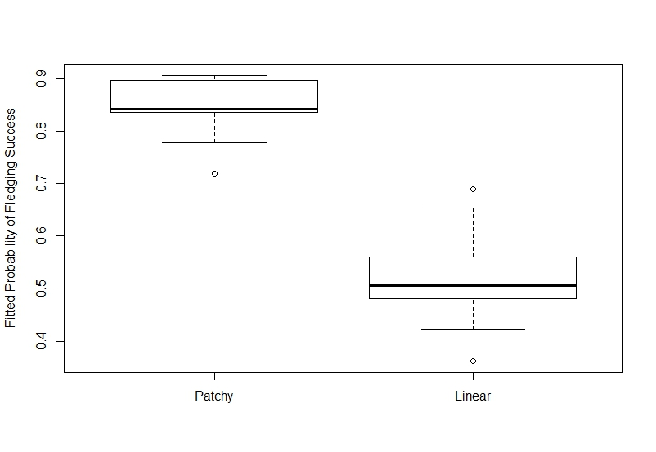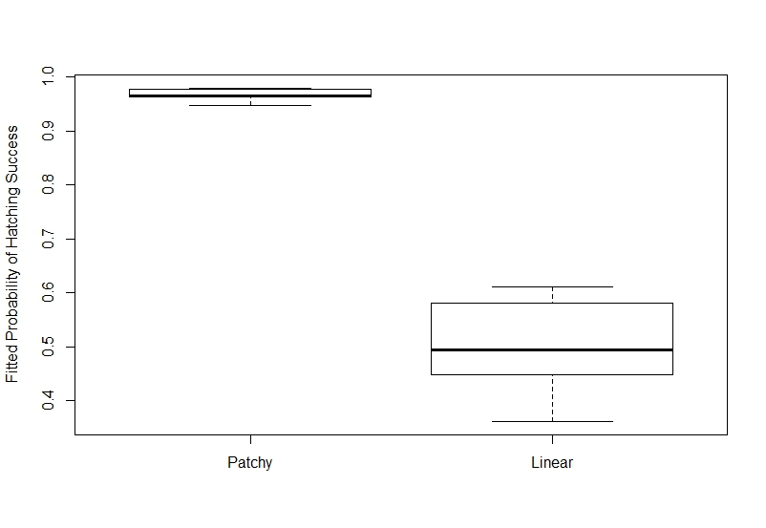
Figure 1 Hatching (a) and fledgling (b) success of Red-backed Shrike L. collurio in Western Poland during 2008–11 when nests are placed in patch and linear clusters of habitat.

