Supporting Information for

**A reactive oxygen species-generating, cyclooxygenase-2 inhibiting, cancer stem cell-potent tetranuclear copper(II) cluster**

Chunxin Lu,a,b Kristine Laws,a Arvin Eskandari,a and Kogularamanan Suntharalingama*

a Department of Chemistry, King’s College London, London, SE1 1DB, United Kingdom

b College of Biological, Chemical Sciences and Engineering, Jiaxing University, Jiaxing 314001, China

Email: kogularamanan.suntharalingam@kcl.ac.uk

**Table of Content**

**Experimental Details**

**Scheme S1.** The reaction scheme for the preparation of tetranuclear copper(II) complexes, **1**-**4** comprising of four diclofenac moieties and two Schiff base ligands.

**Fig. S1** Crystal structure of compound **1** (ellipsoid thermal probability was drawn at the level of 50%, hydrogen atoms and co-crystallizing solvent molecules were omitted for clarity).

**Table S1.** Crystallographic data of **1**•2(C3H6NO)•2(C2H3N).

**Table S2.** Selected bond lengths (Å) and angles (°) for **1**•2(C3H6NO)•2(C2H3N).

**Fig. S2** UV-Vis spectrum of **1** (50 μM) in Tris-HCl (pH 7.4)/DMSO (200:1) over the course of 24 h at 37 oC.

**Fig. S3** UV-Vis spectrum of **1** (50 μM) in PBS (pH 7.4)/DMSO (200:1) over the course of 24 h at 37 oC.

**Fig. S4** UV-Vis spectrum of **1** (50 μM) in sodium acetate buffer (pH 5.12)/DMSO (200:1) over the course of 24 h at 37 oC.

**Fig. S5** UV-Vis spectrum of **1** (50 μM) in the presence of ascorbic acid (500 μM) in PBS (pH 7.4)/DMSO (200:1) over the course of 24 h at 37 oC.

**Fig. S6** UV-Vis spectrum of **L1** (50 μM), **L1** (50 μM) + CuI (50 μM), diclofenac (25 μM) in PBS (pH 7.4)/DMSO (200:1) at 37 oC.

**Fig. S7.** ESI mass spectrum (positive mode, 150-650 *m/z*) of **1** (50 μM) in PBS (pH 7.4)/DMSO (200:1), in the presence of ascorbic acid (0.5 mM) after 24 h at 37 oC.

**Fig. S8.** ESI mass spectrum (negative mode, 100-650 *m/z*) of **1** (50 μM) in PBS (pH 7.4)/DMSO (200:1), in the presence of ascorbic acid (0.5 mM) after 24 h at 37 oC.

**Fig. S9.** ESI mass spectrum (negative mode, 400-2200 *m/z*) of **1** (50 μM) in PBS (pH 7.4)/DMSO (200:1), in the presence of ascorbic acid (0.5 mM) after 24 h at 37 oC.

**Fig. S10** UV-Vis spectrum of **1** (250 μM) in the presence of ascorbic acid (2.5 mM) in PBS (pH 7.4)/DMSO (95:5) over the course of 24 h at 37 oC.

**Fig. S11** UV-Vis spectrum of **1** (50 μM) in the presence of ascorbic acid (500 μM) and bathocuproine disulfonate, BCS (100 μM) in PBS (pH 7.4)/DMSO (200:1) over the course of 24 h at 37 oC.

**Fig. S12** Representative dose-response curves for the treatment of HMLER and HMLER-shEcad cells with **1** after 72 h incubation.

**Fig. S13** Representative dose-response curves for the treatment of HMLER and HMLER-shEcad cells with **2** after 72 h incubation.

**Fig. S14** Representative dose-response curves for the treatment of HMLER and HMLER-shEcad cells with **3** after 72 h incubation.

**Fig. S15** Representative dose-response curves for the treatment of HMLER and HMLER-shEcad cells with **4** after 72 h incubation.

**Fig. S16** Representative dose-response curves for the treatment of HMLER and HMLER-shEcad cells with diclofenac after 72 h incubation.

**Fig. S17** Representative dose-response curves for the treatment of HMLER and HMLER-shEcad cells with CuCl2 after 72 h incubation.

**Fig. S18** Representative dose-response curves for the treatment of HMLER and HMLER-shEcad cells with **1** pre-incubated with 10 equivalents of ascorbic acid for 24 h after 72 h incubation.

**Fig. S19** Representative bright-field images (× 10) of HMLER-shEcad mammospheres in the absence and presence of **2** and **3** at their respective IC20 values for 5 days.

**Fig. S20** Quantification of mammosphere formation with HMLER-shEcad cells untreated and treated with diclofenac and CuCl2 at their respective IC20 values for 5 days.

**Fig.** **S21** Representative bright-field images (× 10) of HMLER-shEcad mammospheres in the absence and presence of diclofenac and CuCl2 at their respective IC20 values for 5 days.

**Fig. S22** Representative dose-response curves for the treatment of HMLER-shEcad mammospheres with **1**-**3** and salinomycin after 5 days incubation.

**Fig. S23** Representative dose-response curves for the treatment of HMLER-shEcad mammospheres with diclofenac and CuCl2 after 5 days incubation.

**Table S3.** IC50 values of **1**-**3**, salinomycin, diclofenac, and CuCl2 against HMLER-shEcad mammospheres determined after 5 days incubation (mean of three independent experiments ± SD).

**Fig. S24** Copper content in HMLER cells treated with **1**-**4** (10 μM for 24 h).

**Fig. S25** Copper content in HMLER-shEcad cells treated with diclofenac, CuCl2, and **1** pre-incubated with 10 equivalents of ascorbic acid for 24 h(10 μM for 24 h).

**Fig. S26** Copper content in whole cell, cytoplasm, and nucleus fractions isolated from HMLER-shEcad cells treated with **1** (10 µM for 24 h).

**Fig. S27** Normalised ROS activity in untreated HMLER-shEcad cells (control) and HMLER-shEcad cells treated with H2O2(150 µM for 3, 6, 12, and 24 h) and co-treated with H2O2 (150 µM for 3, 6, 12, and 24 h) and *N*-acetylcysteine (2.5 mM for 3, 6, 12, and 24 h). Error bars represent standard deviations and Student *t test*, ** = *p* < 0.01.

**Fig. S28** Representative dose-response curves for the treatment of HMLER-shEcad cells with **1** after 72 incubation in the presence and absence of *N*-acetylcysteine (2.5 mM ).

**Fig. S29** Representative histograms displaying the green fluorescence emitted by anti-COX-2 Alexa Fluor 488 nm antibody-stained HMLER-shEcad cells treated with LPS (2.5 μM) for 24 h (red) followed by 48 h in media containing diclofenac (20 μM, blue).

**References**

**Experimental Details**

**Materials and Methods.** All synthetic procedures were performed under normal atmospheric conditions. Fourier transform infrared (FTIR) spectra were recorded with a IRAffinity-1S Shimadzu spectrophotometer. High resolution electron spray ionisation mass spectra were recorded on a BrukerDaltronics Esquire 3000 spectrometer by Dr. Lisa Haigh (Imperial College London). UV-Vis absorption spectra were recorded on a Cary100 UV-Vis spectrophotometer. For the UV studies, a 10 mM stock solution of **1** in DMSO was initially prepared. The copper concentration of the stock solution was determined by inductively coupled plasma mass spectrometry (ICP-MS, PerkinElmer NexION 350D). The stock solution was then diluted in the appropriate solution to the working concentration. Elemental analysis of the compounds prepared was performed commercially by London Metropolitan University. The Schiff based ligands, **L1**-**4** were prepared according to previously reported protocols.1

**Synthesis of Cu4(diclofenac)4(L1)2 (1).** Diclofenac sodium (190.9 mg, 0.6 mmol) in methanol (10 mL) was added dropwise to a mixture of **L1** (58.5 mg, 0.3 mmol) and Cu(NO3)2·3H2O (144 mg, 0.6 mmol) in methanol (10 mL). The pH was adjusted to 7 using triethylamine and the solution was refluxed for 24 h. The resulting precipitate was filtered and thoroughly washed with water (3 x 10 mL) and diethyl ether (3 x 10 mL). The tetranuclear copper(II) complex, **1** was isolated as a green solid (171 mg, 60%). IR (solid, cm-1): 1620, 1614, 1597, 1578, 1540, 1505, 1466, 1448, 1395, 1362, 1308, 1268, 1196, 1147, 1130, 1069, 1029, 944, 766, 741, 718, 603 (Cu-O), 573, 528, 467 (Cu-O), 441 (Cu-O); UV (acetonitrile, nm): 275, 323, 377; Anal. Calcd. for **1**, C76H66Cl8Cu4N6O12S2: C, 49.15; H, 3.58; N, 4.52. Found: C, 49.15; H, 3.23; N, 4.75.

**Synthesis of Cu4(diclofenac)4(L2)2 (2).** Diclofenac sodium (190.9 mg, 0.6 mmol) in methanol (10 mL) was added dropwise to a mixture of **L2** (67.5 mg, 0.3 mmol) and Cu(NO3)2·3H2O (144 mg, 0.6 mmol) in methanol (10 mL). The pH was adjusted to 7 using triethylamine and the solution was refluxed for 24 h. The resulting precipitate was filtered and thoroughly washed with water (3 x 10 mL) and diethyl ether (3 x 10 mL). The tetranuclear copper(II) complex, **1** was isolated as a green solid (137 mg, 48%). IR (solid, cm-1):1622, 1495, 1449, 1394, 1281, 1034, 1022, 1015, 775, 768, 743, 718, 704, 660, 609 (Cu-O), 534, 472 (Cu-O), 451 (Cu-O);UV (acetonitrile, nm): 277, 453; Anal. Calcd. for compound **2**, C78H70Cl8Cu4N6O14S2: C, 48.86; H, 3.68; N, 4.38. Found: C, 48.80; H, 3.57; N, 4.25.

**Synthesis of Cu4(diclofenac)4(L3)2 (3).** Diclofenac sodium (190.9 mg, 0.6 mmol) in methanol (10 mL) was added dropwise to a mixture of **L3** (67.5 mg, 0.3 mmol) and Cu(NO3)2·3H2O (144 mg, 0.6 mmol) in methanol (10 mL). The pH was adjusted to 7 using triethylamine and the solution was refluxed for 24 h. The resulting precipitate was filtered and thoroughly washed with water (3 x 10 mL) and diethyl ether (3 x 10 mL). The tetranuclear copper(II) complex, **1** was isolated as a green solid (158 mg, 57%). IR (solid, cm-1): 1609, 1577, 1562, 1534, 1502, 1444, 1369, 1220, 1124, 769, 744, 619 (Cu-O), 577, 532, 469 (Cu-O), 444 (Cu-O); UV (acetonitrile, nm): 285, 321, 363; Anal. Calcd. for compound **3**, C78H70Cl8Cu4N6O14S2: C, 48.86; H, 3.68; N, 4.38. Found: C, 48.82; H, 3.51; N, 4.25.

**Synthesis of Cu4(diclofenac)4(L4)2 (4).** Diclofenac sodium (190.9 mg, 0.6 mmol) in methanol (10 mL) was added dropwise to a mixture of **L4** (67.5 mg, 0.3 mmol) and Cu(NO3)2·3H2O (144 mg, 0.6 mmol) in methanol (10 mL). The pH was adjusted to 7 using triethylamine and the solution was refluxed for 24 h. The resulting precipitate was filtered and thoroughly washed with water (3 x 10 mL) and diethyl ether (3 x 10 mL). The tetranuclear copper(II) complex, **1** was isolated as a green solid (155 mg, 54%). IR (solid, cm-1): 1622, 1494, 1449, 1391, 1283, 1034, 1015, 768, 741, 718, 660, 609 (Cu-O), 533, 472 (Cu-O), 442 (Cu-O); UV (acetonitrile, nm): 276, 454; Anal. Calcd. for compound **4**, C78H70Cl8Cu4N6O14S2: C, 48.86; H, 3.68; N, 4.38. Found: C, 48.77; H, 3.64; N, 4.27.

**X-ray Single Crystal Diffraction Analysis.** Standard procedures were used to mount the crystal on a Gemini diffractometer with graphite-monochromated Mo Kα radiation (λ = 0.71073 Å) at 293 K. The crystal structure was solved using direct methods in SHELXS and refined by full-matrix least-squares routines, based on *F*2, using the SHELXL program.2 All the H atoms were placed in geometrically idealised positions and constrained to ride on their parent atoms. The structure has been deposited with the Cambridge Crystallographic Data Centre (CCDC 1548878). This information can be obtained free of charge from www.ccdc.cam.ac.uk/data_request/cif.

**Cell Lines and Cell Culture Conditions.** The human mammary epithelial cell lines, HMLER and HMLER-shEcad were kindly donated by Prof. R. A. Weinberg (Whitehead Institute, MIT). HMLER and HMLER-shEcad cells were maintained in Mammary Epithelial Cell Growth Medium (MEGM) with supplements and growth factors (BPE, hydrocortisone, hEGF, insulin, and gentamicin/amphotericin-B). The cells were grown at 310 K in a humidified atmosphere containing 5% CO2.

**Cytotoxicity MTT assay.** The colourimetric MTT assay was used to determine the toxicity of **1**-**4**. HMLER or HMLER-shEcad (5 × 103) were seeded in each well of a 96-well plate. After incubating the cells overnight, various concentrations of the compounds (0.2-100 µM), were added and incubated for 72 h (total volume 200 µL). Stock solutions of the compounds were prepared as 10 mM solutions in DMSO and diluted using media. The final concentration of DMSO in each well was 0.5% and this amount was present in the untreated control as well. After 72 h, 20 μL of a 4 mg/mL solution of MTT in PBS was added to each well, and the plate was incubated for an additional 4 h. The MEGM/MTT mixture was aspirated and 200 μL of DMSO was added to dissolve the resulting purple formazan crystals. The absorbance of the solutions in each well was read at 550 nm. Absorbance values were normalized to (DMSO-containing) control wells and plotted as concentration of test compound versus % cell viability. IC50 values were interpolated from the resulting dose dependent curves. The reported IC50 values are the average of three independent experiments, each consisting of six replicates per concentration level (overall n = 18).

**Tumorsphere Formation and Viability Assay.** HMLER-shEcad cells (5 × 103) were plated in ultralow-attachment 96-well plates (Corning) and incubated in MEGM supplemented with B27 (Invitrogen), 20 ng/mL EGF, and 4 µg/mL heparin (Sigma) for 5 days. Studies were conducted in the absence and presence of **1**-**3** and salinomycin. Mammospheres treated with **1**-**3** and salinomycin (at their respective IC20 values, 5 days) were counted and imaged using an inverted microscope. The viability of the mammospheres was determined by addition of a resazurin-based reagent, TOX8 (Sigma). After incubation for 16 h, the solutions were carefully transferred to a black 96-well plate (Corning), and the fluorescence of the solutions was read at 590 nm (λex = 560 nm). Viable mammospheres reduce the amount of the oxidized TOX8 form (blue) and concurrently increases the amount of the fluorescent TOX8 intermediate (red), indicating the degree of mammosphere cytotoxicity caused by the test compound. Fluorescence values were normalized to DMSO-containing controls and plotted as concentration of test compound versus % mammospheres viability. IC50 values were interpolated from the resulting dose dependent curves. The reported IC50 values are the average of two independent experiments, each consisting of three replicates per concentration level (overall n = 6).

**Cellular Uptake.** To measure the cellular uptake of **1**-**4** *ca.* 1 million HMLER and HMLER-shEcad cells were treated with **1**-**4** (10 μM) at 37 ºC for 24 h. After incubation, the media was removed, the cells were washed with PBS (2 mL × 3), harvested, and centrifuged. The cellular pellets were dissolved in 65% HNO­3 (250 μL) overnight. For **1**, cellular pellets were also used to determine the copper content in the nuclear, cytoplasmic, and membrane fractions. The Thermo Scientific NE-PER Nuclear and Cytoplasmic Extraction Kit were used to extract and separate the nuclear, cytoplasmic, and membrane fractions. The fractions were dissolved in 65% HNO3 overnight (250 μL final volume). All samples were diluted 5-fold with water and analysed using inductively coupled plasma mass spectrometry (ICP-MS, PerkinElmer NexION 350D). Copper levels are expressed as Cu (ppb) per million cells. Results are presented as the mean of five determinations for each data point.

**Intracellular ROS Assay.** HMLER-shEcad cells (5 × 103) were seeded in each well of a 96-well plate. After incubating the cells overnight, they were treated with **1** or H2O2 (20 and 150 µM for 3, 6, 12, and 24 h), in the presence or absence of *N*-acetylcysteine (2.5 mM), and incubated with 6-carboxy-2′,7′-dichlorodihydrofluorescein diacetate (20 μM) for 30 min. The intracellular ROS level was determined by measuring the fluorescence of the solutions in each well at 529 nm (λex = 504 nm).

**Flow cytometry.** HMLER-shEcad cells were seeded in 6-well plates (at a density of 5 × 105 cells/ mL) and the cells were allowed to attach overnight. The cells were treated with lipopolysaccharide (LPS) (2.5 μM for 24 h), and then treated with **1** (5-15 μM) or diclofenac (20 μM) and incubated for a further 48 h. The cells were then harvested by trypsinization, fixed with 4% paraformaldehyde (at 37 oC for 10 min), permeabilized with ice-cold methanol (for 30 min), and suspended in PBS (200 μL). The Alexa Fluor® 488 nm labelled anti-COX-2 antibody (5 μL) was then added to the cell suspension and incubated in the dark for 1 hr. The cells were then washed with PBS (1 mL) and analysed using a FACSCanto II flow cytometer (BD Biosciences) (10,000 events per sample were acquired). The FL1 channel was used to assess COX-2 expression. Cell populations were analysed using the FlowJo software (Tree Star).



**Scheme S1.** The reaction scheme for the preparation of tetranuclear copper(II) complexes, **1**-**4** comprising of four diclofenac moieties and two Schiff base ligands.



**Fig. S1** Crystal structure of compound **1** (ellipsoid thermal probability was drawn at the level of 50%, hydrogen atoms and co-crystallizing solvent molecules were omitted for clarity).

**Table S1.** Crystallographic data of **1**•2(C3H6NO)•2(C2H3N).

|  |  |
| --- | --- |
| **1•**2(C3H6NO)•2(C2H3N) | |
| Moiety formula | C76H66Cl8Cu4N6O12S2•2(C3H6NO)•2(C2H3N) |
| Sum formula | C86H84 Cl8Cu4N10O14S2 |
| *Fw* | 2083.51 |
| crystal system | Monoclinic |
| space group | *P 1 21/n 1* |
| *a*, Å | 17.1514(3) |
| *b*, Å | 12.63396(19) |
| *c*, Å | 21.6626(4) |
| *α*, deg. | 90 |
| *β*, deg. | 98.2803(15) |
| *γ*, deg. | 90 |
| *V*, Å3 | 4645.13(13) |
| *Z* | 2 |
| *D*calcd, Mg/m3 | 1.490 |
| Reflections collected | 18925 |
| Reflections independent (*R*int) | 8987 (0.0314) |
| Goodness-of-fit on *F*2 | 1.027 |
| *R*(*I*> 2σ*I*) | 0.0472, 0.1246 |

**Table S2.** Selected bond lengths (Å) and angles (°) for **1**•2(C3H6NO)•2(C2H3N).

|  |  |  |  |
| --- | --- | --- | --- |
| Cu(1)-Cu(1A) | 3.0057(7) | Cu(1)-O(2A) | 1.9836(18) |
| Cu(1)-O(2) | 1.9831(18) | Cu(1)-Cu(2) | 3.0536(5) |
| Cu(1)-O(1) | 2.366(2) | Cu(1)-O(3) | 1.9586(19) |
| Cu(1)-O(5) | 1.940(2) | O(2)-Cu(1A) | 1.9837(18) |
| O(2)-Cu(2) | 1.9728(18) | Cu(2)-S(1) | 2.3914(9) |
| Cu(2)-O(1) | 1.931(2) | Cu(2)-O(6) | 2.295(2) |
| Cu(2)-N(1) | 1.952(2) | Cu(1A)-Cu(1)-Cu(2) | 66.887(15) |
| O(2)-Cu(1)-Cu(1A) | 40.74(5) | O(2A)-Cu(1)-Cu(1A) | 40.73(5) |
| O(2)-Cu(1)-O(2A) | 81.47(8) | O(2A)-Cu(1)-Cu(2) | 100.27(5) |
| O(2)-Cu(1)-Cu(2) | 39.35(5) | O(2A)-Cu(1)-O(1) | 91.12(8) |
| O(2)-Cu(1)-O(1) | 73.48(7) | O(1)-Cu(1)-Cu(1A) | 79.93(6) |
| O(1)-Cu(1)-Cu(2) | 39.22(5) | O(3)-Cu(1)-Cu(1A) | 137.44(6) |
| O(3)-Cu(1)-O(2) | 175.87(8) | O(3)-Cu(1)-O(2A) | 96.83(8) |
| O(3)-Cu(1)-Cu(2) | 144.77(6) | O(3)-Cu(1)-O(1) | 110.39(8) |
| O(5)-Cu(1)-Cu(1A) | 132.05(7) | O(5)-Cu(1)-O(2A) | 162.77(9) |
| O(5)-Cu(1)-O(2) | 93.43(8) | O(5)-Cu(1)-Cu(2) | 85.55(6) |
| O(5)-Cu(1)-O(1) | 103.27(9) | O(5)-Cu(1)-O(3) | 87.12(9) |
| Cu(1)-O(2)-Cu(1A) | 98.53(8) | Cu(2)-O(2)-Cu(1A) | 115.15(9) |
| Cu(2)-O(2)-Cu(1) | 101.05(8) | O(2)-Cu(2)-Cu(1) | 39.60(5) |
| O(2)-Cu(2)-S(1) | 94.33(6) | O(2)-Cu(2)-O(6) | 89.13(7) |
| S(1)-Cu(2)-Cu(1) | 129.32(2) | O(1)-Cu(2)-Cu(1) | 50.79(6) |
| O(1)-Cu(2)-O(2) | 84.29(8) | O(1)-Cu(2)-S(1) | 176.04(7) |
| O(1)-Cu(2)-O(6) | 90.63(9) | O(1)-Cu(2)-N(1) | 93.74(11) |
| O(6)-Cu(2)-Cu(1) | 71.81(5) | O(6)-Cu(2)-S(1) | 93.06(6) |
| N(1)-Cu(2)-Cu(1) | 141.80(8) | N(1)-Cu(2)-O(2) | 172.00(10) |
| N(1)-Cu(2)-S(1) | 87.12(9) | N(1)-Cu(2)-O(6) | 98.66(9) |



**Fig. S2** UV-Vis spectrum of **1** (50 μM) in Tris-HCl (pH 7.4)/DMSO (200:1) over the course of 24 h at 37 oC.



**Fig. S3** UV-Vis spectrum of **1** (50 μM) in PBS (pH 7.4)/DMSO (200:1) over the course of 24 h at 37 oC.



**Fig. S4** UV-Vis spectrum of **1** (50 μM) in sodium acetate buffer (pH 5.12)/DMSO (200:1) over the course of 24 h at 37 oC.



**Fig. S5** UV-Vis spectrum of **1** (50 μM) in the presence of ascorbic acid (500 μM) in PBS (pH 7.4)/DMSO (200:1) over the course of 24 h at 37 oC.



**Fig. S6** UV-Vis spectrum of **L1** (50 μM), **L1** (50 μM) + CuI (50 μM), diclofenac (25 μM) in PBS (pH 7.4)/DMSO (200:1) at 37 oC.

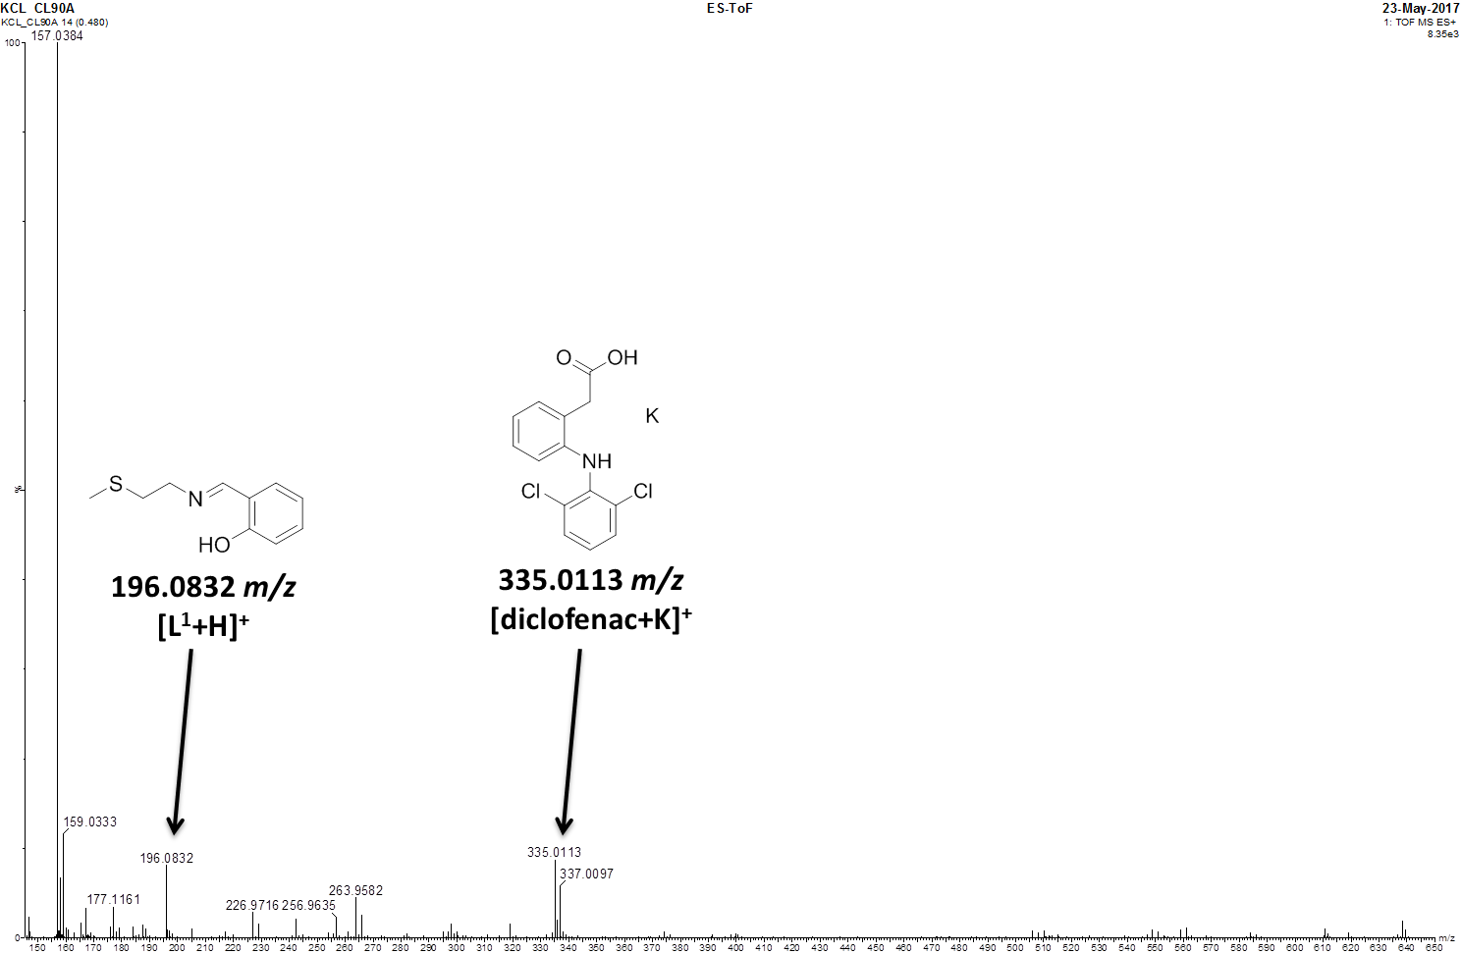

**Fig. S7.** ESI mass spectrum (positive mode, 150-650 *m/z*) of **1** (50 μM) in PBS (pH 7.4)/DMSO (200:1), in the presence of ascorbic acid (0.5 mM) after 24 h at 37 oC.

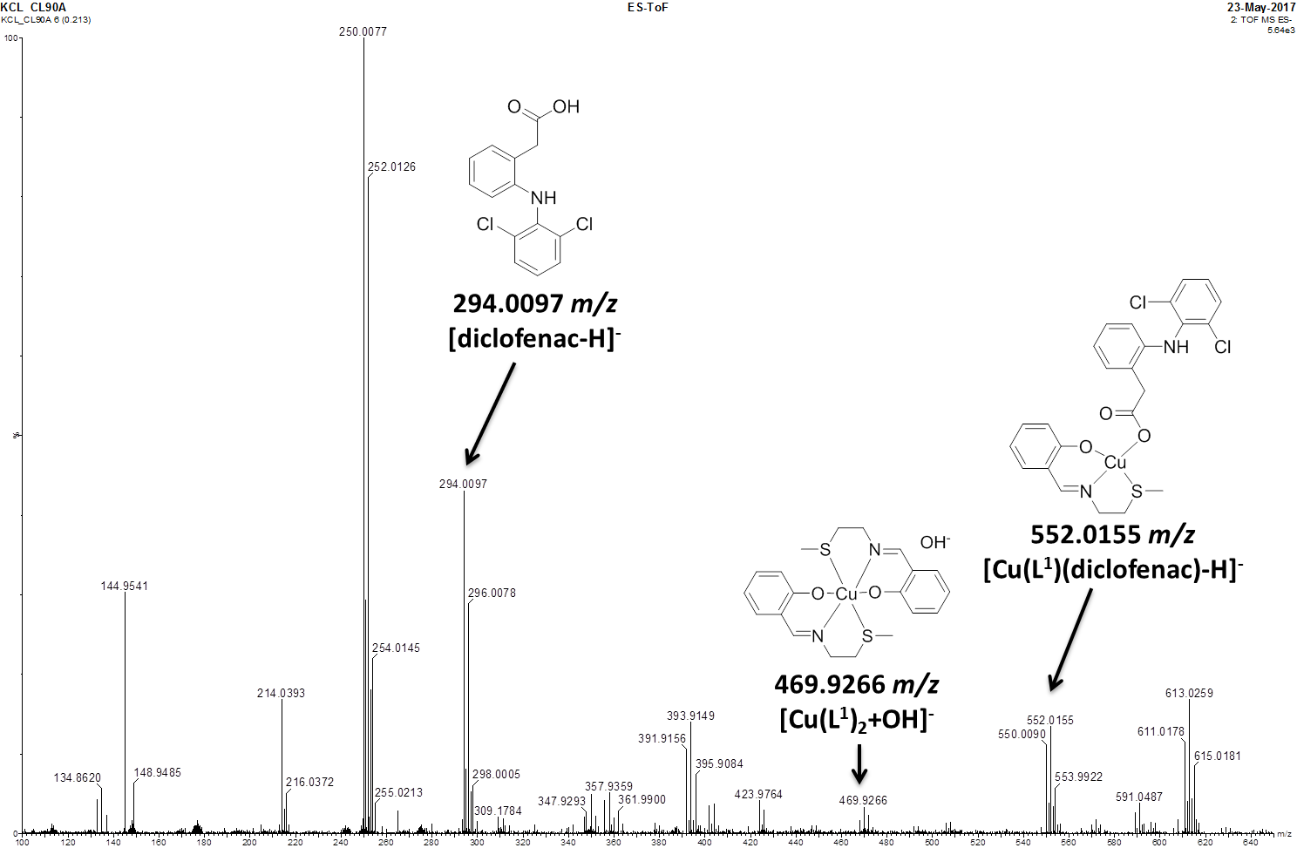

**Fig. S8.** ESI mass spectrum (negative mode, 100-650 *m/z*) of **1** (50 μM) in PBS (pH 7.4)/DMSO (200:1), in the presence of ascorbic acid (0.5 mM) after 24 h at 37 oC.

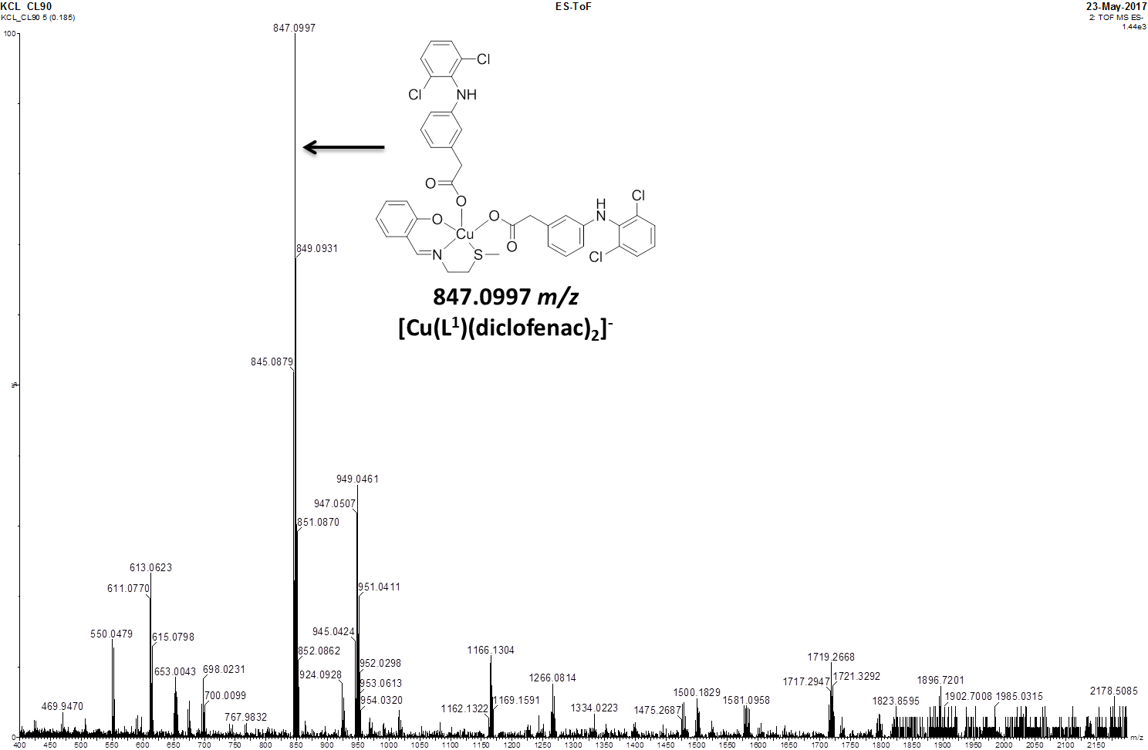

**Fig. S9.** ESI mass spectrum (negative mode, 400-2200 *m/z*) of **1** (50 μM) in PBS (pH 7.4)/DMSO (200:1), in the presence of ascorbic acid (0.5 mM) after 24 h at 37 oC.



**Fig. S10** UV-Vis spectrum of **1** (250 μM) in the presence of ascorbic acid (2.5 mM) in PBS (pH 7.4)/DMSO (95:5) over the course of 24 h at 37 oC.



**Fig. S11** UV-Vis spectrum of **1** (50 μM) in the presence of ascorbic acid (500 μM) and bathocuproine disulfonate, BCS (100 μM) in PBS (pH 7.4)/DMSO (200:1) over the course of 24 h at 37 oC.



**Fig. S12** Representative dose-response curves for the treatment of HMLER and HMLER-shEcad cells with **1** after 72 h incubation.



**Fig. S13** Representative dose-response curves for the treatment of HMLER and HMLER-shEcad cells with **2** after 72 h incubation.



**Fig. S14** Representative dose-response curves for the treatment of HMLER and HMLER-shEcad cells with **3** after 72 h incubation.



**Fig. S15** Representative dose-response curves for the treatment of HMLER and HMLER-shEcad cells with **4** after 72 h incubation.



**Fig. S16** Representative dose-response curves for the treatment of HMLER and HMLER-shEcad cells with diclofenac after 72 h incubation.



**Fig. S17** Representative dose-response curves for the treatment of HMLER and HMLER-shEcad cells with CuCl2 after 72 h incubation.



**Fig. S18** Representative dose-response curves for the treatment of HMLER and HMLER-shEcad cells with **1** pre-incubated with 10 equivalents of ascorbic acid for 24 h after 72 h incubation.

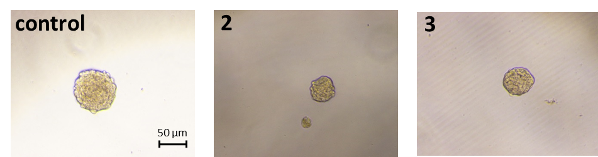

**Fig. S19** Representative bright-field images (× 10) of HMLER-shEcad mammospheres in the absence and presence of **2** and **3** at their respective IC20 values for 5 days.

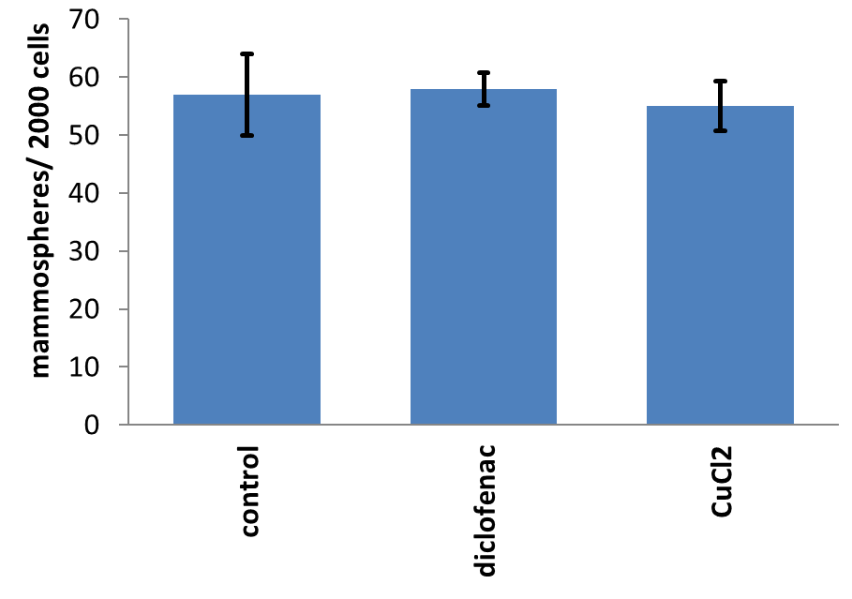

**Fig. S20** Quantification of mammosphere formation with HMLER-shEcad cells untreated and treated with diclofenac and CuCl2 at their respective IC20 values for 5 days.

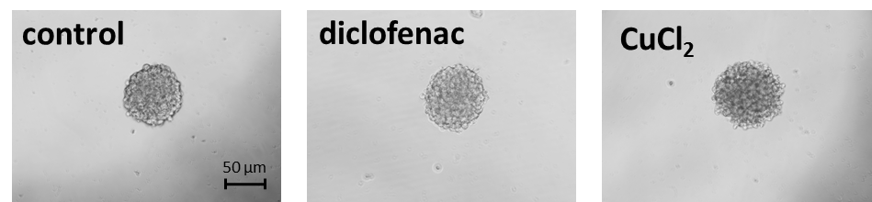

**Fig. S21** Representative bright-field images (× 10) of HMLER-shEcad mammospheres in the absence and presence of diclofenac and CuCl2 at their respective IC20 values for 5 days.



**Fig. S22** Representative dose-response curves for the treatment of HMLER-shEcad mammospheres with **1**-**3** and salinomycin after 5 days incubation.



**Fig. S23** Representative dose-response curves for the treatment of HMLER-shEcad mammospheres with diclofenac and CuCl2 after 5 days incubation.

**Table S3.** IC50 values of **1**-**3**, salinomycin, diclofenac, and CuCl2 against HMLER-shEcad mammospheres determined after 5 days incubation (mean of three independent experiments ± SD).

|  |  |
| --- | --- |
| Compound | Mammosphere  IC50 [μM] |
| **1** | 27.9 ± 1.3 |
| **2** | 62.5 ± 0.6 |
| **3** | 36.3 ± 0.5 |
| **diclofenac** | > 133.3 |
| **CuCl2** | > 133.3 |
| **salinomycin** | 18.5 ± 1.5 |

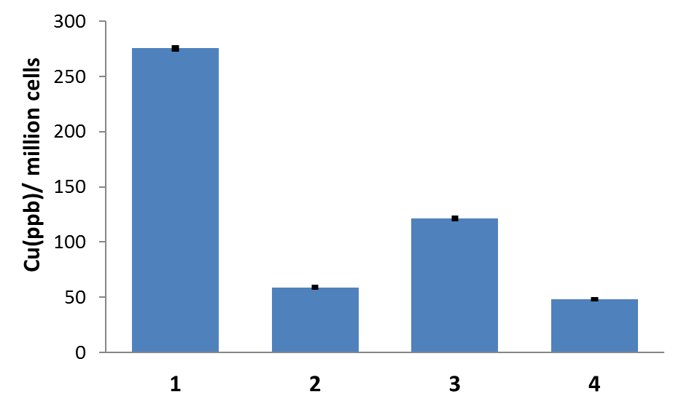

**Fig. S24** Copper content in HMLER cells treated with **1**-**4** (10 μM for 24 h).

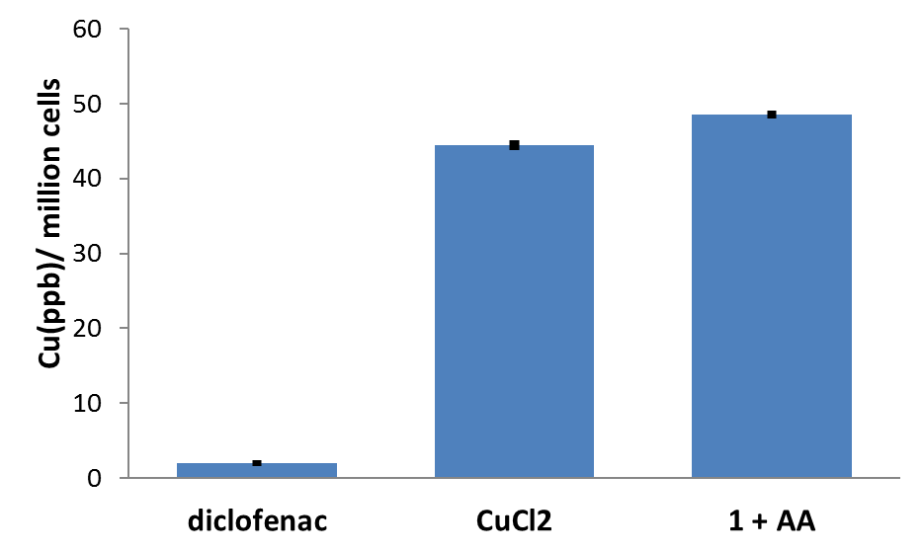

**Fig. S25** Copper content in HMLER-shEcad cells treated with diclofenac, CuCl2, and **1** pre-incubated with 10 equivalents of ascorbic acid for 24 h(10 μM for 24 h).

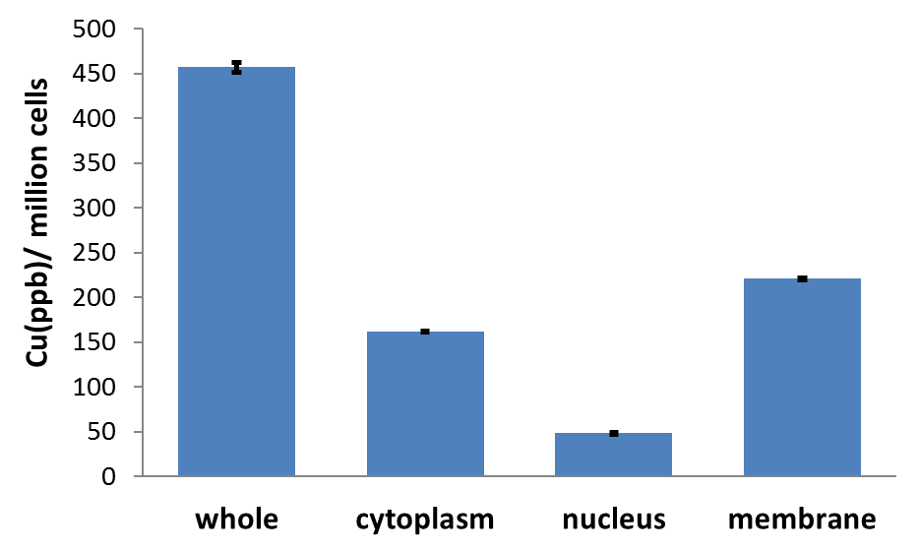

**Fig. S26** Copper content in whole cell, cytoplasm, and nucleus fractions isolated from HMLER-shEcad cells treated with **1** (10 µM for 24 h).

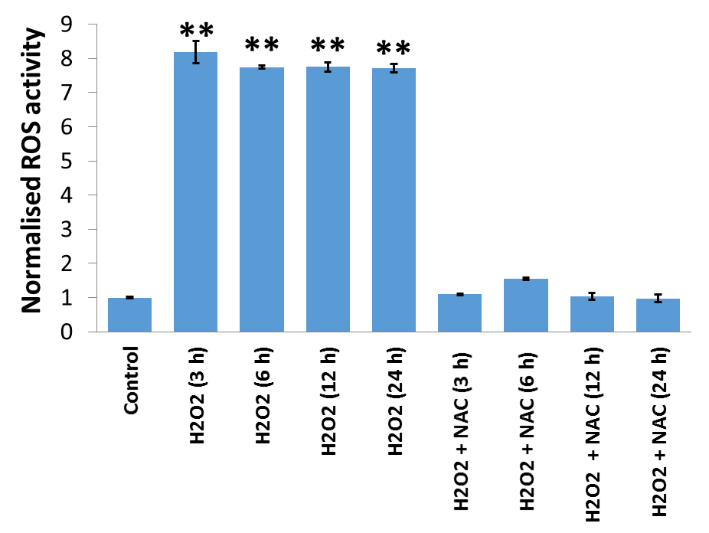

**Fig. S27** Normalised ROS activity in untreated HMLER-shEcad cells (control) and HMLER-shEcad cells treated with H2O2(150 µM for 3, 6, 12, and 24 h) and co-treated with H2O2 (150 µM for 3, 6, 12, and 24 h) and *N*-acetylcysteine (2.5 mM for 3, 6, 12, and 24 h). Error bars represent standard deviations and Student *t test*, ** = *p* < 0.01.



**Fig. S28** Representative dose-response curves for the treatment of HMLER-shEcad cells with

**1** after 72 incubation in the presence and absence of *N*-acetylcysteine (2.5 mM ).

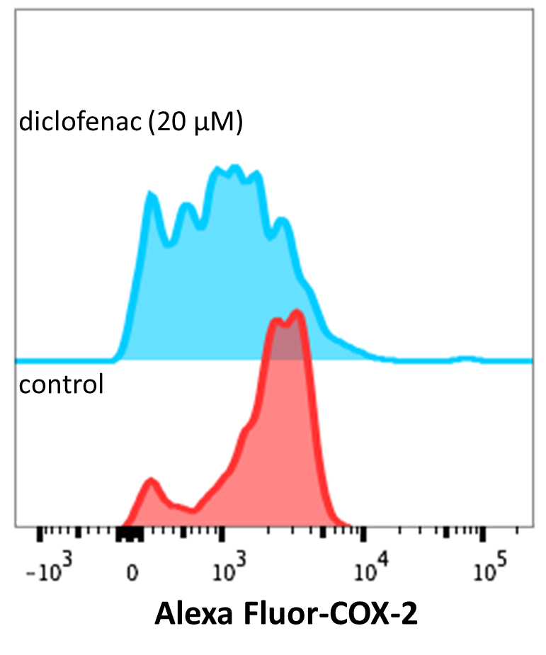

**Fig. S29** Representative histograms displaying the green fluorescence emitted by anti-COX-2 Alexa Fluor 488 nm antibody-stained HMLER-shEcad cells treated with LPS (2.5 μM) for 24 h (red) followed by 48 h in media containing diclofenac (20 μM, blue).

**References**

1. C. Lu, A. Eskandari, P. Cressey and K. Suntharalingam, *Chemistry*, 2017, DOI: 10.1002/chem.201701939.

2. G. Sheldrick, *Acta Cryst.*, 2008, **A64**, 112-122.