Life in the Roman Army

“We shall next examine whether the city or the country produces the best and most capable soldiers. No one, I imagine, can doubt that the peasants are the most fit to carry arms for they from their infancy have been exposed to all kinds of weather and have been brought up to the hardest labour. They are able to endure the greatest heat of the sun, are unacquainted with the use of baths, and are strangers to the other luxuries of life. They are simple, content with little, inured to all kinds of fatigue, and prepared in some measure for a military life by their continual employment in their country-work, in handling the spade, digging trenches and carrying burdens.

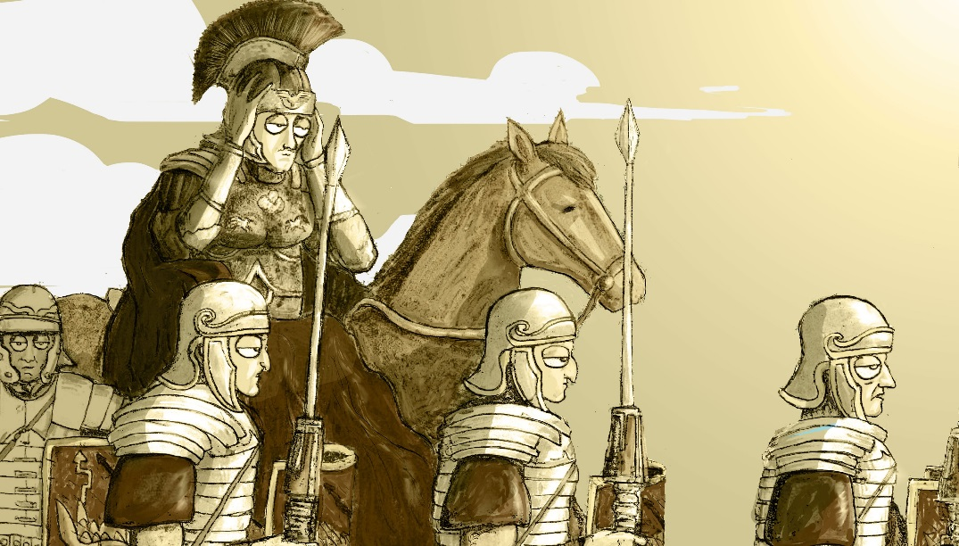
Design by Giacomo Savani

In cases of necessity, however, they are sometimes obliged to make levies in the cities. And these men, as soon as enlisted, should be taught to work on entrenchments, to march in ranks, to carry heavy burdens, and to bear the sun and dust. Their meals should be coarse and moderate; they should be accustomed to lie sometimes in the open air and sometimes in tents. After this, they should be instructed in the use of their arms. And if any long expedition is planned, they should be encamped as far as possible from the temptations of the city. By these precautions their minds, as well as their bodies, will properly be prepared for the service.”

Life in the Roman Army

“If we follow the ancient practice, the proper time for enlisting youth into the army is at their entrance into the age of puberty. At this time instructions of every kind are more quickly imbibed and more lastingly imprinted on the mind. Besides this, the indispensable military exercises of running and leaping must be acquired before the limbs are too much stiffened by age. For it is activity, improved by continual practice, which forms the useful and good soldier.

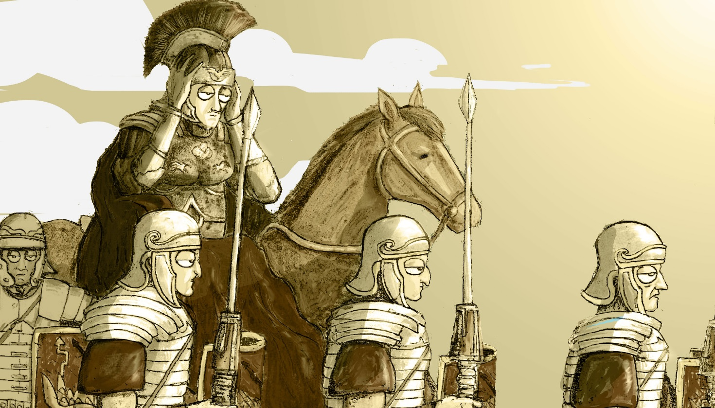
Design by Giacomo Savani

Those employed to superintend new levies should be particularly careful in examining the features of their faces, their eyes, and the make of their limbs, to enable them to form a true judgment and choose such as are most likely to prove good soldiers. For experience assures us that there are in men, as well as in horses and dogs, certain signs by which their virtues may be discovered. The young soldier, therefore, ought to have a lively eye, should carry his head erect, his chest should be broad, his shoulders muscular and brawny, his fingers long, his arms strong, his waist small, his shape easy, his legs and feet rather nervous than fleshy. When all these marks are found in a recruit, a little height may be dispensed with, since it is of much more importance that a soldier should be strong than tall.”

Life in the Roman Army

“The first thing the soldiers are to be taught is the military step, which can only be acquired by constant practice of marching quick and together. Nor is anything of more consequence either on the march or in the line than that they should keep their ranks with the greatest exactness. For troops who march in an irregular and disorderly manner are always in great danger of being defeated. They should march with the common military step twenty miles in five summer-hours, and with the full step, which is quicker, twenty-four miles in the same number of hours. If they exceed this pace, they no longer march but run, and no certain rate can be assigned.

Design by Giacomo Savani

Leaping is another very necessary exercise, to enable them to pass ditches or embarrassing eminences of any kind without trouble or difficulty. There is also another very material advantage to be derived from these exercises in time of action; for a soldier who advances with his javelin, running and leaping, dazzles the eyes of his adversary, strikes him with terror, and gives him the fatal stroke before he has time to put himself on his defence.”

