Lower Cretaceous pterosaurs from Colombia
Edwin-Alberto Cadena¹, David M. Unwin² and David M. Martill³
¹Universidad del Rosario, Facultad de Ciencias Naturales y Matemáticas, Grupo de Investigación en Paleontología Neotropical Tradicional y Molecular (PALEONEO), Bogotá, Colombia. edwin.cadena@urosario.edu.co
²School of Museum Studies, University of Leicester, University Road, Leicester, LE1 7RH, United Kingdom.
³School of the Environment, Geography and Geological Sciences, University of Portsmouth, Burnaby Road, PO1 3QL, United Kingdom.

ABSTRACT
The global fossil record of lowermost Cretaceous pterosaurs is meagre, and much of the material is fragmentary. Here we report three occurrences of pterosaurs from the Rosablanca Formation (Valanginian), the first records of this extinct group of flying reptiles from Colombia. Specimens from Zapatoca, Santander Department, consist of fragments of the left mandible and the proximal portion of a wing phalange. A third specimen, from Cundinamarca Department, is the proximal termination of a radius. Although fragmentary, these remains are clearly pterosaurian, on account of their remarkably thin bone walls and provide evidence of pterodactyloids, including a large non-pteranodontian ornithocheiroid, in the northernmost part of South America in the early Lower Cretaceous.
Keywords: Pterosauria, Ornithocheiroidea, South America, Colombia, Lower Cretaceous, Valanginian.

1. Introduction
Pterosaurs have a fossil record that is distinctly patchy, both in time and space. Relatively large numbers of taxa have been reported from the Upper Jurassic and the late Lower Cretaceous, intervals for which the record exhibits relatively high degrees of completeness at more inclusive taxonomic levels (Dean et al., 2016). By contrast, very few remains have been recovered from intervals such as the early Lower Cretaceous. Only six named taxa have been reported from the 12 million year long Berriasian-Valanginian interval (Witton et al., 2009; Rodrigues and Kellner, 2013; Rigal et al., 2017) and only five of the eleven principal clades known to have existed during these two stages are represented by fossils. This corresponds to one of the lowest rates of completeness for any part of the pterosaur fossil record (Dean et al., 2016).
Similarly, the geographic distribution of finds within the Berriasian-Valanginian is also highly uneven with essentially no records, to date, from Gondwanaland or North America, one from Morocco and a few from Europe and East Asia respectively (Barrett et al. 2008). Fossil material from this interval consists almost exclusively of isolated fragmentary bones, the one exception being Tatal in Western Mongolia, which has yielded several partial skeletons (Lü et al., 2009) alongside numerous well-preserved, isolated bones (Bakhurina, 1982; Bakhurina and Unwin, 1995). (We note there is some controversy over the age of these Mongolian strata, known as the Tsagaantsav Svita with some authors referring them to the ?Berriasian-Valanginian [see Unwin and Bakhurina 2000], while others prefer a younger age of Aptian to Albian [e.g. Lucas, 2006]. The marked incompleteness of the lowermost Cretaceous pterosaur fossil record, presumably a consequence of the lack of Konservat Lagerstätten deposits in this time interval, is in sharp contrast to well documented assemblages from the Upper Jurassic (e.g. plattenkalk sequences of Germany; Kimmeridge Clay of southern England) and mid Lower Cretaceous (e.g. Yixian and Jiufotang Formations of China; Crato limestone of Brazil).
Pterosaur assemblages from the Upper Jurassic, contain basal forms (rhamphorhynchids, anurognathids), basal monofenestratans and several pterodactyloid lineages (basal ctenochasmatoids, ctenochasmatids and basal dsungaripteroids). This assemblage is very different from that of the mid Lower Cretaceous, which is dominated by dentate (ornithocheirids, istiodactylids, ctenochasmatids, lonchodectids) and edentate forms (tapejarids and chaoyangopterids). Clearly, several important evolutionary events took place in the latest Jurassic-earliest Cretaceous, including the disappearance of many typical Jurassic clades (most notably all non-pterodactyloids) and the appearance of several important Cretaceous clades including the ornithocheiroids and azhdarchoids. The nature and timing of this transition remains poorly understood, however, in part because of the exceptionally poor fossil record for the Berriasian-Valanginian interval.
Here we describe new pterosaur material from the Lower Cretaceous Rosablanca Formation (Valanginian) of Colombia. Despite the abundant record of Lower Cretaceous vertebrates from Colombia (Cadena, 2015; Cadena and Gaffney, 2005; Cadena et al., 2013; Cadena and Parham, 2015; Carballido et al., 2015; Carrillo-Briceño et al., 2015; Páramo-Fonseca et al., 2016), pterosaurs have never been formally reported or described. Presently, the only potential record consists of a partial limb bone housed in the University of California Museum of Paleontology collections (UCMP 38367). This specimen was found by J. D. Macgregor from an unrecorded locality in Cundinamarca Department, but has never been described or published. Here we formally describe this specimen, UCMP 38367, and two new fossil occurrences of pterosaurs from Colombia, a partial lower jaw and a fragment of a wing phalange from Zapatoca, Santander Department. This new material adds to the meagre record of earliest Cretaceous pterosaurs, provides the first record of pterosaurs from the early Lower Cretaceous of South America and throws new light on pterosaur evolution during this interval.
1.1 Abbreviations used
AMNH, American Museum of Natural History; MB, Museum für Naturkunde, Berlin; NHMUK, Natural History Museum, London, UK; UCMP, University of California Museum of Paleontology, Berkeley, California, U.S.A.; UR CP, Paleontological Collection Universidad del Rosario, Bogotá, Colombia.

2. Material and methods
UCMP 38367 was collected by J.D. Macgregor in 1944 during fieldwork in Colombia, however it lacks precise geographical provenance data, only that it was collected from the Rosablanca Formation in Cundinamarca Department, Colombia. The two other specimens described here (UR CP 0002 and UC CP 0003), were found by the first author in 2017, during fieldwork in Zapatoca, Santander Department, Colombia (Fig. 1A), in different horizons of section I of the Rosablanca Formation (Guzman, 1985) (Fig. 1B). Specimens from Zapatoca were prepared with a mechanical airscribe tool and 5% HCl to remove excess carbonate rock matrix. Both specimens are housed at UR CP. All measurements are given in mm. The global Valanginian record shown in Fig. 1C was obtained from Paleobiology Database (fossilworks.org) using advanced tool options and palaeoreconstructions of continents at 135 Ma, adding the new records from Colombia described herein.

3. Locality and stratigraphy
The new specimens were recovered from the Lower Cretaceous Rosablanca Formation, an approximately 425 metre thick series of marine limestones, dolomites and shales (Wheeler, 1929). These strata crop out in the Altiplano Cundiboyacense, Eastern Ranges of the Colombian Andes and the Middle Magdalena Basin (Fig. 1). They are richly fossiliferous (molluscs, brachiopods and arthropods occur abundantly) and have been securely dated as Valanginian on the basis of ammonites, including the genera Acantholissonia, Lissonia and Raimondiceras (Gomez-Cruz et al., 2015).

4. Systematic palaeontology
Pterosauria Kaup, 1834
Pterodactyloidea Plieninger, 1901
Ornithocheiroidea Seeley, 1891
?Ornithocheiridae Seeley, 1870
Referred material. UR CP 0002 six fragments of the left mandibular ramus; UR CP 0003, fragment of the proximal part of a wing phalange.
Locality and horizon. El Caucho farm locality, Zapatoca, Santander Department, Colombia (6°49′31.2′′N, -73°15′9.43′W). Rosablanca Formation. The occurrence of the ammonite Saynoceras verrucosum (Fig. 1B) indicates the base of the upper Valanginian (Lower Cretaceous) dated at approximately 138 Ma according to the biochronostratigraphic framework of Ogg et. al., (2008).

Description
UR CP 0002. This specimen consists of a proximal portion of the left ramus of the mandible (Figs 2-3). It is broken into six pieces: four central pieces which fit together and two additional pieces, one from posterior to the four cojoined fragments and the other anterior to this set. As the broken surfaces of the anterior and posterior fragments do not match the corresponding surfaces of the cojoined set it is assumed that short intermediate portions of the mandible are missing (Figs 2A, B, G, H). The presence of all but the posterior termination of the Meckelian foramen shows that the six fragments represent a section of the mandible immediately anterior to, but lacking, the articular region (cf. Wellnhofer, 1985, fig. 5). Bones present in the preserved fragment are partially fused to one another, suggesting a degree of osteological maturity. Sutures remain, for example, between the dentary, the articular and the splenial, and allow bone contacts to be traced with some confidence.
The mandible was deep and narrow with a rounded ventral margin, a flatter dorsal margin and slightly dorso-ventrally convex lateral and concave medial surfaces. This portion of the mandibular ramus was slightly curved, seen in dorsal or ventral view, with a gentle anterior-posterior convexity of the lateral surface and correspondingly concave medial surface. The width of the ramus gently tapers anteriorly. In lateral, or medial view the ramus has a near straight ventral margin and a slightly convex dorsal margin, declining in height from 30.5 mm posteriorly to 24.3 mm anteriorly.
A deep, oval Meckelian foramen perforated the posterior portion of the medial surface of the mandible. The long axis of the opening is inclined from anterodorsal to posteroventral such that the anterior termination is level with the dorsal margin. Overall, the shape of the opening corresponds closely to that described for several ornithocheirids (e.g. Wellnhofer, 1985, fig. 5; Veldmeijer, 2003, fig. 4).
A ridge-like structure, present on the lateral surface of the jaw just below, and parallel to, the dorsal margin may represent a suture between the coronoid (dorsally) and the dentary (ventrally). The bone is poorly preserved on the dorsal margins of the medial surface, but faint traces of a ridge-like structure might indicate the contact between the coronoid and the splenial. If these interpretations are correct, the coronoid was a lath-like bone capping the posterior part of the dorsal surface of each mandibular ramus. On the medial surface of the anterior and cojoined fragments an antero-posteriorly trending suture someway below the dorsal margin of the mandible likely represents the contact between the splenial (below) and the dentary (above). A low antero-posteriorly oriented ridge running parallel to and a little above the ventral margin of the medial surface of the mandible would appear to mark the boundary between the angulare (below) and the splenial (above) (Fig. 2). The splenial formed much of the medial wall of the mandibular ramus (Fig. 2A,B), decreasing slightly in height anteriorly (Fig. 2A-L), while the elongate angulare formed the ventral margin of the ramus (Fig. 2E,F) (see Wellnhofer, 1985 for a comparator).
Well preserved portions of periosteal bone on the lateral surface of the mandible bear a series of fine (possibly vascular) anteroventrally directed grooves that branch along the length of the ramus (Fig. 3I, J). Elongate foramina pierce the medial surface adjacent to its ventral margin (Fig. 4) (cf. Wellnhofer, 1985, fig. 5e).
The total length of the preserved portion of the specimen, restored as in life, is estimated at 150 mm, although it is possible that the gaps between preserved fragments were larger than assumed here. Typically, in ornithocheirid pterosaurs, the length of the mandible is approximately fifteen times its depth just anterior to the articular region (based on seven examples; Frey et al., 2003; Veldmeijer, 2005). On this basis the mandible of UR CP 0002 is likely to have reached approximately 0.4 m in length, comparable in size to the mandible of Anhanguera santanae Wellnhofer, 1991 (AMNH 22555) which has an estimated wingspan of 4.0 m
UR CP 0003. This specimen is a proximal fragment of a ?right wing phalange (Fig. 5A-D). The periosteal bone has largely flaked away revealing the internal trabecular framework which has a lineation reflecting the long axis of the bone. The bone has an oval-shaped cross-section, the ventral profile being markedly more convex than that of the dorsal. In cross-section, both proximally and distally, the trabeculae occupy only the outer portion of the bone’s interior, resulting in a lumen that occupies approximately 80% of the bone interior. The lumen and trabeculae are filled with sediment, suggesting the bone was fragmented prior to burial, thus allowing the ingress of sediment. The fragment has a maximum length of 51 mm, a maximum width of 37.5 mm and a depth of 18 mm proximally and 13.2 mm distally.

Pterosauria Kaup, 1834
Pterodactyloidea Plieninger, 1901
Family indet.
Referred material. UCMP 38367, proximal portion of a radius.
Age and horizon. Rosablanca Formation. Late Valanginian (Early Cretaceous).
Locality. Unknown locality, Cundinamarca Department, Colombia.

Description.
UCMP 38367. This specimen consists of the proximal end of a left radius, identified on the basis of the near circular cross-sectional shape of the diaphysis and the distinctive shape of the articular surface (Fig. 5 E-I). The bone, exposed in posterior view, lies on a slab of buff coloured marly limestone, and displays a sharp break at the end of the slab revealing its near circular cross section, a partial geopetal sediment infill and an empty void in which can be seen a few trabeculae with a thin drusy ?calcite coating. The cross-section diameters are 9.5 mm x 8.4 mm. The bone wall is 0.36 mm thick. The maximum length of the specimen is 31.6 mm, and the width across the proximal articulation is 13.8 mm. Comparison with more complete remains (primarily azhdarchoid material from the Santana Formation of Brazil) suggests a wingspan within the range of 2-3 m.
The articular expansion consists of a sub-hemispherical ventral condyle that projects a little below the ventral margin of the shaft in anterior view. The ventral condyle is rounded and separated from a dorsal tubercle by a saddle-shaped excavation forming the cotylar surface that articulated with the radial condyle of the humerus. The dorsal tubercle is more angular in appearance than the ventral condyle and projects well above the dorsal margin of the shaft.
4.1 Taphonomy.
The material described here is fragmentary and largely lacks contextual data. From its general appearance it appears to have been weathered at the surface, resulting in surficial bone having fallen away to reveal internal moulds or the internal trabecular structure (e.g. Fig. 5A,B). The generally 3-D preservation of the material, and the infilling of void specimen with (presumably) early diagenetic calcite is comparable to pterosaur material from the slightly younger Santana Formation fossil Lagerstätte of north east Brazil (Martill, 2007). The Santana Formation pterosaurs occur within rounded carbonate concretions, that often reflect the general shape of the elements contained within. The block of matrix for specimen 38367 appears to have rounded margins on one side (the other side appears to be a break) suggesting that this specimen too is enclosed with a carbonate concretion (Fig. 5H,I). It is tempting the think that this new Colombian site may have similarities with the Santana Formation of Brazil and efforts should be made to obtain additional field data.
5. Discussion.
5.1 Affinities
Despite the highly fragmentary nature of the material described here, the remains can be confidently identified as pterosaurian based on the remarkable thinness of the cortical bone and the presence of large internal spaces (lumen) in the long bones and jaw fragment.

Comparison of the radius (UCMP 38367) with well-preserved examples for a range of pterosaurs including basal forms, basal monofenestratans and pterodactyloids suggests that the Colombian specimen is likely pterodactyloid. This assignment is supported by two features: the remarkably thin cortical bone, which tends to be relatively thicker in non-pterodactyloids (and dsungaripteroids) and the relatively robust construction of the proximal articulation, which tends to be much more flattened (antero-posteriorly) in non-pterodactyloids. The morphology of the articular region of the radius, most notably the well-developed somewhat angular dorsal tubercle of the radius, is quite unlike that of ornithocheiroids (e.g. Wellnhofer, 1985, fig. 19), but compares closely to that of azhdarchoids (e.g. Wellnhofer, 1985, figs 45f-i). However, a similar morphology is also present in some ctenochasmatoids (e.g. Pterodactylus sp. MB R 3657). At present therefore, it seems likely that UCMP 38367 is pterodactyloid, and possibly ctenochasmatoid, or azhdarchoid, but almost certainly not ornithocheiroid, or dsungaripteroid.

The jaw fragment (UR CP 0002) compares closely to the mandibles of Lower Cretaceous pterosaurs such as Anhanguera santanae (Wellnhofer, 1991) and is highly likely to be ornithocheirid. The mandible is preserved in several istiodactylids including Istiodactylus (Hooley, 1913) and Nurhachius (Wang et al., 2005; Zhou et al., 2019) and seems comparable in its general morphology to that of ornithocheirids. However, well preserved examples exhibiting the medial aspect of the mandible have yet to be described, precluding further comparison with UR CP 0002. The construction of the mandibular ramus of pteranodontians is markedly different from that of ornithocheirids or istiodactylids. Most notably the mandibular ramus rapidly deepens anterior to the articular region (e.g. Bennett, 2001, fig. 22; Frey et al.. 2006, fig. 4), quite unlike UR CP 0002 which, as in ornithocheirids and istiodactylids, remains of similar, or slightly decreasing, depth throughout its length.

The specimen identified as a partial wing phalanx (Fig. 5A-D) has a slightly flat oval cross section. Such a cross-sectional outline is typical for Ornithocheiroidea, whereas that for many azhdarchoids is sub-triangular or even T-shaped in cross-section (Martill and Frey, 1999).
5.2 Temporal and palaeobiogeographical implications
The new finds from Colombia add some important data to the meagre fossil record of early Lower Cretaceous pterosaurs and throw some light on pterosaur evolution in this interval. Although pterosaurs have been reported from the Jurassic and Cretaceous of South America (e.g. Barrett et al., 2008; Codorniú and Gasparini, 2013; Manzig et al., 2014; Codorniú et al., 2016; Ortiz et al., 2017; Perea et al., 2018; Kellner et al., 2019) these are the first finds from the early Lower Cretaceous of South America and, currently, the earliest records of pterosaurs from the northern half of South America.
These discoveries represent one of the earliest records for ornithocheiroids, predated only by an ornithocheirid mandible from the Purbeck Limestone (Tithonian-Berriasian) of England (Howse and Milner, 1995), and the earliest record of this clade in Gondwana.
The new finds are consistent with current understanding of pterosaur evolution. Ornithocheiroids have a fossil record that extends back to the start of the Cretaceous and, based on inferences from phylogenetic analyses (e.g. Zhou et al., 2017), originated in the Upper Jurassic, or possibly even earlier. The Colombian remains show that ornithocheirids achieved a wide, possibly global, distribution and large size early in the Cretaceous. Irrespective of whether the radius represents an azhdarchoid, or possibly a ctenochasmatoid, it is consistent with the known stratigraphic range of either group. Ctenochasmatoids are present in the Jurassic and Lower Cretaceous of South America (Perea et al., 2018), while the fossil record of azhdarchoids ranges from the Upper Jurassic to end Cretaceous (Averianov, 2010; Zhou et al., 2017).
Thus, the Colombian finds are consistent with, and further emphasise, two seemingly key features of pterosaur evolution in the latest Jurassic- earliest Cretaceous interval: (1) the absence of non-pterodactyloids; (2) The presence of widely distributed clades typical of the Early Cretaceous (e.g. ornithocheiroids) some species of which achieved relatively large size. This adds weight to the idea that the replacement of typical Late Jurassic pterosaur assemblages, by typical Early Cretaceous assemblages happened quite rapidly in the late Tithonian–early Berriasian.
6. Conclusions
New bone material from the Lower Cretaceous Rosablanca Formation is identified as fragmentary pterosaur jaw and wing elements on account of its thin bone wall and general morphology. The parallel sided mandibular dorsal and ventral margins and the suture of the splenial compare well with the same elements in ornithocheirid pterosaurs, and contrast with the situation seen on Cretaceous non-ornithocheirids such as azhdarchoids and dsungaripteroids. We are able therefore to assign the Colombian mandible to Ornithocheiridae. The material is confidently dated as Valanginian using biostratigraphically significant ammonite taxa. Although fragmentary, the new material represents the first occurrence of Pterosauria in Colombia, and suggests that further field work may discover better and more complete material.

Acknowledgments
We thank P. Holroyd (UCMP, Berkeley, California) for high-resolution photos of CMP 36387. Thanks also to Sandra Chapman and Lorna Steel (NHMUK) for access to specimens in their care. We are especially grateful to Alexander Averianov and an anonymous reviewer, both of whom greatly improved the manuscript.

References
Averianov, A.O., 2010. The osteology of Azhdarcho lancicollis Nessov, 1984 (Pterosauria, Azhdarchidae) from the Late Cretaceous of Uzbekistan. Proceedings of the Zoological Institute RAS, 314(3), 264-317.
Bakhurina, N.N., 1982. A pterodactyl from the Lower Cretaceous of Mongolia. Palaeontologicheskii Zhurnal 4, 104-108. [In Russian]
Bakhurina, N.N., Unwin, D.M., 1995. A survey of pterosaurs from the Jurassic and Cretaceous of the former Soviet Union and Mongolia. Historical Biology, 10, 197-245.
Barrett, P.M., Butler, R.J., Edwards, N.P., Milner, A.R., 2008 Pterosaur distribution in time and space: an atlas. Zitteliana B 28, 61–107.
Bennett, S.C., 2001. The osteology and functional morphology of the Late Cretaceous pterosaur Pteranodon. Palaeontographica Abteilung A, 260, 1-153.
Cadena, E.A., 2015. The first South American sandownid turtle from the Lower Cretaceous of Colombia. PeerJ 1431, 1-25.
Cadena, E.A., Gaffney, E.S., 2005. Notoemys zapatocaensis, a new side-necked turtle (Pleurodira: Platychelyidae) from the Early Cretaceous of Colombia. American Museum Novitates 3470, 1-12.
Cadena, E.A., Jaramillo, C.A., Bloch, J.I., 2013. New material of the platychelyid turtle Notoemys zapatocaensis from the Early Cretaceous of Colombia; implications for understanding Pleurodira evolution. 105-120 In, Brinkman, D.B., Holroyd, P.A., Gardner, J.D., (eds.), Morphology and Evolution of Turtles. Springer, Dordrecht.
Cadena, E.A., Parham, J.F., 2015. Oldest known marine turtle? A new protostegid from the Lower Cretaceous of Colombia. PaleoBios 32, 1-45.
Carballido, J.L., Pol, D., Parra-Ruge, M.L., Padilla-Bernal, S., Páramo-Fonseca, M.E., Etayo-Serna, F., 2015. A new Early Cretaceous brachiosaurid (Dinosauria, Neosauropoda) from northwestern Gondwana (Villa de Leiva, Colombia). Journal of Vertebrate Paleontology 35, 1-12.
Carrillo-Briceño, J.D., Cadena, E.A., Dececchi, A.T., Larson, H.C.E., Du, T.Y., 2015. First record of a hybodont shark (Chondrichthyes: Hybodontiformes) from the Lower Cretaceous of Colombia. Neotropical Biodiversity 2, 81-86.
Codorniú, L., Gasparini, Z., 2013. The Late Jurassic pterosaurs from northern Patagonia, Argentina. Earth and Environmental Science Transactions of the Royal Society of Edinburgh. doi:10.1017/S1755691013000388
Codorniú, L., Paulina-Carabajal, A., Pol, D., Unwin, D.M., Rauhut, O.W.M., 2016. A Jurassic pterosaur from Patagonia and the origin of the pterodactyloid neurocranium. PeerJ 4: e2311. doi:10.7717/peerj.2311.
Dean, C.D., Mannion, P.D., Butler, R. J., 2016. Preservational bias controls the fossil record of pterosaurs. Palaeontology 59, 1-23.
Frey, E., Martill, D.M., Buchy, M.-C., 2003. A new crested ornithocheirid from the Lower Cretaceous of northeast Brazil and the unusual death of an unusual pterosaur. In: Buffetaut, E., Mazin, J.-M. (eds), Evolution and Palaeobiology of Pterosaurs. Geological Society of London, Special Publication, 217, 55-64.
Frey, E., Buchy, M.-C., Stinnesbeck, W., González, A.G., Stefano, A., 2006. Muzquizopteryx coahuilensis n.g., n. sp., a nyctosaurid pterosaur with soft tissue preservation from the Coniaician (Late Cretaceous) of northeast Mexico) (Coahuila). Oryctos 6, 19-40.
Gómez-Cruz, A. de J., Bermudez, H.D., Vega, F.J., 2015. A new species of Diaulax Bell, 1863 (Brachyura: Dialucidae) in the Early Cretaceous of the Rosablanca Formation, Colombia. Boletín de la Sociedad Geológica Mexicana 67(1), 103-112.
Guzman, G., 1985. Los Grifeidos infracretacicos Aetostreon couloni y Ceratrostreon boussingaulti, de la Formación Rosablanca, como indicadores de oscilaciones marinas [Lower Cretaceous ostreids Aetostreon couloni and Ceratrostreon boussingaulti of the Rosablanca Formation, as indicators of marine fluctuations]. 1-16 In, Etayo-Serna, F., (ed.), Proyecto Cretácico. Ingeominas, Bogotá.
Hooley, R.W., 1913. On the skeleton of Ornithodesmus latidens; an ornithosaur from the Wealden Shales of Atherfield (Isle of Wight). Quarterly Journal of the Geological Society of London, 69, 372-420.
Howse, S.C.B., Milner, A.R., 1995. The pterodactyloids from the Purbeck Limestone Formation of Dorset. Bulletin of the Natural History Museum, London (Geology Series) 51(1), 73-88.
Kaup, J.J., 1834. Versuch einer Eintheilung der Saugethiere in 6 Stamme und der Amphibien in 6 Ordnungen. Isis 3, 311e315.
Kellner, A.W.A., Weinschütz, L.C., Holgado, B., Bantim, R.A., Sayão, J.M., 2019. A new toothless pterosaur (Pterodactyloidea) from Southern Brazil with insights into the paleoecology of a Cretaceous desert". Anais da Academia Brasileira de Ciências. 91 (suppl 2): e20190768. doi:10.1590/0001-3765201920190768.
Lü, J., Azuma, Y., Dong, Z., Barsbold, R., Kobayashi, Y., Lee, Y.-N., 2009. New material of dsungaripterid pterosaurs (Pterosauria: Pterodactyloidea) from western Mongolia and its palaeoecological implications. Geological Magazine 146(5) 690-700.
Lucas, S.G., 2006. The Psittacosaurus biochron, Early Cretaceous of Asia. Cretaceous Research 27(2), 189-198.
Manzig, P.C., Kellner, A.W.A., Weinschütz, L.C., Fragoso, C.E., Vega, C.S., Guimarães, G.B., Godoy, L.C., Liccardo, A., Ricetti, J.H.C., Moura, C.C., 2014. Discovery of a rare pterosaur bone bed in a Cretaceous desert with insights on ontogeny and behavior of flying Reptiles. PLoS ONE 9 (8), e100005. doi:10.1371/journal.pone.0100005
Martill, D.M., 2007. The age of the Cretaceous Santana Formation fossil Konservat Lagerstätte of north-east Brazil: a historical review and an appraisal of the biochronostratigraphic utility of its palaeobiota. Cretaceous Research 28(6), 895-920.
Martill, D.M., Frey, E., 1999. A possible azhdarchid pterosaur from the Crato Formation (Early Cretaceous, Aptian) of northeast Brazil. Geologie en Mijnbouw 78, 315-318.
Ogg, J.G., Ogg, G., Gradstein, F., 2008. The concise Geologic Time Scale. Cambridge University Press, Cambridge.
Ortiz, D.L.D., González Riga, B.J., Kellner, A.W.A., 2017 Discovery of the largest pterosaur from South America, Cretaceous Research (2017), doi: 10.1016/j.cretres.2017.10.004.
Páramo-Fonseca, M.E., Gómez-Pérez, M., Noé, L.F., Etayo-Serna, F., 2016. Stenorhynchosaurus munozi, gen. et sp. nov. a new pliosaurid from the Upper Barremian (Lower Cretaceous) of Villa de Leiva, Colombia, South America. Revista de la Academía Colombiana de Ciencias Exactas, Físicas, y Naturales 40, 84-103.
Perea, D., Soto, M., Toriño, P., Mesa, V., Maisey, J., 2018. A Late Jurassic-?earliest Cretaceous ctenochasmatid (Pterosauria, Pterodactyloidea): the first report of pterosaurs from Uruguay. Journal of South American Earth Sciences 85, 298-306.
Plieninger, F., 1901. Beiträge zur Kenntnis der Flugsaurier. Palaeontographica 48, 65-90.
Rigal, S., Martill, D.M., Sweetman, S.C., 2017. A new pterosaur specimen from the Upper Tunbridge Wells Sand Formation (Cretaceous, Valanginian) of southern England and a review of Lonchodectes sagittirostris (Owen 1874). Geological Society, London, Special Publications 455(1), 221-232.
Rodrigues, T., Kellner, A.W.A., 2013. Taxonomic review of the Ornithocheirus complex (Pterosauria) from the Cretaceous of England. ZooKeys 308, 1-112.
Seeley, H.G., 1870. The Ornithosauria: an elementary study of the bones of pterodactyles, made from fossil remains found in the Cambridge Upper Greensand, and arranged in the Woodwardian Museum of the University of Cambridge. xii + 135 pp., Deighton, Bell and Co., Cambridge.
Seeley, H.G., 1891. On the shoulder girdle in Cretaceous Ornithosauria. Annals and Magazine of Natural History 6, 438-445.
Unwin, D.M., Bakhurina, N.N., 2000. Pterosaurs from Russia, Middle Asia and Mongolia. The age of dinosaurs in Russia and Mongolia, p.420.
Veldmeijer, A J., 2003. Coloborhynchus spielbergi sp. nov. (Pterodactyloidea) from the Albian (Lower Cretaceous) of Brazil. Scripta Geologica, 125, 35–139.
Veldmeijer, A.J., Signore, M., Meijer, H.J.M., 2005 Description of two pterosaur (Pterodactyloidea) mandibles from the lower Cretaceous Santana Formation, Brazil - DEINSEA 11: 67-86 [ISSN 0923-9308].
Wang, X., Kellner A.W.A., Zhou, Z., Campos, D.A., 2005. Pterosaur diversity and faunal turnover in Cretaceous terrestrial ecosystems in China. Nature 437, 875-879.
Wellnhofer, P., 1985. Neue Pterosaurier aus der Santana Formation (Apt) der Chapada do Araripe, Brasilien. Palaeontographica A 187, 105-182.
Wellnhofer, P., 1991. Weitere Pterosaurierfunde aus der Santana-Formation (Apt) der Chapada do Araripe, Brasilien. Palaeontographica A, 215, 43-101.
Wheeler, O.C., 1929. Report on the Palmira Series with notes on the stratigraphy of the Umir, Lisama and La Paz formations near the Eastern part of De Mares Concession. Internal Report Empresa Colombiana de Petroleos. Unpublished.
Witton, M.P., Martill, D.M., Green, M., 2009. On pterodactyloid diversity in the British Wealden (Lower Cretaceous) and a reappraisal of “Palaeornis” cliftii Mantell, 1844. Cretaceous Research 30, 676-686.
Zhou, C.F., Gao, K.Q., Yi, H., Xue, J., Li, Q., Fox, R.C., 2017. Earliest filter-feeding pterosaur from the Jurassic of China and ecological evolution of Pterodactyloidea. Royal Society Open Science 4, 160672.
Zhou, X., Pêgas, R.V., Leal, M.E.C., Bonde, N., 2019. Nurhachius luei, a new istiodactylid pterosaur (Pterosauria, Pterodactyloidea) from the Early Cretaceous Jiufotang Formation of Chaoyang City, Liaoning Province (China) and comments on the Istiodactylidae. PeerJ 7:e7688 DOI 10.7717/peerj.7688.

FIGURE CAPTIONS
Fig. 1. Locality and stratigraphic data for the new Colombian pterosaur material. A, locality maps showing the location of Colombia within South America, the locality of Santander Department and the locality of Zapotaca and Bucaramanga. B, stratigraphic log for the Rosablanca Formation and its age, with the index ammonite Saynoceras verucossum depicted. C, Map showing the distribution of Valanginian pterosaurs. The circular image depicts an exposure of the Rosablanca Formation near Zapatoca.
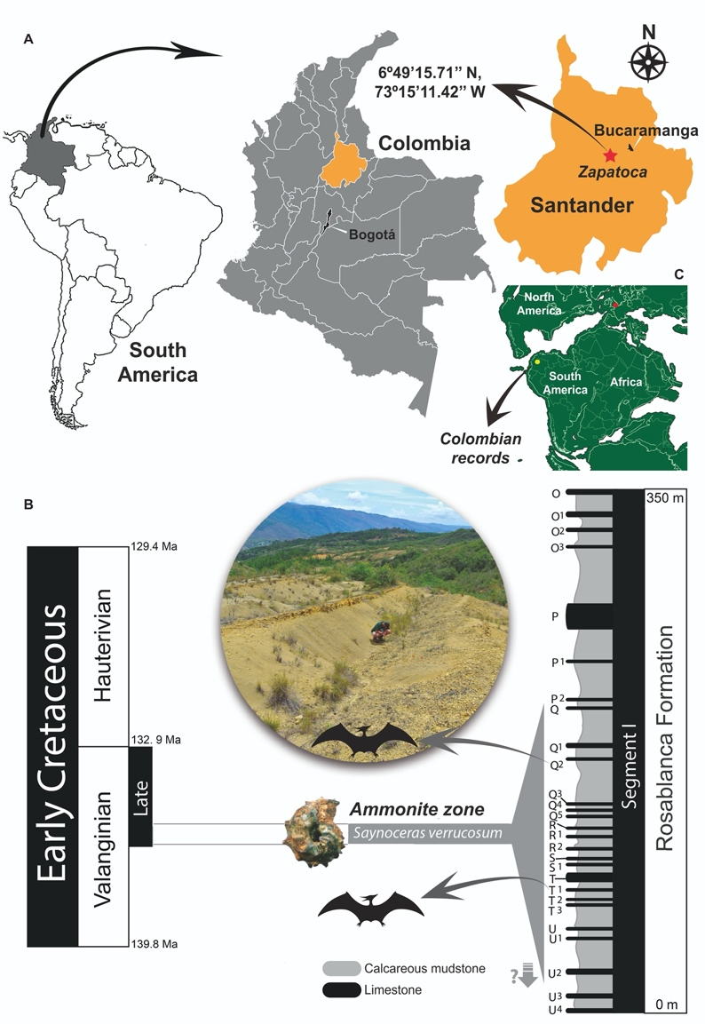
Fig. 2. Photographs and interpretive drawings of Colombian pterosaur specimen UR CP 0002. A,B, posterior left ramus of mandible in left lateral view; C,D, left ramus of mandible in occlusal view; E,F, left ramus of mandible in ventral view; G,H, left ramus of mandible in right medial view. Abbreviations used. co, coronoid; d, dentary, sp. splenial.
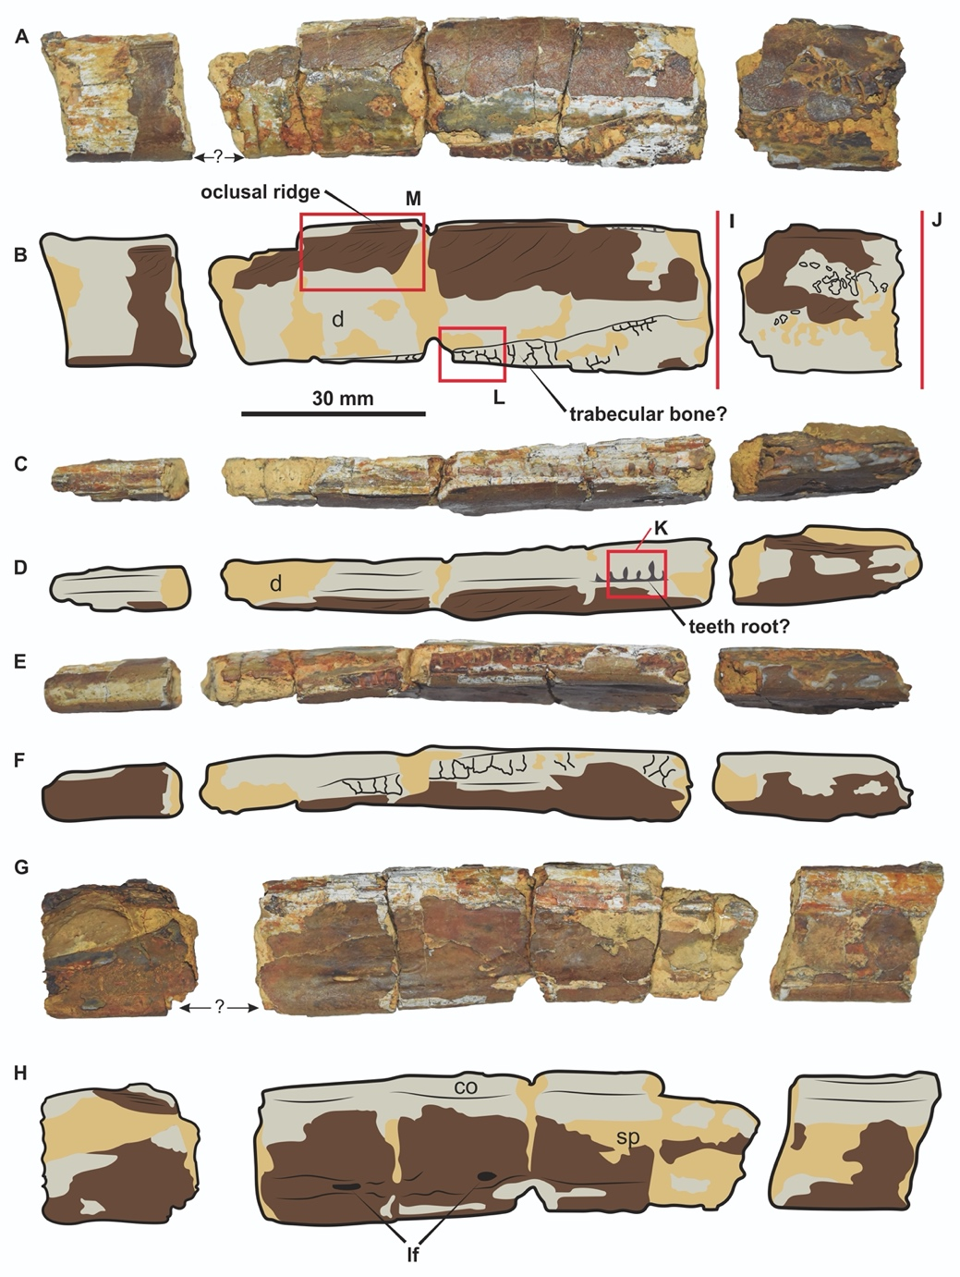

Fig. 3. Posterior left ramus of mandible UR CP 0002 in right medial view showing the adductor fossa (A,B), and the outline in cross section (C,D). Details of the internal trabeculae are visible where periosteal bone has flaked away (F-H) and fine grooving of the external bone surface is seen in I and J.
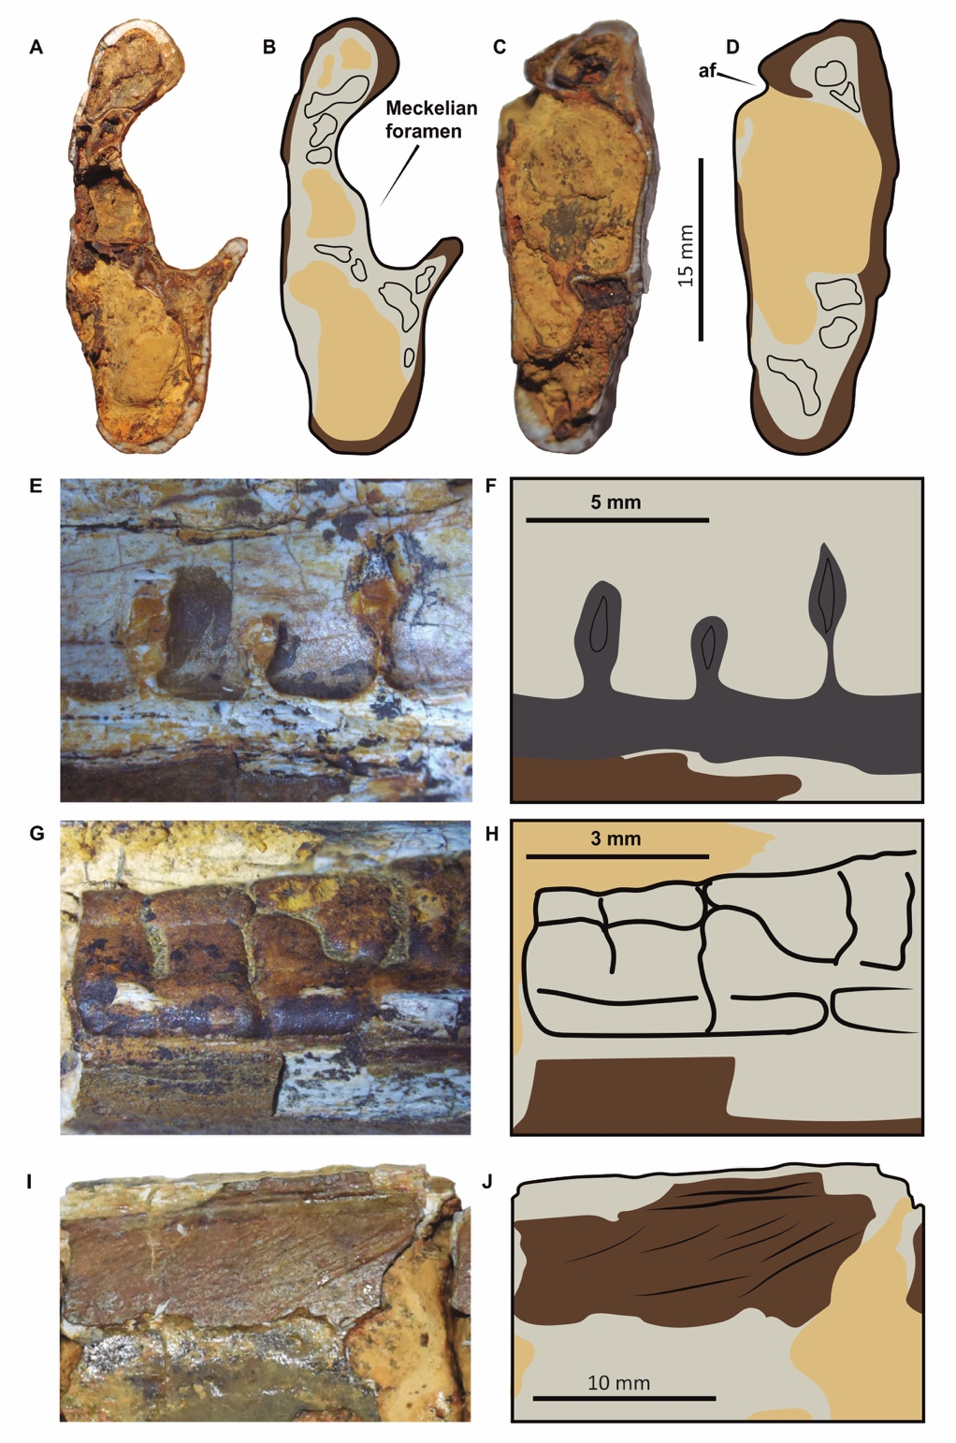
Fig. 4. Fragment of jaw ramus showing slit-like and oval foramina (arrowed) similar to those seen in some Azhdarchoidea.
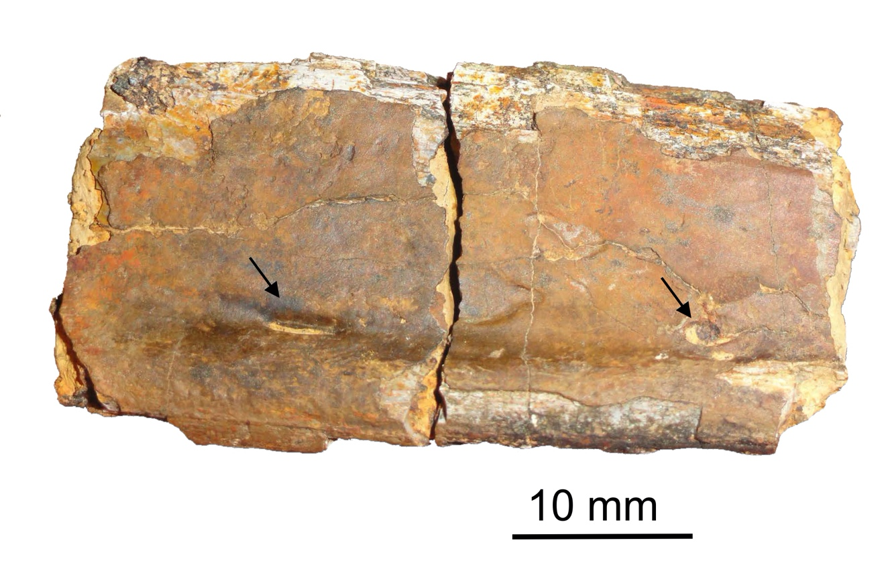

Fig. 5. Fragment of wing phalanx UR CP 0003, A, D, identified as ?Ornithocheiroidea on account of the cross sectional outline (C,D) of flat oval. We have assumed the wider end to be the proximal end, but note that some phalanges do expand slightly distally. E-I proximal end of long bone UCMP V4426/38367, here interpreted as a radius on account of the nearly circular cross-sectional outline and the rapid flaring of the proximal articulatory end.
