Could regional electrogram desynchronization identified using mean phase coherence be potential ablation targets in persistent atrial fibrillation?
Xin Li, Bharat Sidhu, Tiago P Almeida, Mahmoud Ehnesh, Amar R Mistry, Zakariyya Vali, Vivetha Pooranachandran, Gavin S Chu, Peter J Stafford, Fernando S Schlindwein, G André Ng
Background:
It remains controversial as to whether rotors detected using phase mapping during persistent atrial fibrillation (persAF) represent main drivers of the underlying mechanism as others found rotors to be located near line of conduction block. Regional electrogram desynchronization (RED) has been suggested as successful targets for persAF ablation, but automatic tools and quantitative measures are lacking.
Purpose:
We aim to use mean phase coherence (MPC) to automatically identify RED regions during persAF. This method was compared with phase singularity density (PSD) maps.
Methods:
Patients undergoing left atrial (LA) persAF ablation were enrolled (n=10). 2048-channel virtual electrograms (VEGMs) were collected from each patient using non-contact mapping (St Jude Velocity System, Ensite Array) for 10 seconds. To remove far field ventricular activities, QRS onset and T wave end locations were detected from ECG lead I (Figure 1A) and only the VEGM segments from T end to QRS onset were included in the analysis. VEGMs were reconstructed using sinusoidal wavelets fitting and the phase of VEGMs determined using Hilbert transform. Phase singularities (PS) were detected using the topological charge method and repetitive PSD maps were generated. RED was defined as the average of MPC of each node against direct neighbouring nodes on the 3D mesh (Figure 1A-B). Linear regression analysis was used to compare the average MPC vs. PSD and vs. the standard deviation of MPC (MPC_SD).
Results: A total of 221,184 VEGM segments were analysed with mean duration of 364.2 milliseconds. MPC has shown the ability to quantify the level of synchronisation between VEGMs (Figure 1B). Inverse correlation was found between PSD and average MPC values for all 10 patients (p<0.0001, Figure 1C). Average MPC and MPC_SD were found to be inversely correlated (p<0.0001, Figure 1C). Spatially, similar graphic patterns can be found from LA MPC maps and PSD maps for all patients (Figure 1D).
Conclusion: We have proposed a method to quantify the level of synchronisation between VEGMs. Phase density mapping showed a considerable agreement with RED regions reflecting regional conducting delays, which supports the previous finding where rotors found at conduction block. Inverse correlation between local average MPC and MPC_SD suggests that conduction delays of the identified regions are not heterogenous, posing directional preferences. Rather than solely looking for rotational activities, this method could identify comprehensive RED regions, which may also explain the conflicting results from different studies targeting rotational activities, where incomplete subsets of RED regions could have been targeted. Atrial RED regions can easily be identified with simultaneously collected electrograms from multi-polar catheters and should be targeted in future persAF studies.

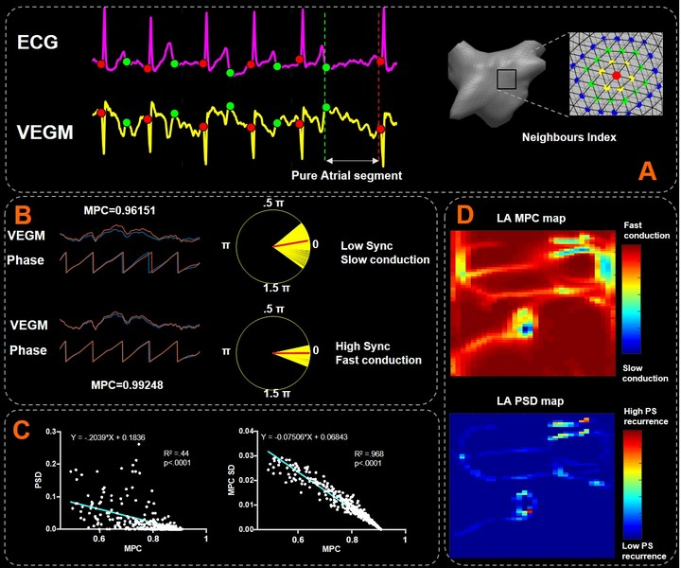
Figure 1. A. Left: QRS onset and T wave end detected from ECG for finding pure atrial segments, Right: neighbours indexing from 3D triangular mesh for calculation local average MPC; B. An example of MPC quantifying the level of synchronisation of two VEGMs; C. Left: the scatter plot and linear regression of average MPC and PSD values, Right: the scatter plot and linear regression of average MPC and MPC_SD values; D. An example of LA MPC and PSD maps, where slow conduction region was correlated with rotor core region.

$$MPC=\left|\frac{1}{N}\sum_{j=1}^{N}{e^{i\left[ϕ_{x}\left(t_{j}\right)-ϕ_{y}\left(t_{j}\right)\right]}}\right|$$

