**3-D Printed Polyvinyl Alcohol Matrix for Detection of Airborne Pathogens in Respiratory Bacterial Infections**

**Alaa Al Taie1, 5*,Xiaoxiao Han2, Caroline Williams3, Mohamad Abdulwhhab3, Andrew P. Abbott4, Alex Goddard4, Malgorzata Wegrzyn3, Natalie J. Garton3, Michael R. Barer3 and Jingzhe Pan1.**

1 School of Engineering, University of Leicester, Leicester, LE1 7RH, UK.

2State Key Laboratory of Advanced Design and Manufacturing for Vehicle Body, Hunan University, China, 410082.

3 Department of Respiratory Sciences, University of Leicester, Leicester, UK.

4 Department of Chemistry, University of Leicester, Leicester LE1 7RH, UK.

5 Department of Biomedical Engineering, College of Engineering, Al-Nahrain University, Baghdad, Iraq.

**\***E-mail:[alualtˍ1982@yahoo.com](mailto:alualt_1982@yahoo.com)

**Keywords: 3D printing, PVA, *Mycobacterium*, Sampling matrix.**

**Abstract**

Novel sampling matrices were manufactured using 3D printing for the detection of respiratory pathogens in expired air. A specific configuration of the matrices was designed using Computer-Aided Design software. Polyvinyl alcohol (PVA) was printed using fused deposition modelling to create a multilayer matrix to enhance the capture of bacteria. The performance of these matrices was compared with gelatine filters that have been used for this work to date. PVA matrices (60 mm diameter) were contaminated with bacteria either by direct inoculation, or by aerosol exposure using an Omron A3 nebuliser. Rough and smooth morphotypesof *Mycobacterium abscessus, M. smegmatis* and *M. bovis* BCG, were used in this study to contaminate the matrices. PVA matrices and gelatine sampling filters were contaminated to compare recovery rates for quantitative analyses. These were dissolved in water, bacteria pelleted and DNA extracted followed by a *Mycobacterium*-specific quantitative Polymerase Chain Reaction (qPCR).The results showed that 3D printed PVA matrices are very effective to capture the bacteria. 3D printed PVA matrix and gelatine filters yielded results of the same order of magnitude for mycobacterial analyses, however, PVA matrix offers several advantages over the latter material. 3D printed PVA is considered as an economic and time-effective matrix as it is cheaper than gelatine filters. PVA is sufficiently robust to be handled and loaded into the surgical masks for sampling, compared to the brittle gelatine filters that required supportive frames. PVA is a synthetic material and it is suitable for DNA-based analyses, whilst gelatine is derived from animal collagen, and carries a high bacterial DNA background that interferes with the target DNA analysis. Furthermore, PVA dissolves in distilled water without requiring chemicals or enzymes, such as the case for gelatine hydrolysis. To summarise, 3D printed PVA sampling matrix is considered a promising tool used for microbiological diagnostic purposes.

# 1. Introduction

Traditionally, diagnoses of pulmonary bacterial infections such as tuberculosis (TB) are approached by X-rays, supported by taking sputum and culture samples. Recently, several epidemiological studies have demonstrated that sputum positivity for *Mycobacterium tuberculosis* is not linked to transmission [1]. Furthermore, molecular detection from bioaerosols in untreated patients with TB was shown to be more sensitive than mycobacterial cultures on solid media [2]. In this work, a new technology – an alternative sampling matrix within a pathogen entrapment mask – is assessed for potential use in detecting pulmonary bacterial infections. Fused deposition modelling (FDM) is used to 3D printed water-soluble matrices of polyvinyl alcohol (PVA), which are then used to collect the mycobacteria. The matrices are fabricated using FDM by extruding a filament of PVA through a heated nozzle and depositing this onto a plate; the plate then lowers to allow the deposition of the subsequent layer [3, 4]. FDM technology is the most common type of the material extrusion-based Additive Manufacturing (AM) as it has been used in different industries and in various fields [3, 5]. In the biomedical field, 3D printing has been applied to develop different medical devices using metals [6, 7] and biopolymers [8]. Computer Aided Design (CAD) software is used to create the required designs for tissue engineering scaffolds [9-12], drug delivery [4, 13], surgical models and prosthetics [14, 15]. By using FDM printers, scaffolds and complex designs can be produced [16]. In this case, FDM can be used to print membranes, these can then be used for biological diagnostic purposes.

In microbiology, some mycobacterial, *e.g. Mycobacterium tuberculosis,* and viral infections are transmitted via air, from one host to another, via inhalation of droplet nuclei. Particles aerosolized by breathing, sneezing, talking, coughing, singing and other activities have different sizes, where infectious droplet nuclei of TB bacilli are 1-5 µm in size [17]. Previous research on sampling airborne viruses has studied the collection efficiency of different types of filters such as cotton filters [18], cellulose filters with a 0.45 µm pore size [19], PTFE filters with 3, 1, 0.5 and 0.3 µm pore sizes, polycarbonate filters with 3, 1 and 0.4 µm pore sizes and gelatine filters with a 3 µm pore size [20]. These types of filters differ from each other by pore size, thickness and composition. Many studies have found that gelatine filters show good collection efficiency for hydrophilic viruses as they preserve the infectivity of virus aerosols [21]; however, they may be unsuitable for the collection of bacteria with sensitive strain as dehydration stress increases when the filter is dried during sampling [22]. Williams *et al* [1] used FFP30 face masks adapted with gelatine filters to detect *M. tuberculosis*. Successful detection in TB patients was demonstrated in this instance. However, the small filter size used, necessary owing to its fragility, limited the study. Gelatine filters can be degraded as a result of the breathing environment during sampling. Furthermore, gelatine is not free of microbial DNA as it is derived from animal collagen, and such background interferes with the targeted bacterial DNA analyses [23]. All these disadvantages suggest a requirement for the fabrication of new sampling matrices (SM) using alternative materials. In this case, polymers are more amenable to down-stream processing and analysis, can be printed layer by layer to create a robust matrix that can be used for capturing bacteria such as *M. tuberculosis*. This can be considered an important medical sampling device for use in diagnosis and research of exhaled microorganisms.

PVA is considered a promising material for use in cell entrapment as it does not have any harmful effects on cells [24]. PVA cryogel has been used as matrix for cell immobilization as it is not brittle [25]. In addition, the extension of *Escherichia coli* within PVA scaffold microstructure has been studied using fluorescence microscopy and impedance measurements, demonstrating microbial compatibility [26]. In the same way, scaffolds have been used for immobilizing growth factor for tissue engineering [27]. Recenty, the developed PVA matrices described in this work have been successfully used by our research group to screen patients for *M. tuberculosis* output by face mask sampling [28]. The purpose of this paper is to demonstrate that a 3D-printed PVA matrix represents a highly effective material for entrapment of pathogens. This work includes: (i) the design of sampling matrices using CAD software; (ii) printing models using the new candidate (PVA) polymer via FDM; (iii) fulfilling the specific requirements of the desired ductility and dissolvability (one-hour maximum) for the new matrices; (iv) examination of the recovery rate of mycobacterial16S target DNA copies from the matrices via real-time qPCR, which are contaminated either by being inoculated directly with mycobacterial suspension or exposed to mycobacterial aerosols via nebulisation; and (v) improvement the design of PVA matrices in order to increase the mycobacterial DNA recovery.

# 2. Materials and Characterisation Methods

Commercially available soluble filaments of PVA (Orbi-Tech®, Germany) were purchased from Kühling & Kühling. This is a natural product, and sold with a dimension of Ø2.85 ± 0.1 mm. Distilled water (DNase/RNase-Free) and tris-base (Thermo Fisher Scientific, UK), Lysing matrix B (MP-Biomedicals, UK), ethylenediamine tetraacetic acid (EDTA) and Chelex® 100 sodium (Sigma Aldrich, UK), octyl phenoxypolyethoxylethanol- 40(NP-40) (Bio Basic Inc., Canada), gelatine-filters (pore size 3 µm) (Sartorius Stedim Biotech GmbH, Germany), and collagenase A (COLLA-RO Roche, Sigma, UK (REF 10103578001)).

PVA matrix was dissolved in distilled water, the solution centrifuged and the bacteria pelleted. This was followed by DNA extraction of resultant pellets using a bead-beating technique. An additional centrifugation step was applied to collect bacterial DNA required for the downstream molecular analysis via the qPCR technique. An illustrative diagram of the processing steps is given in Fig.1. All steps will be detailed in relevant sections.

The original PVA filament was treated with ultraviolet (UV) light in the range of 300 nm to 480 nm of a ProCure™ 350 UV Chamber (3D Systems Corporation, USA) to reduce the viscosity of the PVA solution. The treatment was optimised at 4 hours. The PVA filament was dried at 75°C in the oven (Gallenkamp, UK) for 4 hours. The viscosity of the UV-treated and untreated PVA filaments was measured using a Brookfield DV-E Viscometer (Brookfield Instruments, USA) (Fig.S1).

The 3D models of the sampling matrices were designed using the SolidWorks 2015 software (SolidWorks Corporation, USA). These were exported as files in the STL (.stl) format into the 3D printer software Cura, 15.04.2 (Ultimaker BV, The Netherlands). The fill density was set to 100% in order to create a dense structure. The printer settings were optimised as follows: print speed, 30 mm/s; travel speed, 150 mm/s; layer height, 0.08 mm for matrices of 0.25 mm thickness, and 0.04 mm for others of 0.15 mm thickness; extrusion temperature, 210°C; and platform temperature, 60°C. FFP1 face masks (Moldex 2380 Smart FFP1 Non-valved respirator, Scientific Laboratory Supplies, UK) were adapted for the previous gelatine filters and the PVA matrix developed ( Fig.2). The 3D printed samples of the circular disc (Fig.3A) were developed by designing four side patches for the stickers having dimension of 21 × 12 mm (Fig.3B). The development of 3D printed circular matrix inside the face mask is shown in (Fig.3C). The stickers can be discarded after sampling. The 3D printed strips (including bridges to facilitate handling), 3D printed face mask were printed as shown in (Fig.S2 A and B) and the development of 3D printed matrices for different face masks, including the plastic masks is shown (Fig.S2C and D respectively). Optical profilometry (Zeta Instruments, Zeta-2000, California, USA), as controlled by the Zeta3D version 1.8.5 software, was used to measure the PVA matrix roughness (Table S1). Theta Lite Optical tensiometer (Biolin Scientific, UK) was used to measure the surface wettability (Table S2). The structure of 3D printed PVA samples with the 0.25 mm thickness was examined using a Nikon XT H 225 with a tungsten filament, and Varian detector 2520Dx with a 127 µm pixel size. Philips XL 30 scanning electron microscope (SEM) (Thermo Fisher Scientific, Netherlands), with an accelerating voltage of 20 kV, was used to examine the top and bottom matrix surfaces (Supplementary Section.5). The micrograph of the 3D printed PVA matrix, as recorded using a Nikon Eclipse MA200 microscope (Nikon Metrology NV, Europe), using 5X magnification lens is shown in (Fig.S3).

# 3. Biological Examination of PVA Material

To examine the efficiency of the PVA matrix developed for mycobacterial DNA detection, the matrices were either directly inoculated with bacterial suspensions or contaminated via aerosol exposure using an Omron A3 nebuliser (Omron, UK). Four sets of experiments have been performed to validate the efficiency of the bacterial recovery rate of these matrices, where each experiment was conducted in triplicate to examine its repeatability, as follows:

### Experiment 1: Recovery Percentages of PVA Matrices of Different Microorganisms (Direct Inoculation)

This refers to step 1 of Fig.1. Three sets of PVA matrices of 60 mm diameter and 0.25 mm thickness were treated with 1J/cm2 UV using Stratalinker UV (Stratagene, USA) prior to spiking with mycobacterial cells for sterilisation. A certain mycobacterial species was used to inoculate each set. PVA matrices were spiked with 100 µl *M. bovis* BCG and *M. abscessus* rough and smooth morphotype broth cultures at exponential phase (optical density (OD): 0.7 at wavelength of 580 nm [29] and 600 nm [30] for BCG and *M. abscessus*, respectively). The samples were left in a plastic Petri dish for 2 hours at room temperature to completely dry alongside a blank/unspiked PVA matrix (negative control). Positive controls consisted of distilled water at the same volume used to dissolve the PVA matrix, inoculated with the same volume of inoculum used to spike the PVA matrix.

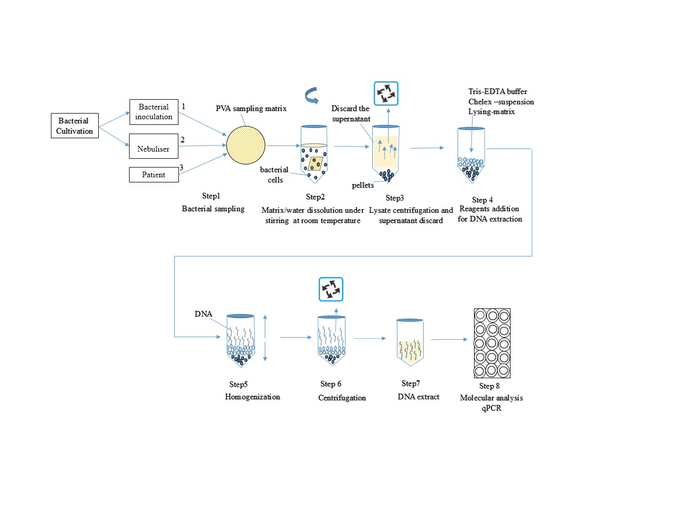

Fig.1. Schematic diagram of sampling process, further matrix analysis and subsequent DNA quantification.

|  |
| --- |
|  |

Fig.2. Face masks adapted with gelatine filter (left) and PVA matrix (right).

|  |
| --- |
| A  B C |

Fig.3. PVA sampling matrix of 60 mm diameter and 0.25 mm thickness (A), 60 mm diameter circular PVA matrix with stickers of (21 ×12 mm) (B) circular matrix with stickers loaded in FFP1 (C).

### Experiment 2: Comparison between PVA Matrices and Gelatine Filters (Direct Inoculation)

This refers to step 1 of Fig.1. Two sets of gelatine filters and circular PVA matrices (0.25 mm thick and 60 mm diameter) were inoculated with 100 µl of early mid-exponential *M. bovis* BCG broth culture (OD580: 0.4). All spiked samples were left at room temperature to dry alongside blank/unspiked PVA and gelatine samples (negative controls). In addition, DNA was extracted from the BCG inoculum (100 µl). All samples were treated with 1J/cm2 of UV using Stratalinker UV (Stratagene, USA) prior to spiking with mycobacterial cells for sterilisation.

### Experiment 3: Comparison between PVA matrices and gelatine filters (Nebulisation)

This refers to step 1 of Fig.1. An Omron A3 complete nebuliser was used to generate a mycobacterial aerosol for contaminating a half gelatine filter and half 3D printed PVA matrix (0.25 mm thick) deposited on a metallic holder (60 mm) and sealed via a metallic ring using pins, as shown in Fig.4A. The samples were fixed to the centre of a self-standing plastic board (50 cm x 40 cm) inside a sealed autoclave bag (78 cm x 62 cm), as shown in Fig.4B. Based on measurements from the centre of the plastic board, a circular hole was cut into the autoclave bag to fit the nebuliser outlet. The bag was heat-sealed using a sealer. The nebulisation setting of the nebuliser was set at position 1. The droplet size generated at this position is described by the manufacturer to be 10 µm. The nebuliser nozzle was inserted into the bag and sealed with tape. The impeller was placed in the reservoir, containing the bacterial suspension, and this was connected to the nozzle. The reservoir was then attached to a clamp. The tube from the nebuliser compressor was attached to the reservoir base. The nozzle was aligned with the centre of the targeted matrices and fixed in position 20 cm away from the plastic board. 10 ml of *M. abscessus* (smooth morphotype) broth culture (original OD600: 0.85) was used and the nebuliser was activated for 10 minutes to generate aerosols. A second hole was made at the right corner of the autoclave bag near the base of the board and a syringe with a plunger was inserted and sealed using a plastic cable tie. A 0.22 µm filter was connected to the syringe, which was attached to a vacuum pump to allow the aerosol to be withdrawn from the autoclave bag at the end of the experiment. All matrix samples were treated with 1J/cm2 of UV using Stratalinker UV (Stratagene, USA) prior to nebulisation for sterilisation. DNA of *M. abscessus* inoculum (1 ml) was extracted from pre- and post-nebulisation reservoir suspension. Blank unexposed matrix samples (negative controls) were examined using both gelatine filters and PVA matrices. This study was performed in triplicate to ensure its repeatability.

A

|  |
| --- |
|  |
| B |

Fig.4. The setup of half-3D printed PVA matrix and half- gelatine filter on a metallic holder (60 mm)(A).The nebulisation system setup illustrating all parts and devices used in nebulisation process (B).

### Experiment 4: Matrix Design Improvement on the Recovery Efficiency (Nebulisation)

*M. smegmatis* with an original OD580 of 0.8 in liquid culture was used to contaminate two semicircular half-matrices (one of 0.25 mm and other of 0.15 mm in thickness) placed on the metallic holder, as described in Experiment 3 (Nebulisation). The matrix dissolution was performed for each matrix with an optimised amount of distilled water, and the DNA extraction and molecular analysis were performed. This study was performed in triplicate to ensure its repeatability.

## 3.1 Dissolution of Matrices

This process refers to steps 2 and 3 of Fig.1. PVA matrices of 0.25 mm thickness were dissolved in 8 ml, and matrices of 0.15 mm thickness dissolved in 5 ml of distilled water in polypropylene centrifuge tubes (50 ml) using a magnetic stirrer for 1 hour at room temperature. To harvest bacterial pellets, aliquots of the solutions were centrifuged in 2ml screw-capped tubes at 21,100xg using a Fresco 21 Thermo Scientific centrifuge for 10 minutes, with discard of the supernatant. This was repeated to collect the bacterial pellet from one dissolved matrix sample into a single tube. This protocol was optimised in this study and the centrifugation force of 21,100xg was selected as compared with other ranges of forces. One way ANOVA followed by Tukey’s multiple comparisons results showed that there was no significant difference between the yield at any of the tested g forces used for centrifugation (P value between each pairs of forces was > 0.05) for both 0.25 mm and 0.15 mm thickness samples (Table S3). For gelatine filter digestion, 1900 µl of 50 µg/ml collagenase in buffer [50 mM *N*-tris-methyl-2-aminoethanesulfonic acid (TES), 0.36 mM calcium chloride, pH7.4] was used in 40 ml crystallizing dishes (Fisher Scientific, UK), and was incubated for 15 minutes on a hot-plate at 37oC. The solutions were then transferred to 2 ml screw-capped tubes and centrifuged at 15,000xg for 10 minutes, after which the supernatant was discarded [23].

## 3.2 DNA Extraction

This process refers to steps 4, 5 and 6 of Fig.1. The bacterial pellets from experiments 1, 2, 3 and 4 underwent DNA extraction using bead-beating technique. 100 µl of tris-EDTA (20 mM tris base, 2 mM EDTA, pH8), 100 µl of Chelex-suspension (50% w/v Chelex-100, 1% w/v Nonidet P-40, 1% w/v Tween 20), and 0.25 g of lysing matrix B were added to each sample. A RiboLyser (Hybaid, USA) was used to homogenize the samples for 45 seconds at 6.5 m/sec. The samples were then incubated in ice for 2 minutes. The homogenization and ice incubation processes were repeated four times in total. PVA samples were then centrifuged at 21,100xg, and the gelatine samples at 15,000xg for 2 minutes. The supernatant from each sample was used for the quantitative analysis.

## 3.3 Real-Time PCR Data Analysis

This refers to step 7 and 8 of Fig.1. Experiments 1, 2, 3 and 4 were analysed using qPCR. The DNA extracts were quantitatively analysed using a mycobacterial-specific 16S- assay. The method was adapted from Cheah *et al* [31]. PCR mixture (25 μl) contained: 12.5 µl SYBR-Green (SensiFAST SYBR No-ROX Kit, BIOLINE, UK), 1 µl (10 µM) each of MYCO16SF-forward (5'-GAAACTGGGTCTAATACCG-3') and MYCO16SR-reverse (5'-ATCTCAGTCCCAGTGTGG-3') primers (Integrated DNA Technologies, UK), 1 µl of DNA template and 9.5 µl of molecular-grade water. Cycling conditions were: 56°C for 2 minutes, 95°C for 15 minutes, 40 cycles at 95°C for 30 seconds, 65°C for 30 seconds, 72°C for 20 seconds and 82°C for 20 seconds with the acquisition on the FAM/Green channel (470 nm). The melting conditions were 59oC to 99oC, pre-melt 5 seconds. Distilled water was used as a negative control for amplification. The cycle threshold (Ct) was automatically set by the Rotor-Gene Q Series software. All samples were assayed in triplicate. Runs with correlation coefficients (R2) above 0.98 and replicates with less than 1 difference in cycle threshold (Ct) were considered acceptable [32]. *M. tuberculosis* H37Rv and HN878 genomic DNA was used to prepare genome copy number standards for the first two experiments, and the other two experiments, respectively. The lower limit of detection was 102 MYCO16S copies per PCR reaction.

## 3.4 Fluorescence Microscope Examination

A growing culture (OD580:0.5) of *M. bovis* BCG transformed with pMSP12::dsRed 2 [33] and expressing the red-fluorescing ds-Red protein was used in this experiment. An Omron A3 nebuliser was used to generate bacterial aerosol, for 10 minutes at a distance of 20 cm directly from the nozzle of the nebuliser to the 3D printed PVA matrix inside a sealed autoclave bag as described in Experiment 3 (Nebulisation). The exposed PVA matrix absorbed water during the nebulisation process. When that matrix dried, the bacteria trapped within the matrix. Bacteria within the matrix were viewed by epifluorescence microscopy using a Nikon Ti Eclipse microscope and mercury halide light source and a 49008 (excitation 560 ± 20 nm; emission: 630 ± 37.5 nm, Chroma Technology) ﬁlter set. Images were recorded with a DS-Qi1Mc Digital Monochrome Cooled Camera using NIS Elements (Nikon Instruments Ltd) software.

## 3.5 Statistical Analysis

Statistical analyses were performed using GraphPad Prism (version 7) (GraphPad Software, Inc., CA). Two-tailed unpaired t-test, two-tailed unpaired t-test with Welch’s correction and one way ANOVA followed by Tukey’s multiple comparisons test were used for statistical analysis of the PVA-gelatine comparison and PVA recovery evaluations. A probability value less than 0.05 was considered statistically significant. All data presented as mean ± standard deviation.

# 4. Results

## 4.1Physical and Chemical Characteristics of PVA Matrices Suggest Potential as a Sampling Matrix for Capture and Recovery of Exhaled Bacteria.

Configurations of 3D-printed PVA matrices of two different thicknesses (0.15mm and 0.25mm) suitable for placement as sampling matrices in face masks were designed. These PVA matrices were characterised for surface topography (roughness (Table S1) and porosity (Supplementary Section.5), wettability (Table S2) and viscosity of aqueous solutions (Fig.S1)). The topological profile of peaks and troughs and numerous small pores indicates the presence of a high surface area for adherence of bacteria. PVA water solubility would provide a more direct means of recovery by centrifugation than that previously used for gelatine filters [1]. Therefore, these PVA matrices were considered suitable for further testing and performance comparison against gelatine filters.

## 4.2 Real Time PCR Analysis

The quantitative assessment of bacterial recovery from the matrices on test was achieved via the qPCR analysis of different organisms. The results found for all experiments are as follows:

### Experiment 1: Mycobacteria can be Recovered from PVA Matrices

In this experiment, DNA recovery from the PVA matrix was compared with DNA recovery from the equivalent volume of inoculum spiked into the equivalent volume of water used for PVA matrix dissolution. The detected mycobacterial-specific 16S DNA copies/ µl for different microorganisms are shown in Fig.5. The DNA recovery from the PVA matrix for *M. bovis* BCG, rough and smooth *M. abscessus* was compared with DNA recovery from the directly spiked aqueous suspension for each set. For each organism, recovery and detection of 16S DNA from the PVA matrix and the control water suspension in were of the same order of magnitude. Recovery from water inoculated with *M. bovis* BCG was 1.13-fold higher than that from the PVA matrix (Fig.5). However, an unpaired t-test with Welch’s correction showed that this difference was not significant (P > 0.05). The percentage recovery of *M. bovis* BCG DNA from PVA, (defined as a percentage of calculated yield from PVA with respect to water suspension used for inoculation), was found to be 95± 34%.

Interestingly, the DNA recovery from the PVA sample inoculated with the rough *M. abscessus* morphotype was 2.86-fold higher than that from the water suspension (P < 0.0001), whereas, the DNA recovery from the water inoculated with the smooth *M. abscessus* morphotype, was 2.29-fold higher than that of PVA (P < 0.0001) (Fig.5). The percentage recovery of 16S DNA by the PVA matrix inoculated with rough *M. absces*sus was 288 ± 29% compared with 46 ± 11% for the smooth morphotype.

|  |
| --- |
| Fig.5. Quantitative assessment (qPCR) of the 16S DNA recovery from PVA matrices, made of 0.25 mm thickness, and water suspension for different microorganisms. All results are described as means ± standard deviation (SD) of three experiments, each including three technical replicates. ns – Difference not statistically significant. **** = P < 0.0001 according to unpaired t-test with Welch’s correction. The DNA detection in all blank matrices was below the limit of detection, which is 102 copies per PCR reaction. |

### Experiment 2: Recovery and Detection of Mycobacteria from PVA Matrices and Gelatine Filters Following Direct Inoculation is Comparable

In order to compare the efficiency of mycobacterial recovery from PVA matrices and gelatine filters, equivalent amounts of BCG were used to spike each. The 16S DNA detected as a marker of recovery from PVA matrices and gelatine filters is shown in Table1. Recovery from the gelatine filter was 1.03 fold greater than that recovered by the PVA matrix, an unpaired t-test showed that this was a significant difference (P = 0.0040). Mycobacterial 16S DNA detection from blank, unspiked PVA matrices and gelatine filter controls was below the limit of detection (102 MYCO16S copies per PCR reaction).

Table 1. Recovery of BCG from spiked PVA matrix and gelatine filters determined by 16S DNA analysis. Data are presented as mean ±SD of three experiments, each including three technical replicates.

|  |  |
| --- | --- |
| **Sample** | **Detected *16S rDNA* (log10 copies/µl)**  **Mean ± SD** |
| PVA | 5.13 ± 0.06 |
| Gelatine | 5.28 ± 0.11 |

### Experiment 3: Recovery and Detection of Mycobacteria from PVA Matrices and Gelatine Filters Following Exposure to Nebulised Bacterial Suspension is Comparable

To directly compare the efficiency of the PVA matrices and gelatine filters for capture of mycobacterial aerosol, these were exposed to a nebulised suspension of *M. absesscus* smooth morphotype. The 16S DNA detected for recovered bacteria from both the PVA matrices and gelatine filters was of the same order of magnitude (Fig.6). Recovery from the gelatine filter was 1.06 fold greater than that recovered by the PVA matrix (unpaired t-test shows P = 0.0042).

### Experiment 4: Reducing the Thickness of the PVA Matrix Improves Recovery and Detection of Mycobacteria

In order to improve recovery and detection of captured microorganisms by the PVA matrices, the performance of a PVA matrix with reduced thickness (0.15mm compared with the originally tested matrix of 0.25mm thickness) was assessed following exposure to nebulisation (Fig.7). Based on the reduction in viscosity (Fig.S1), and to decrease the time required for subsequent processing after the sampling process, the volume of water used to dissolve the PVA matrix with a 0.15 mm thickness was 5 ml, instead of the 8 ml used for the PVA matrix with a 0.25 mm thickness. The recovery of bacterial DNA using the PVA with 0.15 mm matrix thickness, was 2.13-fold greater than that recovered by the PVA with 0.25 mm thickness (P value < 0.0001).

|  |
| --- |
|  |

Fig.6. Mycobacterial recovery and detection following exposure of PVA matrices and gelatine filters to nebulised suspensions of mycobacteria. Quantitative assessment (16S DNA qPCR) of bacterial recovery from PVA matrices and gelatine filters exposed to a nebulised suspension of a smooth *M. abscessus* morphotype. All results are described as mean ± standard deviation (SD) of three experiments, each including three technical replicates. Assessments of blank, unexposed PVA matrices and gelatine filters were below than the limit of detection (102 MYCO16S copies per PCR reaction).

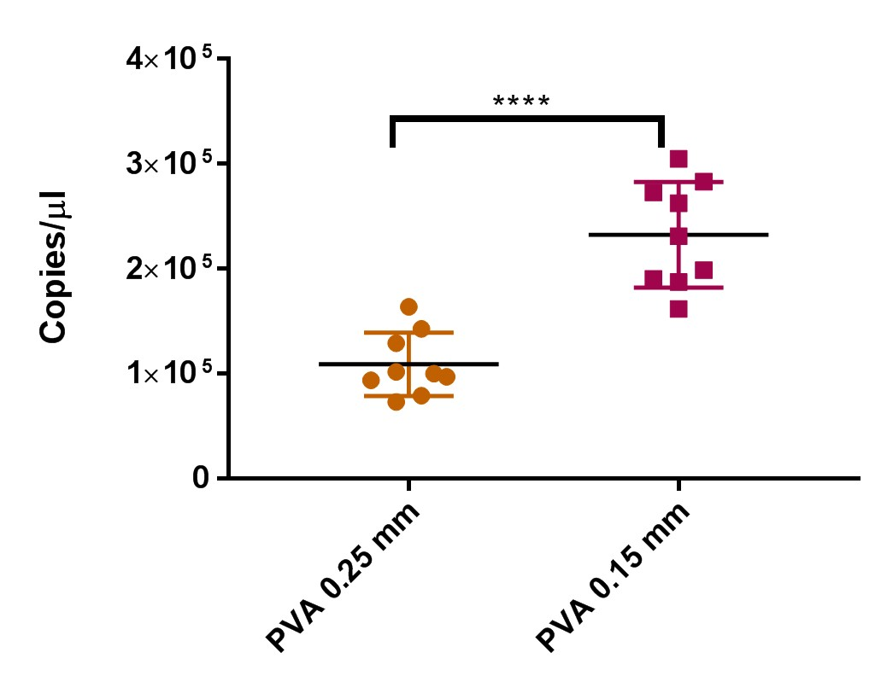

Fig.7. Quantitative assessment (16S DNA qPCR) comparison of the recovery efficiency of PVA matrix of two thicknesses (0.25 mm vs 0.15 mm) following exposure to nebulised *M. smegmatis* suspension **** P value < 0.0001 unpaired t-test. All results are described as mean ± standard deviation (SD) of three experiments, each including three technical replicates. Assessments of blank, unexposed PVA matrices and gelatine filters were below than the limit of detection (102 MYCO16S copies per PCR reaction).

## 4.3 Entrapped BCG Bacilli can be Detected in PVA Matrix Exposed to a Nebulised Suspension of BCG

An exposed PVA matrices absorb water during the nebulisation process, once dried it was expected that would trap bacteria would become entrapped within the matrix. Following exposure to a nebulised suspension of BCG pMSP12::dsRed 2 and drying of the matrix, dsRed fluorescence of the bacteria could be detected at different depths within the matrix by epifluorescence microscopy (Fig.8).

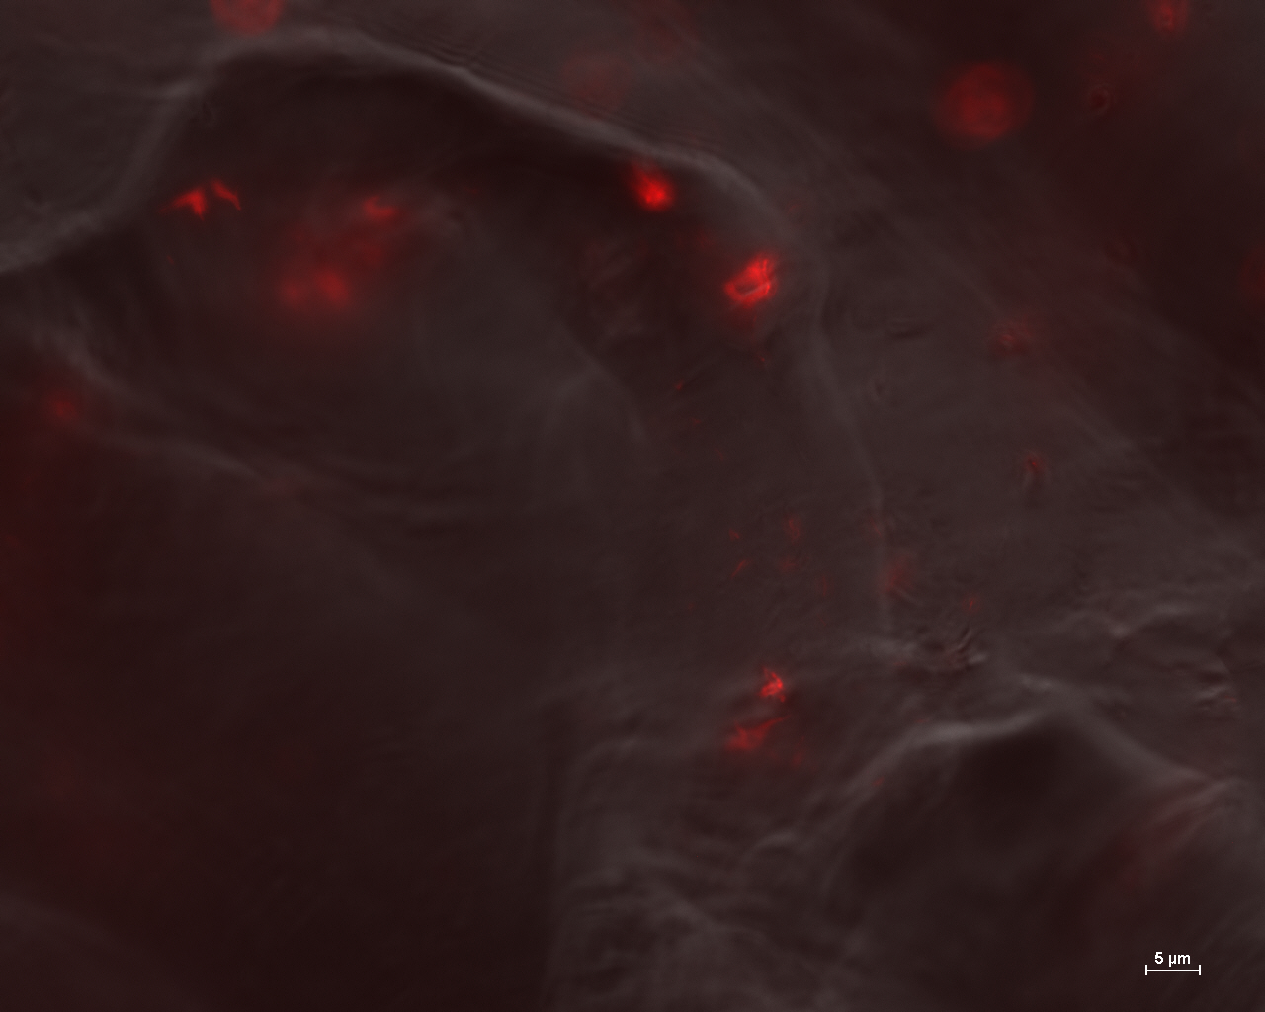

Fig.8. *M. bovis* BCG pMSP12::dsRed 2 are shown trapped at different depths within the PVA matrix. An overlay of phase contrast and fluorescence images is shown. Scale bar is 5 µm.

# 5. Discussion

The present study has primarily focussed on developing and validating a PVA sampling matrix for bacterial entrapment for the purpose of molecular diagnostics. Specific configurations of 3D-printed PVA matrices were designed and the physical features of these were characterised. The overlap of the PVA fibres in the 3D-printed matrices, with layers built up one upon another, was expected to produce a surface topography (roughness and porosity) suitable for the adherence of bacteria. Such roughness could improve the capturability of different bacteria since the adhesion and colonization of bacterial cells on rough surfaces is known to be greater than on smooth ones [34] [35]. Surfaces with Ra ≥ 0.8 µm are more susceptible to bacterial attachment [36]. As the average surface roughness (Ra)of the PVA matrices tested was greater than this (2.1 µm for 0.25 mm matrix, and 1.1 µm for 0.15 mm matrix (Table S1) which may promote bacterial entrapment within the matrix; however, it should be noted that bacterial colonization has also been observed on smooth surfaces [35]. The peak to valley roughness and root mean square roughness (Rpv and Rq) is more favourable for bacterial attachment as the presented peaks and valleys can create depressions that can enhance the colonisation and entrapment of bacteria. Surface hydrophilicity may further enhance bacterial entrapment upon the PVA matrix. Dou and colleaguesobserved that the maximum adhesion of bacteria on the substrates occurred with water droplet contact angles (CA) between 54°-130° [37]. Similarly, Arima and Iwata found that the effective cell adhesion on Self-assembled monolayers of alkanethiols,appeared when the water CA was 40°-70° [38]. The contact angles of the PVA matrix surfaces (62.5° - 63.7°) were within this range (Table S2). Internal pore formation in the 3D printed PVA structure could be due to the overlap between the printed PVA fibres (Supplementary Section.5). A nanoscale or submicrometre pore size may restrict bacterial attachment to the surfaces since the contact area available to bacterial cells might be reduced on such a surface [39]. The pore size suggests a weak correlation between the porosity and the capturability of the PVA sampling matrix. With these parameters, the PVA matrices were considered suitable for their designed purpose.

The PVA matrices were examined in terms of the ability to capture mycobacterial cells, following direct inoculation and exposure to nebulised bacterial suspensions. The efficiency of PVA material for the recovery of mycobacteria was tested by measuring the DNA extracted form bacteria recovered from these matrices, compared with recovery from water suspension (identical inoculum and in a volume of distilled water used to dissolve PVA matrix). While recovery from PVA matrices was within the same order of magnitude compared with that from water suspension, differences were observed between the two *M. absesscus* morphotypes tested. The relative recovery of mycobacterial-specific 16S DNA from PVA matrix spiked with the rough *M. abscessus* morphotype compared with water suspension, was higher than for the PVA matrix inoculated with the smooth *M. abscessus* morphotype. This could be due to the significant hydrophobicity of the rough morphotype compared to that of smooth [40, 41]. The enhanced hydrophobicity of the rough morphotype may promote adherence to the walls of the polypropylene tubes, rather than favouring suspension in the aqueous phase, however, it is possible that the greater viscosity of the PVAs solution might affect this interaction, or the recovery of the bacterial pellet by centrifugation.

Gelatine filters have been used previously for *M. tuberculosis* detection [1] and have also shown efficient recovery of viruses using molecular methods [42]. The validation of PVA as an alternative sampling matrix mycobacterial entrapment was achieved by comparison with gelatine filters. The results obtained from direct comparisons showed that the DNA recovery from PVA matrix and gelatine filters were of the same order of magnitude, with the gelatine filters showing slightly higher (Table 1, Fig.6). This difference in recovery between the PVA matrices and gelatine filters could be the result of the viscosity of the PVA solution, as this may decrease the efficiency of bacterial harvest by centrifugation, as sedimentation efficiency is dependent on fluid viscosity. Residual PVA may impact DNA extraction and analysis.

PVA has many practical and analytical advantages over gelatine as a diagnostic sampling matrix. PVA can be handled and loaded into the surgical masks without the use of a support, such that used for the more fragile gelatine filters. For bacterial recovery, PVA can be dissolved in water, however, gelatine requires hydrolysis, either with sodium hydroxide or collagenase. Derived from animal collagen, the bacterial DNA background of gelatine filters can be substantial and interfere with certain bacteria target gene analysis [23] (*e.g.* universal 16S qPCR; data not shown); this is less of a problem with synthetic PVA.

The viscosity of the PVA aqueous solution is principally determined by the molecular weight of the polymer and the polymer concentration. UV light may enhance chain scission and change the molecular weight distribution of the polymer [43]. However, the PVA solution is still viscous after the treatment, as a result of intra- and interchain hydrogen bonds remaining between the hydroxyl groups of the PVA molecules. Furthermore, hydrogen bonds form between the water molecules and the PVA chains during dissolution [44].

UV treatment of PVA prior to 3D-printing was optimised for reducing the molecular weight of the polymer and, consequently reducing the viscosity of the PVA solution. Although extending the UV treatment can lead to molecular weight reduction providing a reduction in viscosity advantageous for bacterial recovery, this can increase the loss of the mechanical properties of the filament. In addition, the filament material should ultimately be viscous enough to allow it to be printed [5]. Moreover, time-effectiveness is a prerequisite for clinical applications. Therefore, the UV treatment of the PVA filament was optimised at 4h to overcome these limitations (Fig.S1). It is noted that the viscosity of the UV-treated 0.25 mm thick PVA matrix dissolved in 8 ml of distilled water was 39.26 cP, whilst the viscosity of the treated 0.15 mm thick PVA matrix dissolved in 5 ml of distilled water was 21.18 cP at 20°C.

The improved mycobacterial recovery with a reduction of PVA matrix thickness (Fig.7) suggests that the recovery of the mycobacteria is affected by the viscosity of the resulting bacterial suspension in PVA solution, Momen-Heravi *et al* [45] reported in a study that there is a significant relationship between the viscosity and the recovery of microvesicles (MVs), which are nanosized lipid vesicles released by all cells. The sedimentation recovery of plasma was lower than those for serum and culture media as plasma has the greatest viscosity of the three. A larger number of MVs were pelleted in the culture media compared to plasma. In addition to increasing bacterial recovery, reducing thickness of the PVA matrix was found to be a worthwhile improvement as it reduced the amount of material required for printing the model, reduced the volume of water required for dissolving the matrix and decreased processing time.

It can be highlighted that the possibility of bacterial observation under the fluorescence microscope using PVA matrices which is considered as another advantage of PVA matrix. However, it is difficult to do this examination with aerosol-exposed gelatine filters due to its fragility after being dried. Thus, further improvement could be made to decrease the PVA matrix thickness using other manufacturing techniques or by including other additives within the matrix to enhance solubility or to reduce the viscosity of the current matrix. Overall, PVA sampling matrices can be considered a promising alternative tool in the field of respiratory disease diagnostics.

# 6. Conclusion

In conclusion, 3D printing was used to produce a time- and cost-effective PVA matrices suitable for application as a novel non-invasive tool to sample exhaled bacteria for diagnostic and research purposes. PVA sampling matrices were quantitatively assessed for bacterial recovery and detection using qPCR. The use of PVA matrices led to efficient recovery of mycobacteria. In direct comparisons of mycobacterial recovery, PVA matrices performed similarly to gelatine filters, however, the use of PVA affords more practical and analytical advances over gelatine. PVA matrices are soluble in distilled water without the need to use hazardous chemicals such as sodium hydroxide that is usually used for gelatine hydrolysis. The strength and ductility of PVA supports the fabrication of larger sample matrix size of any required geometry facilitating manipulations of DNA material-capturing surface; furthermore, PVA is considered a surface of choice for DNA-based analyses as it is a synthetic material. The large volume of water used to dissolve the circular PVA membranes has led to the extension of the centrifugation process compared to that of hydrolysed gelatine. PVA viscosity remains to be addressed for further improvements. Matrix features such as hydrophilicity and surface roughness when constructing multilayer models may increase capture efficiency further. 3D matrix designs may represent a future innovative technology for microbiology applications.

# Acknowledgments

Alaa Al-Taie gratefully acknowledges the Iraqi Ministry of Higher Education and Scientific Research (MOHESR) and the University of Leicester which supported this work. The authors would like to thank David Thompson at Loughborough University and Graham Clark at the University of Leicester for the help in the 3D printing and Microscope training.

# Appendix A. Supplementary Data

## 1. Roughness Test and Wettability

The topographical features of the PVA matrices were measured as reported in Table S1. A sputter coater Edwards Scancoat six Pirani 501 (Edwards Vacuum, UK) was used to coat PVA matrices with gold material. 3D micrographs were taken at 190 µm ×143 µm using the lens at a 50x magnification and with a step size of 0.101 µm to generate the micrograph. Ra, Rq and Rpv were auto-calculated by the Zeta 3D software.

|  |  |  |  |  |  |  |  |  |  |  |  |  |
| --- | --- | --- | --- | --- | --- | --- | --- | --- | --- | --- | --- | --- |
| Table S1. Values of the topographical features of PVA matrix surface, where Ra is the arithmetic average of the absolute values of the profile heights, Rq is the root mean square roughness, Rpv is the peak to valley roughness. All data are presented as mean ± SD. Three surfaces were studied for each sample model of (1×1) cm each, and at least three measurements recorded for each surface.   |  |  |  |  | | --- | --- | --- | --- | | **Sample** | **Average Ra (µm)** | **Average Rq (µm)** | **Average Rpv (µm)** | | **SM (0.25 mm)** | 2.1 ± 0.9 | 3.3 ± 1.3 | 24.2 ±10.3 | | **SM (0.15 mm)** | 1.1 ± 0.7 | 1.4 ± 0.9 | 8.4 ± 5.5 | |

|  |  |  |  |  |  |  |  |  |  |  |  |  |  |  |  |  |  |  |  |  |
| --- | --- | --- | --- | --- | --- | --- | --- | --- | --- | --- | --- | --- | --- | --- | --- | --- | --- | --- | --- | --- |
| Table S2: The static contact angles and droplet volume of water used to study the wettability of the top and bottom surfaces of the uncoated PVA (0.25 and 0.15 mm thick matrices), data are presented as mean ± SD. Three samples for each matrix type were studied, including at least three measurements recorded for each test.   |  |  |  |  |  |  | | --- | --- | --- | --- | --- | --- | | **Sample Thickness**  **(mm)** | **Droplet volume (top rough surface) (µl)** | **Droplet volume (bottom smooth surface) (µl)** | **Contact Angle (top rough surface) (°)** | | **Contact Angle (bottom smooth surface) (°)** | | **SM(0.25)** | | 4.0 ± 0.4 | 5.1 ± 0.4 | | 62.5 ± 2.7 | 62.5 ± 6.9 | | **SM(0.15)** | | 4.6 ± 0.9 | 4.5 ± 0.7 | | 62.8 ± 5.4 | 63.7 ± 2.8 | |

## 2. The Effect of Centrifugation Force on Bacterial DNA Detection from PVA SM

The centrifugation is important to recover bacteria for DNA extraction and further molecular analysis. The optimisation of the centrifugation force is described here. *M. smegmatis* liquid culture with an OD580 of 0.8 was used to spike PVA SM (circular 60 mm diameter, 0.25 mm and 0.15 mm thickness). Each matrix was contaminated with 100 µl of culture and left for one hour in a class II microbiological safety cabinet to dry. The matrices of 0.25 mm and 0.15 mm thicknesses were dissolved in 8 ml and 5 ml of distilled water, respectively, after which DNA was extracted and the 16S rDNA qPCR were performed*.* The impact of centrifugation force on the recovery efficiency for both matrix sets (0.25 mm and 0.15 mm thicknesses) was investigated for 15,000xg, 18,000xg and 21,100xg for 10 minutes. The study was performed in triplicate for each set to test the reproducibility of the experiment.

The results reported in Table S3 show that all the DNA copies of the *16S rDNA* gene detected in the 0.25 mm matrices were of same order of magnitude. No significant difference between the yields at these tested forces was found using one way ANOVA, followed by Tukey’s multiple comparisons test. In addition, all detected DNA copies of the *16S rDNA* gene in the 0.15 mm matrices were of the same order of magnitude, with no significant difference between the yield of any of these (one way ANOVA followed by Tukey’s multiple comparisons test). This suggests that for 10 minutes, increasing the centrifugation force for these particular test matrix solutions, had no significant impact on the sedimentation rate of the bacteria. In this work, the same protocol and centrifugation time (10 minutes per run) as used for processing gelatine filters were followed, but the centrifugation force used was increased to 21,100xg.

|  |  |  |  |  |  |  |  |  |  |  |  |  |  |  |  |  |  |
| --- | --- | --- | --- | --- | --- | --- | --- | --- | --- | --- | --- | --- | --- | --- | --- | --- | --- |
| Table S3: The DNA copies of *16S rDNA* detected in both 0.15 mm and 0.25 mm thickness PVA matrices at 15,000xg, 18,000xg and 21,100xg. All results are described as means ± standard deviation (SD) of three experiments, each including three technical replicates.   |  |  |  | | --- | --- | --- | | **Sample**  **Thickness(mm)** | **Centrifugation Force (xg)** | **Detected 16S rDNA target**  **(log10 copies/µl)**  **Mean ± SD** | | **0.15 SM** | **15,000** | **5.86 ± 0.07** | | **18,000** | **5.83 ± 0.05** | | **21,100** | **5.77 ± 0.09** | | **0.25 SM** | **15,000** | **5.94 ± 0.10** | | **18,000** | **5.92 ± 0.12** | | **21,100** | **5.89 ± 0.14** | |

## 3. Viscosity

UV treatment reduced the viscosity of the PVA, for 0.25 mm and 0.15 mm thick PVA matrices as shown in Fig.S1. PVA solutions of UV-treated and untreated PVA were prepared by dissolving the circular PVA matrix of 0.25 mm thick and weight (0.89 g) in the optimised volume (8 ml) of distilled water. The PVA solution viscosity produced using the treated filament was significantly decreased to 39.26 cP compared to the 45.41 cP of the original (untreated) filament, for the same polymer weight and same water volume at room temperature (here considered to be 20°C). The improvement of the designed matrix (0.15 mm thick matrix treated with UV) showed an additional reduction in the viscosity of the solution that was prepared by dissolving the PVA matrix weight (0.46 g) in 5 ml of distilled water which was significantly decreased to 21.18 cP compared with 39.26 cP (treated filament with 0.25 mm thickness) at 20°C. The viscosity was recorded five times, and an average taken for each sample.

|  |
| --- |
|  |

Fig.S1. PVA solution viscosity for UV-treated and untreated filament. All the results are described as mean ± standard deviation (SD).

## 4. Developed 3D Printed Matrices and Face Mask

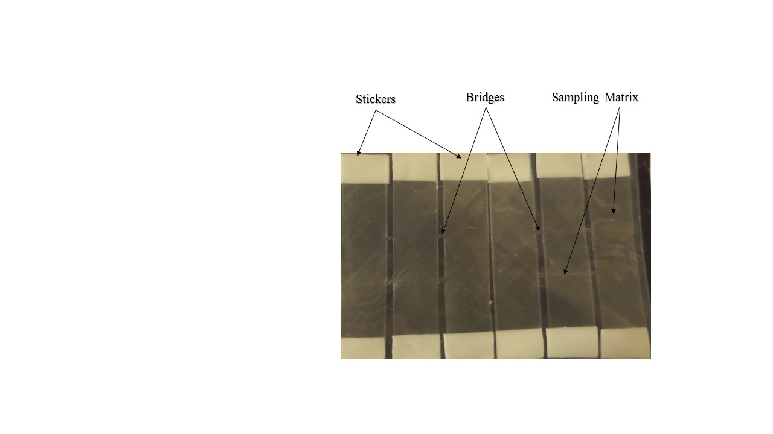 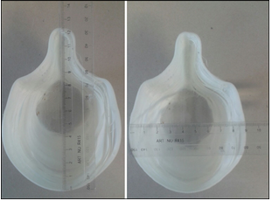

A

B

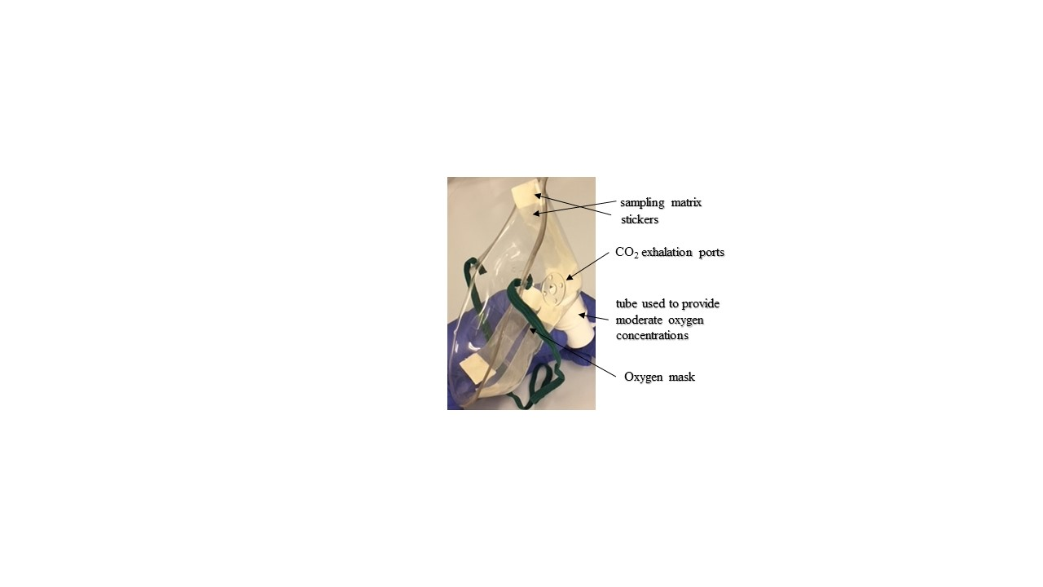

D

C

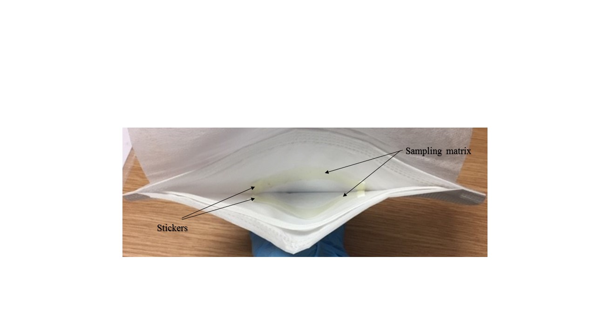

Fig.S2. Strips (92×20 mm) with stickers (A) and 3D printed face mask (120 mm length, 90 mm width, 60 mm height and 1 mm thickness) (B). Strips loaded in the Oxygen mask (C) and in a Duckbill mask to improve the effective facial fit for respiratory sampling (D).

## 5. X-ray CT scans and SEM

CT scans of the cross section of 0.25 mm thickness PVA (multilayer membrane) demonstrated irregular pores formed internally in the 3D printed PVA structure, which have dimensions of 40 µm on the horizontal axis and 30 µm on the vertical axis. A sputter coater was used to coat the PVA membrane with gold material to examine it by SEM. The bottom surface of the PVA matrices appears smoother than the top when examined by SEM, as the former is deposited directly onto the hot platform of the 3D printer. The bed temperature may give rise to the observed surface smoothness, whilst the top surface represents the overlap between the printed fibres. The overlap may be affected by the printing speed, nozzle size and the extrusion rate of the polymer based on the temperature variation while printing, as well as the rate at which the fibre solidifies.The micrograph of the 3D printed PVA matrix is shown in Fig.S3.

|  |
| --- |
| Fig.S3. Magnified image of 100% infill PVA sampling matrix (left), micrograph of 0.25 mm thick 3D printed PVA matrix (right). |

# 7. References

1. Williams, C.M., et al., *Face mask sampling for the detection of Mycobacterium tuberculosis in expelled aerosols.* PloS One, 2014. **9**(8): p. e104921.

2. Patterson, B., et al., *Detection of Mycobacterium tuberculosis bacilli in bio-aerosols from untreated TB patients.* Gates open research, 2017. **1**.

3. Hopkinson, N., R. Hague, and P. Dickens, *Rapid manufacturing: an industrial revolution for the digital age*. 2006, England: John Wiley & Sons.

4. Goyanes, A., et al., *3D printing of medicines: engineering novel oral devices with unique design and drug release characteristics.* Molecular pharmaceutics, 2015. **12**(11): p. 4077-4084.

5. Gibson, I., D.W. Rosen, and B. Stucker, *Additive manufacturing technologies*. Vol. 238. 2010, Singapore: Springer.

6. Chou, D.-T., et al., *Novel processing of iron–manganese alloy-based biomaterials by inkjet 3-D printing.* Acta biomaterialia, 2013. **9**(10): p. 8593-8603.

7. Pattanayak, D.K., et al., *Bioactive Ti metal analogous to human cancellous bone: fabrication by selective laser melting and chemical treatments.* Acta Biomaterialia, 2011. **7**(3): p. 1398-1406.

8. Sudarmadji, N., et al., *Investigation of the mechanical properties and porosity relationships in selective laser-sintered polyhedral for functionally graded scaffolds.* Acta biomaterialia, 2011. **7**(2): p. 530-537.

9. Serra, T., et al., *Relevance of PEG in PLA-based blends for tissue engineering 3D-printed scaffolds.* Materials Science and Engineering: C, 2014. **38**: p. 55-62.

10. Mohanty, S., et al., *Fabrication of scalable and structured tissue engineering scaffolds using water dissolvable sacrificial 3D printed moulds.* Materials Science and Engineering: C, 2015. **55**: p. 569-578.

11. Cheng, Y.-L. and F. Chen, *Preparation and characterization of photocured poly (ε-caprolactone) diacrylate/poly (ethylene glycol) diacrylate/chitosan for photopolymerization-type 3D printing tissue engineering scaffold application.* Materials science & engineering. C, Materials for biological applications, 2017. **81**: p. 66-73.

12. Bose, S., S. Vahabzadeh, and A. Bandyopadhyay, *Bone tissue engineering using 3D printing.* Materials Today, 2013. **16**(12): p. 496-504.

13. Goyanes, A., et al., *Effect of geometry on drug release from 3D printed tablets.* International journal of pharmaceutics, 2015. **494**(2): p. 657-663.

14. Giovinco, N.A., et al., *A novel combination of printed 3-dimensional anatomic templates and computer-assisted surgical simulation for virtual preoperative planning in Charcot foot reconstruction.* The Journal of Foot and Ankle Surgery, 2012. **51**(3): p. 387-393.

15. He, Y., G.-h. Xue, and J.-z. Fu, *Fabrication of low cost soft tissue prostheses with the desktop 3D printer.* Scientific reports, 2014. **4**.

16. Zein, I., et al., *Fused deposition modeling of novel scaffold architectures for tissue engineering applications.* Biomaterials, 2002. **23**(4): p. 1169-1185.

17. Cole, E.C. and C.E. Cook, *Characterization of infectious aerosols in health care facilities: an aid to effective engineering controls and preventive strategies.* American journal of infection control, 1998. **26**(4): p. 453-464.

18. Meiklejohn, G., et al., *Air sampling to recover variola virus in the environment of a smallpox hospital.* Bulletin of the World Health Organization, 1961. **25**(1): p. 63.

19. Sawyer, M.H., et al., *Detection of varicella-zoster virus DNA in air samples from hospital rooms.* Journal of Infectious Diseases, 1994. **169**(1): p. 91-94.

20. Burton, N.C., S.A. Grinshpun, and T. Reponen, *Physical collection efficiency of filter materials for bacteria and viruses.* Annals of Occupational Hygiene, 2007. **51**(2): p. 143-151.

21. Tseng, C.-C. and C.-S. Li, *Collection efficiencies of aerosol samplers for virus-containing aerosols.* Journal of Aerosol Science, 2005. **36**(5): p. 593-607.

22. Li, C.-S., *Evaluation of microbial samplers for bacterial microorganisms.* Aerosol Science and Technology, 1999. **30**(2): p. 100-108.

23. Kennedy, M., et al., *Face mask sampling reveals antimicrobial resistance genes in exhaled aerosols from patients with chronic obstructive pulmonary disease and healthy volunteers.* BMJ open respiratory research, 2018. **5**(1): p. e000321.

24. El-Gendy, N.S. and J.G. Speight, *Handbook of refinery desulfurization*. Vol. 140. 2015, New York: CRC Press.

25. Lozinsky, V. and F. Plieva, *Poly (vinyl alcohol) cryogels employed as matrices for cell immobilization. 3. Overview of recent research and developments.* Enzyme and microbial technology, 1998. **23**(3): p. 227-242.

26. Gutiérrez, M.C., et al., *Hydrogel scaffolds with immobilized bacteria for 3D cultures.* Chemistry of materials, 2007. **19**(8): p. 1968-1973.

27. Nakamura, S., T. Kubo, and H. Ijima, *Heparin-conjugated gelatin as a growth factor immobilization scaffold.* Journal of bioscience and bioengineering, 2013. **115**(5): p. 562-567.

28. Williams, C.M., et al., *Exhaled Mycobacterium tuberculosis output and detection of subclinical disease by face-mask sampling: prospective observational studies.* The Lancet Infectious Diseases, 2020.

29. Wayne, L.G. and L.G. Hayes, *An in vitro model for sequential study of shiftdown of Mycobacterium tuberculosis through two stages of nonreplicating persistence.* Infection and immunity, 1996. **64**(6): p. 2062-2069.

30. Choi, G.-E., et al., *Macrolide treatment for Mycobacterium abscessus and Mycobacterium massiliense infection and inducible resistance.* American journal of respiratory and critical care medicine, 2012. **186**(9): p. 917-925.

31. Cheah, E.S., et al., *A two-tube combined TaqMan/SYBR Green assay to identify mycobacteria and detect single global lineage-defining polymorphisms in Mycobacterium tuberculosis.* The Journal of Molecular Diagnostics, 2010. **12**(2): p. 250-256.

32. Dorak, M.T., *Real-time PCR.* 2006, Oxford: Taylor & Francis Group.

33. Cosma, C.L., O. Humbert, and L. Ramakrishnan, *Superinfecting mycobacteria home to established tuberculous granulomas.* Nature immunology, 2004. **5**(8): p. 828-835.

34. Yuan, Y., et al., *Surface characteristics influencing bacterial adhesion to polymeric substrates.* RSC Advances, 2017. **7**(23): p. 14254-14261.

35. Sousa, C., et al., *Superhydrophobic poly (L-lactic acid) surface as potential bacterial colonization substrate.* AMB express, 2011. **1**(1): p. 34.

36. Hsu, L.C., et al., *Effect of micro-and nanoscale topography on the adhesion of bacterial cells to solid surfaces.* Applied and Environmental Microbiology, 2013. **79**(8): p. 2703-2712.

37. Dou, X.-Q., et al., *Bioinspired hierarchical surface structures with tunable wettability for regulating bacteria adhesion.* ACS nano, 2015. **9**(11): p. 10664-10672.

38. Arima, Y. and H. Iwata, *Effect of wettability and surface functional groups on protein adsorption and cell adhesion using well-defined mixed self-assembled monolayers.* Biomaterials, 2007. **28**(20): p. 3074-3082.

39. Feng, G., et al., *Bacterial attachment and biofilm formation on surfaces are reduced by small-diameter nanoscale pores: how small is small enough?* npj Biofilms and Microbiomes, 2015. **1**: p. 15022.

40. Bendinger, B., et al., *Physicochemical cell surface and adhesive properties of coryneform bacteria related to the presence and chain length of mycolic acids.* Applied and Environmental Microbiology, 1993. **59**(11): p. 3973-3977.

41. Jankute, M., et al., *The role of hydrophobicity in tuberculosis evolution and pathogenicity.* Scientific Reports, 2017. **7**.

42. Fabian, P., et al., *Airborne influenza virus detection with four aerosol samplers using molecular and infectivity assays: considerations for a new infectious virus aerosol sampler.* Indoor air, 2009. **19**(5): p. 433-441.

43. Chahal, R.P., et al., *UV irradiated PVA–Ag nanocomposites for optical applications.* Applied Surface Science, 2015. **343**: p. 160-165.

44. Briscoe, B., P. Luckham, and S. Zhu, *The effects of hydrogen bonding upon the viscosity of aqueous poly (vinyl alcohol) solutions.* Polymer, 2000. **41**(10): p. 3851-3860.

45. Momen-Heravi, F., et al., *Impact of biofluid viscosity on size and sedimentation efficiency of the isolated microvesicles.* Frontiers in Physiology, 2012. **3**: p. 162.