# The Hospital Frailty Risk Score - outcomes in specialised services

# Background

Frailty describes impaired resolution following a stressor event [1]. There is a growing recognition of the utility of frailty to stratify older people based on their likely outcomes in a range of settings [2-11].

A current focus of English National Health Service (NHS) policy is to improve outcomes for older people living with frailty [12]. NHS Specialised Services are commissioned directly by NHS England and cover treatments for conditions requiring specialist clinical input. Examples include Transcatheter Aortic Valve Implantation (TAVI), critical care or complex spinal surgery. Whilst there is growing interest in assessing frailty in older people needing NHS specialised services, there is no standardised approach, making case-mix comparisons difficult. The electronic Frailty Index [3] is used in primary care, but has not been validated for its predictive utility in secondary care or specialised services.

The Hospital Frailty Risk Score (HFRS) was validated in people aged 75 or more who had been admitted to an acute hospital. The HFRS uses International Classification of Disease 10 (ICD-10) codes pertaining elective or non-elective hospital admissions to generate a frailty risk score. This data is routinely submitted by hospitals to populate the Secondary Uses Service (SUS) database. The HFRS uses diagnostic information in an algorithm that identifies the risk of frailty and outcomes such as death or unplanned hospital readmissions [13]. . In the national validation cohort (n=1,013,590), compared with the 42% patients with the lowest risk scores, the 20% patients with the highest HFRSs had increased odds of 30-day mortality (odds ratio 1.71; 95% CI 1.68–1.75), long hospital stay (6.03; 5.92–6.10), and 30-day readmission (1.48; 1.46–1.50). The c-statistics between individuals for these three outcomes were 0.60, 0.68, and 0.56, respectively. The HFRS offers an opportunity to assess frailty as a case-mix characteristic; its relative ease of application makes it an ideal tool for use in national datasets to provide a population perspective.

The aim of this paper was to assess the feasibility of using the HFRS to describe outcomes for older people within specialised services across England.



# Methods

This was a retrospective cohort study using the Secondary Uses Service (SUS) electronic database. SUS is the single, comprehensive repository for healthcare data in England which enables a range of reporting and analyses to support the NHS in the delivery of healthcare services (<https://digital.nhs.uk/services/secondary-uses-service-sus>). It contains up to 20 ICD-10 diagnosis fields about a patient during their admission to hospital.

The HFRS was applied to national SUS database for people aged 75 or older, admitted between April 2017 to March 2018. The SUS database allows searching of any previous admission (in this case, over the preceding two years) to identify any of the ICD-10 codes used to generate the HFRS. In the original HFRS validation, three categories of low (<5), intermediate (5-15), and high risk (>15) were used based on discrimination between different outcomes [13]. These were renamed mild, moderate and severe frailty to mirror the generally used approach to frailty risk stratification. To capture those individuals with no relevant ICD-10 codes the categories were slightly expanded to include those who were assumed not to have frailty – so an individual with previous hospital admission data containing no HFRS related codes was rated as ‘not frail-. For individuals who had no hospital admission in the preceding two years, the HFRS could not be calculated.

The HFRS was tested on six specialties which were participating in the Specialised Clinical Frailty Network (an improvement programme commissioned by NHS England in 2018; <https://www.scfn.org.uk/>). These were TAVI (elective and emergency), critical care (all admissions), renal (all dialysis patients), chemotherapy (all forms), spinal surgery (deformity and fracture) and neurosurgery (emergency). Each specialty’s population was identified from the SUS database using procedure codes defined by NHS England and through consultation with the NHS England Clinical Reference Groups (CRG). These are groups of clinicians, commissioners, public health experts, patients and carers who advise NHS England on the commissioning of a specialised service (Appendix 1). HFRS was applied to each population and proportions of patients with frailty across the specialty were identified. Where an inpatient episode involving a treatment was involved, the index event was the date of admission for the relevant treatment; each patient was included only once in the data.

We compared the patient volumes identified in the SUS data through speciality codes against existing speciality specific registries, in order to ‘sense-check’ that we had identified the correct cohorts for each specialty. The total numbers of patients for each specialty data set were cross-referenced with specialty data repositories where these existed including the renal registry (<https://www.renalreg.org/wp-content/uploads/2018/06/20th-Annual-Report_web_book.pdf>), National Cardiac Audit Programme (<https://www.nicor.org.uk/national-cardiac-audit-programme/>) and Systemic Anti-Cancer Therapy Dataset (<http://www.ncin.org.uk/collecting_and_using_data/data_collection/chemotherapy>). Each repository was contacted to cross reference the numbers and the CRG leads reviewed the HFRS data to check the extent to which it correlated with clinical practice in their specialty.

For renal and chemotherapy each patient was included only once in the dataset. For TAVI, neurosurgery, critical care, spinal fracture or spinal deformity, some patients could appear more than once in the dataset, relating to clinical complications following the index admission or further treatment under the same specialty during the study period. In this case, frailty scores and outcomes were calculated per admission, but only the patient’s first admission was used for survival estimates.

The main outcomes recorded in SUS relate to service metrics in the year following the index event (admissions, length of stay, readmission), mortality and some treatment specific complications (which had been prioritised by the CRG leads). The method for differentiating an admission from a readmission has been taken from the NHS Digital definition [4]. For 30 day readmissions these were defined as emergency admissions to any hospital in England occurring within 30 days of the last, previous discharge from hospital after admission excluding obstetrics related admissions. As length of stay could not be related to a discrete index event for haemodialysis and chemotherapy, total inpatient days over a year alone were extracted instead of 7-21 day length of stay. Complications are defined in Appendix 1. Mortality was defined as death during an admission either during or following the index admission up until the date the data was extracted in March 2019; out of hospital deaths were not captured.

Analyses were limited to descriptive statistics, capturing the outcomes of interest by frailty risk and survival analyses for time to death. For survival, all admission records following index event were examined to establish date of death. Patients with no date of death recorded were assumed to be alive at the end of the study period or censored in the Kaplan-Meier model. The interval between index event and the date of death was calculated in months, displayed in Kaplan-Meier plots.

No ethical review was undertaken as the work was performed as a service evaluation to aid with commissioning and healthcare planning under the permission of NHS England (<https://digital.nhs.uk/services/secondary-uses-service-sus>).

# RESULTS

Table 1 shows the numbers of older people captured in specialty specific registries (where available) in comparison to those identified using the codes detailed in Appendix 1. Slightly fewer individuals were identified in the TAVI and renal registries as compared to SUS data, and slightly more in the cancer registry; overall, the variance was no greater than 6%.

Table 1 SUS identified vs. registry recorded patients with specialised conditions

|  |  |  |  |  |
| --- | --- | --- | --- | --- |
| Specialty | Specialty registry | People aged 75+ identified in specialty registry | People aged 75+ identified in SUS | Variance |
| TAVI | [NICOR 2017](http://www.bcis.org.uk/wp-content/uploads/2018/11/TAVI-slide-deck-to-2017-data-15-11-2018.pdf)-18 | 3189 | 3261 | 2% |
| Renal dialysis | Renal registry 201[7](https://www.renalreg.org/reports/2017-twentieth-annual-report/)-18 | 6269 | 6474 | 3% |
| Cancer chemotherapy | NCRAS/SACT data 2017-18 | 23,084 | 21751 | 6% |

Table 2 shows the distribution of frailty risk by HFRS; very few individuals (<2%) could not be risk stratified for frailty risk, as they had no hospital episode (and therefore SUS records) in the previous two years. Frailty was differentially distributed across the specialties, but for the most part, at least mild frailty was present in the most people aged 75. Around one-third had mild frailty; another third had moderate frailty and one-quarter severe frailty.

Table 2 Distribution of frailty risk by HFRS

|  |  |  |  |  |  |  |  |  |
| --- | --- | --- | --- | --- | --- | --- | --- | --- |
|  | Adult Critical Care | Chemotherapy | Neurosurgery | Renal | Spinal Deformity Surgery | Spinal Fracture Surgery | Elective TAVI | Emergency TAVI |
| Number of people aged 75+ accessing the specialty | 56039 | 21751 | 1460 | 6474 | 92 | 1460 | 2157 | 565 |
| Unable to calculate HFRS - no SUS data on previous two years | 1121 (2%) | 0 (0%) | 0 (0%) | 0 (0%) | 1 (1%) | 18 (1%) | 11 (1%) | 5 (1%) |
| Total at risk of frailty by HFRS | | | | | | | | | |
| Not frail | 3923 (7.1%) | 6090 (28.0%) | 0 (0%) | 0 (0%) | 4 (4.3%) | 70 (4.8%) | 315 (14.6%) | 43 (7.6%) |
| Mild | 16251 (29.6%) | 8265 (38.0%) | 146 (10.0%) | 1230 (19.0%) | 54 (58.7%) | 704 (48.2%) | 835 (38.7%) | 160 (28.3%) |
| Moderate | 21855 (39.8%) | 5438 (25.0%) | 584 (40.0%) | 2719 (42.0%) | 24 (26.1%) | 407 (27.9%) | 606 (28.1%) | 206 (36.5%) |
| Severe | 12889 (23.5%) | 1958 (9.0%) | 730 (50.0%) | 2525 (39.0%) | 9 (9.8%) | 261 (17.9%) | 390 (18.1%) | 151 (26.7%) |

Some patients appeared more than once in the dataset (TAVI n=6/2706, 0.2%; neurosurgery n=171/1460, 11.7%; critical care n=2270/54918, 4.1%; spinal n=123/1533, 8.0%), relating to clinical complications or further treatment following the index admission during the study period. Table 3 shows the service outcomes following the index treatment event by each specialty. Increasing frailty risk was associated with increased length of stay for the index admission, more days in hospital in the year following intervention (42 days on average for those with high frailty risk) and increased risk of dying in hospital. When death occurred, most of these happened within one year of specialist intervention.

Table 3 Service outcomes following specialised interventions by frailty status

|  |  |  |  |  |  |  |  |  |
| --- | --- | --- | --- | --- | --- | --- | --- | --- |
|  | Adult Critical Care | Chemotherapy | Neurosurgery | Renal | Spinal Deformity Surgery | Spinal Fracture Surgery | Elective TAVI | Emergency TAVI |
| Median length of stay in days for the index admission (Interquartile range) | | | | | | | | | |
| Not frail | 6 (4-9) | Not applicable (outpatient setting) |  | Not applicable (outpatient setting) | 13.5 (11-23) | 2 (1-5) | 3 (2-4) | 6 (3-10) |
| Risk of mild frailty | 8 (4-13) | 4 (2-6) | 8 (4-13) | 2 (1-5) | 4 (3-5) | 7 (4-14) |
| Risk of moderate frailty | 12 (6-21) | 5 (3-10) | 10 (7-16) | 10 (3-22) | 4 (3-7) | 12 (4-20) |
| Risk of severe frailty | 20 (11-36) | 17 (9-26) | 31 (16-77) | 20 (9-39) | 5 (3-9) | 15 (7-24) |
| Proportion of 7/21 day stranded LOS | | | | | | | | | |
| Not frail | 7%/2% | Not applicable (outpatient setting) |  | Not applicable (outpatient setting) | 100/25% | 16/1% | 5/ 1% | 44/5% |
| Risk of mild frailty | 11%/4% | 28/4% | 50/9% | 17/4% | 12/1% | 45/8% |
| Risk of moderate frailty | 22%/16% | 49/10% | 701/13% | 55/25% | 25/5% | 66/22% |
| Risk of severe frailty | 30%/40% | 73/25% | 89/56% | 77/46% | 31/8% | 72/31% |
| Median number of inpatient days in the year following treatment initiation (Interquartile range) | | | | | | | | | |
| Not frail | 7 (4-11) | 0 (0-1) |  |  | 5 (4-14) | 3 (2-7) | 3 (2-5) | 6 (3-14) |
| Risk of mild frailty | 10 (5-17) | 2 (0-8) | 6 (4-12) | 1 (0-5) | 8 (4-15) | 3 (1-9) | 5 (3-10) | 11 (5-22) |
| Risk of moderate frailty | 17 (8–32) | 12 (5-24) | 13 (6-27) | 10 (3-21) | 17 (9-45) | 21 (8-44) | 13 (7-24) | 21 (12-36) |
| Risk of severe frailty | 43 (23-76) | 32 (17-54) | 42 (22-71) | 34 (18-60) | 46 (30-137) | 57 (29-98) | 38 (19-68) | 52 (28-71) |
| Proportion of patients readmitted within 30 days as an emergency following discharge from index intervention | | | | | | | | | |
| Not frail | 4% | 3% | 0% | 0% | 0% | 4% | 0% | 30% |
| Risk of mild frailty | 6% | 15% | 11% | 12% | 6% | 5% | 0% | 33% |
| Risk of moderate frailty | 9% | 26% | 20% | 29% | 4% | 18% | 0% | 39% |
| Risk of severe frailty | 14% | 30% | 35% | 34% | 22% | 26% | 0% | 36% |

Figure 1 shows the survival post-index procedure; severe frailty was a powerful discriminator of the risk of death; between 25-40% of those with severe frailty risk died at 30 months across all specialties (NB only in-hospital deaths captured, not those occurring out of hospital).

Figure 1 Survival curves for 30-month in-hospital mortality post index specialty intervention, by frailty risk

Insert Figure 1 about here

Elective TAVI, emergency TAVI, renal dialysis and spinal surgery patients had an increased risk of complications with frailty (Appendix 2). For neurosurgery patients there was a rise of admissions with a diagnosis of fall within one year of neurosurgery with frailty.

# DISCUSSIon

This is the first application of the HFRS to a national dataset, describing service outcomes and mortality for older people undergoing a range of specialised interventions. Whilst there were differences in the precise number of individuals identified in registry data vs. SUS data the variance was 6% or less. For those who were identified in SUS data, we have shown that it is feasible as the vast majority (>98%) of patients undergoing specialised interventions could be risk stratified. Within specialised services, the HFRS performs in a manner commensurate with the initial validation – namely that increasing frailty risk is associated with poorer outcomes and often higher use of health care resource in specific cohorts with specialised conditions.

Whilst a strength of this approach is the use of nationally representative data, the HFRS does depend upon coding practice, which is known to vary across the country. However, in the original study [13], coding variation did not alter the direction of the results, suggesting this is random rather than systematic error. SUS data only captures in-hospital deaths, so deaths occurring outside of hospital may have been missed, reducing the number of events and thus the precision of the study. We estimated frailty at the time of the index presentation, but frailty can be dynamic, and may have changed over the course of follow-up, especially following an intervention. It would be interesting to explore the dynamic nature of frailty in future research.

Although useful at a population health level, the HFRS is not designed to be used as a clinical decision making tool – patient assessments should always be individualised. Even frailty tools developed with specific specialised conditions in mind do not exhibit sufficiently robust predictive characteristics to direct individual patient decision-making [2-11]. However, the knowledge of the risk of frailty should sensitise the clinician to think about holistic assessment and prognosis when helping patients decide the right approach to their care. For example, this data has underpinned specialties selected to participate in a national improvement programme designed to enhance the delivery of frailty-attuned care for older people with frailty and specialised conditions (https://www.scfn.org.uk/).

This methodology could be reproduced across other specialties, but also general acute care, to understand population health needs without the need for manual frailty scores. This will provide a standardised approach to population risk stratification that could be used for benchmarking [14], service evaluation or research. It could also be used by commissioners to take account of frailty distributions that vary across different settings [15]. The HFRS is an example of the NHS Long Term plan (<https://www.longtermplan.nhs.uk/>) commitment to using population health management solutions to match NHS resources to need. It states that by identifying groups of people who are at risk of adverse health outcomes we can predict the value for patients and the system from different health and care interventions.

## Appendix 1 – Codes used to define patient populations

### Adult Critical Care

Patients with one or more records in the SUS Plus PbR critical care dataset, spells selected from discharges in 2017/18

### Chemotherapy

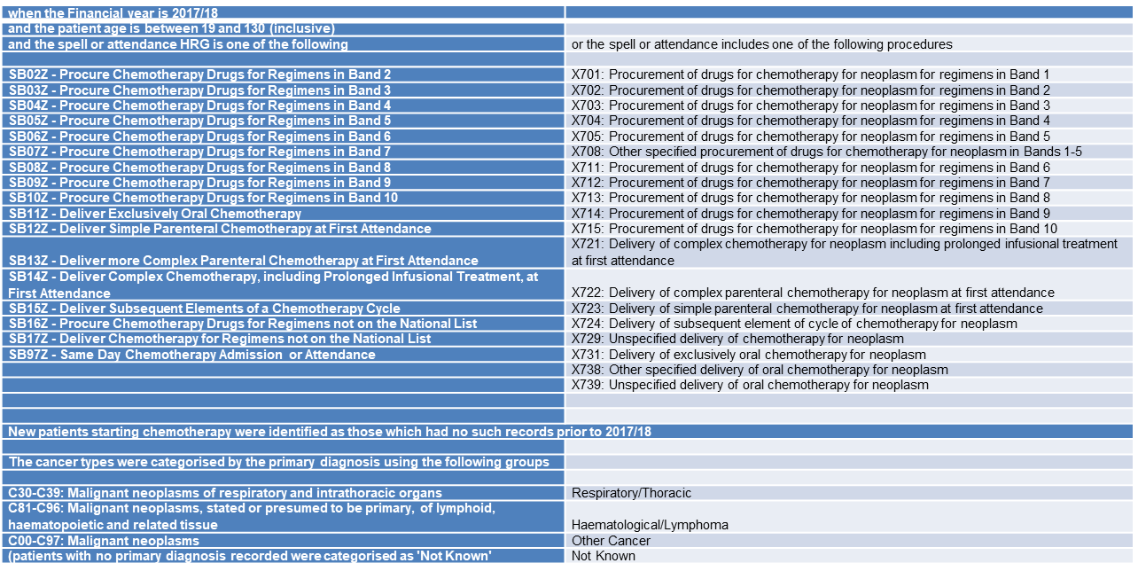

### Neurosurgery

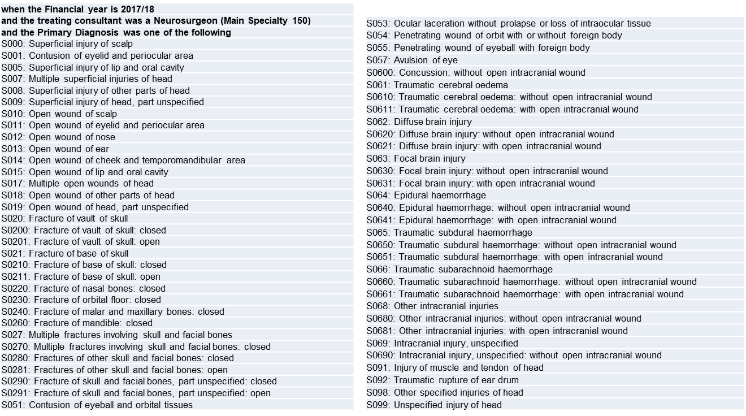

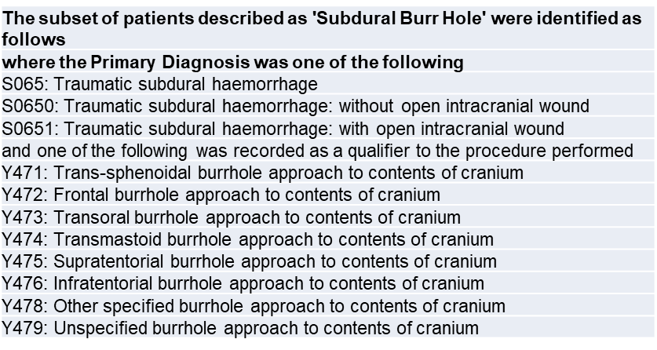

### Renal

The Renal Dialysis population was identified by inpatient records with a diagnosis code N185 Chronic Kidney Disease Stage 5 (in any position) and diagnosis Z992 Dependence on renal dialysis (in any position).

These criteria yield multiple records during 2017-18 (circa 58,000 records), for the purposes of this analysis only the first record in 2017-18 for this patient group is captured as an ‘index event’ (circa 22,000 patients).

Additionally, those patients who have no inpatient record fitting the above criteria prior to their index event in 2017-18 were flagged. This proxy measure is intended to identify those patients starting dialysis in 2017-18

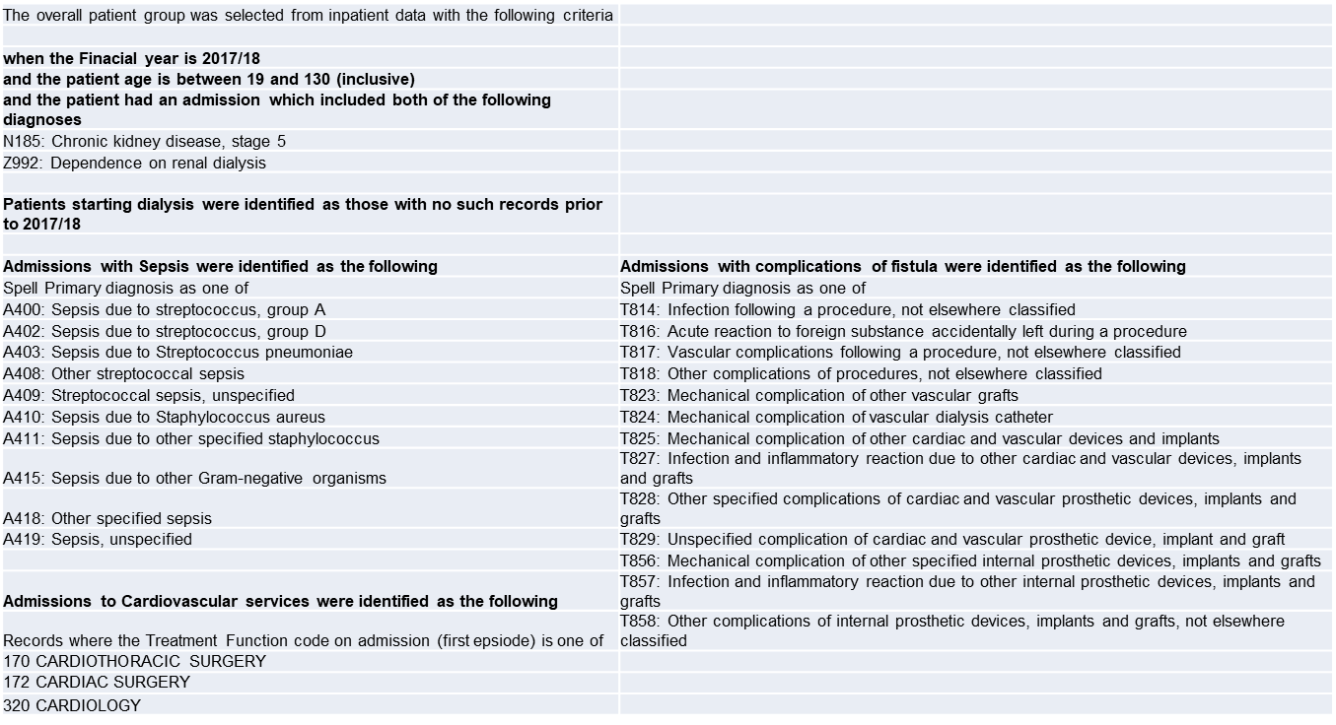

### Spinal Surgery

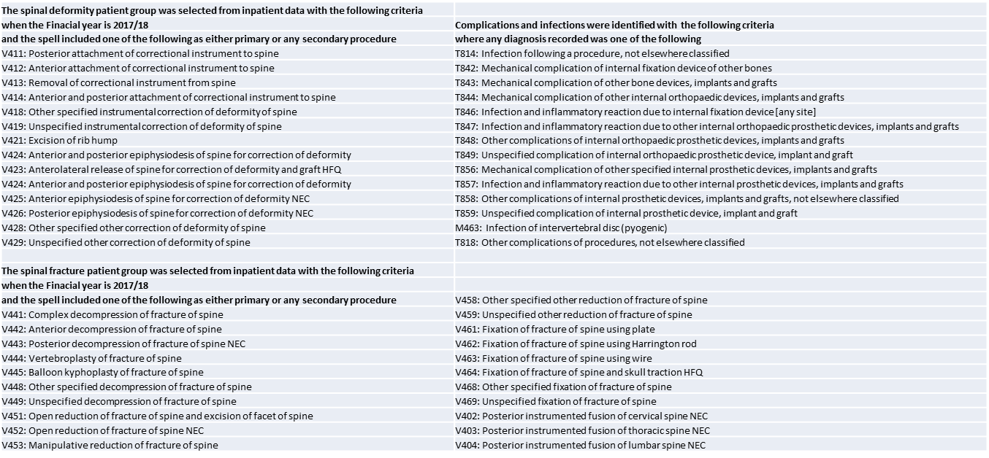

### Transaortic Valve Implantation (TAVI)

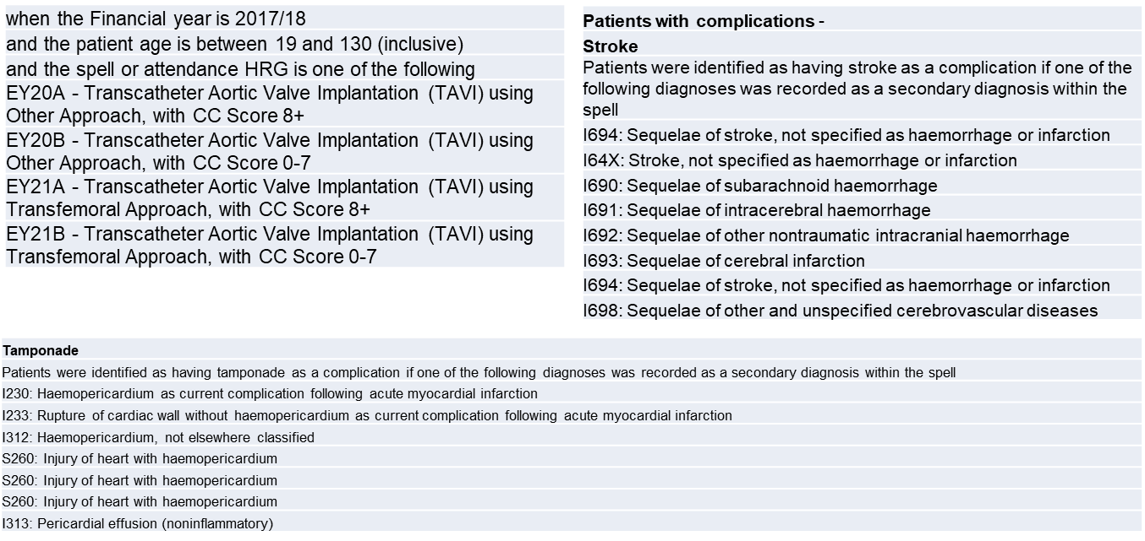

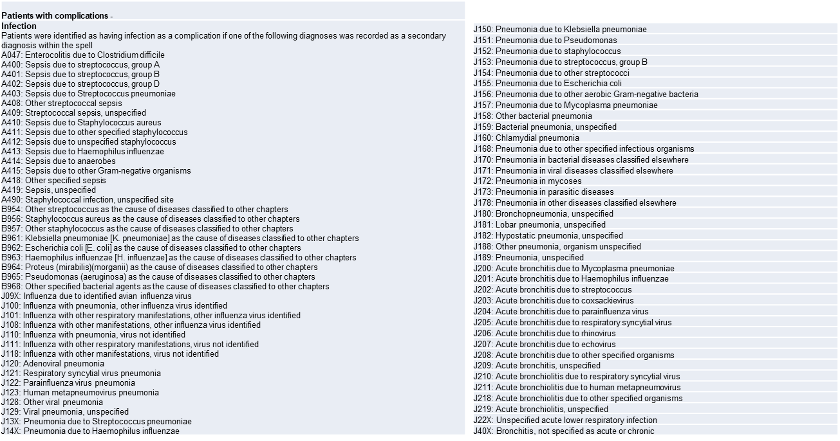

## APPENDIX 2 – SPECIALTY SPECIFIC METRICS

|  |  |
| --- | --- |
| Neurosurgery |  |
|  | Mean number of admissions within 1 year of surgery |
| Risk of mild frailty | 1.0 |
| Risk of moderate frailty | 2.0 |
| Risk of severe frailty | 3.0 |
|  | Proportion of patients admitted with falls within 18 months of surgery |
| Risk of mild frailty | 12.5% |
| Risk of moderate frailty | 25.9% |
| Risk of severe frailty | 65.9% |
|  |  |
| Renal |  |
|  | Proportion of patients with admission to cardiac services within one year of starting dialysis |
| Risk of mild frailty | 9.0% |
| Risk of moderate frailty | 11.3% |
| Risk of severe frailty | 12.0% |
|  |  |
|  | Proportion of patients readmitted within 365 days with complications/infection |
| Spinal Deformity Surgery |  |
| Not frail | 0% |
| Risk of mild frailty | 7.8% |
| Risk of moderate frailty | 14.9% |
| Risk of severe frailty | 11.1% |
|  |  |
| Spinal Fracture Surgery |  |
| Not frail | 0% |
| Risk of mild frailty | 9.3% |
| Risk of moderate frailty | 16.7% |
| Risk of severe frailty | 11.1% |
|  |  |
|  | Complication rate within admission |
| Elective TAVI |  |
| Not frail | 2.6% |
| Risk of mild frailty | 5.7% |
| Risk of moderate frailty | 14.6% |
| Risk of severe frailty | 15.3% |
|  |  |
| Emergency TAVI |  |
| Not frail | 3.3% |
| Risk of mild frailty | 11.3% |
| Risk of moderate frailty | 26.4% |
| Risk of severe frailty | 29.1% |

## References

1. Clegg A, Young J, Iliffe S, Rikkert MO, Rockwood K. Frailty in elderly people. Lancet (London, England). 2013 Mar 02, 2013;381:752-62.

2. Keeble E, Arora S, van Oppen J, Williams C, Roberts H, Conroy S. Outcomes of even brief hospital admissions amongst frail older people: a role for secondary prevention of frailty crises in the community? British Journal of General Practice. 2019;In press.

3. Clegg A, Bates C, Young J, Ryan R, Nichols L, Ann Teale E, et al. Development and validation of an electronic frailty index using routine primary care electronic health record data. Age Ageing. 2016 May;45(3):353-60.

4. Sridharan ND, Chaer RA, Wu BB, Eslami MH, Makaroun MS, Avgerinos ED. An Accumulated Deficits Model Predicts Perioperative and Long-term Adverse Events after Carotid Endarterectomy. Annals of Vascular Surgery. 2018;46:97-103.

5. Hubbard RE, Peel NM, Samanta M, Gray LC, Mitnitski A, Rockwood K. Frailty status at admission to hospital predicts multiple adverse outcomes. Age and Ageing. 2017 May 22, 2017:1-6.

6. Muscedere J, Waters B, Varambally A. The impact of frailty on intensive care unit outcomes: a systematic review and meta-analysis. Intensive Care Med. 2017;43(8):1105–22.

7. Allum W, Lordick F, Alsina M, Andritsch E, Ba-Ssalamah A, Beishon M, et al. ECCO essential requirements for quality cancer care: Oesophageal and gastric cancer. Critical Reviews in Oncology/Hematology. 2018 2018/02/01/;122:179-93.

8. Kirkhus L, Šaltytė Benth J, Rostoft S, Grønberg BH, Hjermstad MJ, Selbæk G, et al. Geriatric assessment is superior to oncologists’ clinical judgement in identifying frailty. British Journal Of Cancer. [Clinical Study]. 2017 06/29/online;117:470.

9. Rajabali N, Rolfson D, Bagshaw SM. Assessment and Utility of Frailty Measures in Critical Illness, Cardiology, and Cardiac Surgery. Canadian Journal of Cardiology. [Review]. 2016;32(9):1157-65.

10. Kallenberg MH, Kleinveld HA, Dekker FW, van Munster BC, Rabelink TJ, van Buren M, et al. Functional and Cognitive Impairment, Frailty, and Adverse Health Outcomes in Older Patients Reaching ESRD-A Systematic Review. Clinical Journal of The American Society of Nephrology: CJASN. [Review]. 2016;11(9):1624-39.

11. Houghton JSM, Nickinson ATO, Morton AJ, Nduwayo S, Pepper CJ, Rayt HS, et al. Frailty Factors and Outcomes in Vascular Surgery Patients: A Systematic Review and Meta-analysis. Annals of Surgery. 9000;Publish Ahead of Print.

12. NHS England. The NHS Long Term Plan. 2019 [January 2019]; Available from: www.longtermplan.nhs.uk.

13. Gilbert T, Neuburger J, Kraindler J, Keeble E, Smith P, Ariti C, et al. Development and validation of a Hospital Frailty Risk Score focusing on older people in acute care settings using electronic hospital records: an observational study. The Lancet. 2018;391(10132):1775-82.

14. NHS Benchmarking Network. Older People in Acute Settings. NHS Benchmarking Network, 2016.

15. Care NR. NHS RightCare: Frailty Toolkit. London: NHS England, 2019 April 2019. Report No.