Supporting information

Design and fabrication of a smart sensor using in silico epitope mapping and electro-responsive imprinted polymer nanoparticles for determination of insulin levels in human plasma

Alvaro Garcia-Cruz¹, Isma Haq², Sabrina Di Masi³, Samir Trivedi¹, Kaseb Alanazi¹, Todd Cowen¹, Elena Piletska¹, Adnan Mujahid,² Sergey A. Piletsky¹

¹Department of Chemistry, University of Leicester, University Road, LE1 7RH, Leicester, UK
²Institute of Chemistry, University of the Punjab, Quaid-e-Azam Campus, Lahore, Pakistan
³Department of Science and Biological and Environmental Technology, University of Salento Via Monteroni, 73100 Lecce, Italy

Section 1. Synthesis of nanoMIP
Table S1. Compositions of polymers
Monomer | NanoMIP 1, mg | NanoMIP 2, mg | NanoMIP 3, mg
NIPAM | 39 (0.34 mmol) | 39 (0.34 mmol) | 20 (0.17 mmol)
NAPMA | 2.2 (0.012 mmol) | - | 6 (0.03 mmol)
MBA | 2 (0.013 mmol) | 52 (0.34 mmol) | 52 (0.34 mmol)
Allylamine | 2 (0.013 mmol) | - | 9 (0.15 mmol)
ITA | - | 15 (0.08 mmol) | -
EGMP | 67.2 (0.32 mmol) | 16 (0.08 mmol) | 16 (0.08 mmol)
FcMMA | 8 (0.02 mmol) | 8 (0.02 mmol) | 8 (0.02 mmol)
TBAm | 33 (0.26 mmol) | - | -
TFEMA | - | - | 29 (0.17 mmol)
HEMA | - | - | 4.5 (0.03 mmol)

Section 2. Molecular modelling
Computational modelling of imprinted polymers, which was pioneered by our group, is based on the screening and selection of functional monomers using molecular mechanics.(Leach 2001) This approach is especially important for the design of the multicomponent polymeric mixture. Molecular modelling was carried out using an HP Elite-Desk PC with two Intel Core ™Duo CPU E8400 @3GHz processors running on a CentOS Linux 7 operating system. The software package used was Sybil ™ 7.3 software (Tripos Inc., USA) in a Linux Gnome 2.28.2 environment.
The insulin epitope mapping was performed using the insulin crystal structure (Nicol and Smith 1960; Sanger 1959) obtained from the RCSB PDB (id. 3I40).(Berman et al. 2000; Timofeev et al. 2010) It is worth highlighting that “epitopes” here are the surface peptides that could be used for imprinting and preparation of insulin-specific nanoMIP. For that, water molecules were first removed from the insulin crystal structure and external residues were identified. Insulin residues were then examined in order to discard those that were internal or belonging to the structural sequences of the protein. The resulting insulin epitopes were screened against a database of common functional monomers used in MIP synthesis using the Leapfrog algorithm available in Sybyl molecular modelling package.(Cowen et al. 2016; Piletsky et al. 2001) The database used consisted of 44 monomers, representing both charged and neutral forms, and each screening was performed for 200,000 iterations. In the screening, only exposed external residues were considered for this interaction, in this way, specific insulin epitopes were identified. In this manner, nanoMIP were computationally designed to recognize insulin.

Table S2. Computational insulin epitope mapping
Monomer | Functional group of Interaction | Insulin epitope | Amino acids | Number of interactions
Allylamine | Carboxyl | Epitope 1 | Aspartic Acid, D | 1
 |  |  | Glutamic Acid, E | 3
EGMP | Amine | Epitope 2 | Histidine, H | 1
 |  |  | Lysine, K | 2
 | Aromatic | Epitope 3 | Tyrosine, Y | 4
 |  |  | Phenylalanine, F | 3
MBA | Amide | Epitope 4 | Glutamine, Q | 2
 |  |  | Asparagine, N | 3
 | Hydroxyl | Epitope 5 | Threonine, T | 2
 |  |  | Serine, S | 1
 | Aliphatic | Epitope 6 | Leucine, L | 2
 |  |  | Isoleucine, I | 1
 |  |  | Valine, V | 4
 |  |  | Proline, P | 1
 |  |  | Alanine, A | 1

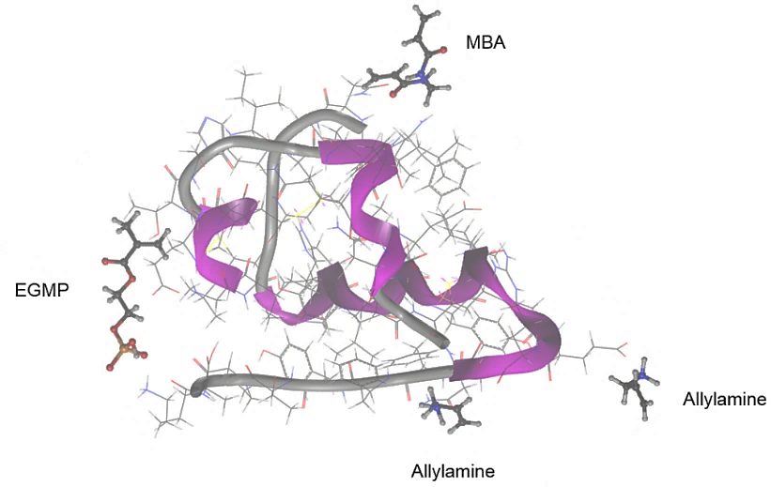

Figure S1. Complex between Insulin and functional monomers showing the interaction between allylamine and epitope 1 (-488.8 kJ mol⁻¹), EGMP and epitope 2 (-526.6 kJ mol⁻¹), and MBA and epitope 4 (-307 kJ mol⁻¹).
Section 3. Characterisation of nanoMIP
Figure S2. Infrared spectra analysis for (1) nanoMIP 1, (2) nanoMIP 3 and (3) nanoMIP 2 specific for Insulin.

Table S3. DLS measurements for nanoMIP in solution
Nanoparticle type | molecule in solution | Size (nm) | PDI | Size change (%)
NanoMIP 1 | water | 249.7 ± 4.4 | 0.230 | -
 | insulin | 285.2 ± 4.0 | 0.196 | 14.2.
NanoMIP 2 | water | 261.2 ± 1.0 | 0.201 | -
 | insulin | 319.7 ± 0.8 | 0.188 | 22.4
NanoMIP 3 | water | 269 ± 7.0 | 0.323 | -
 | insulin | 316 ± 6.4 | 0.295 | 17.5
NanoMIP (0.5 mg mL⁻¹) and insulin 500 pM in 5 mM PBS

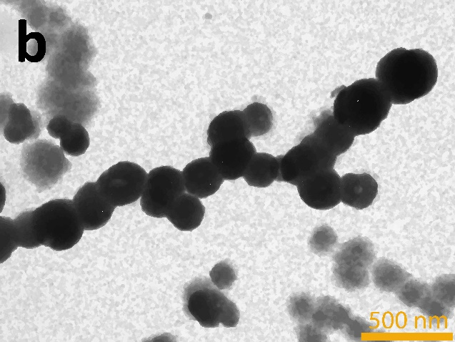
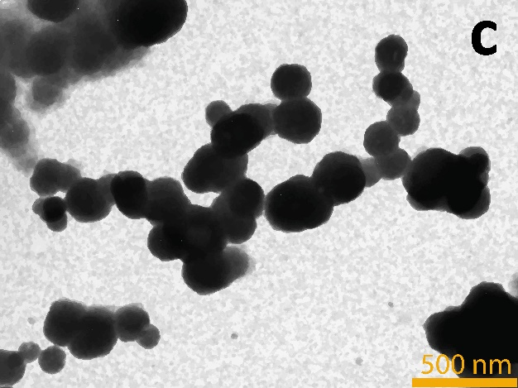
Figure S3. TEM images of (a) nanoMIP 1, (b) nanoMIP 2, and (c) nanoMIP 3, scale bar at 500 nm.
Surface Plasmon Resonance (SPR) analysis
The affinity of the nanoMIP towards the insulin and the cross-reactivity were evaluated by SPR. The gold SPR chip surface was cleaned using hydrogen plasma and then functionalized by incubation in an ethanol solution of MDA (2.2 mg mL⁻¹) for 24 h. After that, the gold chip was rinsed with ethanol and water and dried under with nitrogen. Subsequently, a nanoMIP solution (1 mg mL⁻¹) was injected and immobilised by using the EDC/NHS coupling (0.4 mg mL⁻¹ and 0.6 mg mL⁻¹, respectively) on the functionalised chip surface. The insulin solutions tested were in the concentration range from 0.044 to 440 nM. Thus, the sensorgrams were collected sequentially for all insulin concentrations running in KINJECT mode (injection volume 100 μL, and dissociation time of 120 seconds). Dissociation constants (K_{d}) were calculated from plots of the equilibrium biosensor response using the BiaEvaluation v4.1.1 software. The K_{d} was also calculated with the Langmuir Blodgett (LB) model using the absorption component of the SPR response, which was obtained after the subtraction of the drift and bulk effect. The SPR analysis were performed using Biacore 3000 instrument (GE Healthcare Life Sciences, UK) at 25 °C using PBS as the running buffer (0.01 M phosphate buffer, 0.0027 M potassium chloride and 0.137 M sodium chloride, pH =7.4) at flow rate 35 µL min⁻¹.

a)
b)
c)
Figure S4. SPR responses for (a) NanoMIP 1, (b) NanoMIP 2 and (c) NanoMIP 3 towards insulin in the concentration range from 44 pM to 440 nM in 5 mM PBS. The concentration of each nanoMIP solution was 1 mg mL⁻¹. The injection volume was 100 μL, and dissociation time was 120 seconds while the flow rate was 35 µL min⁻¹.
a)

b)
c)
Figure S5. SPR response for nanoMIP 3 to a) insulin, b) IGF1 and c) HPC in a concentration range from 44 pM to 440 nM in 5mM PBS. The concentration of nanoMIP 3 solution was 1 mg mL⁻¹. The injection volume was 100 μL, and dissociation time was 120 seconds while the flow rate was 35 µL min⁻¹.
a)
b)
c)
Figure S6. SPR response for NanoMIP 2 to a) insulin, b) IGF and c) HPC in a concentration range from 44 pM to 440 nM in 5 mM PBS. The concentration of nanoMIP 2 solution was 1 mg mL⁻¹. The injection volume was 100 μL, and dissociation time was 120 seconds while the flow rate was 35 µL min⁻¹.
Section 4. Electrochemical measurements
a)
b)
Figure S7. (a)Cyclic voltammetry (CV) performed for bare screen printed platinum electrode (1), nanoMIP-modified SPPE (2) in 5 mM PBS. (b) DPV response for bare electrode (1) and NanoMIP-modified SPPE (2) to 2000 pM insulin in 5 mM PBS under the following voltammetric conditions: potential range from -0.2 to 0.6 V (vs Ag/AgCl); scan rate: 25 mV s⁻¹; cycles: 3.

Figure S8. Calibration plot obtained by varying (A) the concentration of APTES at a) 1%, b) 6%, and c) 10%. (B) Calibration plot obtained by varying the APTES incubation time a) 1 h and b) 24 h and APTES at 6%. Plots show the delta current sensor response to insulin in a concentration range of insulin (100 to 2000 pM) in PBS buffer (pH =7.4), nanoMIP (1 mg mL⁻¹, 24h) immobilized using APTES and glutaraldehyde at 7%.

Figure S9. Calibration plots for insulin-nanoMIP immobilized on SPPE with different concentration of glutaraldehyde at (a) 2 %, (b) 7% and (c) 10 %. Plots show the delta current sensor response to insulin in a concentration range of insulin (100 to 2000 pM) in PBS buffer (pH =7.4), nanoMIP (1 mg mL⁻¹, 24h) immobilized using 6% APTES (1 h) and glutaraldehyde.

Figure S10. (A) Calibration plot obtained for insulin specific nanoMIP by varying the concentration of immobilised nanoMIP (24h) between (a) 0.1 mg mL⁻¹, (b) 0.2 mg mL⁻¹, (c) 0.5 mg mL⁻¹ and (d) 1 mg mL⁻¹. (B) Effect of the nanoMIP immobilisation time on the performances of the sensor for (a) 1 h and (b) 24 h using SPPE. Plots show the delta current sensor response to insulin in a concentration range of insulin (100 to 2000 pM) in PBS buffer (pH =7.4), nanoMIP were immobilized using 6% APTES and glutaraldehyde at 7%.

Table. S4. Sensor performance under different conditions
Factors | Quantity | Slope ( nA×pM⁻¹) | R²
[APTES], % | 1 | 0.78 | 0.734
 | 6 | 1.27 | 0.981
 | 10 | 0.83 | 0.934
APTES Incubation time, h | 1 | 1.27 | 0.981
 | 24 | 2.21 | 0.962
[Glutaraldehyde], % | 2 | 0.83 | 0.964
 | 7 | 1.27 | 0.989
 | 10 | 0.96 | 0.990
[nanoMIP], mg mL⁻¹ | 0.1 | 0.96 | 0.981
 | 0.2 | 1.27 | 0.987
 | 0.5 | 1.55 | 0.959
 | 1 | 1.25 | 0.985
Immobilisation time, h | 1 | 1.27 | 0.981
 | 24 | 1.56 | 0.955

Table. S5. Insulin sensor performance for different nanoMIP
Nanoparticle | Sensitivity (nA×pM⁻¹) | Linearity (R²) | LOD (pM)
NanoMIP 1 | 0.27 ± 0.03 | 0.998 | 0.33
NanoMIP 2 | 0.97 ± 0.04 | 0.972 | 0.124
NanoMIP 3 | 1.18 ± 0.01 | 0.998 | 0.026

Table S6. Sensor response to Insulin and interferences
Molecule | Sensitivity (nA×pM⁻¹) | Linearity (R²) | Cross reactivity (%)
Insulin* | 1.18 ± 0.06 | 0.987 | 100
HSA* | 0.14 ± 0.01 | 0.980 | 12
HPC* | 0.10 ± 0.01 | 0.893 | 8.5
Hb* | 0.005 ± 0.00 | 0.943 | 0.4
Insulin** + HSA | 0.99 ± 0.03 | 0.991 | 16
Insulin** + Hb | 1.16 ± 0.04 | 0.985 | 1.7
Insulin** + HPC | 0.92 ± 0.04 | 0.983 | 22
*Analyte concentration ranged from 100 pM to 2000 pM in PBS buffer (pH =7.4)
**Insulin was spiked with 200 pM of the interferent molecule

Figure S11. Stability of sensors stored at 4 °C over 168 days, tested every seven days for the same concentration of 500 pM of insulin. The result meet the industrial accuracy standards (ISO-151917), which states that 95% of results are within ±15% of a laboratory standard.

