The AWSC Third Annual International Conference on the Status of African Women
14-16 October 2020
https://uonresearch.org/current-events/rw-saw2020/

Presenters
Professor Lisa Smith  University of Leicester  Ls149@leicester.ac.uk | Wangu Kanga  Wangu Kanja Foundation  wangukanja@gmail.com | Jessica Ritchie  University of Leicester  Jr416@leicester.ac.uk
Other Project Members
Professor Mark Jobling  University of Leicester  Maj4@leicester.ac.uk | Dr Jon Wetton  University of Leicester  jw418@leicester.ac.uk | Dr Richard Oduor  Kenyatta University  oduor.richard@ku.ac.ke
Theme: Women
Sub-theme: Women and technology

Title: Self-examination intimate DNA swabs to enhance prosecutions of sexual violence in Kenya
Abstract
Sexual and gender-based violence (SGBV) is challenging to investigate and prosecute. One of the critical challenges to prosecuting sexual violence is the frequent lack of forensic evidence, the improper handling of evidence, and problems in the chain of custody of evidence. All these issues contribute to complaints being dropped by victims, police not proceeding with an investigation, and lack of successful prosecution. DNA can make a significant contribution towards investigations of sexual violence as it can provide an objective method of identifying offenders of sexual violence. This project introduces a new, but reliable way to collect and preserve DNA in Kenya. The design of the DNA kits enables victims to self-administer intimate DNA swabs, supervised in a healthcare setting. This approach makes DNA evidence recovery possible in clinics with no trained forensic medical professionals, and empowers women to take a more active role in their medical examination. The process encourages the timely collection of DNA evidence (within 72 hours) to ensure a viable sample for analysis. Further, the tamper-proof, self-drying packaging allows the samples to be air-dried to preserve the integrity of the DNA, and also maintains the chain of custody by reducing the chances of contamination, tampering and human error – overall enhancing access to high-quality evidence for victims, police, and prosecutors.
Keywords: sexual violence, DNA evidence, forensic science, investigation, access to justice
- Introduction
Women across the world are at risk of gender-based sexual violence (Abrahams et al., 2014). “Gender inequality continues to be one of the world’s most enduring violations of human rights, and sexual and gender-based violence (SGBV) is one of the most damaging manifestations of gender inequality” (Smith, Flowe, & Kanja, 2019, p. 108). Conservative estimates identify that 35 per cent of women worldwide have experienced physical and/or sexual intimate partner violence or sexual violence by a non-partner at some point in their life (UN Women, 2019). There are both physical and psychological impacts of rape and sexual violence on survivors which include but not limited to: higher rates of depression, unintended pregnancies, requiring an abortion, acquiring HIV, reproductive health problems, reported symptoms of reproductive tract infections, and intergenerational effects (Miheso & Mutugi, 2015; WHO, 2013). “It is estimated that rape and domestic violence account for 5-10% of healthy years lost by women” (Miheso, & Mutugi, 2015, p. 2). The rates of reporting sexual assault and rape are low (Daly & Bouhours, 2010), which means many perpetrators are left in the community without consequences, contributing to a cycle of continuing violence.
The majority of countries with available data, less than 40 per cent of women who experience violence seek the help of any sort (informal or formal), less than 10 per of those women who seek help for an experience of violence sought help by appealing to the police (UN Women, 2019).
SGBV is difficult to investigate and prosecute. This is made more difficult in low resource environments, such as developing countries, remote geographic locations, conflict (and post-conflict) affected regions and displaced communities where access to medical examinations is lacking. Part of the issue is the lack of evidence to support the survivor’s account; as a survivor’s memory is frequently the only evidence in an investigation of rape (Hohl & Conway, 2017). A survivor’s account is impacted by the trauma they have suffered, and the stigma associated with reporting (Deitz, Williams, Rife, & Cantrell, 2015).
Globally it is known that sexual violence is one of the most under-reported crimes, there is a low rate of successful prosecutions for sexual violence (undermining confidence in the criminal justice system), and there is a culture of impunity for sexual violence and no real deterrence to reduce offending. When sexual violence is not reported, it is not recorded, and perpetrators cannot be held accountable. This places the community at risk, and the survivors do not have access to justice. Sexual offences are underreported to police, with victims reporting a lack of confidence in the police and the criminal justice system (Taylor & Gassner, 2010). Having continued low prosecution and conviction rates undermines confidence in the criminal justice system and contributes to deterring people from reporting crime. In addition, a low conviction rate does not offer general or specific deterrence to perpetrators, as a consequence maintaining and contributing to sustained high levels of sexual violence in society. DNA evidence provides investigators and prosecutors with a powerful tool to assist and support their investigations. Further, survivors are more likely to report cases when they feel there is potential physical evidence which can corroborate their statements.
DNA profiling has revolutionised criminal intelligence, investigations and prosecutions of crime globally. DNA can provide a significant contribution towards investigations by providing an objective method of identifying perpetrators (and excluding innocent suspects). DNA is already used frequently in paternity cases in Kenya. When investigating sexual violence, there are two key issues (1) when the perpetrator and survivor are in an intimate partner relationship it makes reporting unlikely and proving a crime has occurred even more difficult and; (2) when the perpetrator is a stranger then the victim is unable to identify a suspect (Smith, Flowe, & Kanja, 2019; Miheso & Mutugi, 2015). Investigating is made even more difficult in Kenya due to critical limitations regarding the chain of custody of evidence, timely collection of samples from survivors, and preserving the DNA samples which undermines its use in the criminal justice system.
DNA has significant probative valuable when there has been recent sexual contact between persons and assists in identifying a suspect, especially when the perpetrator is a stranger to the survivor. For investigators, the presence of DNA in sexual offence cases can substantially contribute to a perpetrator’s decision to plead guilty (Briody, 2002). Further, DNA allows investigators to link crimes committed by the same perpetrator (serial offending) and provides identification evidence to identify a suspect who may remain otherwise unknown to investigators. As useful as DNA evidence is, it is still only one part of the puzzle in a broader investigation, so it is crucial to keep in mind the limitations of DNA.
DNA does not ‘prove’ that someone committed an offence just because their DNA is present. For example, in an allegation of sexual assault between an adult couple, where it is agreed that intercourse has occurred, DNA has limited value for the investigation because it cannot determine whether there was consent or not (consent only applies to adult persons and not child survivors of sexual violence). However, if a suspect alleges that no sexual contact occurred, then a vaginal swab containing the DNA of the suspect would provide probative evidence in the investigation. Survivors experience stigma and blame in reporting sexual violence (Abrahams et al., 2014). Whilst there is a larger role in changing the cultural norms and values around blame and stigma experienced by survivors, DNA can provide survivors with an objective method to identify a perpetrator and support the allegations. Part of the solution in improving timely reporting of sexual violence is providing a victim-centred approach.
Forensic medical examinations are a very intrusive examination for a survivor to undergo and requires a medical professional with specialised forensic training. The use of a speculum (if used) for a high vaginal swab may, in some circumstances, lead to a higher spermatozoa count in the sample. However, a high vaginal sample is not required to prove sexual assault or penetration. Under Kenyan law, the Sexual Offences Act 2006 (SOA) does not prescribe any particular legal threshold for penetration, as such it is the ordinary meaning of the word – when a body part or object enters that of another person, any level of entry is sufficient to prove penetration. Therefore, for the purposes of DNA collection, a low and high vaginal sample are both appropriate for providing a DNA sample of a perpetrator and are not required to prove penetration. The Kenyan courts have stated that there is no necessity for a DNA test to prove penetration (George Muchika Lumbasi v Republic [2016] eKLR, para 40) – the critical value in DNA evidence is the ability to identifying the perpetrator – especially when the perpetrator is a stranger.
The introduction of the Sexual Offences Act 2006 (SOA) has facilitated the opportunity for the rise in reporting, awareness of elements such as consent, and changing societal values. The SOA unequivocally allows for the taking of DNA samples from persons accused of committing sexual offences, and there is no question of enforcement of such orders (Republic v John Kithyululu [2016] eKLR para.17). DNA kits provide survivors with the opportunity for their case to be investigated and prosecuted with the support of DNA evidence. Sexual assault is a human rights violation (Miheso & Mutugi, 2015). The Kenyan Constitution includes a focus on human rights and the principles of gender equality and non-discrimination, and these kits support these goals (Kamau, 2013).
In low-resource environments, there are complex, cultural, political and social factors which play a role in the perpetration, reporting, investigating and prosecution of sexual violence. Barries to the collection of DNA evidence include the lack of access to appropriate medical facilities and trained personnel. All of these factors contribute to discouraging women from undergoing an invasive medical exam and an unwillingness to document sexual violence. The kits we have developed have the potential to improve prosecution rates for sexual violence in low-resource environments through access to high-quality forensic evidence. Standard operating procedures to collect and store evidential samples for forensic purposes already exist in hospitals that treat sexual assault survivors (Miheso & Mutugi, 2015), and these kits can be easily implemented in existing procedures to improve the overall healthcare response.
- Self-examination DNA Kits
The self-examination kits (kits) developed by the University of Leicester provide the option to allow a survivor, who has been vaginally penetrated to conduct a self-examination (under supervision) to collect a DNA sample. These kits provide a “victim-centred approach which priorities the victims’ right to access to justice and aims to treat victims with respect, sensitivity and dignity throughout the investigative process” (Smith, Flowe, & Kanja, 2019, p. 109). The kits allow for DNA evidence to be collected and preserved without requiring any specialised medical training, which makes physical evidence more accessible in a range of low resource settings. The kits are easily integrated into existing medical exam practices. The kits offer the improved element of air-drying samples within a tamper-evident evidence bag. The swabs can be collected by self-examination by the survivor (a ‘blind vaginal’ swab as they are not assisted with a speculum) or by a medical practitioner with or without a speculum. Research into ‘blind’ swabs compare favourably with swabs collected with a speculum (Blake et al., 1998) and the approach the kits use follows international best practice guidelines for self-administered ‘blind vaginal’ swabs (FFLM, 2016).
The kits are packaged in a sealed bag which contains a pair of plastic gloves, a tamper-evident evidence bag, a buccal swab (yellow tube), and a vaginal swab (red tube) (see: Figure 1: Packaged Contents of Self-Examination Kit; Figure 2: Unpacked Contents of Self-Examination Kit). The sample collected from the vaginal swab can be used to extract a DNA sample deposited by the perpetrator (from spermatozoa and/or skin cells). The self-examination vaginal swab should be done before swabs for STI and other biological tests so as not to waste any DNA samples. The kits are low cost and do require any specialised equipment or training.
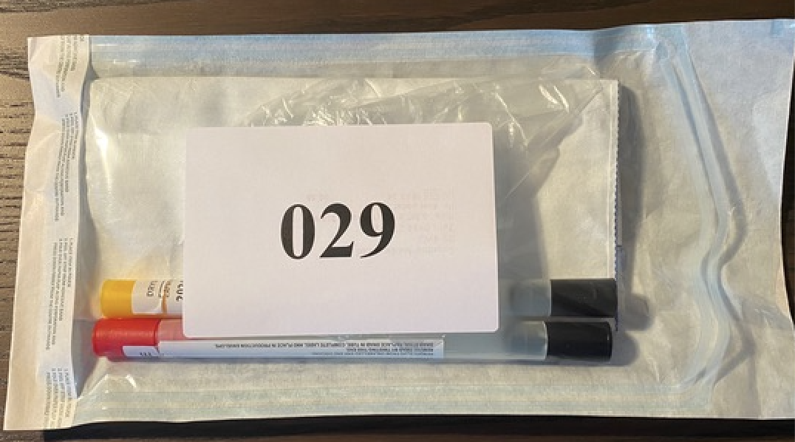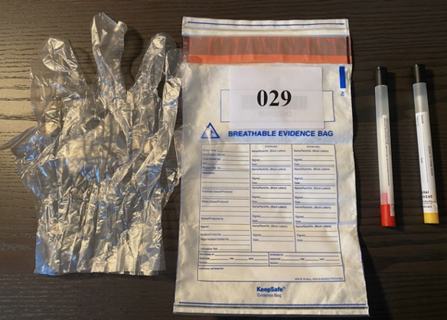
Figure 1: Packaged Contents of Self-Examination Kit; Figure 2: Unpacked Contents of Self-Examination Kit
The kits are particularly useful for providing evidence when the perpetrator is not in an intimate relationship with the survivor, or the survivor is under the age of 18 – where consent is not relevant. In such cases “establishing the identity of the perpetrator is a key question for investigators, as opposed to proving consent, which is a separate issue” (Smith, Flowe, & Kanja, 2019, p. 109). The DNA provides corroborating physical evidence of the offence (Smith, Flowe, and Kanja, 2019), which can form part of a prosecution strategy. Presently the kits are used with female survivors, who have been vaginally penetrated, however in the future, the kits will be adapted to be used by male survivors.

- Improvements to Current Process
Previous research has identified several challenges to the recovery and analysis of DNA samples in cases of sexual violence (Miheso & Mutugi, 2015). “Challenges faced were; contamination of samples resulting from collection and storage conditions, detection and quantification of sperm in samples and DNA extraction and profile generation” (Miheso & Mutugi, 2015, p. 1). The kits are able to overcome these challenges. As mentioned earlier, overall, the kits can support the collection of DNA in low-resource environments. The challenge in investigating SGBV in low resource settings is due to many complex social and political reasons:
This is largely due to barriers such as the lack of availability and accessibility of medical facilities and trained practitioners, as well as cultural norms and safety concerns that deter victims from seeking invasive medical examinations (Smith, Flowe, & Kanja, 2019, p. 111).
The self-examination kits provide three (3) key improvements to the current processes – they allow for the examination to be self-administered, allow for air-drying in a breathable evidence bag, and samples are held in tamper-evident packaging.
  - Supervised self-examination
A full medical examination after a sexual assault is a very intrusive process, and survivors report that interactions with police and the legal system can lead to ‘secondary victimisation,’ and few survivors have positive experiences, and this kit can allow for a reduction in this experience (Lorenz, Kirkner, & Ullman, 2019). The kits allow for either the survivor or a healthcare person to carry out the sample collection. Survivors can be provided with the choice and opportunity to carry out the examination themselves, as the kits do not require specialised training. This means that the DNA collection process can be less intrusive, and the process can also be carried out in a range of low resource settings (e.g. very basic healthcare clinics, NGO facilities, etc.). Having the choice to conduct the examination themselves provides the survivor with greater opportunity for control and agency over their body (Munro-Kramer, Dulin, & Gaither, 2017). The examination still needs to be supervised to maintain the chain of custody of the evidence. The survivor can still elect to have a full medical examination or have a healthcare person carry out the collection, either of which can involve the use of a speculum. However, the detection of DNA from spermatozoa or skin cells is still possible when a speculum has not been used (Astrup, et al., 2012; Smith et al., 2017).
DNA samples must be collected in a timely manner – within 72 hours to maximise the viability of the DNA sample for analysis. As the kits allow for collection to occur outside the traditional medical setting, it means that rural locations or delays which would impact the timely collection of the sample can be overcome. It is about collecting the best evidence possible, in the case of sexual violence, collecting samples in a timely manner but also reducing the risk of contamination by not requiring the survivor to go to multiple locations.
  - Air-Drying and Breathable Evidence Bag
Biological samples are vulnerable to degrading from the time they are collected until they are analysed, and contamination includes bacteria, fungi and enzymes (Garvin et al., 2013). DNA can degrade very quickly (Kuś, Ossowki, & Kielińska, 2016) and should be either dried or frozen (air-drying does not require additional refrigeration equipment). It is best to preserve the DNA sample rather than allowing it to degrade and become unusable (Senge et al., 2011). The swabs in the kit are held in tubes with removable black ends which allows the sample to be air-dried while remaining in the labelled tube (see: Figure 2: Vaginal Swab removed from tube with the end cap removed.) Further, these are then packaged in a breathable evidence bag (indefinitely) which provides for air drying, without the risk of contamination, tampering and human error.
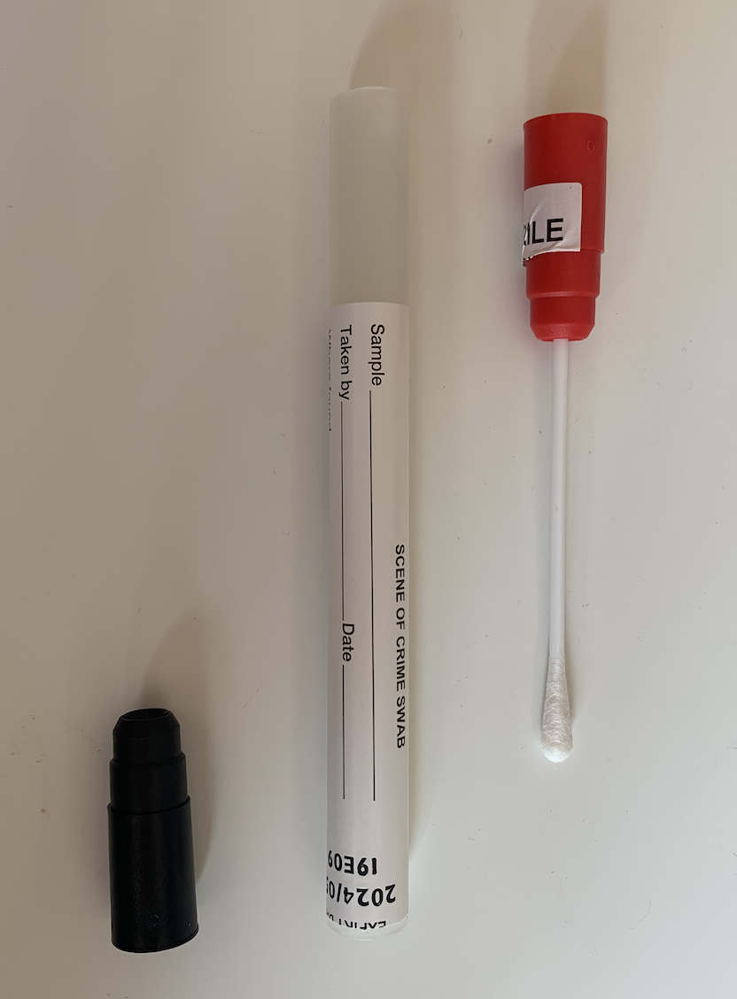
Figure 4: Vaginal Swab removed from the tube with the end cap removed
Reported evidence shows that contamination occurs in several different ways (1) before the sexual assault being committed; (2) in the interval between the crime and a forensic medical examination taking place; (3) during the forensic medical examination; and (4) within the forensic science provider (FSP) laboratory (Newton, 2013, p. 78). The air-drying tubes and the breathable, tamper-evident bag removes many opportunities for contamination and tampering, thus improving the utility and integrity of the evidence.
The current process in many clinics in Kenya has samples being air-dried in an insecure cabinet. Air drying does need to occur, but by taking samples out of the tubes without labelling and having the samples in close proximity to other unrelated case samples means the risk of contamination, tampering and human error are very high (see: Figure 3: Swab Air-drying Cupboard). This undermines the value of any evidence analysed and as a consequence reduces the probative value of the evidence to a police investigation, let alone a prosecution of a perpetrator. It provides the perpetrator with clear opportunities to challenge the evidence in court, and more likely than not have it excluded. The new process and kit mean that the samples do not need to be removed from the evidence bag until analysis at the laboratory, and there is no need for the air-drying cabinets or refrigeration. The samples can be kept in these evidence bags indefinitely until laboratory analysis is undertaken.
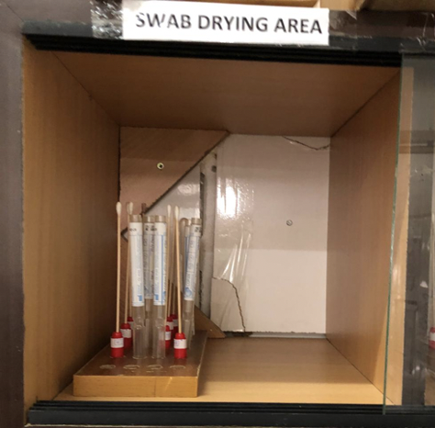
Figure 5: Swab Air-drying Cupboard
  - Tamper-Evident Evidence Bag
The samples are stored in the breathable evidence bags, which are tamper-evident. This means when the sample arrives at the laboratory, it is obvious whether the bag has been tampered with or not. The seal on the evidence bag cannot be reopened once sealed, and if an attempt is made to break the seal, the word ‘void’ appears across the top of the bag. The tamper-evident breathable evidence bag provides a chain of custody of the samples. There is sufficient space on the bag to record any required information for the investigation (see: Figure 4: Tamper-Evident Bag). This is opposed to the current process, which uses brown paper bags and envelopes which do not protect against tampering. Overall the evidence bags provide more confidence in evidence collected as it substantially reduces the risk of contamination, tampering and human error, with a simple solution. Providing the criminal justice system with reliable evidence that can be used in police investigations and prosecutions of perpetrators of sexual violence. The aim is to improve the rate of police collecting the samples (which is currently very low) and providing them to the Government Chemists for analysis.
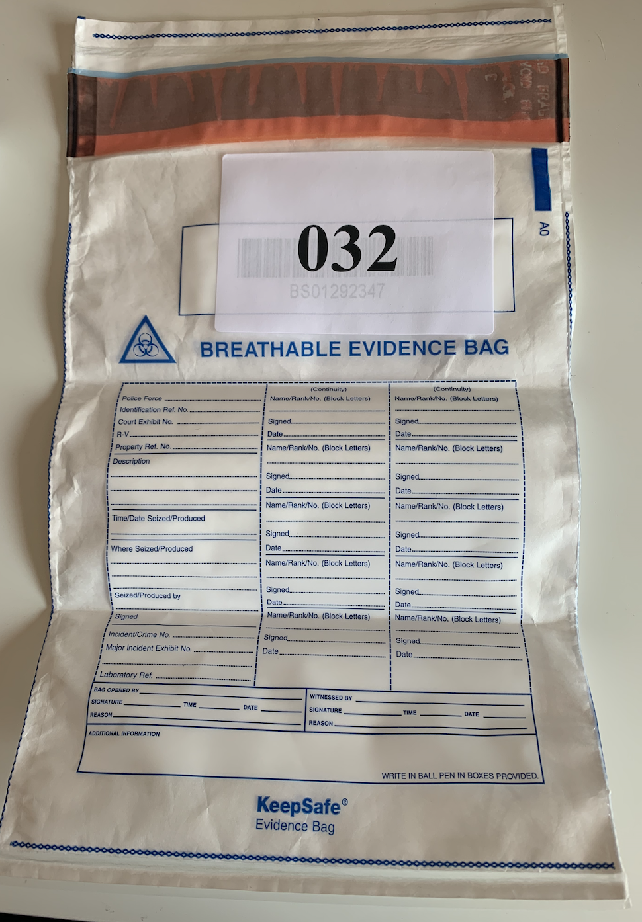
Figure 6: Tamper-Evident Bag
If the chain of custody is not able to be established and/or the sample is not viable for testing, then the sample collection conducted on the survivor is useless – exposing them to another traumatic experience and wasting time and resources on conducting the examination. The kits are a simple solution which are not resource-intensive.
- Current Studies
Two studies are currently being undertaken in Kenya, led by the University of Leicester in collaboration with the Wangu Kanja Foundation and Kenyatta University. First is the ‘Couples Pilot Study’ with heterosexual couples to test the clarity of the instructions and ease of use outside of a healthcare setting. Second, as the kits have been proven to work in providing viable DNA samples, the ‘Clinic Pilot Study’ is also currently underway. This clinic study is piloting the kits in SGBV clinics in Nairobi, by integrating them into routine clinical practice and following the results throughout the criminal justice process.
The Couples Pilot Study is a replication of a study carried out in the United Kingdom (Smith et al., 2017). The Couples Pilot is currently being carried out in Kenya with participants who volunteered to explore how well the instructions work with the sample population. The participants were required to be heterosexual couples over the age of 18, who are engaged in consensual unprotected vaginal intercourse. Participants who use oral contraceptives were able to participate; however, couples using barrier methods of contraception (including condoms and IUDs were not able to participate). Informed consent was obtained from both the male and female parties. Ethical approval was obtained from the University of Leicester, Kenyetta University, and the National Commission for Science, Technology, and Innovation in Kenya. Participants were provided with an information sheet and consent form to each complete. The kit included: a reference buccal swab for each participant (male and female), and a self -examination intimate swab (Smith et al., 2017). Reference buccal swabs were requested from each of the male and female participants as reference samples to use when analysing the vaginal swab. Participants were provided with full written and illustrated instructions and a brief questionnaire about ease of use. Members of the Kenya Survivors of Sexual Violence Network recruited participants in the local community after completing online training on the use of the kit so they could provide support and answer questions. Sixty kits from volunteer couples have been collected, and are currently awaiting analysis at the Kenya Medical Research Institute.
For the Clinic Pilot Study, the kits are in the process of being distributed to clinics in and around Nairobi. In addition, kits are also being placed in Nairobi Women’s Hospital Gender Violence Recovery Centres. The participating clinics and hospital staff have undergone training on how to use the kits to achieve best evidence. Those participating will feedback to the project team with data about the use of the kits. The project team will then work with the Government Chemist to ascertain how many of the kits are collected by police and given to the Government Chemist and the outcomes of the DNA profiling. The long-term goal is to see the evidence be collected and analysed to be used in the investigation and prosecution of sexual violence in Kenya.

- Conclusion
SGBV is an underreported crime, and successful prosecutions are rare. The DNA collected from these kits can help police investigations and support the prosecution of perpetrator/s. These kits can provide strong probative evidence to deter potential perpetrators, identify and prosecute guilty perpetrators, and identify innocent suspects. The expertise to analyse the DNA already exists in Kenya, and the SOA allows for the collection and databasing of perpetrator DNA profiles for comparison. The kits are a simple solution to address several limitations which currently exist in the Kenyan jurisdiction, without any requirement for specialised personnel or equipment. The kits provide the opportunity for more timely collection of DNA evidence (within the 72 hours of the sexual violence), a victim-centred approach to empower the survivors, significantly improves chain of custody to increase the value of the evidence and protects the samples from degradation, tampering and contamination. The success of the kit requires cooperation across the criminal justice system, from victim support, hospitals, laboratories, police and the courts all working together – a holistic approach is needed.

Funding Acknowledgement: Ring for Peace Foundation.

References
Abrahams, N., Devries, K., Watts, C., Pallitto, C., Petzold, M., Shamau, S., and García-Moreno, C. (2014). Worldwide prevalence of non-partner sexual violence: A systematic review, Lancet, 383, 1648-1654.
Astrup, B.S., Thomsen, J.L., Lauritsen, J., and Ravn, P. (2012). Detection of spermatozoa following consensual sexual intercourse. Forensic Science International, 221, 137-141. doi:10.1016/j.forsciint.2012.04.024
Blake, D.R., Duggan, A., Quinn, T., Zenilman, J., and Joffe, A. (1998). Evaluation of vaginal infections in adolescent women: Can it be done without a speculum. Pediatrics, 102(4 Pt 1), 939-944. doi:10.1542/peds.102.4.939
Briody, M. (2002). The effects of DNA evidence on sexual offence cases in court. Current Issues in Criminal Justice, 14(2), 159-181. doi:10.1080/10345329.2002.12036257
Daly, K. and Bouhours, B. (2010). Rape and attrition in the legal process: A comparative analysis of five countries. Crime and Justice, 39(1), 565-650.
Deitz, M.F., Williams, S.L., Rife, S.C., and Cantrell, P. (2015). Examining cultural, social, and self-related aspects of stigma in relation to sexual assault and trauma symptoms. Violence Against Woman, 21(5), 598-615. doi:10.1177/1077801215573330
Faculty of Forensic & Legal Medicine (FFLM). (2016). Recommendations for the collection of forensic specimens from complainants and suspects. Retrieved from: https://fflm.ac.uk/wp-content/uploads/2016/01/Recommendations-for-the-collection-of-forensic-specimens-from-complainants-and-suspects-FSSC-Jan-2016.pdf
Garvin, A.M., Holzinger, R., Berner, F., Krebs, W., Hostettler, B., Lardi, E., Hertli, C., Quartermaine, R., and Stamm, C. (2013). The forensiX evidence collection tube and its impact on DNA preservation and recovery. BioMed Research International, 2013, 1-7. doi:10.1155/2013/105797
George Muchika Lumbasi v Republic [2016] eKLR.
Hohl, K., and Conway, M.A. (2017). Memory as evidence: How normal features of victim memory lead to the attrition of rape complaints. Criminal & Criminal Justice, 17(3), 248-265. doi:10.1177/1748895816668937
Kamau, W. (2013). Legal treatment of consent in sexual offences in Kenya. (Equality Effect). Retrieved from: http://erepository.uonbi.ac.ke/bitstream/handle/11295/80231/Kamau_Legal%20treatment%20of%20consent%20in%20sexual%20offences%20in%20Kenya.pdf?sequence=1
Kuś, M., Ossowki, A., and Kielińska, G. (2016). Comparison of three different DNA extraction methods from a highly degraded biological material. Journal of Forensic and Legal Medicine, 40, 47-53. doi:10.1016/j.jflm.2016.03.002
Lorenz, K., Kirkner, A., and Ullman, S.E. (2019). A qualitative study of sexual assault survivors’ post-assault legal system experiences. Journal of Trauma & Dissociation, 20(3), 263-287. doi:10.1080/15299732.2019.1592643
Miheso, M.M., and Mutugi, M. (2015). Perpetrator DNA profiling in samples from rape victims in Kenya. Journal of Forensic Research and Criminal Studies, 2(401), 1-9.
Munro-Kramer, M.L., Dulin, A.C., and Gaither, C. (2017). What survivors want: Understanding the needs of sexual assault survivors. Journal of American College Health, 65(5), 297-305. doi:10.1080/07448481.2017.1312409
Newton, M. (2013). The forensic aspects of sexual violence. Best Practice & Research Clinical Obstetrics and Gynaecology, 27, 77-90. doi:10.1016/j.bpobgyn.2012.08.020\
Republic v John Kithyululu [2016] eKLR.
Senge, T., Madea, B., Junge, A., Rothschild, M.A., and Schneider, P.M. (2011). STRs, mini STRs and SNPs – A comparative study for typing degraded DNA. Legal Medicine, 13(2), 68-74. doi:10.1016/j.legalmed.2010.12.001
Smith, L., Flowe, H.D., and Kanja, W. (2019). Achieving more with less: A critical review of protocols for forensic investigation of sexual violence in low-resource environments. Forensic Science International: Synergy, 1, 108-113. doi:10.1016/j.fsisyn.2019.07.002
Smith, L.L., Wetton, J.H., Lall, G.K.M., Flowe, H.D., and Jobling, M. (2017). Forensic science and the right to access to justice: Testing the efficacy of self-examination intimate DNA swabs to enhance victim-centred responses to sexual violence in low-resource environments. Science & Justice, 57(5), 331-335. doi:10.1016/j.scijus.2017.07.004
Taylor, S.C., and Gassner, L. (2010). Stemming the flow: Challenges for policing adult sexual assault with regard to attrition rates and under-reporting of sexual offences. Police Practice and Research: An International Journal, 11(3), 240-255. doi:10.1080/15614260902830153
UN Women. (2019). Facts and figures: Ending violence against women. Retrieved from: https://www.unwomen.org/en/what-we-do/ending-violence-against-women/facts-and-figures
WHO, Department of Reproductive Health and Research. (2013). Global and regional estimates of violence against women: Prevalence and health effects of intimate partner violence and non-partner sexual violence. (London School of Hygiene and Tropical Medicine, South African Medical Research Council.) Retrieved from: https://www.who.int/reproductivehealth/publications/violence/9789241564625/en/

