Title: Association of cardiometabolic multimorbidity and depression with cardiovascular events in early-onset adult type 2 diabetes: a multi-ethnic study in the USA

Short Title: Cardiometabolic Multimorbidity, Depression and Cardiovascular Events in Early-Onset T2DM

John Epoh Dibato, MSc^{1#}; Olga Montvida, PhD^{1#}, Francesco Zaccardi, PhD²; Jack Alistair Sargeant, PhD^{2,3}, Melanie J Davies, MD^{2,3}, Kamlesh Khunti, PhD^{2,3}, Sanjoy K Paul, PhD¹

¹Melbourne EpiCentre, University of Melbourne and Melbourne Health, Melbourne, Australia
² Diabetes Research Centre, University of Leicester, Leicester General Hospital, Leicester, UK
³ Leicester NIHR Biomedical Research Centre
# Joint first author

Corresponding Author and person to whom reprint requests should be addressed:
Professor Sanjoy Ketan Paul
The Royal Melbourne Hospital – City Campus | 7 East, Main Building
Grattan Street, Parkville Victoria 3050
Email: sambhupaul@hotmail.com
Phone: +61 3 93428433
Fax: +61 3 93428780

Keywords: Early-onset Type 2 Diabetes; Ethnic Differences; White Caucasian; African American; Co-Morbidity; Depression; Cardiovascular Risk; Electronic Medical Records
Word Count, Abstract: 339
Word Count, Main Body: 2827
Number of Tables: 3
Number of Figures: 2
Supplemental Figures: 1
Supplemental Tables: 2
Number of References: 43
ABSTRACT
Background and Aims: Cardiometabolic Multimorbidity (CM) and depression in people with early-onset Type 2 diabetes (T2DM) and their impact on long-term Atherosclerotic Cardiovascular Disease (ASCVD) risk among White Caucasian (WC) and African American (AA) are not known. The aims were to evaluate the temporal patterns of CM and depression from diagnosis and the interplay of these comorbidities in the cardiovascular risk differentiation between WC and AA in US with a focus on early-onset T2DM.
Methods: From US nationally representative electronic medical record, 101,104 AA and 505,336 WC subjects with new diagnosis of T2DM from 2000 to 2018 were identified (mean follow-up: 5.3 years). Temporal trends in the early onset T2DM, prevalence of CM and depression at diagnosis, and the interplay of these comorbidities in the ASCVD and 3-point Major Atherosclerotic Cardiovascular Events (MACE-3; HF, myocardial infarction, or stroke) risk differences between ethnicities were evaluated by age groups.

Results: The proportion of AA and WC diagnosed at <40 years increased from 34% and 26% in 2012 to 38% and 29% in 2017, respectively. Among AA and WC, the depression prevalence increased from 15% and 20% in 2000 to 23% and 34% in 2017; with an increasing trend for CM at diagnosis in both groups.
Compared to WC, the adjusted MACE-3 risk was significantly higher in AA across all age groups, more pronounced in 18-39 years group (HR CI: 1.42, 1.88) and in people with and without depression. AA had 17% (HR CI: 1.05, 1.31) significantly higher adjusted ASCVD risk in the 18-39 years age group only. Depression was independently associated with ASCVD and MACE-3 risk in both ethnic groups across all age groups. Other comorbidities were independently associated with the ASCVD and MACE-3 risk only among WC.
Conclusions: AA have significantly higher cardiovascular risk compared to WC, particularly in early-onset T2DM. CM and depression at T2DM diagnosis has been increasing over last two decades in both ethnic groups. Strategies for screening and optimal management of CM and depression particularly in early-onset T2DM may result in a lower cardiovascular risk.
INTRODUCTION
Recent evidence from epidemiological studies has shown an increase in the incidence and prevalence of T2DM diagnosed at an earlier age, commonly defined as early-onset type 2 diabetes [1, 2]. Although definitions vary, these studies have indicated differences in the pathophysiological and phenotypical characteristics in patients with early-onset T2DM and a different risk profile of complications and mortality risk [2, 3]. In particular, early-onset T2DM is associated with a faster decline over time of the β-cell function, exacerbated by higher rates of obesity and associated co-morbidities, and sub-optimal self-care behaviours, resulting in a quicker deterioration of glucose control compared to individuals diagnosed at an older age [4-6].
Among the possible risk factors for an earlier diagnosis, ethnicity has been suggested to play a role. Certain ethnicities, including African Americans (AA) are at greater risk of T2DM than White Caucasians (WC). According to the most recent US Centre for Disease Control report (data from 2013-2016), the age-adjusted prevalence (95% CI) of diabetes among adult Non-Hispanic Black [16.8 (15.4-18.1)] was significantly higher compared to the Whites counterpart [10.0 (9.2-11.0)] [7]. However, these individuals, are also further disproportionately represented in early-onset adult T2DM. While the causes of the racial/ethnic differences in incidence of T2DM, as well as further disparities by age are not well understood, non-traditional risk factors such as depression has been identified as a possible risk factor, although its role in the risk of complications such as cardiovascular disease is not clear [8-13].

A recent UK primary care electronic medical records (EMR) based study reported higher risk of cardiovascular events and mortality in people diagnosed with T2DM younger than 50 years compared to others with T2DM diagnosed later in life, irrespective of their cardiometabolic risk factor level at diagnosis [2]. This study also reported that the proportion of people diagnosed with T2DM at the age < 50 years remained similar in the UK between 2011 and 2017. However, we are not aware of any study that has evaluated ethnicity-specific temporal trends of: cardiometabolic multimorbidity, CM (at least 2 events of ASCVD, Microvascular disease, Cancer, Obesity grade 2+ (BMI ≥ 35 kg/m²)); or depression at diagnosis of T2DM; or how ASCVD and mortality risk differ at a population level between different ethnic groups by age of T2DM diagnosis.
Therefore, using a nationally representative EMR database from US we investigated: (1) the trends in early-onset T2DM diagnosis in AA and WC between 2000 and 2018; (2) the trends in CM and depression, and the cardiometabolic risk factor distribution at T2DM diagnosis by age group and ethnicity; and (3) the risk of ASCVD and 3-point MACE-3: heart failure, myocardial infarction, or stroke) by ethnicities and age groups at T2DM diagnosis.

MATERIALS AND METHODS
This study has been conducted following the Reporting of studies Conducted using Observational Routinely-collected Data (RECORD) guidelines.

Data
The Centricity Electronic Medical Records (CEMR) incorporate patient-level data from independent physician practices, academic medical centres, hospitals and large integrated delivery networks in the USA. CEMR partners contribute de-identified patient-level data to enable quality improvement, benchmarking, and population-based medical research. The CEMR database covers over 40,000 health care providers from all US states, where ~70% are primary care providers. The similarity of the general population characteristics and cardiometabolic risk factors in the CEMR database with those reported in the US national health surveys has been reported previously [14, 15].
The CEMR database has been used extensively for academic research [14, 16, 17]. Longitudinal EMRs were available for more than 46 million individuals from 1995 until September 2018, with comprehensive patient-level information on demographics, anthropometric measures, disease events, medications, and clinical and laboratory measures.

Study Design and Variables
The study cohort was identified with the following conditions: (1) data available on age and sex; (2) WC or AA ethnicity; (3) aged 18-70 at the time of T2DM diagnosis; (3) diagnosed on or after 1st January 2000 to 31st Sept 2018; and (4) at least one year of available data in the EMRs prior to T2DM diagnosis, to reduce the bias in identifying incident T2DM patients. The clinically driven machine learning based algorithms to identify patients with T2DM from EMRs have been described previously [18, 19].
Ethnicity in CEMR is coded according to the US Census Bureau categorization [20]. HbA1c measures at baseline were obtained as the nearest measure within 3 months either side of the diagnosis. Baseline body weight, systolic blood pressure (SBP), blood lipid levels, and estimated glomerular filtration rate (eGFR) were calculated as the average of available measures within 3 months of diagnosis.
A robust methodology for extraction and assessment of longitudinal patient-level medication data from the CEMRs has previously been described [21]. A detailed account of glucose-lowering drug use in the US population, based on the CEMR, has also been reported [22]. Antihypertensive drugs included all Food and Drug Administration (FDA) approved diuretics, peripheral vasodilators, beta blockers, calcium channel blockers and agents acting on renin-angiotensin system. Lipid-lowering drugs included statins, bile acid sequestrants, fibrates, nicotinic acid, proprotein convertase subtilisin/kexin type 9 (PCSK9) inhibitors, and potent (≥1g) forms of omega-3/fish/krill oil.
ASCVD was defined by the presence of a clinical diagnosis of ischaemic heart disease (myocardial infarction, unstable angina or coronary revascularization, excluding stable angina) or cerebrovascular disease (ischaemic/haemorrhagic stroke, transient ischaemic attack or carotid revascularisation) or peripheral artery/vascular disease. Cardiovascular disease (CVD) included those with ASCVD and heart failure (HF). Microvascular disease was defined by a clinical diagnosis of neuropathy, retinopathy, or chronic kidney disease (CKD). CKD definition included diagnostic codes (CKD stages 3-5, end stage renal disease, dialysis, transplant, nephropathy, proteinuria, albuminuria, nephrotic syndrome, nephritis or eGFR <60 mL/min/1.73m² or urine albumin-creatinine ratio (UACR) > 30 mg/g. Cancer was defined as any malignant neoplasm excluding melanoma. Hypertension/dyslipidaemia were defined by presence of clinical diagnosis or use of antihypertensive/lipid lowering drugs prior to T2DM. Depression was defined using clinically guided machine learning algorithm [23-25]. The definition included those with a diagnostic code or at least two prescriptions for antidepressants (within 6 months window) used for treating depression: antidepressant medications were limited to those commonly prescribed for depression (Supplementary Table 1) [26, 27]. The algorithm accounted for other mental illnesses specified within the Diagnostic and Statistical Manual of Mental Disorders (DSM-5, excluding developmental and substance use disorders [28]). A disease was considered as prevalent if its first available diagnostic date was on or prior to the T2DM diagnosis (index date).

Statistical Methods
Baseline characteristics were summarised separately by age groups for AA and WC as number (%), mean (SD) or median (first quartile, third quartile), as appropriate. Age groups at T2DM diagnosis were: 18-39, 40-49, 50-59 and 60-70 years; early-onset T2DM was defined by the age cut-point of under 50 years at diagnosis.
We first estimated temporal trends of early-onset T2DM diagnosis as a proportion of total cases of diabetes and the prevalence of depression and CM by ethnicity and calendar year of T2DM diagnosis.
Second, the risks of ASCVD and MACE-3 were evaluated by ethnicity and age groups using flexible parametric survival models with time from index date (T2DM diagnosis) to the event or censoring (31st September 2018). Models were adjusted for age, sex, and smoking status and considered use of insulin, hypertension, dyslipidaemia, depression and other comorbidities as time-dependent covariates [29]. Other comorbidities included: microvascular diseases, cancer, HF, and grade-2 obesity prior to ASCVD event for ASCVD risk assessment; any CVD (except MI, HF or stroke), microvascular diseases, cancer, and grade-2 obesity prior to MACE-3 event for MACE-3 risk assessment. The use of non-insulin anti-diabetes drugs as a potential confounder was excluded from the model based on statistical information criteria. Age-group specific separate regression models were fitted to evaluate associations of depression and other comorbidities with ASCVD and MACE-3 risk in AA and WC. The multivariable model allowed the estimation of hazard ratios (HRs) and restricted mean survival time to ASCVD and MACE-3. The modifiable effect of depression in the risk of ASCVD and MACE-3 were evaluated using interaction modelling by ethnicity and depression status. Separate models were also fitted without depression as a confounder to evaluate the risk differentiation between ethnicities. Statistical significance level was set at 5%, with all confidence intervals set at 95%.

RESULTS

Temporal trend by age at diagnosis of T2DM
Supplementary Figure 1 shows the flow chart of people with incident T2DM identified in the study. The proportion of AA diagnosed with T2DM within in the age groups 18-39 and 40-49 years was 13% and 21% respectively, and was consistently higher by approximately 4% over the last two decades compared to the WC counterpart (10% and 17%, respectively). The proportion of AA and WC diagnosed at <50 years increased from 34% and 26% in 2012, respectively, to 38% and 29% in 2018 (Figure 1A).

Patient characteristics at diagnosis of type 2 diabetes
The baseline characteristics along with missing data in relevant risk factors are presented in Table 1. In the cohorts of 101,104 AA and 505,336 WC, AA had significantly higher mean HbA1c at diagnosis across all age groups compared to WC, while both ethnic groups had the highest HbA1c level in the youngest age group compared to the older age groups (Table 1). The AA group had significantly higher BMI (83% obese) compared to WC (77%) in the 18-39 years age group, while the BMI distributions (including grade 2 obesity) at diagnosis were similar between the ethnic groups in all age groups ≥ 40 years.

Temporal trend of cardiometabolic multimorbidity and depression at T2DM diagnosis
In the overall cohort, proportions with ASCVD, MACE-3, microvascular diseases and depression at diagnosis among AA and WC were 13% and 16%, 6% and 5%, 27% and 26% and 19% and 31%, respectively. While the prevalence of ASCVD and MACE-3 in early-onset T2DM were similar between ethnicities, in older people with T2DM it was marginally higher for ASCVD and marginally lower for MACE-3 among WC (Table 2). Although the proportions with microvascular disease were similar between ethnicities aged <50 years, AA had higher proportion with CKD (9%) compared to WC (7%) compared to WC across all age groups,
The prevalence of depression at the time of T2DM diagnosis has been significantly increasing across all age groups and both ethnicities, being significantly higher for WC compared to AA (Figure 1B). Among AA and WC, the overall prevalence of depression increased from 15% and 20% in 2000 to 23% and 34% in 2017, respectively (Figure 1B). These proportions were similar among people with early-onset T2DM (20% in AA and 34% in WC). The increasing trend in the prevalence of CM post 2010 has been similar in both ethnicities aged <60 years (Figures 1C – 1E).

Risk of ASCVD and MACE-3
The mean (median) follow-up time for ASCVD among AA and WC were 4.8 (5.4) years and 4.1 (4.7) years, respectively. The crude event rates per 1000 person years are presented in Supplementary Table 2.
AA had a 17% (HR 1.17; CI: 1.05, 1.31) higher adjusted ASCVD risk compared to WC only in the 18-39 years age group, while there was no difference in the ASCVD risk between the two ethnic groups in the older age groups (Table 3, Figure 2). In the subgroup of people with depression, the observed higher ASCVD risk in AA aged 18-39 years disappeared (95% HR CI: 0.96, 1.35).
AA had significantly higher adjusted MACE-3 risk compared to WC across all age groups. However, the higher MACE-3 risk among AA was lowest in the oldest group (60-70 years: HR 1.11; CI: 1.06, 1.15) and highest in the youngest age group (HR 1.63; CI: 1.42, 1.88). Higher MACE-3 risk in AA was consistent in people with and without depression (Table 3).
The restricted mean years to ASCVD post T2DM diagnosis in AA and WC in the 50-60 years age group were 15.2 and 15.1 years, about 2.5 years earlier than the expected time to event in the 18-39 years group (17.4 and 17.7 in AA and WC, respectively) in both ethnic groups. The difference in time to MACE-3 was also about 2.5 years in both AA and WC.

Depression and comorbidities
The association of depression and other comorbidities with both ASCVD and MACE-3 risk was in general more pronounced in WC than AA, yet there was overlap between HR CIs.
The depression state at diagnosis or during follow-up was independently associated with 1-36% and 1-28% increased risk of ASCVD and MACE-3 respectively, a modest effect-size consistently similar across age groups and ethnicity (all p<0.05, Table 3).
Other comorbidities were independently associated with the ASCVD and MACE-3 risk only among WC. Hypertension was associated with 2-50% and 2-39% significantly increased risk of ASCVD and MACE-3 respectively, effect size being similar across all age groups and ethnicity.
DISCUSSION

In the absence of any comparative US nationally representative ethnicity based data on the prevalence of co-morbidities including depression in early-onset T2DM, this study provides unique and comprehensive information on the temporal trend in the prevalence of CM and depression, with heterogeneity in early- and usual-onset T2DM. Another novelty of this study is the evaluation of ethnic differences in the risk of ASCVD and MACE-3 by age groups at T2DM diagnosis, and the interplay of depression and other comorbidities in such differences in a large cohort of people from a representative US EMR[15].
We have observed a consistently increasing trend in the prevalence of depression at T2DM diagnosis. The difference in the prevalence estimates between the ethnic groups remain similar over the last decade, prevalence estimates in AA and WC aged <40 years being 18% and 32% respectively. One of the reasons for the significantly lower prevalence estimate of depression at T2DM diagnosis in AA compared to WC is the discrepancies in the presentation of depression among AA when compared to WC. Depression in AA has a much higher likelihood of being underreported, underdiagnosed or misdiagnosed [30, 31]. Studies have suggested that AA with depression, particularly men, are more reticent to seek help from mental health services compared to non-AA [32]. While observed overall proportion with comorbid depression at T2DM diagnosis is similar to that reported in the recent meta-analysis of observational studies [33], we are not aware of any ethnicity specific comparable study evaluating the temporal trend in the prevalence of depression in incident T2DM.

Some studies based on observational data from US have discussed the cardiometabolic risk factor and biomarker differences between AA and WC in general population [34, 35].
However, such ethnicity-based data in people with incidence T2DM is scarce. While we are not aware of any observational study from US reporting prevalence of hypertension, dyslipidaemia and other comorbidities by age group at diagnosis of T2DM, the observed prevalence of hypertension and dyslipidaemia at T2DM diagnosis based on the CEMR database is comparable to those reported from survey data and observational studies from US [37]. It has been suggested that differences in the risk of CVD complications comparing T2DM diagnosed at younger vs older age may be related to the differences in the control of risk factors. While this may be a possible explanation, we note that this has not been formally tested in our study (i.e., accounting for levels of risk factors) yet CM was associated with a higher relative risk of ASCVD in those diagnosed at younger compared to older age.

The role of ethnicity in the higher risk of ASCVD events in general population has been investigated in the previous studies and US surveys [38-40]. However, the extent to which differences by age groups and multimorbidity interplay with the CVD outcomes has not been investigated, to our knowledge. We showed consistently higher MACE-3 risk in AA compared to WC in early-onset T2DM, while this difference tended to be lower for those diagnosed at older age. Importantly, these differences were present regardless of the presence of depression, which was independently associated with a greater risk of ASCVD and MACE-3.

This EMR based study has several limitations. Coding of conditions is a common limitation when using EMRs. However, we used machine learning methods to identify both the population and the depression at diagnosis. The US Centre for Disease Control and Prevention 2015 survey reported 20% prevalence of any mental illness, similar to our US CEMR during that period (23%)[41, 42]. Other limitations include unavoidable indication bias and residual confounding that remains as a common problem in any EMR based outcome studies, and lack of data on socioeconomic characteristics, physical activity, the nature of insurance, education, income, and other cultural drivers. Furthermore, while reliable information on medication adherence is a common problem in all clinical studies, detailed validation studies of US EMRs suggests high level of agreement between EMR prescription data and the pharmacy claims data, especially in chronic diseases [43].
Nevertheless, our study highlights the increasing burden of early-onset T2DM and in AA the increased risk of ASCVD in this early-onset group. The increased risk of depression in both ethnic groups regardless of age highlights that early detection and management of depression in T2DM may be an important strategy in reducing CV risk.

ACKNOWLEDGEMENTS
SKP and OM conceptualized and designed the study. OM and JED conducted the data extraction. OM, JED and SKP jointly conducted the statistical analyses. The first draft of the manuscript was developed by OM and SKP, while KK, MJD, FZ, JAS and JED contributed in the interpretation of results and finalisation of the manuscript. SKP and OM had full access to all the data in the study and takes responsibility for the integrity of the data and the accuracy of the data analysis.
Melbourne EpiCentre gratefully acknowledges the support from the National Health and Medical Research Council and the Australian Government’s National Collaborative Research Infrastructure Strategy (NCRIS) initiative through Therapeutic Innovation Australia. No separate funding was obtained for this study.

Source of Funding
No separate funding was obtained for this project.

Declaration of interests
SKP has acted as a consultant and/or speaker for Novartis, Sanofi Avantis, GI Dynamics, Roche, AstraZeneca, Guangzhou Zhongyi Pharmaceutical and Amylin Pharmaceuticals LLC. He has received grants in support of investigator and investigator initiated clinical studies from Merck, Novo Nordisk, AstraZeneca, Hospira, Amylin Pharmaceuticals, Sanofi-Aventis and Pfizer. OM and JED have no conflict of interest to declare. JAS has received funding from AstraZeneca UK in the form of an investigator-initiated trial. MJD has acted as consultant, advisory board member and speaker for Novo Nordisk, Sanofi-Aventis, Lilly, Merck Sharp & Dohme, Boehringer Ingelheim, AstraZeneca and Janssen, an advisory board member for Servier and Gilead Sciences Ltd and as a speaker for NAPP, Mitsubishi Tanabe Pharma Corporation and Takeda Pharmaceuticals International Inc. She has received grants in support of investigator and investigator initiated trials from Novo Nordisk, Sanofi-Aventis, Lilly, Boehringer Ingelheim, AstraZeneca and Janssen. K.K. has served as a consultant for and received speakers’ fees from Amgen, AstraZeneca, Bayer, Berlin-Chemie AG/ Menarini Group, Boehringer Ingelheim, Eli Lilly, Merck Sharp & Dohme, NAPP, Novartis, Novo Nordisk, Roche, Sanofi, and Servier; has served on an advisory board for AstraZeneca, Eli Lilly, MerckSharp&Dohme, NovoNordisk, and Sanofi; and has received grants in support of investigator and investigator-initiated trials from Astra- Zeneca, Boehringer Ingelheim, Eli Lilly,MerckSharp & Dohme, Novartis, Novo Nordisk, Pfizer, Sanofi, and Servier.

REFERENCES
1. Magliano, D.J., et al., Young-onset type 2 diabetes mellitus — implications for morbidity and mortality. Nature Reviews Endocrinology, 2020. 16(6): p. 321-331.
2. Koye, D.N., et al., Temporal Trend in Young-Onset Type 2 Diabetes—the Macrovascular and Mortality Risk: Study of U.K. Primary Care Electronic Medical Records. Diabetes Care, 2020: p. dc200417.
3. Huo, L., et al., Impact of age at diagnosis and duration of type 2 diabetes on mortality in Australia 1997–2011. Diabetologia, 2018. 61(5): p. 1055-1063.
4. Lascar, N., et al., Type 2 diabetes in adolescents and young adults. Lancet Diabetes Endocrinol, 2018. 6(1): p. 69-80.
5. Weinstock, R.S., et al., Self-Monitoring of Blood Glucose in Youth-Onset Type 2 Diabetes: Results From the TODAY Study. Diabetes Care, 2019. 42(5): p. 903-909.
6. Nanayakkara, N., et al., Younger people with Type 2 diabetes have poorer self-care practices compared with older people: results from the Australian National Diabetes Audit. Diabet Med, 2018. 35(8): p. 1087-1095.
7. Centers for Disease Control and Prevention, National diabetes statistics report: estimates of diabetes and its burden in the United States, 2020. Atlanta, GA: US Department of Health and Human Services, 2020.
8. Pan, A., et al., Bidirectional association between depression and type 2 diabetes mellitus in women. Arch Intern Med, 2010. 170(21): p. 1884-91.
9. Tang, B., et al., Major depressive disorder and cardiometabolic diseases: a bidirectional Mendelian randomisation study. Diabetologia, 2020. 63(7): p. 1305-1311.
10. Paul, S., et al. Temporal trend in prevalence and incidence of type 2 diabetes in early-onset depression and mortality risk: study of UK primary care electronic medical records. in DIABETOLOGIA. 2019. SPRINGER 233 SPRING ST, NEW YORK, NY 10013 USA.
11. Shah, B.M., et al., Association of ABC (HbA1c, blood pressure, LDL-cholesterol) goal attainment with depression and health-related quality of life among adults with type 2 diabetes. 2015. 29(6): p. 794-800.
12. Browne, J.L., et al., Depression, anxiety and self-care behaviours of young adults with Type 2 diabetes: results from the International Diabetes Management and Impact for Long-term Empowerment and Success (MILES) Study. Diabetic Medicine, 2015. 32(1): p. 133-140.
13. Excess Burden of Mental Illness and Hospitalization in Young-Onset Type 2 Diabetes. Annals of Internal Medicine, 2019. 170(3): p. 145-154.
14. Brixner, D., et al., Assessment of cardiometabolic risk factors in a national primary care electronic health record database. Value in health, 2007. 10(s1): p. S29-S36.
15. Montvida, O., J. Dibato, and S.K. Paul, Evaluating the Representativeness of US Centricity Electronic Medical Records with Reports from Centers for Disease Control and Prevention: Office Visits and Cardiometabolic Conditions. JMIR Medical Informatics, 2020. in production.
16. Crawford, A.G., et al., Comparison of GE Centricity Electronic Medical Record database and National Ambulatory Medical Care Survey findings on the prevalence of major conditions in the United States. Popul Health Manag, 2010. 13(3): p. 139-50.
17. Montvida, O., et al., Long‐term sustainability of glycaemic achievements with second‐line antidiabetic therapies in patients with type 2 diabetes: A real‐world study. Diabetes, Obesity and Metabolism, 2018. 20(7): p. 1722-1731.
18. Owusu Adjah, E.S., et al., Data mining approach to identify disease cohorts from primary care electronic medical records: a case of diabetes mellitus. The Open Bioinformatics Journal, 2017. 10: p. 16-27.
19. Moreno-Iribas, C., et al., Validity of type 2 diabetes diagnosis in a population-based electronic health record database. BMC Medical Informatics and Decision Making, 2017. 17(1): p. 34.
20. United States Census Bureau. Race & Ethnicity. 2018; Available from: https://www.census.gov/mso/www/training/pdf/race-ethnicity-onepager.pdf.
21. Montvida, O., et al., Long-term trends in antidiabetes drug usage in the US: real-world evidence in patients newly diagnosed with type 2 diabetes. Diabetes care, 2017: p. dc171414.
22. Montvida, O., et al., Long-term trends in antidiabetes drug usage in the US: real-world evidence in patients newly diagnosed with type 2 diabetes. Diabetes Care, 2018. 41(1): p. 69-78.
23. Marie Ingram, W., et al., Defining Major Depressive Disorder Cohorts Using the EHR: Multiple Phenotypes Based on ICD-9 Codes and Medication Orders. bioRxiv, 2018: p. 227561.
24. Deferio, J.J., et al., Using electronic health records to characterize prescription patterns: focus on antidepressants in nonpsychiatric outpatient settings. JAMIA Open, 2018. 1(2): p. 233-245.
25. Schneider, G., et al., A systematic review of validated methods for identifying erythema multiforme major/minor/not otherwise specified, Stevens-Johnson Syndrome, or toxic epidermal necrolysis using administrative and claims data. Pharmacoepidemiol Drug Saf, 2012. 21 Suppl 1: p. 236-9.
26. U.S. Food and Drug Administration (FDA), FDA approved drugs 2019.
27. Formulary, B.N., BNF 76 (September 2018 – March 2019) 2018.
28. NIMH. Mental Illness. 2019 [cited 2019 July 31]; Available from: https://www.nimh.nih.gov/health/statistics/mental-illness.shtml#part_154785.
29. Lambert, P.C. and P. Royston, Further development of flexible parametric models for survival analysis. Stata Journal, 2009. 9(2): p. 265-290.
30. Bailey, R.K., J. Mokonogho, and A. Kumar, Racial and ethnic differences in depression: current perspectives. Neuropsychiatric disease and treatment, 2019. 15: p. 603-609.
31. Woodward, A.T., et al., Major depressive disorder among older African Americans, Caribbean blacks, and non-Hispanic whites: secondary analysis of the National Survey of American Life. Depress Anxiety, 2013. 30(6): p. 589-97.
32. Shim, R.S., et al., Racial/ethnic disparities, social support, and depression: examining a social determinant of mental health. Ethnicity & disease, 2012. 22(1): p. 15-20.
33. Khaledi, M., et al., The prevalence of comorbid depression in patients with type 2 diabetes: an updated systematic review and meta-analysis on huge number of observational studies. Acta Diabetol, 2019. 56(6): p. 631-650.
34. Hackler, E., 3rd, et al., Racial Differences in Cardiovascular Biomarkers in the General Population. Journal of the American Heart Association, 2019. 8(18): p. e012729-e012729.
35. Osei, K. and T. Gaillard, Disparities in Cardiovascular Disease and Type 2 Diabetes Risk Factors in Blacks and Whites: Dissecting Racial Paradox of Metabolic Syndrome. Front Endocrinol (Lausanne), 2017. 8: p. 204.
36. Bancks, M.P., et al., Long-term absolute risk for cardiovascular disease stratified by fasting glucose level. Diabetes Care, 2019. 42(3): p. 457-465.
37. Loop, M.S., et al., Heat Maps of Hypertension, Diabetes Mellitus, and Smoking in the Continental United States. Circulation: Cardiovascular Quality and Outcomes, 2017. 10(1): p. e003350.
38. Racial and Ethnic Disparities in Heart Disease, in Health, United States Spotlight. 2019, Centre for Disease Control and Prevention: US.
39. Bahrami, H., et al., Differences in the incidence of congestive heart failure by ethnicity: the multi-ethnic study of atherosclerosis. Archives of internal medicine, 2008. 168(19): p. 2138-2145.
40. Suzuki, T., M.Z. Israr, and A. Salzano, Biomarkers in Cardiovascular Disease: The Dilemma of Racial Differences. Journal of the American Heart Association, 2019. 8(18): p. e014295-e014295.
41. Brody, D.J., L.A. Pratt, and J.P. Hughes, Prevalence of Depression Among Adults Aged 20 and Over: United States, 2013-2016. NCHS Data Brief, 2018: p. 1-8.
42. Bethesda, M., Chronic Illness & Mental Health. National Institute of Mental Health, 2015.
43. Rowan, C.G., et al., Agreement and validity of electronic health record prescribing data relative to pharmacy claims data: A validation study from a US electronic health record database. Pharmacoepidemiology and Drug Safety, 2017. 26(8): p. 963-972.

Table 1: Baseline characteristics of the study cohort at the time of type 2 diabetes diagnosis.
Characteristics |  | 18-39 Years |  | 40-49 Years |  | 50-59 Years |  | 60-70 Years
 | Statistics | WC  (N= 48,118) | AA  (N= 13,520) | WC  (N= 86,041) | AA  (N= 20,923) | WC  (N= 164,745) | AA  (N= 35,646) | WC  (N= 206,432) | AA  (N= 31,015)
Follow-up, years | Mean (SD) | 5.2 (4.0) | 4.7 (3.7) | 5.4 (4.0) | 4.9 (3.7) | 5.3 (3.9) | 4.8 (3.6) | 5.5 (4.1) | 4.9 (3.7)
Male | N (%) | 15,787 (33) | 3,563 (26) | 38,832 (45) | 7,123 (34) | 78,299 (48) | 12,127 (34) | 101,413 (49) | 11,053 (36)
Age, years | Mean (SD) | 33 (5) | 32 (6) | 45 (3) | 45 (3) | 55 (3) | 55 (3) | 65 (3) | 64 (3)
Ever-smoker | N (%) | 19,872 (41) | 4,411 (33) | 37,270 (43) | 7,196 (34) | 73,917 (45) | 14,807 (42) | 89,120 (43) | 12,301 (40)
Unknown smoking status | N (%) | 13,993 (29) | 4,021 (30) | 24,817 (29) | 6,462 (31) | 47,260 (29) | 10,598 (30) | 64,958 (31) | 10,569 (34)
HbA1c, % | N (%) non-missing | 26,443 (55) | 7,782 (58) | 46,972 (55) | 11,697 (56) | 83,368 (51) | 18,726 (53) | 95,270 (46) | 14,781 (48)
 | Mean (SD) | 7.9 (2.2) | 8.2 (2.4) | 7.7 (2.1) | 7.9 (2.3) | 7.5 (1.9) | 7.7 (2.1) | 7.2 (1.6) | 7.4 (1.9)
HbA1c ≥ 7.5% | N (% of non-missing) | 12,064 (46) | 3,619 (47) | 18,366 (39) | 4,675 (40) | 28,001 (34) | 6,548 (35) | 24,037 (25) | 4,305 (29)
Weight, kg | N (%) non-missing | 44,108 (92) | 12,403 (92) | 76,920 (89) | 18,624 (89) | 144,264 (88) | 31,143 (88) | 176,833 (86) | 26,240 (85)
 | Mean (SD) | 106 (31) | 111 (31) | 106 (27) | 107 (27) | 102 (24) | 100 (23) | 96 (22) | 94 (21)
BMI | N (%) non-missing) | 43,693 (91) | 12,307 (91) | 76,181 (89) | 18,511 (89) | 142,947 (87) | 30,904 (87) | 174,431 (85) | 25,946 (84)
 | Mean (SD) | 37.6 (10.0) | 39.4 (10.4) | 37.0 (8.6) | 37.6 (9.1) | 35.5 (8.0) | 35.5 (8.2) | 33.6 (7.3) | 33.6 (7.7)
BMI obese | N (% of non-missing) | 33,814 (77) | 10,226 (83) | 61,266 (80) | 15,103 (82) | 108,491 (76) | 23,026 (75) | 117,083 (67) | 17,029 (66)
--- BMI obese Grade 2+ | N (% of Obese) | 25,070 (74) | 7,876 (77) | 41,909 (68) | 10,371 (69) | 66,975 (62) | 14,209 (62) | 62,837 (54) | 9,364 (55)
SBP, mmHg | N (%) non-missing) | 44,312 (92) | 12,492 (92) | 77,054 (90) | 18,721 (90) | 143,649 (87) | 31,042 (87) | 175,658 (85) | 26,153 (84)
 | Mean (SD) | 125 (13) | 128 (15) | 128 (14) | 132 (16) | 130 (15) | 133 (16) | 132 (15) | 135 (17)
SBP ≥ 140 mmHg | N (% of non-missing) | 5,566 (13) | 2,404 (19) | 14,653 (19) | 4,962 (27) | 33,674 (23) | 9,594 (31) | 49,607 (28) | 9,490 (36)
LDL mg/dL | N (%) non-missing) | 17,514 (36) | 4,817 (36) | 38,413 (45) | 8,724 (42) | 71,384 (43) | 14,524 (41) | 84,251 (41) | 11,588 (37)
 | Mean (SD) | 111 (35) | 111 (36) | 113 (36) | 116 (37) | 110 (36) | 114 (38) | 102 (36) | 110 (37)
LDL-C ≥100 mg/dL | N (% of non-missing) | 10,808 (62) | 2,904 (60) | 24,583 (64) | 5,702 (65) | 42,064 (59) | 9,210 (63) | 41,201 (49) | 6,607 (57)
LDL-C ≥ 70 mg/dL | N (% of non-missing) | 15,656 (89) | 4,289 (89) | 34,475 (90) | 7,909 (91) | 62,391 (87) | 12,954 (89) | 69,485 (82) | 10,067 (87)
Non-HDL-C, mg/dL | N (%) non-missing | 22,025 (46) | 6,255 (46) | 47,716 (56) | 11,213 (54) | 88,592 (54) | 18,667 (52) | 102,666 (50) | 14,921 (48)
 | Mean (SD) | 153 (48) | 140 (43) | 156 (47) | 145 (43) | 149 (45) | 142 (43) | 137 (42) | 136 (42)
Non-HDL-C ≥ 130 mg/dL | N (% of non-missing) | 15,132 (69) | 3,475 (56) | 34,010 (71) | 6,844 (61) | 57,270 (65) | 11,043 (59) | 54,519 (53) | 7,732 (52)
Non-HDL-C ≥ 100 mg/dL | N (% of non-missing) | 20,031 (91) | 5,288 (85) | 43,926 (92) | 9,781 (87) | 78,654 (89) | 15,995 (86) | 84,389 (82) | 12,117 (81)
Triglycerides, mg/dL | N (%) non-missing | 22,108 (46) | 6,321 (47) | 47,778 (56) | 11,339 (54) | 88,716 (54) | 18,809 (53) | 102,064 (49) | 15,103 (49)
 | Median (Q1, Q3) | 174 (118, 266) | 114 (81, 167) | 179 (124, 267) | 118 (84, 173) | 168 (119, 242) | 117 (85, 170) | 155 (111, 218) | 111 (82, 155)
Triglycerides ≥ 150mg/dL | N (% of non-missing) | 13,394 (61) | 1,967 (31) | 29,855 (62) | 3,836 (34) | 52,492 (59) | 6,116 (33) | 53,971 (53) | 4,140 (27)
eGFR, ml/min/1.73m2 | N (%) non-missing | 28,226 (59) | 8,122 (60) | 56,516 (66) | 13,503 (65) | 103,094 (63) | 22,035 (62) | 123,499 (60) | 17,952 (58)
eGFR < 60 ml/min/1.73m2 | N (% non-missing) | 587 (2) | 282 (3) | 2,684 (5) | 976 (7) | 9,960 (10) | 2,931 (13) | 28,300 (23) | 4,158 (23)

Table 2: History of comorbidities on or prior to diagnosis of T2DM and use of medications any time during follow-up.
 | 18-39 Years |  | 40-49 Years |  | 50-59 Years |  | 60-69 Years |  | Total
 | WC  (N= 48,118) | AA  (N= 13,520) | WC  (N= 86,041) | AA  (N= 20,923) | WC  (N= 164,745) | AA  (N= 35,646) | WC  (N= 206,432) | AA (N= 31,015) | N= 606,440
History of comorbidities on or prior to T2DM diagnosis
Any CVD | 1,684 (3) | 503 (4) | 6,917 (8) | 1,703 (8) | 23,813 (14) | 4,693 (13) | 47,879 (23) | 6,042 (19) | 93,234 (15)
ASCVD | 1,440 (3) | 319 (2) | 6,081 (7) | 1,212 (6) | 21,729 (13) | 3,731 (10) | 44,063 (21) | 5,149 (17) | 83,724 (14)
MACE-3 | 589 (1) | 302 (2) | 2,491 (3) | 940 (4) | 7,920 (5) | 2,320 (7) | 14,865 (7) | 2,674 (9) | 32,101 (5)
Heart Failure | 278 (1) | 225 (2) | 1,135 (1) | 616 (3) | 3,474 (2) | 1,366 (4) | 7,313 (4) | 1,547 (5) | 15,954 (3)
Myocardial Infarction | 201 (0) | 48 (0) | 998 (1) | 183 (1) | 3,387 (2) | 503 (1) | 5,854 (3) | 632 (2) | 11,806 (2)
Stroke | 144 (0) | 51 (0) | 517 (1) | 205 (1) | 1,638 (1) | 626 (2) | 2,879 (1) | 767 (2) | 6,827 (1)
Peripheral artery disease | 270 (1) | 81 (1) | 1,118 (1) | 219 (1) | 4,128 (3) | 787 (2) | 8,779 (4) | 1,286 (4) | 16,668 (3)
Microvascular disease | 6,810 (14) | 1,900 (14) | 18,524 (22) | 4,723 (23) | 41,632 (25) | 10,120 (28) | 65,945 (32) | 10,102 (33) | 159,756 (26)
CKD | 2,013 (4) | 775 (6) | 7,148 (8) | 2,176 (10) | 20,532 (12) | 5,453 (15) | 45,315 (22) | 6,924 (22) | 90,336 (15)
Cancer | 940 (2) | 203 (2) | 2,834 (3) | 641 (3) | 8,075 (5) | 1,731 (5) | 16,707 (8) | 2,650 (9) | 33,781 (6)
Depression | 15,541 (32) | 2,473 (18) | 29,251 (34) | 4,315 (21) | 54,072 (33) | 7,405 (21) | 58,252 (28) | 5,107 (16) | 176,416 (29)
Hypertension | 19,330 (40) | 6,499 (48) | 51,363 (60) | 14,568 (70) | 117,177 (71) | 28,438 (80) | 162,916 (79) | 26,527 (86) | 426,818 (70)
Dyslipidaemia | 13,855 (29) | 2,895 (21) | 43,655 (51) | 8,498 (41) | 104,331 (63) | 19,312 (54) | 146,395 (71) | 19,677 (63) | 358,618 (59)
Multimorbidity | 5,320 (11) | 1,538 (11) | 14,378 (17) | 3,629 (17) | 32,547 (20) | 7,221 (20) | 50,182 (24) | 7,158 (23) | 121,973 (20)
Use of medications any time during follow-up
Metformin | 30,623 (64) | 8,869 (66) | 62,457 (73) | 14,867 (71) | 117,727 (71) | 24,460 (69) | 132,604 (64) | 18,821 (61) | 410,428 (68)
Insulin | 10,583 (22) | 3,692 (27) | 18,925 (22) | 5,116 (24) | 34,196 (21) | 8,152 (23) | 40,294 (20) | 6,548 (21) | 127,506 (21)
Sulfonylurea | 12,231 (25) | 3,619 (27) | 26,853 (31) | 6,520 (31) | 51,707 (31) | 10,939 (31) | 68,387 (33) | 10,109 (33) | 190,365 (31)
GLP-1RA | 6,905 (14) | 1,452 (11) | 12,796 (15) | 2,147 (10) | 18,925 (11) | 2,627 (7) | 13,879 (7) | 1,280 (4) | 60,011 (10)
DPP-4i | 6,965 (14) | 1,946 (14) | 16,756 (19) | 4,019 (19) | 31,593 (19) | 6,610 (19) | 34,779 (17) | 5,303 (17) | 107,971 (18)
SGLT-2i | 3,765 (8) | 883 (7) | 8,964 (10) | 1,536 (7) | 14,000 (8) | 1,925 (5) | 9,165 (4) | 876 (3) | 41,114 (7)
Antihypertensives | 27,392 (57) | 8,580 (63) | 65,410 (76) | 17,213 (82) | 138,808 (84) | 31,722 (89) | 185,594 (90) | 28,846 (93) | 503,565 (83)
Lipid Lowering | 20,410 (42) | 4,972 (37) | 58,076 (67) | 12,665 (61) | 127,525 (77) | 25,240 (71) | 171,289 (83) | 24,031 (77) | 444,208 (73)
Data values are in count (%). Multiple comorbidity: at least 2 of ASCVD, microvascular disease, cancer, or obesity grade 2+ (≥35 kg/m2); CVD: cardiovascular disease; ASCVD: atherosclerotic cardiovascular disease; CKD: chronic kidney disease; GLP-1RA: glucagon like peptide 1 receptor agonist; DPP-4i: dipeptidyl peptidase 4 inhibitor; SGLT-2i: sodium-glucose cotransporter-2 inhibitor.

Table 3: Adjusted risk (HR (CI)) for atherosclerotic cardiovascular disease (ASCVD) and MACE-3 (heart failure, myocardial infarction, stroke) in African American (AA) compared to White Caucasian (WC) – in the overall cohort and separately in people with and without depression. The independent association of depression and other comorbidities with the ASCVD and MACE-3 risk separately in African American (AA) / White Caucasian (WC) are presented under the “Confounder” section. Other comorbidities included: microvascular diseases, cancer, HF and grade-2 obesity prior to ASCVD event for ASCVD risk assessment; any CVD (except MI, HF or stroke), microvascular diseases, cancer and grade-2 obesity prior to MACE-3 event for MACE-3 risk assessment.
 |  |  | AA vs WC |  |  |  | Confounder
 | Number of Subjects | Number of Events | Overall | Without Depression | With  Depression | Depression  AA / WC |  | Other Comorbidities  AA / WC
ASCVD
18-39 | 59,451 | 1,883 | 1.17  (1.05, 1.31) | 1.21  (1.05, 1.39) | 1.14  (0.96, 1.35) | 1.16 (1.01, 1.36) /  1.11 (1.02, 1.20) |  | 1.14 (0.95, 1.36) /  1.14 (1.04, 1.25)
40-49 | 98,344 | 7,541 | 1.02  (0.96, 1.08) | 0.96  (0.93, 1.03) | 1.10  (0.99, 1.22) | 1.15 (1.05, 1.26) /  1.13 (1.09, 1.18) |  | 1.03 (0.94, 1.14) /  1.06 (1.01, 1.11)
50-59 | 171,885 | 19,949 | 0.97  (0.93, 1.01) | 0.94  (0.90, 0.99) | 0.95  (0.88, 1.02) | 1.06 (1.00, 1.13) /  1.13 (1.11, 1.16) |  | 1.01 (0.95, 1.08) /  1.04 (1.01, 1.07)
60-70 | 183,526 | 33,179 | 0.94  (0.90, 1.01) | 0.90  (0.87, 0.93) | 0.90  (0.84, 0.97) | 1.02 (0.96, 1.08) /  1.07 (1.05, 1.10) |  | 1.00 (0.95, 1.06) /  1.01 (0.99, 1.03)
MACE-3
18-39 | 59,451 | 986 | 1.63  (1.42, 1.88) | 1.82  (1.52, 2.18) | 1.42  (1.13, 1.78) | 1.02 (1.01, 1.13) /  1.13 (1.01, 1.26) |  | 1.22 (0.98, 1.51) /  1.27 (1.11, 1.44)
40-49 | 98,344 | 3,681 | 1.48  (1.37, 1.60) | 1.54  (1.39, 1.69) | 1.38  (1.22, 1.56) | 1.10 (1.02, 1.23) /  1.21 (1.14, 1.28) |  | 0.99 (0.88, 1.11) /  1.14 (1.07, 1.21)
50-59 | 171,885 | 10,525 | 1.37  (1.31, 1.44) | 1.38  (1.30, 1.46) | 1.32  (1.21, 1.43) | 1.14 (1.06, 1.23) /  1.15 (1.11, 1.19) |  | 1.09 (0.99, 1.17) /  1.14 (1.10, 1.19)
60-70 | 183,526 | 20,764 | 1.11  (1.06, 1.15) | 1.09  (1.04, 1.14) | 1.09  (1.00, 1.18) | 1.10 (1.03, 1.18) /  1.10 (1.07, 1.12) |  | 1.04 (0.97, 1.11) /  1.08 (1.05, 1.11)

Supplementary Figure 1: Flow-chart of study cohort.

Patients with non-missing age and sex, n=46,074,872
African American, n=3,513,255 (8%)
White Caucasian, n=25,066,157 (54%)
Unknown, n=16,321,658 (35%)
Other, n=1,173,802 (3%)
Type 2 Diabetes, n=3,333,685
African American, n=385,394 (12%)
White Caucasian, n=2,118,417 (64%)
Unknown, n=727,177 (22%)
Other, n=102,697 (3%)
18-70 years at diagnosis, n=1,848,337
African American, n=317,127 (17%)
White Caucasian, n=1,531,210 (83%)
T2DM dx post 1999, n=1,803,005
African American, n=311,333
White Caucasian, n=1,491,672

At least 1 year in the EMRs prior to T2DM dx, n=606,440
African American, n=101,104
White Caucasian, n=505,336
White Caucasian or African American, n=2,503,811
African American, n=385,384
White Caucasian, n=2,118,417
Figure 1: By year of T2DM diagnosis: (A) proportion of early-onset diabetes; (B) prevalence of depression in the whole cohort; (C)-(F) by age groups prevalence of cardiometabolic comorbidity (CM) (presence of at least 2 of: atherosclerotic cardiovascular disease, microvascular disease, cancer, grade 2+ obesity).
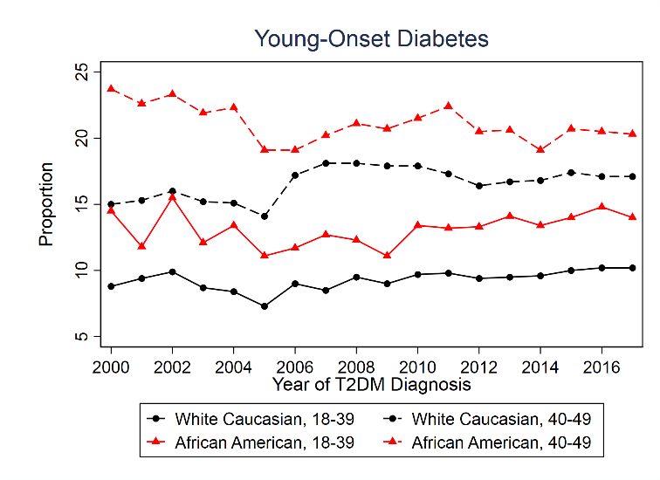  (A) | 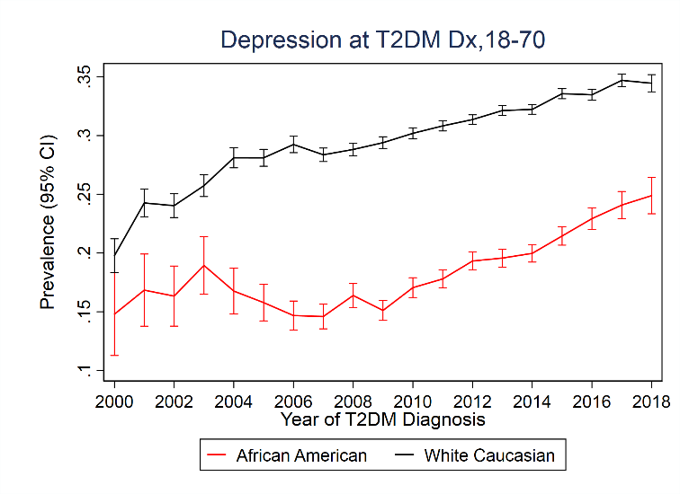  (B)
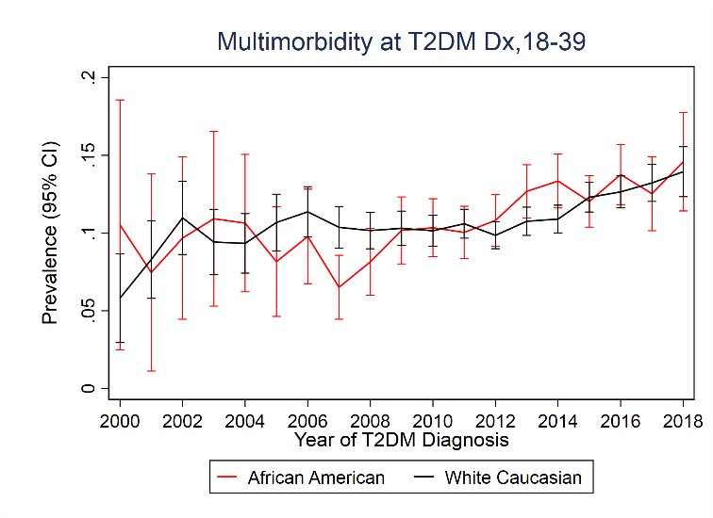  (C) | 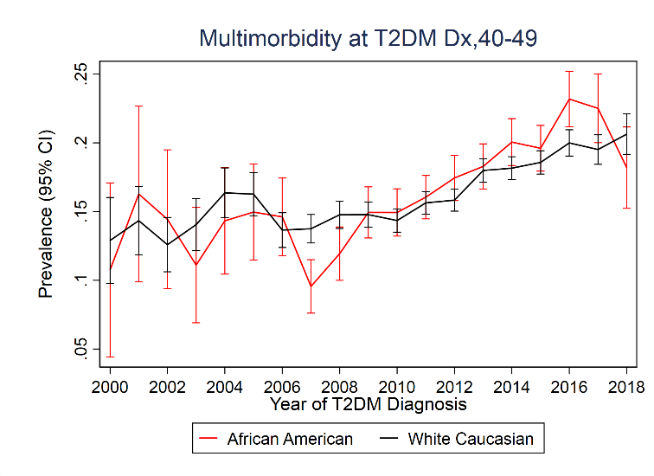  (D)
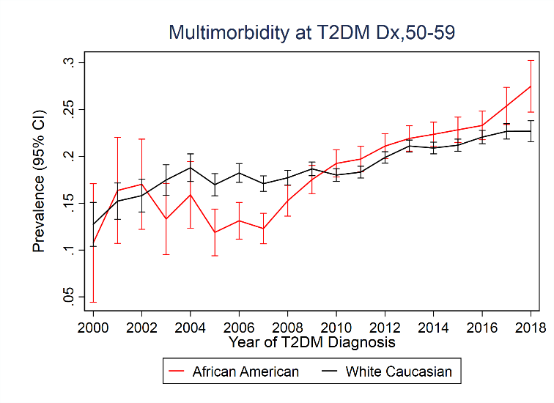  (E) | 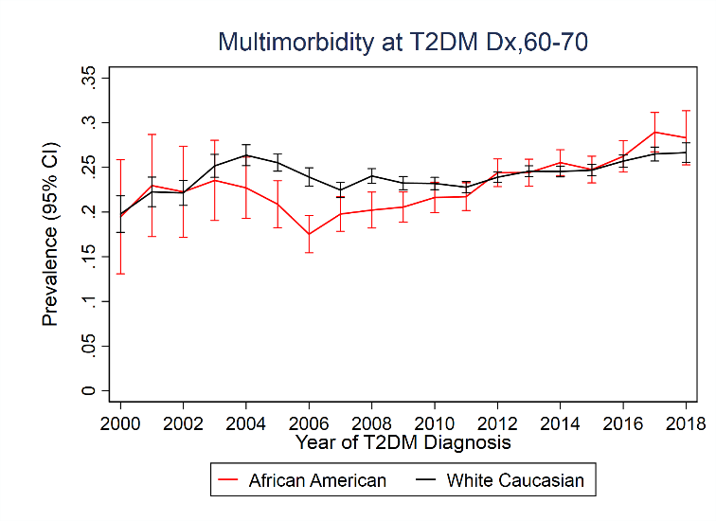  (F)

Figure 2: Adjusted risk (95 % CI) for ASCVD and MACE-3 in African American (AA) compared to White Caucasian (WC).

Supplementary Table 1: List of antidepressants drugs coded in the US Centricity Electronic Medical Records that was used to identify people with depression.
Drug class | Generic name | Brand name | Indications
Tricyclic antidepressants (TCAs) | amitriptyline | ALAVIL(Elavil), SENTRAVIL, LIMBITROL, TRIAVIL, VANATRIP, ETRAFON | major depressive disorder (MDD), anxiety disorders, and less commonly attention deficit hyperactivity disorder (ADHD) and bipolar disorder,
 | amoxapine | ASENDIN | anxiety, depression
 | clomipramine | ANAFRANIL | depression, anxiety, panic disorder
 | doxepin | SILENOR, SINEQUAN | insomnia (low dose of doxepin), depression, anxiety
 | trimipramine, desipramine, imipramine | SURMONTIL, NORPRAMIN, TOFRANIL, | depression
 | nortriptyline | PAMELOR, AVENTYL | depression, ADHD
 | protriptyline | VIVACTIL | depression, ADHD
Monoamine -oxidase inhibitors (MAOIs) | isocarboxazid | MARPLAN | depression
 | Phenelzine | NARDIL | depression
 | tranylcypromine | PARNATE | depression
Selective serotonin reuptake inhibitors (SSRIs) | Fluoxetine | Prozac, SYMBYAX, SARAFEM, SELFEMRA | MDD, obsessive compulsive disorder (OCD), bulimia nervosa, panic disorder, and premenstrual dysphoric disorder (PMDD), depression associated with bipolar, anxiety, anorexia nervosa, Posttraumatic Stress Syndrome (PTSD), Binge Eating Disorder
 | sertraline | ZOLOFT | depression, OCD, panic disorder, PTSD, social anxiety disorder, and PMDD
 | paroxetine | PAXIL, PEXEVA | depression, OCD, panic attacks, anxiety disorders, PTSD, and PMDD
 | citalopram | CELEXA, CIPRAMIL | depression, anxiety, OCD, panic disorder, PTSD, and PMDD
 | escitalopram | LEXAPRO, CIPRALEX | anxiety in adults and MDD
 | fluvoxamine | LUVOX | OCD, depression
 | vortioxetine | BRINTELLIX, TRINTELLIX | major depressive disorder
Serotonin-noradrenaline reuptake inhibitors (SNRIs) | Venlafaxine, desvenlafaxine | EFFEXOR, PRISTIQ, KHEDEZLA | anxiety, depression
 | duloxetine | CYMBALTA, IRENKA | depression, anxiety
 | levomilnacipran | FETZIMA | depression
Other antidepressants | buproprion | BUDEPRION¸ BUPROBAN, WELLBUTRIN, APLENZIN, APPBUTAMONE, FORFIVO, APLENZIN | depression
 | trazodone | OLEPTRO, DESYREL | depression
 | mirtazapine | REMERON | depression
 | nefazodone | SERZONE | depression
 | maprotiline | LUDIOMIL | depression, anxiety
 | vilazodone | VIIBRYD, TIANEPTINE | depression, anxiety

Supplementary Table 2: Crude rate (95% CI) per 1000 persons years of follow-up for ASCVD and MACE-3 in White Caucasian (WC) and African American (AA) by age groups at diagnosis of T2DM.
 | ASCVD |  | MACE-3
 | AA | WC | AA | WC
18-39 | 7.1 (6.5, 7.8) | 6.3 (6.0, 6.6) | 4.6 (4.1, 5.2) | 2.9 (2.7, 3.1)
40-49 | 15.3 (14.5, 16.2) | 15.7 (15.3, 16.1) | 9.1 (8.5, 9.7) | 6.5 (6.2, 6.7)
50-59 | 23.1 (22.3, 23.9) | 25.3 (24.9, 25.7) | 13.7 (13.2, 14.3) | 10.6 (10.4, 10.8)
60-69 | 36.0 (34.9, 37.2) | 40.6 (40.1, 41.0) | 19.4 (18.6, 20.1) | 18.6 (18.3, 18.8)

