An Operations Management perspective on the effectiveness of homeworkers

Dr Nicola Bateman University of Leicester nab34@le.ac.uk
Dr Gail Kinman Visiting Birkbeck University of London. g.kinman@bbk.ac.uk
Dr Cheryl Travers, Loughborough University c.travers@lboro.ac.uk
Dr Karen Maher Nottingham Trent University karen.maher@ntu.ac.uk

Introduction
The exodus to homeworking caused by the pandemic may underpin future working patterns and if organisations are to responsibly undertake homeworking, they need to consider the implications to operational activities, particularly the part of the supply chain between homeworkers and the employers. This study was initiated by the authors as users of social media - at the start of the Covid-19 pandemic we noticed people spontaneously posting about homeworking. We wanted to explore their experiences in order to support people and organisations as part of the response to the pandemic and also examine the apparent societal shift towards more homeworking and its implications for wellbeing and productivity.
Other studies have been initiated in this area using traditional methods such as questionnaires or interviews, but our approach was to develop the open sharing of experiences on social media using a ‘netnographic’ method (Kozinets, 2015). The objectives for the wider study were to explore the demands of homeworking, and to help organisations manage homeworking more effectively during and beyond the Covid-19 crisis. Relating specifically to supply chain resilience, the ability to have “The adaptive capability of the supply chain to prepare for unexpected events, respond to disruptions, and recover from them by maintaining continuity of operations at the desired level of connectedness and control over structure and function.” (Ponomarov and Holcomb, 2009, p.131) is particularly salient during the Covid-19 pandemic. As Bhamra, Dani, and Burnard state (2011 p.5376), resilience is therefore related to both the individual and organisational responses to turbulence and discontinuities.

Literature
The gradual shift to home working in the UK pre-existed the pandemic with 1.5% people in employment in 1981 reporting working mainly at home, increasing to 4.7% by 2019. This substantially increased in April 2020 to 43.1%, remaining high for subsequent months. During this time initial studies have shown the effect on productivity has been mixed with no substantial overall effect being detected (Felstead and Reuschke, 2020). However, there is growing evidence that this shift has affected different workers in substantially different ways; some positive and some quite negatively. Those that were positively affected tended to be in occupations that had previously been identified as suitable for home working (Etheridge, Wang and Tang 2020). Those negatively affected tended to “include women and those in low-paying jobs. Declines in productivity are strongly associated with declines in mental wellbeing.” (Etheridge, Wang and Tang 2020). The effect on women tends to be associated with childcare responsibilities identified in Felstead and Reuschke, 2020 who also highlight problems for younger workers which our research also supports. In the ONS (2020) survey on coronavirus and anxiety, sex was a significant factor although this changed over time “anxiety was higher for women than men in the early stages of lockdown but the gap between the sexes narrowed in subsequent weeks, such that in the latter part of the period covered, there was no significant gap between men and women. Prior to lockdown, anxiety was usually higher for women than men” (ONS 2020).
In terms of operations, the role of individuals as part of the supply chain ecosystem, either as part of traditional goods or service supply chains is known to be related to their wellbeing (Mollenkopf, Ozanne, and Stolze, 2020). The sudden shift to homeworking also represents an opportunity for event-based supply chain research into the links between organisations and the individual as called for in Remko (2020). The visibility of data to support decision-making is particularly important in supporting effective supply chains (Somapa, Cools, and Dullaert, 2018) and it will be interesting to explore if this emerges as a theme by respondents.

Methodology
We created a closed Facebook group following BPS ethical guidelines for conducting internet-mediated research (BPS, 2017) and using Facebook rules for group conduct. We invited participants initially using our networks and subsequently using snowballing techniques. This resulted in 211 participants with a core of active posters.
We adopted a participant-observer approach (Kozinets, 2015) by sharing our own experiences and stimulating discussions. Some participants who heard about the research through friends but were not Facebook users sent direct messages to the researchers. This overall approach provided a supportive environment that was ethical and approved by our institutions. It allowed a fairly free-flowing discussion on topics that emerged within the group. The participants were mainly from the UK and varied in terms of demographic and employment backgrounds. The initial analysis consisted of reviewing the contributions for prominent themes. A more systematic analysis of textual and visual data is planned to validate and enrich these findings.

Findings
The overall response to the Facebook group was positive with the group mostly self-managing and sparking a range of debates as different issues emerged and the pandemic unfolded. Responses ranged from longer statements, to several paragraphs, and one-word responses. Group members also shared memes, photographs, and jokes. This resulted in a rich data source and the following themes emerged:
- Workplace organisation: i.e., desk set-up, access to software etc. This was often affected by the following factors:
- Home resources
- Supplied equipment
- Organisational online services and support
- Wellbeing.
- Routine, including home-work separation and managing conflicting roles
- The comforting presence of pets
- Personal circumstances:
  - fit between work-life balance preferences and what respondents are experiencing.
  - psychosocial factors (e.g. loneliness, support for example from co-workers and family)
- Social inequalities being emphasised, for example having enough workspace, caring responsibilities (Figure 2).
Participants commented on being able to fit a good quality working space into their homes
“I live in a compact living space and I am working from my bedroom as I don't have an office I can use or a dining area”
Comments were also posted about issues with accommodating everyone at home, for example a part time worker making way for a full time worker in the best workspace. With regard to work colleagues being able to see your workspace through video conferencing apps such as Zoom, there were comments about expectations from work organisations:
“Being able to 'craft' your background is a sign of privilege. Many people cannot afford the space to do this”
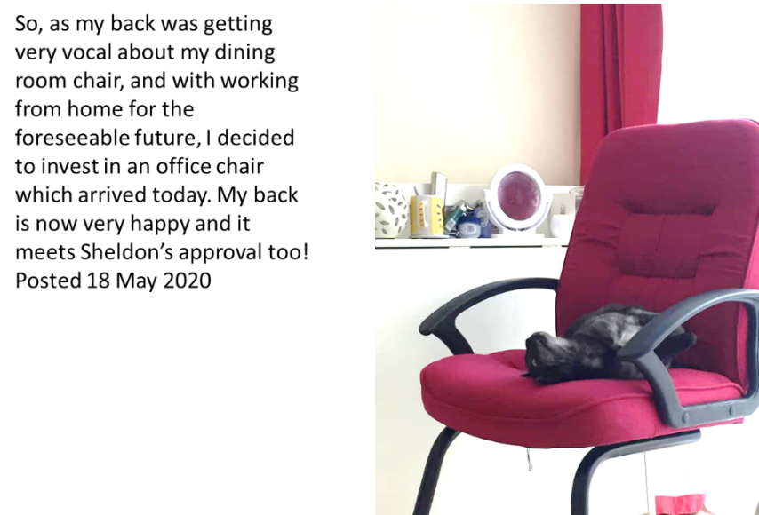
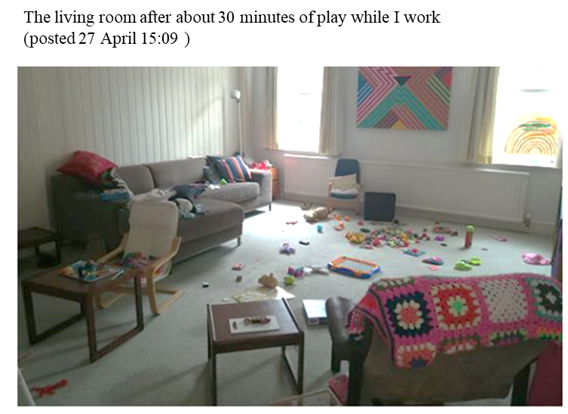
Figure 1- Image of new office chair with Sheldon the cat
Figure 2: Caring responsibilities
We also observed that the same themes were expressed differently over the short and long term, as people came to terms with certain aspects of homework or aspects became more irksome. For example:
“The first week of lockdown I was really productive and thought I was going to get a lot done. But then I hit a wall and had five weeks when I just managed to keep on top of things. The simplest of tasks took hours. But last week I moved my working to another room, set specific targets for each day (smaller targets than I would otherwise set) and I seem to have become more productive again.”
This reflects the short- and long-term response by organisations as highlighted in (Belhadi, et al, 2020) who emphasise the importance of human awareness (and thus capability) in the process of supply chain evaluation and response.
The inequality of load was also reflected both in childcare and having sufficient space to home work. A participant with young children commented on both the burden but also the enjoyment of spending more time with family:
“I'm loving my time with them, especially whilst they're so young ……this is definitely much harder overall - like doing 2 full time jobs at the same time!”
Appropriate provision for practical aspects of workplace organisation from employers, particularly IT, was patchy, and respondents regarded themselves as ‘lucky’ if they were well supported.
I’m so grateful to my employers … and for making sure all the IT works. I’m very lucky!

Relevance and contribution
Supply chains are reliant on people – despite the rise of automation and data-driven decision-making. This research addresses that part of the supply chain between homeworkers and the outside world. It looks both at the workplace organisation in terms of physical environment and on-line support tools - but also the wellbeing of homeworkers. Wellbeing has been shown to have a strong effect on productivity when working from home during the pandemic (Etheridge, Wang and Tang 2020).
This research uses an innovative netnographic methodology to gain insights that might be neglected by more conventional methods. This can provide vivid illustrations to organisations to improve resilience over the short and long term such as office equipment and live IT support. In addition, organisations can provide guidance as to good habits for homeworkers to support their personal resilience. This approach complements research using more conventional methods where similar findings for causes of reduction in productivity, such as childcare, were reported (Etheridge, Wang and Tang 2020).
The posts from the participants provide examples of what helps e.g. routines and there have been many suggestions of self-help. The participants also comment openly on what interventions from their workplace they have found supportive and has worked well to enable working from home.

Conclusion
The method of data collection allowed the issues of workplace organisation to be vividly illustrated by the submission of photographs and informal comments. Our findings in relation to Operations Management and Supply Chains address three areas:
- Resilience of the supply chain. When part of the supply chain includes people working from home, the resilience of the whole supply chain will be affected. This is because supply chains are reliant on individual decision-makers as well as the physical parts of the supply chain that are more obviously affected by catastrophic events. The effects on resilience of homeworkers apply differently over short and long term as reflected in previous supply chain research.
- Effect on wellbeing and its relation to productivity for workers at home. It is evident from our research and others researchers such as Felstead, and Reuschke, (2020) that for some people working from home has benefits but that for some people wellbeing and productivity is adversely affected. In addition to ethics of concern for employees wellbeing is important because it has been established that wellbeing affects productivity both in our own research and more extensively by Etheridge, Wang and Tang 2020. Wellbeing is affected by a whole raft of criteria but in our research pets and the comfort of the workplace emerged as particularly important.
- Workplace organisation affects peoples’ wellbeing both physically and mentally and this has an effect on their productivity. In relation to Operations Management workplace organisation forms part of job design and 5S. Such a formal approach is probably inappropriate for a home setting but consideration of having the appropriate equipment in terms of ergonomics is important. It is also important that the home workplace is organised appropriate equipment and supported in terms of access to software and ‘on-demand’ support.
We acknowledge that all the data here is self-reported and respondents self-selected. However, the validity of the data in terms of other studies supports its veracity. This work is on-going and we will be continue to explore various areas. including specifically relating to operations:
- Visibility of data to support decision-making
- Lack of informal learning opportunities – particularly for newer workers or relating to unfamiliar working practices.

References

Belhadi, A., Kamble, S., Jabbour, C.J.C., Gunasekaran, A., Ndubisi, N.O. and Venkatesh, M., (2020). Manufacturing and service supply chain resilience to the COVID-19 outbreak: Lessons learned from the automobile and airline industries. Technological Forecasting and Social Change, 168 Feb p.120447.
Bhamra, R., Dani, S. and Burnard, K., (2011). Resilience: the concept, a literature review and future directions. International Journal of Production Research, 49(18), pp.5375-5393.
British Psychological Society (2017). Ethics Guidelines for Internet-mediated Research. INF206/04.2017. Leicester: Author. Available from: www.bps.org.uk/publications/policy-and-guidelines/
Etheridge, B., Wang, Y. and Tang, L., 2020. Worker Productivity during Lockdown and Working from Home: Evidence from Self-Reports. Covid Economics, 52, pp.118-151.
Felstead, A. and Reuschke, D., 2020. Homeworking in the UK: before and during the 2020 lockdown. WISERD Report, Cardiff: Wales Institute of Social and Economic Research. Available for download from: https://wiserd.ac.uk/publications/homeworking-ukand-during-2020-lockdown
Kozinets, R. (2015). Netnography. In Anabel Quan-Haase and Luke Sloan (Eds) Sage Handbook of Social Media Methods. DOI: 10.1002/9781118767771.wbiedcs067
Mollenkopf, D.A., Ozanne, L.K. and Stolze, H.J., 2020. A transformative supply chain response to COVID-19. Journal of Service Management.
ONS (2020) “Coronavirus and anxiety, Great Britain: 3 April 2020 to 10 May 2020” https://www.ons.gov.uk/peoplepopulationandcommunity/wellbeing/articles/coronavirusandanxietygreatbritain/3april2020to10may2020
Remko, V.H., 2020. Research opportunities for a more resilient post-COVID-19 supply chain–closing the gap between research findings and industry practice. International Journal of Operations & Production Management.
Somapa, S., Cools, M. and Dullaert, W., 2018. Characterizing supply chain visibility–a literature review. The International Journal of Logistics Management.

