ADA/KDIGO Consensus Report: Diabetes Management in Chronic Kidney Disease

Ian H. de Boer¹, Kamlesh Khunti², Tami Sadusky³, Katherine R. Tuttle⁴, Joshua J. Neumiller⁵, Connie M. Rhee⁶, Sylvia E. Rosas⁷, Peter Rossing^{8,9}, George Bakris¹⁰

¹University of Washington, Kidney Research Institute, Seattle, WA, USA; ²Diabetes Research Centre, University of Leicester, United Kingdom; ³University of Washington, Seattle, WA, USA; ⁴University of Washington, Spokane, WA, USA; ⁵College of Pharmacy and Pharmaceutical Sciences, Washington State University, Spokane, WA, USA; ⁶University of California Irvine, Orange, CA, USA; ⁷Joslin Diabetes Center and Harvard Medical School, Boston, MA; ⁸Steno Diabetes Center Copenhagen; and ⁹University of Copenhagen, Copenhagen, Denmark; ¹⁰University of Chicago Medicine, Chicago, IL, USA

Running headline: Consensus Report on Diabetes Management in CKD

Abstract: 181 words

Manuscript text: 6690 (without tables and figures)

Corresponding and senior author:
Ian de Boer, MD, MS
Box 359606, 325 9th Ave
Seattle, WA 98104
United States
(206) 616-5403
deboer@u.washington.edu

Abstract:
People with diabetes and chronic kidney disease (CKD) are at high risk for kidney failure, atherosclerotic cardiovascular disease, heart failure, and premature mortality. Recent clinical trials support new approaches to treat diabetes and CKD. The 2022 American Diabetes Association (ADA) Standards of Care and Kidney Disease: Improving Global Outcomes (KDIGO) 2022 Clinical Practice Guideline for Diabetes Management in CKD each provide evidence-based recommendations for management. A joint group of ADA and KDIGO representatives reviewed and developed a series of consensus statements to guide clinical care from the Standards of Care and KDIGO Guideline. The published guidelines are aligned in the areas of CKD screening and diagnosis, glycemia monitoring, lifestyle therapies, treatment goals, and pharmacologic management. Recommendations include comprehensive care in which pharmacotherapy that is proven to improve kidney and cardiovascular outcomes is layered on a foundation of healthy lifestyle. Consensus statements provide specific guidance on use of renin-angiotensin system inhibitors, metformin, SGLT2 inhibitors, GLP-1 receptor agonists, and a nonsteroidal mineralocorticoid receptor antagonist. These areas of consensus provide clear direction for implementation of care to improve clinical outcomes of people with diabetes and CKD.
Introduction
Clinicians and patients refer to clinical practice guidelines to synthesize data and provide expert direction on diagnosis and treatment. Guidelines must be evidence-based, systematic, transparent, and explicit to offer credibility and impact implementation. They must also allow adaptation to local circumstances and provide mechanisms for updates over time.
A rapidly expanding number of clinical trials are advancing clinical care in the field of diabetes and chronic kidney disease (CKD). The American Diabetes Association (ADA) and Kidney Disease: Improving Global Outcomes (KDIGO) each follow structured processes to assess these data and develop rigorous, evidence-based guidelines for adults with diabetes and CKD.^{1, 2} Areas of consensus between the two guidelines therefore represent independent agreement on high priority areas of care.
The goal of this consensus report was to identify and highlight shared recommendations from the ADA 2022 Standards of Medical Care in Diabetes and KDIGO 2022 Clinical Practice Guideline for Management of Diabetes in CKD.^{1, 2} A joint writing group of ADA and KDIGO representatives convened to compare and contrast ADA and KDIGO recommendations. A series of virtual meetings were held from March 2021 through February 2022 to define scope, review published guidelines and supportive evidence, and jointly write and revise the consensus report. Meetings were co-chaired by an ADA representative (GB) and a KDIGO representative (IHdB) and supported by both ADA and KDIGO staff.
Consensus statements were drafted when recommendations from each organization were aligned and supported by high-quality evidence from randomized clinical trials (Box 1). These statements do not specify a level of evidence, which can be found in the individual ADA and KDIGO documents. However, all consensus statements were endorsed by both the ADA and KDIGO and represent broad agreement on evidence-based management of adults with diabetes and CKD.
Box 1.
ADA/KDIGO Consensus Statements
- All patients with T1D or T2D and CKD should be treated with a comprehensive plan, outlined and agreed by health care professionals and the patient together, to optimize nutrition, exercise, smoking cessation, and weight, upon which are layered evidence-based pharmacologic therapies aimed at preserving organ function and other therapies selected to attain intermediate targets for glycemia, blood pressure, and lipids.
- An ACEi or ARB is recommended for patients with T1D or T2D who have hypertension and albuminuria, titrated to the maximum antihypertensive or highest tolerated dose.
- A statin is recommended for all patients with T1D or T2D and CKD, moderate intensity for primary prevention of ASCVD or high-intensity for patients with known ASCVD and some patients with multiple ASCVD risk factors.
- Metformin is recommended for patients with T2D, CKD, and an eGFR ≥30 mL/min/1.73 m²; the dose should be reduced to 1,000 mg daily in patients with an eGFR 30-44 mL/min/1.73 m² and in some patients with eGFR of 45-59 mL/min/1.73 m² who are at high risk of lactic acidosis.
- An SGLT2 inhibitor with proven kidney or cardiovascular benefit is recommended for patients with T2D, CKD, and an eGFR ≥20 mL/min/1.73 m². Once initiated, the SGLT2 inhibitor can be continued at lower levels of eGFR.
- A GLP-1 receptor agonist with proven cardiovascular benefit is recommended for patients with T2D and CKD who do not meet their individualized glycemic target with metformin and/or an SGLT2 inhibitor or because they are unable to use these drugs.
- A nonsteroidal mineralocorticoid receptor antagonist with proven kidney and cardiovascular benefit is recommended for patients with T2D, an eGFR ≥25 mL/min/1.73 m², normal serum potassium concentration, and albuminuria (ACR ≥30 mg/g) despite maximum tolerated dose of RAS inhibitor.

Background
CKD occurring among people with diabetes is common, morbid, and costly. The International Diabetes Federation estimates that 537 million people were living with diabetes in 2021, with an expected increase to 784 million by the year 2045.³ The prevalence of CKD among people with diabetes is over 25%, and it has been estimated that 40% of people with diabetes develop CKD during their lifetime.⁴ As the prevalence of diabetes has increased, the prevalence of CKD attributable to diabetes has grown proportionally.⁴

Diabetes is the most common cause of kidney failure requiring kidney transplantation or dialysis worldwide.⁵ In the United States, diabetes fueled a marked increase in the prevalence of kidney failure over the last 30 years and now accounts for half of all new cases of kidney failure.⁶ Moreover, CKD markedly amplifies risks of atherosclerotic cardiovascular disease (ASCVD), heart failure (HF), cardiovascular death, and all-cause mortality among people with diabetes.^{7, 8}

In the United States, one out of every five adults with diabetes is not aware of their diagnosis.⁹ Awareness to CKD is even lower, with nine of 10 individuals unaware of having underlying CKD, including two out of five with severe CKD.^{6, 10} In addition, both diabetes and CKD disproportionately affect racial and ethnic minorities and older adults. Insufficient screening, diagnosis, and awareness impairs efforts to implement treatment and improve outcomes and exacerbates racial, socioeconomic, and ethnic disparities. Furthermore, recent population-based data uncovering disparities in access to glucose-lowering agents with proven kidney and cardiovascular benefits further highlights the need for interventions that ensure more equitable access to and use of these pharmacotherapies across racial and ethnic minorities.¹¹

In the United States, the total estimated cost of diagnosed diabetes in 2017 was $327 billion, including $237 billion in direct medical costs and $90 billion in reduced productivity.¹² The estimated global direct health expenditure on diabetes in 2019 was $760 billion.¹³ CKD, with and without kidney failure, is a major driver of the cost of diabetes care. Costs of CKD, stroke, and heart disease are additive.^{14, 15}

Screening and diagnosis
CKD is defined as persistent estimated glomerular filtration (eGFR) <60 mL/min/1.73 m², albuminuria (albumin-creatinine ratio [ACR] ≥30 mg/g), or other markers of kidney damage, such as hematuria or structure abnormalities. Importantly, these measurements can vary within individuals over time, and persistence for at least three months is therefore required for diagnosis.¹⁶

Most people with CKD are not identified by symptoms; they are often identified through routine screening. Both the ADA and KDIGO recommend annual screening of patients with diabetes for CKD (Figure 1).^{17, 18} CKD screening should start at diagnosis of type 2 diabetes (T2D) because evidence of CKD is often already apparent at this time. For type 1 diabetes (T1D), screening is recommended commencing five years after diagnosis, prior to which CKD is uncommon. Screening is underutilized, particularly for albuminuria. In typical practice in the United States, less than half of patients with T2D are screened for albuminuria in a given year.¹⁹

Figure 1. CKD screening and diagnosis for people living with diabetes
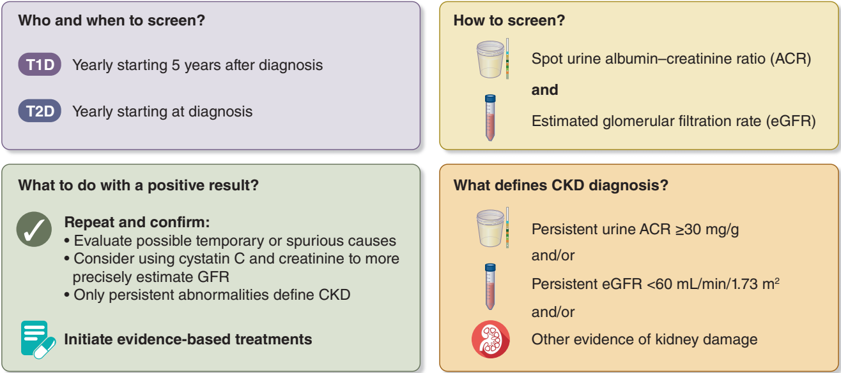

Clinical laboratories routinely report eGFR calculated from serum creatinine and demographic data.²⁰⁻²² The American Society of Nephrology and National Kidney Foundation advocate using the 2021 Chronic Kidney Disease Epidemiological Collaboration (CKD-EPI) equation that was generated without including a term for race and reports eGFR without regard to race to estimate GFR from creatinine, age, and sex.²⁰ Another CKD-EPI equation that additionally incorporates serum cystatin C increases precision and reduces racial and ethnic bias, offering additional value in screening and for confirmation of low eGFR in appropriate cases.²³⁻²⁵

Calculation of the ACR in single-voided “spot” urine samples is most convenient to measure albuminuria. Early morning urine specimens are ideal, although samples collected any time of day may be used. ACR has marked variability, therefore a confirmatory urine sample within three to six months is recommended.^{26, 27}

The KDIGO has codified a CKD classification scheme based on eGFR and albuminuria that is endorsed by the ADA.²⁶ In cohort studies, risks of progressive CKD, cardiovascular events, and mortality all increase with categories of increasing albuminuria or decreasing eGFR. Moreover, CKD stage and corresponding risk category can guide frequency of laboratory monitoring, treatment, and referral to nephrology care (Figure 2).

A cause of CKD other than diabetes should be considered in the presence of other systemic diseases that cause CKD, when retinopathy is not present (particularly in T1D), or with CKD signs not common to diabetes (e.g., glomerular hematuria, large and abrupt changes in eGFR or albuminuria, or abnormal serology tests). In the absence of such “red flags,” CKD is usually attributed to diabetes and treated accordingly. Ongoing research seeks to define CKD subtypes with more granularity and link novel subtypes to precision treatments.^{28, 29}

Figure 2: Risk of CKD progression, frequency of visits, and referral to nephrology according to GFR and albuminuria
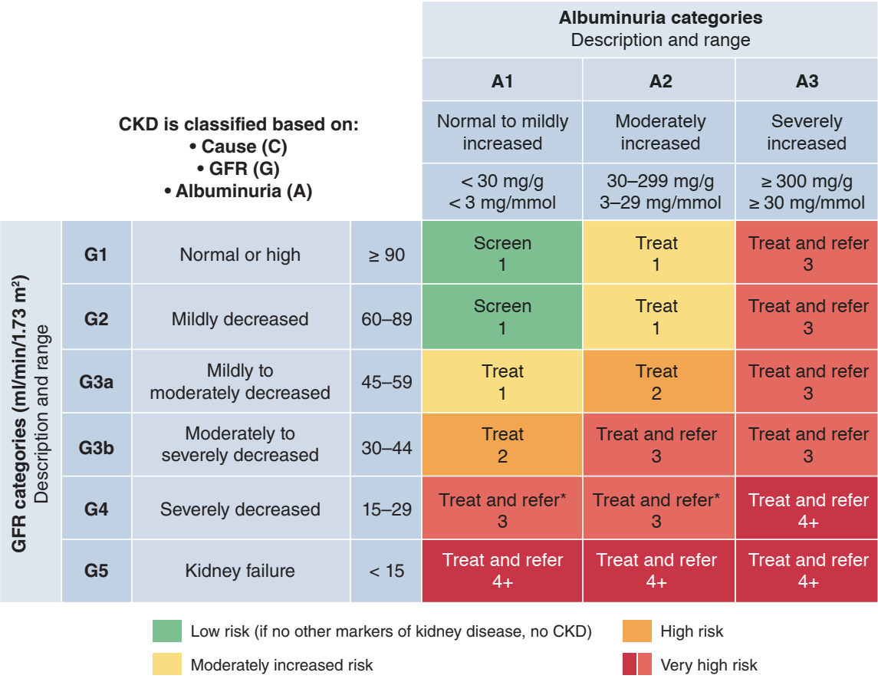
The numbers in the boxes are a guide to the frequency of screening or monitoring (number of times per year). Green reflects no evidence of CKD by eGFR or albuminuria, with screening indicated once per year. For monitoring of prevalent CKD, suggested monitoring varies from once per year (yellow) to 4 times or more per year (i.e. every 1–-3 months, deep red) according to risks of CKD progression and CKD complications. These are general parameters only based on expert opinion and must take into account underlying comorbid conditions and disease state, as well as the likelihood of impacting a change in management for any individual patient. CKD, chronic kidney disease; GFR, glomerular filtration rate.

Comprehensive care
Goals of comprehensive care
Multimorbidity is common in patients with diabetes and CKD, who are at high risk of CKD progression, cardiovascular events, and premature mortality. Therefore, both the ADA¹ and KDIGO² emphasize the importance of comprehensive, holistic, patient-centered medical care to improve overall patient outcomes.

The goals of comprehensive care are to treat the patient as a “whole” person and incorporate coordinated multidisciplinary treatment, structured education to promote self-management, shared-decision making, and primary and secondary prevention of diabetes-related complications, including CKD, ASCVD, and HF.² This approach requires treatment directed to optimize lifestyle, pharmacological therapy aimed at preserving organ function, and additional therapies aimed at improving intermediate risk factors such as glycemia, blood pressure, and lipids (Figure 3).

Figure 3. Holistic approach for improving outcomes in patients with diabetes and CKD
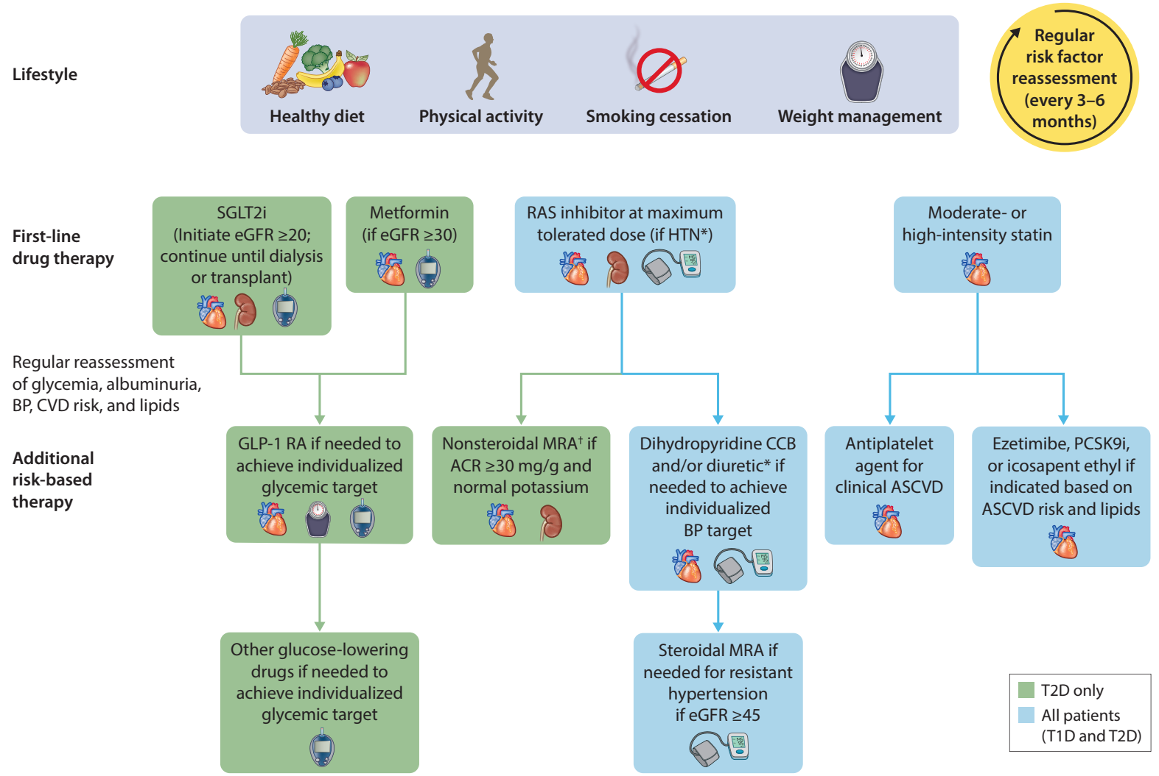
*ACEi or ARB (at maximal tolerated doses) should be first-line therapy for hypertension when albuminuria is present, otherwise dihydropyridine CCB or diuretic can also be considered; all three classes often needed to attain BP targets.
†Finerenone is currently the only nonsteroidal MRA with proven clinical kidney and cardiovascular benefits.
Icons presented indicate the following benefits: blood pressure cuff = blood pressure lowering; glucometer = glucose-lowering; heart = cardioprotection; kidney = kidney protection
ACE, angiotensin-converting enzyme inhibitor; ACR, albumin-creatinine ratio; ARB, angiotensin II receptor blocker; ASCVD, atherosclerotic cardiovascular disease; BP, blood pressure; CCB, calcium channel blocker; CGM, continuous glucose monitoring; eGFR, estimated glomerular filtration rate; GLP-1 RA, glucagon-like peptide-1 receptor agonist; HbA1c, glycated hemoglobin; HTN, hypertension; LDL-C, low-density lipoprotein cholesterol; MRA, mineralocorticoid receptor antagonist; PCSK9i, proprotein convertase subtilisin/kexin type 9 inhibitor; RAS, renin-angiotensin system; SGLT2, sodium-glucose cotransporter-2; T2D, Type 2 diabetes; TG, triglycerides

With multiple interventions ubiquitously needed to optimize the care of people with diabetes and CKD, it is crucial to avoid therapeutic inertia.³⁰ Most patients with diabetes and CKD have high residual risks of CKD progression and cardiovascular disease despite treatment, and increasing options are available for risk mitigation. Patients may need to be seen frequently to identify and implement multiple therapies, some of which may interact. For example, renin-angiotensin system (RAS) inhibitors, SGLT2 inhibitors, and the nonsteroidal mineralocorticoid receptor antagonist (ns-MRA), finerenone, all cause initial hemodynamic reductions in GFR. When indicated, such medications may need to be added and adjusted sequentially, with frequent assessments to institute and optimize care in a timely manner. Empowering patients and facilitating multidisciplinary care can help institute and titrate multiple treatments expeditiously.

Consensus statement:
- All patients with T1D or T2D and CKD should be treated with a comprehensive plan, outlined and agreed by health care professionals and the patient together, to optimize nutrition, exercise, smoking cessation, and weight, upon which are layered evidence-based pharmacologic therapies aimed at preserving organ function and other therapies selected to attain intermediate targets for glycemia, blood pressure, and lipids.

Education, self-care, and patient empowerment
The ADA and KDIGO guidelines both advocate for patients to take an active role in managing their diabetes and kidney disease and to have a voice in decisions that affect their well-being.^{2, 31} Education for patients and an integrated approach to treatment is an effective approach for both patients and clinicians.

Patients know themselves better than anyone else, and although healthcare professionals have the medical background, when a patient and healthcare professional become partners in developing a shared-decision treatment plan the lives of the patient will improve. In addition, the time required by the healthcare professional in managing the patients care will be reduced. Patient priorities often do not align with healthcare professional priorities. Ideally, healthcare professionals will question patients about their priorities and together they will establish an agreed upon care program.³²

Ways in which patients can work with their healthcare professionals to manage their diabetes and CKD include asking questions, becoming educated about diet, physical activity, smoking cessation, glycemic control and medications, talking to their peers and support groups in the diabetes and CKD community, becoming familiar with technology that is available to track progress, and understand test results in preparation for healthcare appointments.³³

Multidisciplinary team care
Diabetes and CKD management is ideal when the health care system model of care includes a multidisciplinary team to assist patients including the patient, physician (or other care provider), and other health care professionals.^{2, 34} Both the ADA and KDIGO guidelines emphasize the importance of a team-based integrated approach that engages diabetes care and education specialists, physicians, nurse practitioners, physician assistants, nurses, dieticians, exercise specialists, pharmacists, dentists, podiatrists, and/or mental health professionals in the care of the patient, with multidisciplinary care models representing a key strategy to overcome barriers to effective management of patients with diabetes and CKD (Figure 4).

Healthcare systems should include team-based care for patients and focus on both short- and long-term treatment plans. Lifestyle interventions for the patient must be included when determining an overall plan of care to ensure individual preferences are addressed and goals are established by all team members, especially the patient.

Figure 4. Overcoming barriers to management of CKD in patients with diabetes*
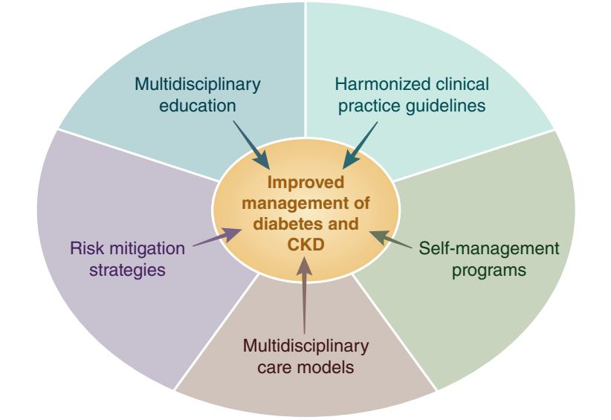
*Barriers such as low CKD awareness, high complexity of care, difficulties with adhering to increasingly complex treatment regimens, and low recognition and application of guideline-directed management all contribute to suboptimal management of patients with diabetes and CKD. Proposed strategies that may contribute to improved management of patients with diabetes and CKD include implementation of multidisciplinary models of care, structured risk mitigation strategies and education, multidisciplinary educational initiatives, harmonization of clinical practice guidelines, and provision of self-management programs for patients with diabetes and CKD.

Behavioral evaluation should be considered in the initial assessment for all patients with diabetes. In addition, it should be considered in patients who are unable to meet goals in order to determine potential psychosocial barriers to treatment and self-management.

Lifestyle
Both the ADA and KDIGO guidelines underscore the integral role of medical nutritional therapy, including adequate access to nutritional management from specialty-trained registered dietician nutritionist (RD/RDN), for optimal diabetes management (Appendix Table 1). The ADA and KDIGO guidelines both recommend individualized and balanced diets that are high in vegetables, fruits, and whole grains, but are low in refined carbohydrates and sugar-sweetened beverages.^{1, 2} Both guidelines also recommend a low-sodium diet (KDIGO <2000 mg per day, ADA 1500-<2300 mg per day), largely to control blood pressure and reduce cardiovascular risk.

The ADA and KDIGO guidelines also recommend targeting a dietary protein intake of 0.8 g/kg/day, the same intake recommended by the World Health Organization for the general population. Higher protein intakes confer theoretical risk of enhancing kidney function decline.³⁵ KDIGO performed a systematic review of randomized trials and found no conclusive evidence that restriction of dietary protein to levels lower than 0.8 g/kg/day improves kidney or other health outcomes among people with diabetes and CKD.² While the ADA and KDIGO are aligned in this regard, the National Kidney Foundation-Kidney Disease Outcomes Quality Initiative (NKF-KDOQI) has somewhat different recommendations, including restricting dietary protein to 0.55-0.60 g/kg/day (or lower with keto acid analog supplementation) for metabolically stable CKD patients without diabetes and to 0.6-0.8 g/kg/day for patients with diabetes and CKD.³⁶ All recommendations call for higher levels of protein intake for patients with kidney failure treated with maintenance dialysis, who are often catabolic or malnourished (e.g., 1.0-1.2 g/kg/day).

The ADA and KDIGO guidelines also advise moderate to intense/vigorous physical activity with a cumulative duration of ≥150 minutes/week and avoidance of sedentary activity.^{1, 2} In overweight or obese patients with diabetes, ADA and KDIGO show overall agreement with respect to achieving and maintaining healthy weight through diet, physical activity, and behavioral therapy (Appendix Table 1). Though specific evidence is low, smoking cessation is also strongly advised.

Treatment targets and pharmacotherapy
Glycemic control
Metrics and frequency
Both the ADA and KDIGO recommend twice-yearly glycemic assessment using glycated hemoglobin (HbA1c) among stable patients with T2D who are meeting treatment goals, and quarterly assessment among those who are intensively managed, whose therapy has changed or treatment goals are not met (Appendix Table 1). While both ADA and KDIGO focus on HbA1c as the primary tool for assessing long-term glycemic control, both guidelines acknowledge limitations in its accuracy and precision as an indirect metric of glycemic status, particularly in advanced CKD (i.e., CKD G4-G5 without kidney replacement therapy [KRT]) and kidney failure treated by dialysis, and the inability of HbA1c to adequately capture glycemic variability and hypoglycemic events. Consequently, both guidelines emphasize the concurrent use of 1) HbA1c as a metric upon which therapeutic targets are defined based on randomized controlled trial (RCT) data, 2) continuous glucose monitoring (CGM) to assess effectiveness and safety of treatment among patients at risk for hypoglycemia or to assess overall glycemia when HbA1c is inaccurate, and 3) self-monitored blood glucose (SMBG) as a tool to guide medication adjustment, particularly in patients treated with insulin.³⁷

Individualized targets
Both the ADA and KDIGO emphasize use of individualized glycemic targets that take into consideration key patient characteristics that may modify risks and benefits of intensive glycemic control (Appendix Table 1). Based on RCT data, KDIGO recommends an individualized HbA1c target of <6.5% to <8.0% in patients with diabetes and CKD, with targets in this range having been associated with improved survival, cardiovascular outcomes, and microvascular endpoints, as well as lower risk of CKD progression. The ADA recommends a starting HbA1c target of <7% to reduce microvascular complications in most nonpregnant adult patients with T1D and T2D without hypoglycemia risk, although with higher goals (i.e., <8%) acceptable for patients with limited life expectancy and in whom the harms of treatment may outweigh the benefits.

Continuous glucose monitoring and diabetes technology
Diabetes technology refers to the hardware, devices, and software that patients with diabetes use to manage their chronic disease, and encompasses 1) insulin administered by syringe, pen, or pump, 2) blood glucose monitoring by meter or CGM, and 3) hybrid devices that monitor glucose and deliver insulin. The ADA and KDIGO guidelines highlight the important role of CGM technology in improving diabetes management as a tool to identify and correct glycemic derangements, prevent hypoglycemia, direct medication management, and guide medical nutritional therapy and physical activity, as well as its rapid evolution in affordability and accuracy (Appendix Table 1).^{2, 37} Furthermore, ADA and KDIGO underscore that CGM may provide advantage in glycemic control assessment among patients with T1D, as well as patients with T2D using glucose-lowering therapies associated with hypoglycemia. Other technology supported by the ADA include sensor-augmented pumps which suspend insulin when glucose is low or predicted to become low, as well as automated insulin delivery systems that increase and decrease insulin delivery based on sensor-derived glucose levels and trends.

Blood pressure management
Blood pressure (BP) management is universally accepted as a critical goal for prevention of CKD progression, ASCVD, and HF. The ADA includes BP recommendations in each annual Standards of Care and published a Hypertension Position Statement in 2017.³⁸ BP control was highlighted as a key component of comprehensive care in the KDIGO 2020 and 2022 Clinical Practice Guideline for Diabetes Management in CKD and addressed in more detail in the KDIGO 2021 Clinical Practice Guideline for the Management of BP in CKD.³⁹

The ADA and KDIGO BP recommendations share many similarities, including a focus on proper BP measurement techniques, individualization of BP targets, and preferred drugs for treatment. Considerations for individualization of BP targets include both anticipated benefits (e.g., higher absolute benefit for patients with higher underlying cardiovascular or kidney disease risk) and potential risks (e.g., ability to tolerate pharmacotherapy without experiencing adverse effects).

Among patients with diabetes, hypertension, and high cardiovascular risk (i.e., 10-year ASCVD risk ≥15%), the ADA advises a BP target of <130/80 mm Hg if this target can be safely attained. In patients with diabetes, hypertension, and low cardiovascular risk (i.e., defined as those with 10-year ASCVD risk <15%), the ADA recommends a BP target of <140/90 mm Hg (Grade A recommendation).⁴⁰ The KDIGO 2021 Clinical Practice Guideline for the Management of BP in CKD recommends a target systolic blood pressure (SBP) of <120 mm Hg measured using standardized guideline recommended office measurement in CKD patients (Grade 2B recommendation) based largely on a single, high-quality RCT that was conducted exclusively in people without diabetes.³⁹ However, the KDIGO BP Work Group outlined certain caveats with respect to safety considerations and/or limited evidence for this threshold in certain populations, including those with diabetes and CKD. All of these thresholds are proposed as starting places for individualization of targets.⁴¹

With respect to preferred antihypertensive pharmacotherapies, there is consensus that a RAS inhibitor, i.e., an angiotensin converting enzyme inhibitor (ACEi) or angiotensin II receptor blocker (ARB), should be initiated in patients with concomitant diabetes, hypertension, and albuminuria, with titration to the highest tolerated approved dose. This recommendation is based on RCTs that demonstrated decreased risk of CKD progression, for which patients with albuminuria are at elevated risk, with a maximally dosed RAS inhibitor compared with placebo or an active antihypertensive drug comparator.⁴²⁻⁴⁴ A recent report in almost three million patients found that both classes performed similarly; however, the ARB was better tolerated.⁴⁵ Dihydropyridine calcium channel blockers and thiazide-like diuretics are also recommended for patients with hypertension who do not have albuminuria, for whom cardiovascular events and mortality are more common than kidney failure. Multiple drugs are often required to control BP, and a RAS inhibitor, dihydropyridine calcium channel blockers, and diuretics can be combined to attain individualized BP targets (Figure 3).

Consensus statement:
- An ACEi or ARB is recommended for patients with T1D or T2D who have hypertension and albuminuria, titrated to the maximum antihypertensive or highest tolerated dose.

Lipid management
Statin therapy is a cornerstone of therapy for the primary and secondary prevention of ASCVD among people with diabetes and CKD. The KDIGO 2013 Clinical Practice Guideline for Lipid Management in CKD recommended statin initiation for most adults with diabetes and CKD who are not treated with dialysis.^{46, 47} Specifically, this included 1) adults ≥50 years old with CKD and eGFR ≥60 mL/min/1.73 m² (Grade 1B recommendation), and 2) adults aged 18-49 years with CKD with diabetes, known coronary heart disease, prior ischemic stroke, or estimated 10-year incidence of coronary heart disease death or non-fatal myocardial infarction >10% (Grade 2A recommendation). These recommendations are based largely on results of the SHARP trial of CKD.⁴⁸ Subsequent trials providing additional evidence were incorporated into recommendations in the 2022 ADA Standards of Care, which are endorsed by this consensus statement.

For primary prevention of ASCVD, the ADA recommends a moderate-intensity statin for all adults with diabetes aged 40-75 years, those aged 20-39 years with additional ASCVD risk factors (such as CKD), and, with individualized decision-making, those aged >75 years (who are not well-represented in completed trials). An exception may be patients with kidney failure treated with dialysis for whom primary prevention of ASCVD events with a statin has been generally ineffective.^{47, 49, 50} High-intensity statin is recommended for secondary prevention for all patients with known ASCVD. For some patients, intensification of statin therapy (for primary prevention), addition of ezetimibe, or addition of a PCSK-9 inhibitor is recommend based on ASCVD risk and attained low density lipoprotein-cholesterol concentrations. For patients with high triglyceride or low high-density lipoprotein levels, intensification of lifestyle intervention, optimization of glycemic control, and then consideration of icosapent ethyl are advised (Appendix Table 1).⁵¹

Consensus statement:
- A statin is recommended for all patients with T1D or T2D and CKD, moderate intensity for primary prevention of ASCVD or high-intensity for patients with known ASCVD and some patients with multiple ASCVD risk factors.

Glucose-lowering agents in T2D and CKD
The ADA 2022 Standards of Medical Care in Diabetes and the KDIGO 2022 Clinical Practice Guideline for Diabetes Management in CKD recommend early initiation of metformin plus a sodium-glucose cotransporter-2 (SGLT2) inhibitor in most patients with T2D and CKD (Table 1).^{2, 17} Additional glucose-lowering agents can then be added as needed to meet individualized glycemic targets based on patient-specific considerations (Table 2).^{2, 17} Prescription of glucose-lowering medications may be limited by eGFR (Table 3). Appropriate dose adjustment based on eGFR is important for medications that increase risk of side effects with low eGFR or undergo elimination through the kidney (Table 4). When needed, careful use and titration of insulin and sulfonylurea agents is recommended to avoid hypoglycemia.
Table 1. Key glucose-lowering agent recommendations for patients with T2D and CKD from ADA and KDIGO^{2, 17}
Medication Class | ADA 2022 Standards of Medical Care in Diabetes | KDIGO 2022 Guideline for Diabetes Management in CKD
Metformin | - 9.4a First line therapy depends on comorbidities, patient-centered treatment factors, and management needs and generally includes metformin and comprehensive lifestyle modification. A | - We recommend treating patients with T2D, CKD, and an eGFR ≥30 ml/min per 1.73 m² with metformin (1B).  - Adjust the dose of metformin when the eGFR is <45 mL/min per 1.73 m², and for some patients when the eGFR is 45–59 ml/min per 1.73 m²
SGLT2 inhibitors | - Consider use of SGLT2 inhibitor for organ protection independent of baseline HbA1c, individualized HbA1c target, or metformin use  - 10.42 Among patients with type 2 diabetes who have established atherosclerotic cardiovascular disease or established kidney disease, a sodium–glucose cotransporter 2 inhibitor or glucagon-like peptide 1 receptor agonist with demonstrated cardiovascular disease benefit is recommended as part of the comprehensive cardiovascular risk reduction and/or glucose-lowering regimens. A  - 10.42a In patients with type 2 diabetes and established atherosclerotic cardiovascular disease, multiple atherosclerotic cardiovascular disease risk factors, or diabetic kidney disease, a sodium–glucose cotransporter 2 inhibitor with demonstrated cardiovascular benefit is recommended to reduce the risk of major adverse cardiovascular events and/or heart failure hospitalization. A  - *11.3a For patients with type 2 diabetes and diabetic kidney disease, use of a sodium–glucose cotransporter 2 inhibitor in patients with an estimated glomerular filtration rate ≥20 mL/min/1.73 m² and urinary albumin ≥300 mg/g creatinine is recommended to reduce chronic kidney disease progression and cardiovascular events. A  - 11.3b In patients with type 2 diabetes and chronic kidney disease, consider use of sodium–glucose cotransporter 2 inhibitors additionally for cardiovascular risk reduction when estimated glomerular filtration rate and urinary albumin creatinine are ≥25 mL/min/1.73 m² or ≥300 mg/g, respectively. A | - We recommend treating patients with T2D, CKD, and an eGFR ≥20 ml/min per 1.73 m² with an SGLT2i (1A).
GLP-1 receptor agonists | - 10.42 Among patients with type 2 diabetes who have established atherosclerotic cardiovascular disease or established kidney disease, a sodium–glucose cotransporter 2 inhibitor or glucagon-like peptide 1 receptor agonist with demonstrated cardiovascular disease benefit is recommended as part of the comprehensive cardiovascular risk reduction and/or glucose-lowering regimens. A | - In patients with T2D and CKD who have not achieved individualized glycemic targets despite use of metformin and SGLT2i, or who are unable to use those medications, we recommend a long-acting GLP-1 RA (1B).
*ADA recommendation 11.3a includes updates made in May 2022 through ADA’s Living Standards of Care guideline update process. 1A, strong recommendation based on high quality evidence; 1B, strong recommendation based on moderate quality evidence; ACR, albumin-creatinine ratio; CVD, cardiovascular disease; eGFR, estimated glomerular filtration rate; GLP-1, glucagon-like peptide-1; HbA1c, glycated hemoglobin; SGLT2 sodium-glucose cotransporter-2; T2D, type 2 diabetes
Table 2. Considerations when selecting glucose-lowering agents in patients with T2D and CKD^{2, 17}
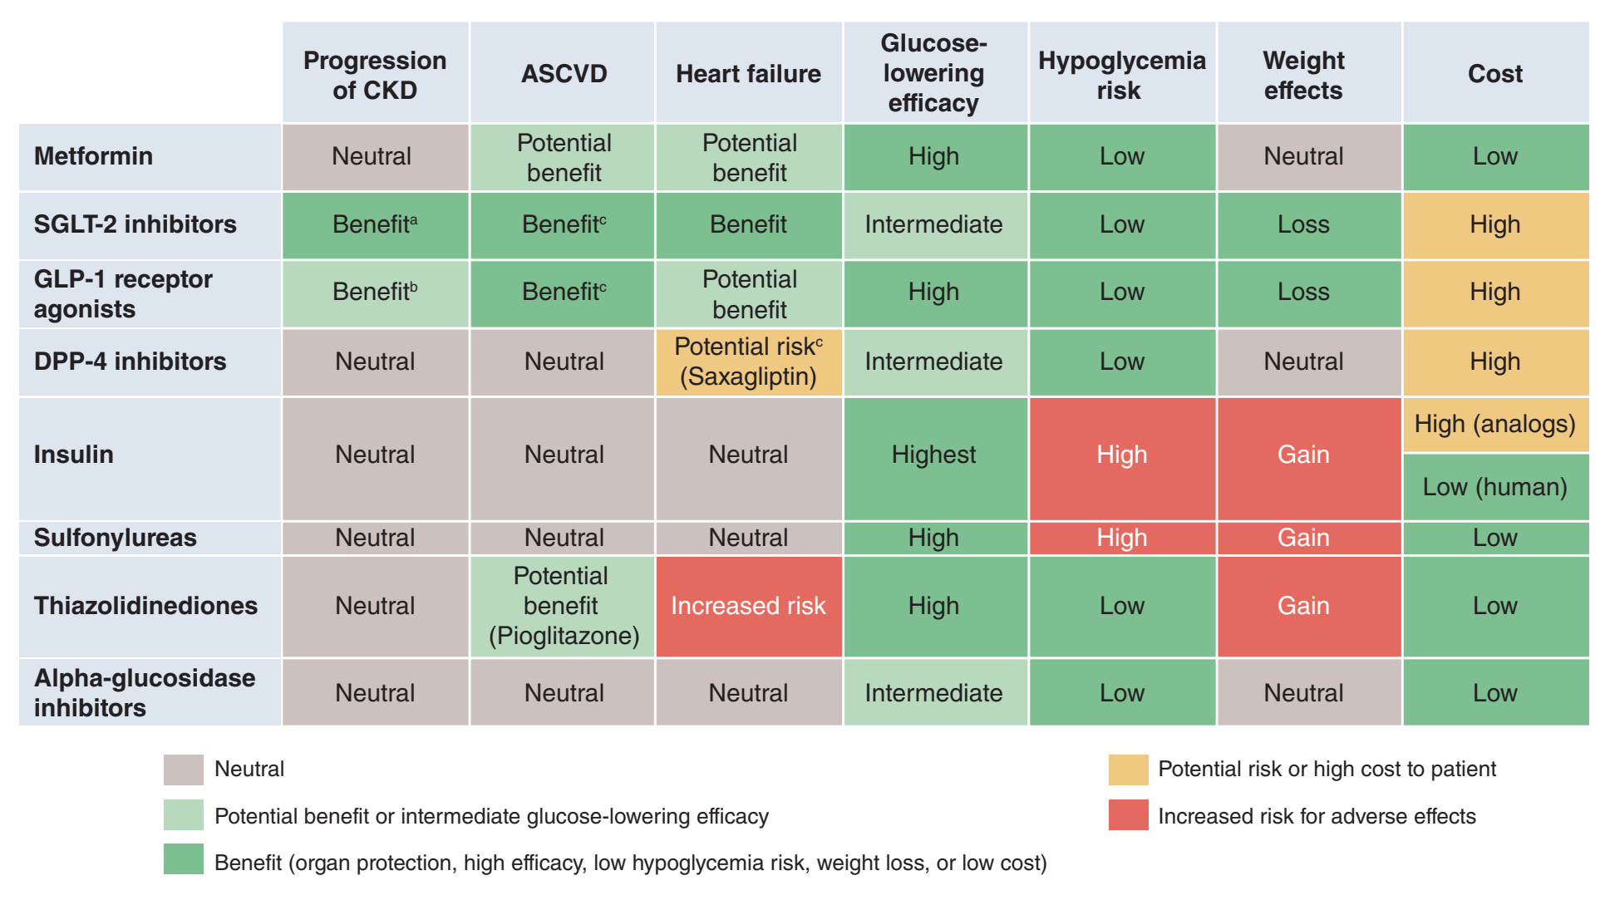
ªBenefit supported by primary and secondary outcome data.
^{b}Benefit supported by secondary outcome data.
^{c}Benefit or risk is agent-specific
ASCVD, atherosclerotic cardiovascular disease; CKD, chronic kidney disease; DPP-4, dipeptidyl peptidase-4; GLP-1, glucagon-like peptide-1; SGLT2 sodium-glucose cotransporter-2

Metformin
Metformin is recommended for use in most patients with T2D and CKD who have an eGFR ≥30 mL/min/1.73 m², although careful patient selection and downward dose adjustment based on eGFR is recommended. Metformin has been proven to be a safe, effective, and affordable foundation for glycemic control in T2D. Metformin is excreted unchanged in urine, with the label including a boxed warning for increased risk of lactic acidosis in patients with CKD due to impaired metformin excretion.⁵² Evidence, however, suggests the overall risk for metformin-associated lactic acidosis is low,⁵³ and the FDA has revised the United States label to reflect its safety in most patients with an eGFR ≥30 mL/min/1.73 m².⁵² To facilitate safe use, eGFR should be monitored at least annually in patients with CKD, with the recommended frequency of monitoring increased to every three to six months once the eGFR falls below 60 mL/min/1.73 m² (Figure 1).² The dose of metformin is recommended to be reduced to 1,000 mg daily in patients with an eGFR between 30-44 mL/min/1.73 m², and a reduction should also be considered in patients with an eGFR of 45-59 mL/min/1.73 m² if they have a comorbidity that places them at increased risk of lactic acidosis due to hypoperfusion and hypoxemia.² Most episodes of metformin-associated lactic acidosis occur concurrent with other acute illness, often when acute kidney injury (AKI) contributes to reduced metformin clearance. Therefore, sick day protocols that specify holding metformin doses during acute illness may help reduce the risk of metformin-associated lactic acidosis.

Consensus statement:
- Metformin is recommended for patients with T2D, CKD, and an eGFR ≥30 mL/min/1.73 m²; the dose should be reduced to 1,000 mg daily in patients with an eGFR 30-44 mL/min/1.73 m² and in some patients with eGFR of 45-59 mL/min/1.73 m² who are at high risk of lactic acidosis.

SGLT2 inhibitors
SGLT2 inhibitors are recommended in most patients with T2D and CKD with an eGFR ≥20 mL/min/1.73 m² independent of HbA1c or the need for additional glucose lowering.^{2, 17} This recommendation is based on strong evidence that SGLT2 inhibitors reduce CKD progression, HF, and ASCVD risk in patients with T2D and CKD. These benefits are independent of glycemia, and an SGLT2i should be used for patients with T2D and CKD even if glycemic targets are already attained. While an SGLT2i will usually be added to lifestyle and metformin therapy, SGLT2i treatment without metformin may be reasonable for patients whose eGFR is too low to safely prescribe metformin, who do not tolerate metformin, or who do not need metformin to achieve glycemic targets.

To date, two clinical trials with primary kidney disease outcomes using canagliflozin and dapagliflozin (CREDENCE and DAPA-CKD) each demonstrated significant benefit on composite outcomes including endpoints of substantial eGFR decline, kidney failure, and mortality.^{54, 55} These trials enrolled participants with albuminuria (ACR ≥300 mg/g and ≥200 mg/g, respectively), therefore current evidence is strongest in this population, as emphasized by ADA recommendations (Table 1).¹⁷ Evidence from combined major SGLT2 inhibitor trials, however, suggest that kidney and cardiovascular benefits are consistent irrespective of baseline albuminuria,⁵⁶ including in patients with normal albumin excretion, as reflected in KDIGO recommendation and consensus statement supporting SGLT2 inhibitor use in most patients with T2D and CKD.²

The lower limit of eGFR for which initiation of SGLT2i is recommended has changed over time as new data has rapidly become available. The KDIGO 2022 Diabetes Management in CKD Guideline recommended initiation of an SGLT2 inhibitor for patients with T2D and CKD who have an eGFR ≥20 mL/min/1.73 m² (a change from ≥30 mL/min/1.73 m² in the 2020 guideline), while the ADA is also updating this threshold to ≥20 mL/min/1.73 m² in its Living Standards of Care (from ≥25 mL/min/1.73 m² in the initial issue of the 2022 SOC). These changes are driven largely by new trials, including the DAPA-CKD trial (which provided clear evidence of efficacy and safety for dapagliflozin in patients with eGFR ≥25 mL/min/1.73 m² and ACR ≥200 mg/g) and the EMPEROR trials (which provided clear evidence of efficacy and safety for empagliflozin among patients with eGFR ≥20 mL/min/1.73 m² and HF).^{54, 57, 58} Additional support comes from subgroup analyses of participants in the CREDENCE and DAPA-CKD trials with baseline eGFR <30 mL/min/1.73m².^{59, 60} Based on these results, direct evidence supporting initiation of an SGLT2i for patients with T2D and eGFR 20-29 mL/min/1.73m² is strongest for patients with concomitant albuminuria or HF, though the efficacy and safety of SGLT2i are generally consistent among trial participants with or without these conditions.^{56, 61, 62} Moreover, SGLT2i have been observed to have consistent efficacy and safety across studied ranges of eGFR.⁵⁶ Therefore, an SGLT2 inhibitor can be initiated for most patients with T2D, CKD, and eGFR ≥20 mL/min/1.73 m². Further data are anticipated from the EMPA-KIDNEY trial (NCT03594110), which expanded entry criteria to include non-albuminuric CKD with an eGFR initiation threshold ≥20 mL/min/1.73 m² among >6600 participants with or without T2D. Like CREDENCE and DAPA-CKD, EMPA-KIDNEY was stopped early for clear positive efficacy⁶³ corresponding expansion of the indications for use of an SGLT2 inhibitor in CKD may be further supported based upon these findings.

SGLT2 inhibitor initiation is associated with a reversible decline in eGFR, but this generally does not require drug discontinuation. In fact, SGLT2 inhibitor use appears to protect patients from AKI.⁵⁶ Notably, protocols for both CREDENCE and DAPA-CKD specified continuation of study drug when eGFR fell below initiation thresholds. Therefore, it is reasonable to continue therapy if the eGFR falls below the initiation thresholds unless the patient is not tolerating treatment or KRT is initiated.²

Hypovolemia and hypoglycemia may occur with SGLT2 inhibitors, but absolute risks are low, especially at low eGFR. Therefore, adjustment of background therapies is generally not required when initiating an SGLT2i, but it may be prudent in some patients, and follow-up to reassess volume status and glycemia is important.⁶⁴ Euglycemic ketoacidosis with minimal to no elevation in blood glucose may occur in patients taking SGLT2 inhibitors. Patients with T2D requiring insulin are at particular risk. To mitigate risk, it is important to maintain at least low-dose insulin and consider pausing SGLT2 inhibitor treatment during periods of acute illness or stressors. Blood or urine ketone monitoring may be used for ketosis detection. Patients with signs, symptoms, or biochemical evidence of ketoacidosis should discontinue SGLT2 inhibitor therapy and seek immediate medical attention. Genital mycotic infections are a known complication of SGLT2 inhibitors. A meta-analysis of clinical trials reported that genital mycotic infections occurred in 6% of participants assigned to an SGLT2 inhibitor, compared with 1% of those assigned to placebo.⁶⁵ The risk is higher for women than men. Daily hygienic measures may lessen this risk, and most genital mycotic infections are easily treated, but severe cases of Fournier’s gangrene have been reported. Additional research is needed to determine the role of SGLT2 inhibitors in improving kidney outcomes in patients with T1D, among whom diabetic ketoacidosis is more common, and post-transplant, for whom immunosuppression may modify infectious risks.⁶⁶

Consensus statement:
- An SGLT2 inhibitor with proven kidney or cardiovascular benefit is recommended for patients with T2D, CKD, and an eGFR ≥20 mL/min/1.73 m². Once initiated, the SGLT2 inhibitor can be continued at lower levels of eGFR.

Use of additional glucose-lowering agents
For patients with T2D and CKD requiring additional glucose-lowering agents, selection should be made in consideration of patient- and medication-specific considerations (Table 2). Addition of a long-acting glucagon-like peptide-1 (GLP-1) receptor agonist is preferred as per KDIGO in patients not achieving individualized glycemic targets despite use of metformin and/or SGLT2 inhibitor therapy, or in individuals unable to take these medications.² Similarly, ADA gives strong support to use of GLP-1 receptor agonists in patients with T2D and CKD or ASCVD in consideration of their primary cardiovascular and secondary kidney benefits from large cardiovascular outcome trials.¹⁷ Notably, GLP-1 receptor agonists retain glycemic efficacy and safety even in advanced CKD stages.

GLP-1 receptor agonists
GLP-1 receptor agonists reduce albuminuria and slow eGFR decline, evidenced by secondary outcomes assessed in the cardiovascular outcomes trials and a clinical trial for glycemic efficacy and safety in patients with T2D and eGFR 15-59 mL/min/1.73 m².² In cardiovascular outcomes trials, GLP-1 receptor agonists reduced risk of major adverse cardiovascular events (MACE) in patients with T2D.⁶⁷⁻⁷⁰ Notably, the MACE risk reduction with liraglutide was significantly larger with eGFR <60 mL/min/1.73 m² compared to those with eGFR ≥60 mL/min/1.73 m².⁶⁹ Although most participants in the cardiovascular outcomes trials of GLP-1 receptor agonists had established cardiovascular disease, the MACE reduction was similar between those with and without previous cardiovascular or kidney disease.⁷¹

Although there has not been a completed kidney disease outcome trial for GLP-1 receptor agonists, the cardiovascular outcomes trials have included participants with eGFR as low as 15 mL/min/1.73 m². The GLP-1 receptor agonists with favorable CKD outcomes include lixisenatide, exenatide (once weekly), liraglutide, semaglutide, albiglutide, and dulaglutide, and efpeglenatide.^{67, 68, 70, 72-76} In a meta-analysis of eight cardiovascular outcomes trials, GLP-1 receptor agonists significantly reduced risk for a composite kidney disease outcome (macroalbuminuria, eGFR decline, progression to kidney failure, or death from kidney disease) compared to placebo, largely driven by reduction in albuminuria.⁷⁷ In patients with moderate-to-severe CKD (CKD G3-G4), a glycemic efficacy and safety trial compared dulaglutide to insulin glargine as basal therapy.^{71, 78} Dulaglutide produced similar glycemic control but resulted in significantly slower GFR decline. There is an ongoing clinical trial for a GLP-1 receptor agonist in T2D and CKD to evaluate whether semaglutide will prevent ≥50% eGFR decline, kidney failure, or death due to kidney or cardiovascular causes (NCT03819153).

Nausea, vomiting, and diarrhea are the most common side effects of GLP-1 receptor agonists. In patients with moderate-to-severe CKD (CKD G3-G4), these symptoms occur in 15%-20% of patients, but usually are tolerable with dose titration and abate over several weeks to months.⁷⁸ Injection site reactions are rare (<1%), and semaglutide is now available in an oral formulation. Heart rate typically increases by approximately five beats per minute but has not been associated with higher BP or other adverse events. GLP-1 receptor agonist treatment is not recommended in patients at risk for thyroid C-cell tumors (e.g., multiple endocrine neoplasia), pancreatic cancer, or pancreatitis based on theoretical risks from preclinical models.¹

GLP-1 receptor agonists that have shown cardiovascular and CKD benefits (liraglutide, semaglutide, albiglutide [not currently available], and dulaglutide) are preferred agents. GLP-1 receptor agonists do not cause hypoglycemia per se, but when used with insulin or insulin secretagogues, doses of these drugs may be reduced to avoid hypoglycemia. However, in moderate-to-severe CKD (CKD G3-G4), rates of hypoglycemia are reduced in half even with concurrent insulin therapy.⁷⁸

Consensus statement:
- A GLP-1 receptor agonist with proven cardiovascular benefit is recommended for patients with T2D and CKD who do not meet their individualized glycemic target with metformin and/or an SGLT2 inhibitor or because they are unable to use these drugs.

Table 3. Key monitoring and risk mitigation strategies for preferred glucose-lowering agents
Medication class | Consideration | Monitoring and/or risk mitigation strategies
Metformin | - Metformin-associated lactic acidosis | - Monitor eGFR with increasing frequency as eGFR falls <60 mL/min/1.73 m²  - Adjust metformin dose as appropriate per eGFR (see Table 4)  - Consider dose reduction in the presence of conditions that predispose patients to hypoperfusion and hypoxemia if eGFR 45-59 mL/min/1.73 m²  - Discontinue for eGFR <30 mL/min/1.73 m²  - Institute a sick day protocol
 | - B12 malabsorption | - Monitor patients for vitamin B12 deficiency when treated with metformin for >4 years
SGLT2 inhibitors | - Genital mycotic infections | - Counsel on genital hygiene
 | - Volume depletion | - Monitor for hypovolemia and consider proactive dose reduction of diuretics in patients at high risk  - Hold SGLT2 inhibitors during illness
 | - Diabetic ketoacidosis (DKA) | - Educate about signs/symptoms to facilitate early recognition  - Monitor blood or urine ketones for very high risk  - Institute a sick day protocol  - Maintain at least low-dose insulin in insulin-requiring individuals
 | - Hypoglycemia | - Adjust background glucose-lowering agents (e.g., insulin and/or sulfonylureas) as appropriate
GLP-1 receptor agonists | - Nausea/vomiting/diarrhea | - Educate on tolerability and symptom recognition  - Start at lowest recommended dose and titrate slowly
 | - Hypoglycemia | - Adjust background glucose-lowering agents (e.g., insulin and/or sulfonylureas) as appropriate
eGFR, estimated glomerular filtration rate; GLP-1, glucagon-like peptide-1; SGLT2 sodium-glucose cotransporter-2

Table 4. Dose adjustments for eGFR <45 mL/min/1.73 m^{2**}
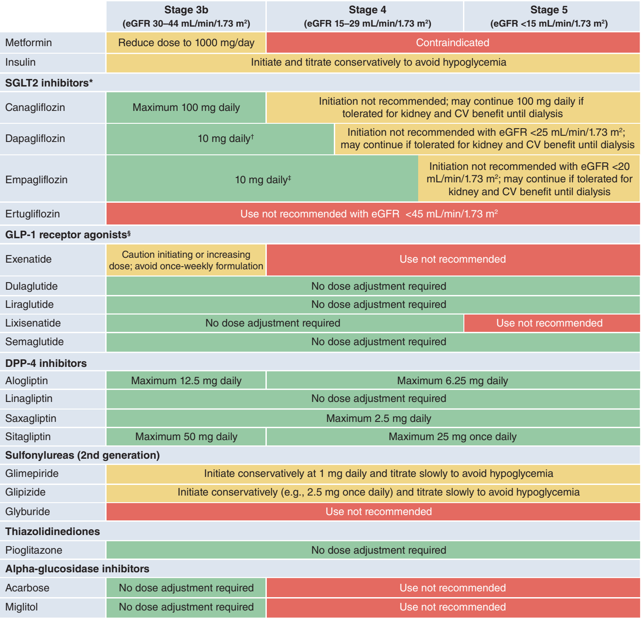
CV, cardiovascular; DPP-4, dipeptidyl peptidase-4; GFR, estimated glomerular filtration rate; GLP-1, glucagon-like peptide-1; SGLT2 sodium-glucose cotransporter-2
*Glucose-lowering efficacy is reduced with SGLT2 inhibitors as eGFR declines, but kidney and cardiovascular benefits are preserved.
†Dapagliflozin is approved for use at 10 mg once daily with an eGFR of 25 to <45 mL/min/1.73 m².
‡Initiation not recommended with eGFR <30 mL/min/1.73 m² for glycemic control or <20 mL/min/1.73 m² for HF. Higher dose can be used but is not effective for glucose-lowering and does not offer further clinical benefit in this range of eGFR
§Dulaglutide, liraglutide, and injectable semaglutide have demonstrated evidence of cardiovascular benefit in large cardiovascular outcome trials.
**Information presented reflects the package inserts rather than guidance from this consensus report.

Glycemic management in advanced CKD (eGFR<30 mL/min/1.73 m² with or without KRT)
Glycemic management is particularly challenging for patients with eGFR<30 mL/min/1.73 m², including those treated with dialysis, because of restrictions on drug use (Table 4) and lack of high-quality RCTs in this population.

For T1D, insulin remains the only approved therapy. Doses are titrated to achieve individualized glycemic goals, but may need to be decreased compared with earlier stages of CKD due to reduced insulin clearance and other changes in metabolism with advanced CKD.⁷⁷

In T2D, advanced CKD is a risk factor for hypoglycemia,^{29, 79} and when possible, drugs that control glycemia without increasing risk of hypoglycemia are preferred. Metformin is contraindicated with eGFR<30 mL/min/1.73 m² and with dialysis treatment. SGLT2 inhibitors can be initiated with eGFR 20-29 mL/min/1.73 m² and can continued at lower eGFR if previously initiated and well tolerated. However, SGLT2 inhibitors have minimal effects on glycemia in this range of eGFR and are of use mainly for kidney and cardiovascular benefits not mediated through glycemia.

GLP-1 receptor agonists have been studied with eGFR as low as 15 mL/min/1.73 m² and retain glucose-lowering potency across the range of eGFR and among dialysis patients. GLP-1 receptor agonists reduced ASCVD events and albuminuria in large RCTs, and thus are theoretically appealing for people with T2D and CKD but have not been prospectively tested for cardiovascular efficacy or safety in this population. However, a meta-analysis of the cardiovascular outcome trials showed that the ASCVD risk was reduced at least as much among individuals with eGFR <60 mL/min/1.73 m² compared those with higher eGFR.⁷¹ GLP-1 receptor agonists induce weight loss and can cause nausea and vomiting, so caution is warranted among patients with or at risk of malnutrition. Notably, in people with T2D and advanced CKD who have obesity exceeding body mass index limits required for kidney transplant listing, GLP-1 receptor agonists can be used to aid with weight loss that may facilitate qualification for transplant.

Selected dipeptidyl-peptidase 4 (DPP4) inhibitors can be used with eGFR <30 mL/min/1.73 m² and in dialysis (Table 4) and provide a safe and effective option for treatment of patients who are not treated with a GLP-1 receptor agonists. Thiazolidinediones improve insulin sensitivity, a common abnormality in advanced CKD, and retain antihyperglycemic effects in this population. Fluid retention and HF are concerns with low eGFR and require careful monitoring. Insulin and short-acting sulfonylureas are often necessary to control glucose when medications with less propensity to cause hypoglycemia are contraindicated, not tolerated, unavailable, or insufficient.

Glycemic management for patients with a kidney transplant
Patients with a kidney transplant have been excluded from most clinical trials of glucose-lowering therapy. Therefore, data must be extrapolated from general diabetes populations, considering differences in diabetes pathophysiology (i.e., post-transplant diabetes) and unique aspects of treatment (such as immunosuppressive medications). High-quality trial data are needed for this population.

For T2D and post-transplant diabetes, it is reasonable to treat kidney transplant recipients with metformin according to eGFR, as for the broader population with T2D, because risks of metformin are related to kidney function.⁸⁰⁻⁸⁵ SGLT2 inhibitors are promising drugs for kidney transplant recipients because they reduce intraglomerular pressure, which may be elevated in single functional kidneys, and may improve graft outcomes through this and other mechanisms. However, these benefits have not been confirmed in clinical trials, and there is a theoretical concern that infectious risks (i.e., genital mycotic infections, urinary tract infections, Fournier’s gangrene) may be increased due to immunosuppression. Therefore, more data are needed prior to making recommendations for or against treatment with SGLT2 inhibitors for kidney transplant recipients. Kidney transplantation and its treatments do not substantially modify the known risks and benefits of other glucose-lowering medications, other than restrictions associated with eGFR.

Renin-angiotensin-aldosterone system inhibition
Angiotensin-converting enzyme inhibitors and angiotensin II receptor blockers
RAS inhibition with ACEi or ARBs has been standard of care in patients with T1D and T2D and CKD for decades. ACEi or ARBs are the preferred first-line agent for BP treatment among patients with diabetes, hypertension, and ACR ≥300 mg/g because of their proven benefits for prevention of CKD progression. In the setting of lower levels of albuminuria (30–299 mg/g), ACEi or ARB therapy has been demonstrated to reduce progression to more advanced albuminuria (≥300 mg/g) and cardiovascular events but not progression to kidney failure. Therefore, both KDIGO and the ADA recommend an ACEi or ARB for treatment of hypertension among people with T1D or T2D who have hypertension and ACR ≥30 mg/g.^{1, 2}

Rarely, patients with albuminuria have normal blood pressure, and in this situation, evidence for treatment with RAS inhibition is less strong. Although short-term studies demonstrated added benefit of the combination of ACEi and ARBs on albuminuria reduction, long-term studies found no benefit and more adverse events, particularly hyperkalemia and AKI, and thus it is recommended to avoid this combination.

Nonsteroidal mineralocorticoid receptor antagonists (ns-MRA)
The steroidal MRA spironolactone is effective for management of resistant hypertension and treatment of primary hyperaldosteronism, in the setting of normal eGFR. Additionally, they reduce mortality in patients with heart failure with reduced and preserved ejection fraction. However, spironolactone causes hyperkalemia, particularly with reduced kidney function (i.e., eGFR <45 mL/min/1.73 m²), and long-term outcome studies are missing.

A novel class of ns-MRAs, including esaxerenone and finerenone, has recently been investigated among people with T2D and CKD, added to RAS inhibition. Esaxerenone lowered blood pressure and albuminuria with limited changes in potassium, but long-term studies with clinical endpoints are lacking.⁸⁶ Finerenone was investigated in two complementary phase 3 studies of patients with T2D, kidney disease (defined primarily by ACR ≥30 mg/g), and potassium <4.8 mmol/L and only one approved in the world for slowing CKD progression and reduced CV events. In FIDELIO-DKD both the primary kidney endpoint of progression of kidney disease (40% decline in eGFR or kidney failure) and the pre-specified secondary composite cardiovascular endpoint (MACE or hospitalization for HF) were reduced with finerenone compared to placebo. Serum potassium was monitored regularly, and 2.6% of participants stopped treatment because of hyperkalemia with finerenone compared to 0.9% on placebo.⁸⁷ In FIGARO-DKD, the primary composite cardiovascular endpoint (MACE or hospitalization for HF) was reduced with finerenone compared to placebo, with similar estimates of effect for kidney outcomes and hyperkalemia as seen in FIDELIO-DKD.⁸⁸

The FIDELITY individual patient, pre-specified combined analysis of both trials (13,191 total participants) demonstrated significant reductions of 18% for the composite cardiovascular outcome; 23% for a composite outcome of doubling of creatinine, kidney failure, or renal death; and 20% for dialysis initiation with a 22% reduction in heart failure hositalizations.⁸⁹ While <10% of participants were treated with a SGLT2 inhibitor or a GLP-1 receptor agonist, subgroup analyses suggested that benefits of finerenone were similar with and without concomitant SGLT2 inhibitor or GLP-1 receptor agonist treatment. Moreover, the risk of hyperkalemia was significantly reduced by the presence of an SGLT2 inhibitor.⁹⁰

In summary, FIDELIO-DKD and FIGARO-DKD demonstrated cardiovascular and kidney benefits for finerenone among people with T2D who were treated with standard of care (including a RAS inhibitor at maximally tolerated doses and good control of glycemia and BP) who were at high residual risk, based largely on albuminuria (ACR ≥30 mg/g). These effects appear to be additive based on pre-clinical studies to those of SGLT2 inhibitors and GLP-1 receptor agonists, though further clinical research on these combinations is needed. Therefore, it is reasonable to add finerenone to the treatment regimen of patients with T2D who have any level of persistent albuminuria despite current standard of care treatment with glucose-lowering and antihypertensive medications, as shown in Figure 3.

Finerenone can be initiated with an eGFR ≥25 mL/min/1.73 m² (as per trial eligibility) and serum potassium 4.8 mmol/L (per trial eligibility criteria) or ≤5.0 mmol/L (as per FDA label). As per trial protocols, finerenone should be started at a dose of 20 mg daily if eGFR >60 mL/min/1.73 m² and 10 mg if eGFR 25-60 mL/min/1.73 m², and uptitrated to 20 mg daily if possible. Potassium should be followed four weeks after dose change and regularly during treatment. With potassium <4.8 mmol/L, dose can be uptitrated to 20 mg and continued if potassium ≤5.5 mmol/L. If potassium increases to above 5.5 mmol/L, finerenone should be withheld and can be re-started at 10 mg daily when potassium is ≤5.0 mmol/L. Finerenone can be continued with eGFR <25 mL/min/1.73m² as long as potassium is acceptable and the drug is otherwise tolerated.

Consensus statement
- A nonsteroidal mineralocorticoid receptor antagonist with proven kidney and cardiovascular benefit is recommended for patients with T2D, an eGFR ≥25 mL/min/1.73 m², normal serum potassium concentration, and albuminuria (ACR ≥30 mg/g) despite maximum tolerated dose of RAS inhibitor.

Conclusions
The 2022 ADA Standards of Care and KDIGO 2022 Clinical Practice Guideline for Diabetes Management in CKD are aligned on issues of CKD screening and diagnosis, glycemia monitoring, lifestyle therapies, treatment goals, and pharmacologic management.^{1, 2} Both recommend comprehensive care in which pharmacotherapy that is proven to improve clinical kidney and cardiovascular outcomes is layered upon a foundation of healthy lifestyle approaches. This consensus approach to management is based on high-quality evidence. Randomized clinical trial data are most abundant for drug therapies, and other professional societies have also made similar recommendations for use of these agents.

Implementation of proven therapies is paramount to improving health outcomes. There is a critical need for patients with diabetes and CKD to be treated with the most up-to-date recommendations. The ADA and KDIGO, individually and now in combination, offer clear guidance on applying and prioritizing interventions. High cost, limited workforce, and other resource constraints in healthcare systems will limit implementation of some recommendations among individuals and populations, and efforts to improve accessibility are essential to maximizing benefit and minimizing disparities.

Investigation remains active in the fields of diabetes, CKD, and cardiovascular disease, and additional data on existing and novel approaches are anticipated. Clinical practice guidelines will continue to evolve. When possible, consensus approaches to diagnosis and management will help interpret new data in context and translate discoveries to improved outcomes for patients.
Funding source: None

Author Contributions: I.H.dB. and G.B. were co-chairs for the consensus report writing group. J.J.N., C.M.R., and S.E.R. were the writing group members for the ADA. K.K., T.S., K.R.T., and P.R. were the writing group members for the KDIGO. All authors were responsible for drafting the report and revising it critically for important intellectual content. All authors approved the version to be published.
References
1. American Diabetes Association Professional Practice Committee, American Diabetes Association Professional Practice Committee, Draznin B, et al. Standards of Medical Care in Diabetes - 2022. Diabetes Care 2022; 45: S1-S264.

2. Kidney Disease: Improving Global Outcomes Diabetes Work Group. KDIGO 2020 Clinical Practice Guideline for Diabetes Management in Chronic Kidney Disease. Kidney Int 2020; 98: S1-S115.

3. International Diabetes Federation. Available at: https://idf.org/. Accessed October 1, 2021

4. Afkarian M, Zelnick LR, Hall YN, et al. Clinical Manifestations of Kidney Disease Among US Adults With Diabetes, 1988-2014. JAMA 2016; 316: 602-610.

5. Levin A, Tonelli M, Bonventre J, et al. Global kidney health 2017 and beyond: a roadmap for closing gaps in care, research, and policy. Lancet 2017; 390: 1888-1917.

6. United States Renal Data System. 2020 USRDS Annual Data Report: Epidemiology of kidney disease in the United States. National Institutes of Health, National Institute of Diabetes and Digestive and Kidney Diseases, Bethesda, MD, 2020.

7. Afkarian M, Sachs MC, Kestenbaum B, et al. Kidney disease and increased mortality risk in type 2 diabetes. J Am Soc Nephrol 2013; 24: 302-308.

8. Fox CS, Matsushita K, Woodward M, et al. Associations of kidney disease measures with mortality and end-stage renal disease in individuals with and without diabetes: a meta-analysis. Lancet 2012; 380: 1662-1673.

9. Centers for Disease Control and Prevention. National Diabetes Statistics Report, 2020. Centers for Disease Control and Prevention. National Diabetes Statistics Report, 2020. Centers for Disease Control and Prevention: Atlanta, GA, 2020.

10. Chu CD, McCulloch CE, Banerjee T, et al. CKD Awareness Among US Adults by Future Risk of Kidney Failure. Am J Kidney Dis 2020; 76: 174-183.

11. Eberly LA, Yang L, Eneanya ND, et al. Association of Race/Ethnicity, Gender, and Socioeconomic Status With Sodium-Glucose Cotransporter 2 Inhibitor Use Among Patients With Diabetes in the US. JAMA Netw Open 2021; 4: e216139.

12. Marathe PH, Gao HX, Close KL. American Diabetes Association Standards of Medical Care in Diabetes 2017. J Diabetes 2017; 9: 320-324.

13. Williams R, Karuranga S, Malanda B, et al. Global and regional estimates and projections of diabetes-related health expenditure: Results from the International Diabetes Federation Diabetes Atlas, 9th edition. Diabetes Res Clin Pract 2020; 162: 108072.

14. Chen HY, Kuo S, Su PF, et al. Health Care Costs Associated With Macrovascular, Microvascular, and Metabolic Complications of Type 2 Diabetes Across Time: Estimates From a Population-Based Cohort of More Than 0.8 Million Individuals With Up to 15 Years of Follow-up. Diabetes Care 2020; 43: 1732-1740.

15. Wan EYF, Chin WY, Yu EYT, et al. The Impact of Cardiovascular Disease and Chronic Kidney Disease on Life Expectancy and Direct Medical Cost in a 10-Year Diabetes Cohort Study. Diabetes Care 2020; 43: 1750-1758.

16. Stevens PE, Levin A, Kidney Disease: Improving Global Outcomes Chronic Kidney Disease Guideline Development Work Group Members. Evaluation and management of chronic kidney disease: synopsis of the kidney disease: improving global outcomes 2012 clinical practice guideline. Ann Intern Med 2013; 158: 825-830.

17. American Diabetes Association Professional Practice Committee, American Diabetes Association Professional Practice Committee, Draznin B, et al. 11. Chronic Kidney Disease and Risk Management: Standards of Medical Care in Diabetes-2022. Diabetes Care 2022; 45: S175-S184.

18. Shlipak MG, Tummalapalli SL, Boulware LE, et al. The case for early identification and intervention of chronic kidney disease: conclusions from a Kidney Disease: Improving Global Outcomes (KDIGO) Controversies Conference. Kidney Int 2021; 99: 34-47.

19. Stempniewicz N, Vassalotti JA, Cuddeback JK, et al. Chronic Kidney Disease Testing Among Primary Care Patients With Type 2 Diabetes Across 24 U.S. Health Care Organizations. Diabetes Care 2021; 44: 2000-2009.

20. Delgado C, Baweja M, Crews DC, et al. A Unifying Approach for GFR Estimation: Recommendations of the NKF-ASN Task Force on Reassessing the Inclusion of Race in Diagnosing Kidney Disease. Am J Kidney Dis 2021; 79: 268-288.

21. Hatlen G, Romundstad S, Hallan SI. The accuracy of predicting cardiovascular death based on one compared to several albuminuria values. Kidney Int 2014; 85: 1421-1428.

22. Inker LA, Eneanya ND, Coresh J, et al. New Creatinine- and Cystatin C-Based Equations to Estimate GFR without Race. N Engl J Med 2021; 385: 1737-1749.

23. Chen TK, Knicely DH, Grams ME. Chronic Kidney Disease Diagnosis and Management: A Review. JAMA 2019; 322: 1294-1304.

24. Hsu CY, Yang W, Parikh RV, et al. Race, Genetic Ancestry, and Estimating Kidney Function in CKD. N Engl J Med 2021; 385: 1750-1760.

25. Levey AS, Stevens LA, Schmid CH, et al. A new equation to estimate glomerular filtration rate. Ann Intern Med 2009; 150: 604-612.

26. Kidney Disease: Improving Global Outcomes (KDIGO) CKD Work Group. KDIGO 2012 Clinical Practice Guideline for the Evaluation and Management of Chronic Kidney Disease. Kidney Int 2013: 1-150.

27. KDOQI. KDOQI Clinical Practice Guidelines and Clinical Practice Recommendations for Diabetes and Chronic Kidney Disease. Am J Kidney Dis 2007; 49: S12-154.

28. Townsend RR, Guarnieri P, Argyropoulos C, et al. Rationale and design of the Transformative Research in Diabetic Nephropathy (TRIDENT) Study. Kidney Int 2020; 97: 10-13.

29. de Boer IH, Alpers CE, Azeloglu EU, et al. Rationale and design of the Kidney Precision Medicine Project. Kidney Int 2021; 99: 498-510.

30. Davies MJ, D'Alessio DA, Fradkin J, et al. Management of Hyperglycemia in Type 2 Diabetes, 2018. A Consensus Report by the American Diabetes Association (ADA) and the European Association for the Study of Diabetes (EASD). Diabetes Care 2018; 41: 2669-2701.

31. American Diabetes Association Professional Practice Committee, American Diabetes Association Professional Practice Committee, Draznin B, et al. 5. Facilitating Behavior Change and Well-being to Improve Health Outcomes: Standards of Medical Care in Diabetes-2022. Diabetes Care 2022; 45: S60-S82.

32. Tuttle KR, Knight R, Appelbaum PS, et al. Integrating Patient Priorities with Science by Community Engagement in the Kidney Precision Medicine Project. Clin J Am Soc Nephrol 2021; 16: 660-668.

33. Sadusky T, Hurst C. The Patient Voice in Health Care Decision Making: The Perspective of People Living with Diabetes and CKD. Clin J Am Soc Nephrol 2021; 16: 991-992.

34. American Diabetes Association Professional Practice Committee, American Diabetes Association Professional Practice Committee, Draznin B, et al. 4. Comprehensive Medical Evaluation and Assessment of Comorbidities: Standards of Medical Care in Diabetes-2022. Diabetes Care 2022; 45: S46-S59.

35. Joint FAO/WHO/UNU Expert Consultation. Protein and amino acid requirements in human nutrition. World Health Organization: World Health Organization Technical Report Series, 2007.

36. Ikizler TA, Burrowes JD, Byham-Gray LD, et al. KDOQI Clinical Practice Guideline for Nutrition in CKD: 2020 Update. Am J Kidney Dis 2020; 76: S1-S107.

37. American Diabetes Association Professional Practice Committee, American Diabetes Association Professional Practice Committee, Draznin B, et al. 7. Diabetes Technology: Standards of Medical Care in Diabetes-2022. Diabetes Care 2022; 45: S97-S112.

38. de Boer IH, Bangalore S, Benetos A, et al. Diabetes and Hypertension: A Position Statement by the American Diabetes Association. Diabetes Care 2017; 40: 1273-1284.

39. Kidney Disease: Improving Global Outcomes Blood Pressure Work Group. KDIGO 2021 Clinical Practice Guideline for the Management of Blood Pressure in Chronic Kidney Disease. Kidney Int 2021; 99: S1-S87.

40. American Diabetes Association Professional Practice Committee, American Diabetes Association Professional Practice Committee, Draznin B, et al. 10. Cardiovascular Disease and Risk Management: Standards of Medical Care in Diabetes-2022. Diabetes Care 2022; 45: S144-S174.

41. de Boer IH, Bakris G, Cannon CP. Individualizing Blood Pressure Targets for People With Diabetes and Hypertension: Comparing the ADA and the ACC/AHA Recommendations. JAMA 2018; 319: 1319-1320.

42. Brenner BM, Cooper ME, de Zeeuw D, et al. Effects of losartan on renal and cardiovascular outcomes in patients with type 2 diabetes and nephropathy. N Engl J Med 2001; 345: 861-869.

43. Keane WF, Brenner BM, de Zeeuw D, et al. The risk of developing end-stage renal disease in patients with type 2 diabetes and nephropathy: the RENAAL study. Kidney Int 2003; 63: 1499-1507.

44. Lewis EJ, Hunsicker LG, Bain RP, et al. The effect of angiotensin-converting-enzyme inhibition on diabetic nephropathy. The Collaborative Study Group. N Engl J Med 1993; 329: 1456-1462.

45. Chen R, Suchard MA, Krumholz HM, et al. Comparative First-Line Effectiveness and Safety of ACE (Angiotensin-Converting Enzyme) Inhibitors and Angiotensin Receptor Blockers: A Multinational Cohort Study. Hypertension 2021; 78: 591-603.

46. Wanner C, Tonelli M, Kidney Disease: Improving Global Outcomes Lipid Guideline Development Work Group Members. KDIGO Clinical Practice Guideline for Lipid Management in CKD: summary of recommendation statements and clinical approach to the patient. Kidney Int 2014; 85: 1303-1309.

47. Sharp Collaborative Group. Study of Heart and Renal Protection (SHARP): randomized trial to assess the effects of lowering low-density lipoprotein cholesterol among 9,438 patients with chronic kidney disease. Am Heart J 2010; 160: 785-794 e710.

48. Baigent C, Landray MJ, Reith C, et al. The effects of lowering LDL cholesterol with simvastatin plus ezetimibe in patients with chronic kidney disease (Study of Heart and Renal Protection): a randomised placebo-controlled trial. Lancet 2011; 377: 2181-2192.

49. Fellstrom BC, Jardine AG, Schmieder RE, et al. Rosuvastatin and cardiovascular events in patients undergoing hemodialysis. N Engl J Med 2009; 360: 1395-1407.

50. Wanner C, Krane V, Marz W, et al. Randomized controlled trial on the efficacy and safety of atorvastatin in patients with type 2 diabetes on hemodialysis (4D study): demographic and baseline characteristics. Kidney Blood Press Res 2004; 27: 259-266.

51. American Diabetes Association. Introduction: Standards of Medical Care in Diabetes-2022. Diabetes Care 2022; 45: S1-S2.

52. Glucophage [package insert]. Princeton, NJ: Bristol-Myers Squibb Company, 2018; https://packageinserts.bms.com/pi/pi_glucophage.pdf. Accessed March 31, 2022

53. Inzucchi SE, Lipska KJ, Mayo H, et al. Metformin in patients with type 2 diabetes and kidney disease: a systematic review. JAMA 2014; 312: 2668-2675.

54. Heerspink HJL, Stefansson BV, Correa-Rotter R, et al. Dapagliflozin in Patients with Chronic Kidney Disease. N Engl J Med 2020; 383: 1436-1446.

55. Perkovic V, Jardine MJ, Neal B, et al. Canagliflozin and Renal Outcomes in Type 2 Diabetes and Nephropathy. N Engl J Med 2019; 380: 2295-2306.

56. Neuen BL, Young T, Heerspink HJL, et al. SGLT2 inhibitors for the prevention of kidney failure in patients with type 2 diabetes: a systematic review and meta-analysis. Lancet Diabetes Endocrinol 2019; 7: 845-854.

57. Anker SD, Butler J, Filippatos G, et al. Empagliflozin in Heart Failure with a Preserved Ejection Fraction. N Engl J Med 2021; 385: 1451-1461.

58. Packer M, Anker SD, Butler J, et al. Cardiovascular and Renal Outcomes with Empagliflozin in Heart Failure. N Engl J Med 2020; 383: 1413-1424.

59. Bakris G, Oshima M, Mahaffey KW, et al. Effects of Canagliflozin in Patients with Baseline eGFR <30 ml/min per 1.73 m²: Subgroup Analysis of the Randomized CREDENCE Trial. Clin J Am Soc Nephrol 2020; 15: 1705-1714.

60. Chertow GM, Vart P, Jongs N, et al. Effects of Dapagliflozin in Stage 4 Chronic Kidney Disease. J Am Soc Nephrol 2021; 32: 2352-2361.

61. Razuk V, Chiarito M, Cao D, et al. SGLT-2 inhibitors and cardiovascular outcomes in patients with and without a history of heart failure: a systematic review and meta-analysis. Eur Heart J Cardiovasc Pharmacother 2022; doi: 10.1093/ehjcvp/pvac001.

62. Staplin N, Roddick AJ, Emberson J, et al. Net effects of sodium-glucose co-transporter-2 inhibition in different patient groups: a meta-analysis of large placebo-controlled randomized trials. EClinicalMedicine 2021; 41: 101163.

63. Boehringer-Ingelheim. (2022, March 16). Jardiance (empagliflozin) Phase III EMPA-KIDNEY trial will stop early due to clear positive efficacy in people with chronic kidney disease [Press release]. Retrieved from, https://www.boehringer-ingelheim.com/human-health/metabolic-diseases/early-stop-chronic-kidney-disease-trial-efficacy

64. Zoungas S, de Boer IH. SGLT2 Inhibitors in Diabetic Kidney Disease. Clin J Am Soc Nephrol 2021; 16: 631-633.

65. Shi FH, Li H, Shen L, et al. Appraisal of Non-Cardiovascular Safety for Sodium-Glucose Co-Transporter 2 Inhibitors: A Systematic Review and Meta-Analysis of Placebo-Controlled Randomized Clinical Trials. Front Pharmacol 2019; 10: 1066.

66. Tuttle KR, Brosius FC, 3rd, Cavender MA, et al. SGLT2 Inhibition for CKD and Cardiovascular Disease in Type 2 Diabetes: Report of a Scientific Workshop Sponsored by the National Kidney Foundation. Diabetes 2021; 70: 1-16.

67. Gerstein HC, Colhoun HM, Dagenais GR, et al. Dulaglutide and cardiovascular outcomes in type 2 diabetes (REWIND): a double-blind, randomised placebo-controlled trial. Lancet 2019; 394: 121-130.

68. Hernandez AF, Green JB, Janmohamed S, et al. Albiglutide and cardiovascular outcomes in patients with type 2 diabetes and cardiovascular disease (Harmony Outcomes): a double-blind, randomised placebo-controlled trial. Lancet 2018; 392: 1519-1529.

69. Mann JFE, Fonseca V, Mosenzon O, et al. Effects of Liraglutide Versus Placebo on Cardiovascular Events in Patients With Type 2 Diabetes Mellitus and Chronic Kidney Disease. Circulation 2018; 138: 2908-2918.

70. Marso SP, Bain SC, Consoli A, et al. Semaglutide and Cardiovascular Outcomes in Patients with Type 2 Diabetes. N Engl J Med 2016; 375: 1834-1844.

71. Sattar N, Lee MMY, Kristensen SL, et al. Cardiovascular, mortality, and kidney outcomes with GLP-1 receptor agonists in patients with type 2 diabetes: a systematic review and meta-analysis of randomised trials. Lancet Diabetes Endocrinol 2021; 9: 653-662.

72. Bethel MA, Mentz RJ, Merrill P, et al. Microvascular and Cardiovascular Outcomes According to Renal Function in Patients Treated With Once-Weekly Exenatide: Insights From the EXSCEL Trial. Diabetes Care 2020; 43: 446-452.

73. Gerstein HC, Sattar N, Rosenstock J, et al. Cardiovascular and Renal Outcomes with Efpeglenatide in Type 2 Diabetes. N Engl J Med 2021; 385: 896-907.

74. Holman RR, Bethel MA, Mentz RJ, et al. Effects of Once-Weekly Exenatide on Cardiovascular Outcomes in Type 2 Diabetes. N Engl J Med 2017; 377: 1228-1239.

75. Mann JFE, Orsted DD, Brown-Frandsen K, et al. Liraglutide and Renal Outcomes in Type 2 Diabetes. N Engl J Med 2017; 377: 839-848.

76. Pfeffer MA, Claggett B, Diaz R, et al. Lixisenatide in Patients with Type 2 Diabetes and Acute Coronary Syndrome. N Engl J Med 2015; 373: 2247-2257.

77. Hahr AJ, Molitch ME. Optimizing insulin therapy in patients with type 1 and type 2 diabetes mellitus: optimal dosing and timing in the outpatient setting. Dis Mon 2010; 56: 148-162.

78. Tuttle KR, Lakshmanan MC, Rayner B, et al. Dulaglutide versus insulin glargine in patients with type 2 diabetes and moderate-to-severe chronic kidney disease (AWARD-7): a multicentre, open-label, randomised trial. Lancet Diabetes Endocrinol 2018; 6: 605-617.

79. Pathak RD, Schroeder EB, Seaquist ER, et al. Severe Hypoglycemia Requiring Medical Intervention in a Large Cohort of Adults With Diabetes Receiving Care in U.S. Integrated Health Care Delivery Systems: 2005-2011. Diabetes Care 2016; 39: 363-370.

80. Attallah N, Yassine L. Use of Empagliflozin in Recipients of Kidney Transplant: A Report of 8 Cases. Transplant Proc 2019; 51: 3275-3280.

81. Beshyah SA, Beshyah AS, Beshyah WS, et al. Use of SGLT2 Inhibitors in Diabetic Renal Transplant Recipients: A Mixed Method Exploratory Exercise. Dubai Diabetes and Endocrinology Journal 2018; 24: 16-21.

82. Cehic MG, Muir CA, Greenfield JR, et al. Efficacy and Safety of Empagliflozin in the Management of Diabetes Mellitus in Heart Transplant Recipients. Transplant Direct 2019; 5: e450.

83. Halden TAS, Kvitne KE, Midtvedt K, et al. Efficacy and Safety of Empagliflozin in Renal Transplant Recipients With Posttransplant Diabetes Mellitus. Diabetes Care 2019; 42: 1067-1074.

84. Mahling M, Schork A, Nadalin S, et al. Sodium-Glucose Cotransporter 2 (SGLT2) Inhibition in Kidney Transplant Recipients with Diabetes Mellitus. Kidney Blood Press Res 2019; 44: 984-992.

85. Schwaiger E, Burghart L, Signorini L, et al. Empagliflozin in posttransplantation diabetes mellitus: A prospective, interventional pilot study on glucose metabolism, fluid volume, and patient safety. Am J Transplant 2019; 19: 907-919.

86. Ito S, Kashihara N, Shikata K, et al. Esaxerenone (CS-3150) in Patients with Type 2 Diabetes and Microalbuminuria (ESAX-DN): Phase 3 Randomized Controlled Clinical Trial. Clin J Am Soc Nephrol 2020; 15: 1715-1727.

87. Bakris GL, Agarwal R, Anker SD, et al. Effect of Finerenone on Chronic Kidney Disease Outcomes in Type 2 Diabetes. N Engl J Med 2020; 383: 2219-2229.

88. Pitt B, Filippatos G, Agarwal R, et al. Cardiovascular Events with Finerenone in Kidney Disease and Type 2 Diabetes. N Engl J Med 2021; 385: 2252-2263.

89. Agarwal R, Filippatos G, Pitt B, et al. Cardiovascular and kidney outcomes with finerenone in patients with type 2 diabetes and chronic kidney disease: the FIDELITY pooled analysis. Eur Heart J 2021; 43: 1-12.

90. Agarwal R, Joseph A, Anker S, et al. Hyperkalemia Risk with Finerenone: Results from the FIDELIO-DKD Trial. J Am Soc Nephrol 2021; 33: 225-237.

Appendix Table 1. ADA 2022 Standards of Medical Care in Diabetes and KDIGO 2022 Clinical Practice Guideline for Diabetes Management comparison^{2, 51}
 | ADA 2022 Standards of Medical Care in Diabetes | KDIGO 2022 Clinical Practice Guideline for Diabetes Management in CKD
Lifestyle
MEDICAL NUTRITION THERAPY | - 5.9 An individualized medical nutrition therapy program as needed to achieve treatment goals, provided by a registered dietitian nutritionist (RD/RDN), preferably one who has comprehensive knowledge and experience in diabetes care, is recommended for all people with type 1 or type 2 diabetes, prediabetes, and gestational diabetes mellitus. A  - 5.10 Because diabetes medical nutrition therapy can result in cost savings B and improved outcomes (e.g., A1C reduction, reduced weight, decrease in cholesterol) A, medical nutrition therapy should be adequately reimbursed by insurance and other payers. E | - Practice Point 3.1.4*: Accredited nutrition providers, registered dietitians and diabetes educators, community health workers, peer counselors, or other health workers should be engaged in the multidisciplinary nutrition care of patients with diabetes and CKD.  - Patients with newly diagnosed diabetes should be referred for individualized nutrition education at diagnosis.  - Patients with longstanding diabetes and CKD should have access to nutrition education yearly, as well as at critical times to help build self-management skills.
DIET | - 5.19 In individuals with type 2 diabetes, ingested protein appears to increase insulin response without increasing plasma glucose concentrations. Therefore, carbohydrate sources high in protein should be avoided when trying to treat or prevent hypoglycemia. B  - 5.25 Sodium consumption should be limited to <2,300 mg/day. B  - 5.12 There is no ideal macronutrient pattern for people with diabetes; meal plans should be individualized while keeping total calorie and metabolic goals in mind. E  - 5.15 Carbohydrate intake should emphasize nutrient-dense carbohydrate sources that are high in fiber (at least 14 g fiber per 1,000 kcal) and minimally processed. Eating plans should emphasize nonstarchy vegetables, fruits, and whole grains, as well as dairy products, with minimal added sugars. B  - 5.20 An eating plan emphasizing elements of a Mediterranean-style eating pattern rich in monounsaturated and polyunsaturated fats may be considered to improve glucose metabolism and lower cardiovascular disease risk. B  - 5.21 Eating foods rich in long-chain n-3 fatty acids, such as fatty fish (EPA and DHA) and nuts and seeds (ALA), is recommended to prevent or treat cardiovascular disease. B | - Recommendation 3.1.1: We suggest maintaining a protein intake of 0.8 g protein/kg (weight)/d for those with diabetes and CKD not treated with dialysis (2C).  - Recommendation 3.1.2: We suggest that sodium intake be <2 g of sodium per day (or <90 mmol of sodium per day, or <5 g of sodium chloride per day) in patients with diabetes and CKD (2C).  - Practice Point 3.1.1*: Patients with diabetes and CKD should consume an individualized diet high in vegetables, fruits, whole grains, fiber, legumes, plant-based proteins, unsaturated fats, and nuts; and lower in processed meats, refined carbohydrates, and sweetened beverages.  - No recommendations on dietary carbohydrate intake.  - No recommendations on dietary fat intake.
PHYSICAL ACTIVITY | - 5.28 Most adults with type 1 C and type 2 B diabetes should engage in 150 min or more of moderate- to vigorous-intensity aerobic activity per week, spread over at least 3 days/week, with no more than 2 consecutive days without activity. Shorter durations (minimum 75 min/week) of vigorous-intensity or interval training may be sufficient for younger and more physically fit individuals.  - 5.29 Adults with type 1 C and type 2 B diabetes should engage in 2–3 sessions/week of resistance exercise on nonconsecutive days.  - 5.30 All adults, and particularly those with type 2 diabetes, should decrease the amount of time spent in daily sedentary behavior. B Prolonged sitting should be interrupted every 30 min for blood glucose benefits. C | - Recommendation 3.2.1: We recommend that patients with diabetes and CKD be advised to undertake moderate-intensity physical activity for a cumulative duration of at least 150 minutes per week, or to a level compatible with their cardiovascular and physical tolerance (1D)
ALCOHOL | - 5.23 Adults with diabetes who drink alcohol should do so in moderation (no more than one drink per day for adult women and no more than two drinks per day for adult men). C | - No recommendations on alcohol intake.
Risk factor control
BLOOD PRESSURE MANAGEMENT | - 10.4 For individuals with diabetes and hypertension at higher cardiovascular risk (existing atherosclerotic cardiovascular disease [ASCVD] or 10-year ASCVD risk ≥15%), a blood pressure target of <130/80 mmHg may be appropriate, if it can be safely attained. B  - 10.5 For individuals with diabetes and hypertension at lower risk for cardiovascular disease (10-year atherosclerotic cardiovascular disease risk <15%), treat to a blood pressure target of <140/90 mm Hg. A | - Recommendation 1.2.1: We recommend that treatment with an angiotensin-converting enzyme inhibitor (ACEi) or an angiotensin II receptor blocker (ARB) be initiated in patients with diabetes, hypertension, and albuminuria, and that these medications be titrated to the highest approved dose that is tolerated (1B).  - BP targets based on KDIGO 2021 BP Management in CKD Guideline³⁹:  - Recommendation 3.1.1: We suggest that adults with high BP and CKD be treated with a target systolic blood pressure (SBP) of <120 mm Hg, when tolerated, using standardized office BP measurement (2B).  - Diabetes: The benefits of intensive BP lowering are less certain among patients with concomitant diabetes and CKD, compared to patients with CKD without diabetes
LIPID MANAGEMENT | - 10.19 For patients with diabetes aged 40-75 years without atherosclerotic cardiovascular disease, use moderate-intensity statin therapy in addition to lifestyle therapy. A  - 10.20 For patients with diabetes aged 20-39 years with additional atherosclerotic cardiovascular disease risk factors, it may be reasonable to initiate statin therapy in addition to lifestyle therapy. C  - 10.21 In patients with diabetes and higher risk, especially those with multiple atherosclerotic cardiovascular disease risk factors or aged 50-70 years, it is reasonable to use high-intensity statin therapy. B  - 10.22 In adults with diabetes and 10-year atherosclerotic cardiovascular disease risk of 20% or higher, it may be reasonable to add ezetimibe to maximally tolerated statin therapy to reduce LDL cholesterol levels by 50% or more. C | - Lipid Management based on KDIGO 2013 Lipid Management in CKD Guideline⁴⁶:  - Recommendation 2.1.1: In adults aged ≥50 years with eGFR <60 ml/min/1.73 m² but not treated with chronic dialysis or kidney transplantation (GFR categories G3a-G5), we recommend treatment with a statin or statin/ezetimibe combination. (1A)  - Recommendation 2.1.2: In adults aged ≥50 years with CKD and eGFR ≥60 ml/min/1.73 m² (GFR categories G1-G2) we recommend treatment with a statin. (1B)  - Recommendation 2.2: In adults aged 18–49 years with CKD but not treated with chronic dialysis or kidney transplantation, we suggest statin treatment in people with one or more of the following (2A):  - known coronary disease (myocardial infarction or coronary revascularization)  - diabetes mellitus  - prior ischemic stroke  - estimated 10-year incidence of coronary death or non-fatal myocardial infarction >10%
ALBUMINURIA | - No recommendations on ACEi or ARB use for albuminuria in the absence of HTN. | - Practice Point 1.2.1*: For patients with diabetes, albuminuria, and normal blood pressure, treatment with an ACEi or ARB may be considered.
OBESITY | - 5.11 For all patients with overweight or obesity, behavioral modification to achieve and maintain a minimum weight loss of 5% is recommended. A  - 8.5 Diet, physical activity, and behavioral therapy to achieve and maintain ≥5% weight loss is recommended for most people with type 2 diabetes and overweight or obesity. Additional weight loss usually results in further improvements in control of diabetes and cardiovascular risk. B | - Practice Point 3.2.4*: Physicians should consider advising/encouraging patients with obesity, diabetes, and CKD to lose weight, particularly patients with eGFR ≥30 ml/min per 1.73 m².  - Practice Point 4.2.5*: GLP-1 RA may be preferentially used in patients with obesity, T2D, and CKD to promote intentional weight loss.
OTHER | - 5.33 Advise all patients not to use cigarettes and other tobacco products or e-cigarettes. A | - Recommendation 1.5.1: We recommend advising patients with diabetes and CKD who use tobacco to quit using tobacco products (1D).
Glycemic control
METRIC & FREQUENCY OF MONITORING | - 6.1 Assess glycemic status (A1C or other glycemic measurement such as time in range or glucose management indicator) at least two times a year in patients who are meeting treatment goals (and who have stable glycemic control). E  - 6.2 Assess glycemic status at least quarterly and as needed in patients whose therapy has recently changed and/or who are not meeting glycemic goals. E | - Practice Point 2.1.1*: Monitoring long-term glycemic control by HbA1c twice per year is reasonable for patients with diabetes. HbA1c may be measured as often as 4 times per year if the glycemic target is not met or after a change in antihyperglycemic therapy.  - Recommendation 2.1.1: We recommend using hemoglobin A1c (HbA1c) to monitor glycemic control in patients with diabetes and CKD (1C).  - Practice Point 2.1.2*: Accuracy and precision of HbA1c measurement declines with advanced CKD (G4–G5), particularly among patients treated by dialysis, in whom HbA1c measurements have low reliability
INDIVIDUAL TARGETS | - 6.5a An A1C goal for many nonpregnant adults of <7% (53 mmol/mol) without significant hypoglycemia is appropriate. A  - 6.7 Less stringent A1C goals (such as <8% [64 mmol/mol]) may be appropriate for patients with limited life expectancy or where the harms of treatment are greater than the benefits. B | - Recommendation 2.2.1: We recommend an individualized HbA1c target ranging from <6.5% to <8.0% in patients with diabetes and CKD not treated with dialysis (1C).
CGM AND TECHNOLOGY | - 7.11 Real-time continuous glucose monitoring (CGM) A or intermittently scanned CGM B should be offered for diabetes management in adults with diabetes on multiple daily injections or continuous subcutaneous insulin infusion who are capable of using devices safely (either by themselves or with a caregiver). The choice of device should be made based on patient circumstances, desires, and needs.  - 7.12 Real-time continuous glucose monitoring (CGM) A or intermittently scanned CGM C can be used for diabetes management in adults with diabetes on basal insulin who are capable of using devices safely (either by themselves or with a caregiver). The choice of device should be made based on patient circumstances, desires, and needs.  - 6.4 Time in range is associated with the risk of microvascular complications and can be used for assessment of glycemic control. Additionally, time below target and time above target are useful parameters for the evaluation of the treatment regimen. C  - 6.5b If using ambulatory glucose profile/glucose management indicator to assess glycemia, a parallel goal for many nonpregnant adults is time in range of >70% with time below range <4% and time <54 mg/dL <1%. B  - 7.21 Connected insulin pens can be helpful for diabetes management and may be used in in patients using injectable therapy. E  - 7.23 Automated insulin delivery systems should be offered for diabetes management to youth and adults with type 1 diabetes A and other types of insulin-deficient diabetes E who are capable of using the device safely (either by themselves or with a caregiver). The choice of device should be made based on patient circumstances, desires, and needs.  - 7.24 Insulin pump therapy alone with or without sensor-augmented low glucose suspend should be offered for diabetes management to youth and adults on multiple daily injections with type 1 diabetes A or other types of insulin- deficient diabetes E who are capable of using the device safely (either by themselves or with a caregiver) and are not able to use/interested in an automated insulin delivery system. The choice of device should be made based on patient circumstances, desires, and needs. A  - 7.25 Insulin pump therapy can be offered for diabetes management to youth and adults on multiple daily injections with type 2 diabetes who are capable of using the device safely (either by themselves or with a caregiver). The choice of device should be made based on patient circumstances, desires, and needs. A | - Practice Point 2.1.4*: Daily glycemic monitoring with CGM or self-monitoring of blood glucose (SMBG) may help prevent hypoglycemia and improve glycemic control when antihyperglycemic therapies associated with risk of hypoglycemia are used.  - Practice Point 2.1.3*: A glucose management indicator (GMI) derived from continuous glucose monitoring (CGM) data can be used to index glycemia for individuals in whom HbA1c is not concordant with directly measured blood glucose levels or clinical symptoms.  - Practice Point 2.2.2*: CGM metrics, such as time in range and time in hypoglycemia, may be considered as alternatives to HbA1c for defining glycemic targets in some patients.
Pharmacotherapy
RAS INHIBITION | - 11.7 In nonpregnant patients with diabetes and hypertension, either an ACE inhibitor or an angiotensin receptor blocker is recommended for those with modestly elevated urinary albumin-to-creatinine ratio (30–299 mg/g creatinine) B and is strongly recommended for those with urinary albumin-to-creatinine ratio ≥300 mg/g creatinine and/or estimated glomerular filtration rate <60 mL/min/1.73 m². A | - Recommendation 1.2.1: We recommend that treatment with an angiotensin-converting enzyme inhibitor (ACEi) or an angiotensin II receptor blocker (ARB) be initiated in patients with diabetes, hypertension, and albuminuria, and that these medications be titrated to the highest approved dose that is tolerated (1B).
 | - Not a recommendation but text states “While ACE inhibitors or ARBs are often prescribed for high albuminuria without hypertension, outcome trials have not been performed in this setting to determine whether they improve renal outcomes. Moreover, two long-term, double-blind studies demonstrated no renoprotective effect of either ACE inhibitors or ARBs in type 1 and type 2 diabetes among those who were normotensive with or without high albuminuria (formerly microalbuminuria)” | - Practice Point 1.2.1*: For patients with diabetes, albuminuria, and normal blood pressure, treatment with an ACEi or ARB may be considered.
 | - 11.9 An ACE inhibitor or an angiotensin receptor blocker is not recommended for the primary prevention of chronic kidney disease in patients with diabetes who have normal blood pressure, normal urinary albumin-to-creatinine ratio (<30 mg/g creatinine), and normal estimated glomerular filtration rate. A | - (Not a PP but text states “not beneficial for patients with neither albuminuria nor elevated blood pressure”)
 | - 11.8 Periodically monitor serum creatinine and potassium levels for the development of increased creatinine or changes in potassium when ACE inhibitors, angiotensin receptor blockers, or diuretics are used. B  - 10.13 For patients treated with an ACE inhibitor, angiotensin receptor blocker, or diuretic, serum creatinine/estimated glomerular filtration rate and serum potassium levels should be monitored at least annually. B | - Practice Point 1.2.2*: Monitor for changes in blood pressure, serum creatinine, and serum potassium within 2–4 weeks of initiation or increase in the dose of an ACEi or ARB.
 | - 11.5 Do not discontinue renin-angiotensin system blockade for minor increases in serum creatinine (≤30%) in the absence of volume depletion. A | - Practice Point 1.2.3*: Continue ACEi or ARB therapy unless serum creatinine rises by more than 30% within 4 weeks following initiation of treatment or an increase in dose.
 | - (11.7 mentions “non pregnant”) | - Practice Point 1.2.4*: Advise contraception in women who are receiving ACEi or ARB therapy and discontinue these agents in women who are considering pregnancy or who become pregnant.
 | - …and restriction of dietary potassium may be necessary to control serum potassium concentration. These interventions may be most important for patients with reduced eGFR, for whom urinary excretion of sodium and potassium may be impaired. For patients on dialysis, higher levels of dietary protein intake should be considered, since malnutrition is a major problem in some dialysis patients. Recommendations for dietary sodium and potassium intake should be individualized on the basis of comorbid conditions, medication use, blood pressure, and laboratory data. | - Practice Point 1.2.5*: Hyperkalemia associated with the use of an ACEi or ARB can often be managed by measures to reduce serum potassium levels rather than decreasing the dose or stopping the ACEi or ARB immediately.
 | - Additionally, when increases in serum creatinine are up to 30% and do not have associated hyperkalemia, RAS blockade should be continued. | - Practice Point 1.2.3*: Continue ACEi or ARB therapy unless serum creatinine rises by more than 30% within 4 weeks following initiation of treatment or an increase in dose.  - Practice Point 1.2.6*: Reduce the dose or discontinue ACEi or ARB therapy in the setting of either symptomatic hypotension or uncontrolled hyperkalemia despite the medical treatment outlined in Practice Point 1.2.5, or to reduce uremic symptoms while treating kidney failure (estimated glomerular filtration rate [eGFR] <15 ml/min per 1.73 m²).
 | - “Therefore, the combined use of ACE inhibitors and ARBs should be avoided.” | - Practice Point 1.2.7*: Use only one agent at a time to block the RAS. The combination of an ACEi with an ARB, or the combination of an ACEi or ARB with a direct renin inhibitor, is potentially harmful.
 | - 10.14 Patients with hypertension who are not meeting blood pressure targets on three classes of antihypertensive medications (including a diuretic) should be considered for mineralocorticoid receptor antagonist therapy. B  - 11.3c In patients with chronic kidney disease who are at increased risk for cardiovascular events or chronic kidney disease progression or are unable to use a sodium–glucose cotransporter 2 inhibitor, a nonsteroidal mineralocorticoid receptor antagonist (finerenone) is recommended to reduce chronic kidney disease progression and cardiovascular events. A | - Recommendation 1.4.1: We suggest a nonsteroidal mineralocorticoid receptor antagonist with proven kidney or cardiovascular benefit for patients with T2D, an eGFR ≥25 ml/min/1.73 m², normal serum potassium concentration, and albuminuria (≥30 mg/g) despite maximum tolerated dose of RAS inhibitor (2A).  - Practice Point 1.4.1*: Nonsteroidal MRAs are most appropriate for patients with T2D who are at high risk of CKD progression and cardiovascular events, as demonstrated by persistent albuminuria despite other standard of care therapies.  - Practice Point 1.4.2*: A nonsteroidal MRA can be added to a RASi and an SGLT2i for treatment of T2D and CKD.  - Practice Point 1.4.3*: To mitigate risk of hyperkalemia, select patients with consistently normal serum potassium concentration and monitor serum potassium regularly after initiation of a nonsteroidal MRA.  - Practice Point 1.4.4*: The choice of a nonsteroidal MRA should prioritize agents with documented kidney or cardiovascular benefits.  - Practice Point 1.4.5*: A steroidal MRA should be used for treatment of heart failure, hyperaldosteronism, or refractory hypertension, but may cause hyperkalemia or a reversible decline in glomerular filtration, particularly among patients with a low GFR.
METFORMIN | - 9.4a First line therapy depends on comorbidities, patient-centered treatment factors, and management needs and generally includes metformin and comprehensive lifestyle modification. A | - Recommendation 4.1.1: We recommend treating patients with T2D, CKD, and an eGFR ≥30 ml/min per 1.73 m² with metformin (1B).  - Practice Point 4.1.3*: Adjust the dose of metformin when the eGFR is <45 mL/min per 1.73 m², and for some patients when the eGFR is 45–59 ml/min per 1.73 m²
SGLT2 INHIBITORS | - 10.42 Among patients with type 2 diabetes who have established atherosclerotic cardiovascular disease or established kidney disease, a sodium–glucose cotransporter 2 inhibitor or glucagon-like peptide 1 receptor agonist with demonstrated cardiovascular disease benefit is recommended as part of the comprehensive cardiovascular risk reduction and/or glucose-lowering regimens. A  - 10.42a In patients with type 2 diabetes and established atherosclerotic cardiovascular disease, multiple atherosclerotic cardiovascular disease risk factors, or diabetic kidney disease, a sodium–glucose cotransporter 2 inhibitor with demonstrated cardiovascular benefit is recommended to reduce the risk of major adverse cardiovascular events and/or heart failure hospitalization. A  - §11.3a For patients with type 2 diabetes and diabetic kidney disease, use of a sodium–glucose cotransporter 2 inhibitor in patients with an estimated glomerular filtration rate ≥20 mL/min/1.73 m² and urinary albumin ≥300 mg/g creatinine is recommended to reduce chronic kidney disease progression and cardiovascular events. A  - 11.3b In patients with type 2 diabetes and chronic kidney disease, consider use of sodium–glucose cotransporter 2 inhibitors additionally for cardiovascular risk reduction when estimated glomerular filtration rate and urinary albumin creatinine are ≥25 mL/min/1.73 m² or ≥300 mg/g, respectively. A | - Recommendation 1.3.1: We recommend treating patients with T2D, CKD, and an eGFR ≥20 ml/min per 1.73 m² with an SGLT2i (1A).  - Practice Point 1.3.1*: The recommendation for SGLT2i is for kidney and cardiovascular protection and has been shown to have safety and benefit in CKD patients, even for those without T2D. Thus, if patients are already being treated with other glucose-lowering agents, an SGLT2i can be added to current treatment regimen.  - Practice Point 1.3.2*: The choice of an SGLT2i should prioritize agents with documented kidney or cardiovascular benefits and take eGFR into account.  - Practice Point 1.3.3*: It is reasonable to withhold SGLT2i during times of prolonged fasting, surgery, or critical medical illness (when patients may be at greater risk for ketosis).  - Practice Point 1.3.4*: If a patient is at risk for hypovolemia, consider decreasing thiazide or loop diuretic dosages before commencement of SGLT2i treatment, advise patients about symptoms of volume depletion and low blood pressure, and follow up on volume status after drug initiation.  - Practice Point 1.3.5*: A reversible decrease in the eGFR with commencement of SGLT2i treatment may occur and is generally not an indication to discontinue therapy.  - Practice Point 1.3.6*: Once an SGLT2i is initiated, it is reasonable to continue an SGLT2i even if the eGFR falls below 20 ml/min per 1.73 m², unless it is not tolerated or kidney replacement therapy is initiated.  - Practice Point 1.3.7*: SGLT2i have not been adequately studied in kidney transplant recipients, who may benefit from SGLT2i treatment, but are immunosuppressed and potentially at increased risk for infections; therefore, the recommendation to use SGLT2i does not apply to kidney transplant recipients (see Recommendation 1.3.1).
GLP-1 RECEPTOR AGONISTS | - 10.42 Among patients with type 2 diabetes who have established atherosclerotic cardiovascular disease or established kidney disease, a sodium–glucose cotransporter 2 inhibitor or glucagon-like peptide 1 receptor agonist with demonstrated cardiovascular disease benefit is recommended as part of the comprehensive cardiovascular risk reduction and/or glucose-lowering regimens. A | - Recommendation 4.2.1: In patients with T2D and CKD who have not achieved individualized glycemic targets despite use of metformin and SGLT2i treatment, or who are unable to use those medications, we recommend a long-acting GLP-1 RA (1B).  - Practice Point 4.2.1*: The choice of GLP-1 RA should prioritize agents with documented cardiovascular benefits.  - Practice Point 4.2.2*: To minimize gastrointestinal side effects, start with a low dose of GLP-1 RA, and titrate up slowly.  - Practice Point 4.2.3*: GLP-1 RA should not be used in combination with dipeptidyl peptidase-4 (DPP-4) inhibitors.  - Practice Point 4.2.4*: The risk of hypoglycemia is generally low with GLP-1 RA when used alone, but risk is increased when GLP-1 RA is used concomitantly with other medications such as sulfonylureas or insulin. The doses of these agents may need to be reduced.  - Practice Point 4.2.5*: GLP-1 RA may be preferentially used in patients with obesity, T2D, and CKD to promote intentional weight loss.
ALA, alpha-linolenic acid; ASCVD, atherosclerotic cardiovascular disease; ACEi, angiotensin converting enzyme inhibitor; ARB, angiotensin receptor blocker; BP, blood pressure; CGM, continuous glucose monitor; CHO, carbohydrate; CV, cardiovascular; DHA, docosahexaenoic acid; EPA, eicosapentaenoic acid; GLP-1 RA, GLP-1, glucagon-like peptide-1 receptor agonst; HbA1c, glycated hemoglobin; HTN, hypertension; NDD-CKD, non-dialysis dependent CKD; PP, Practice Point; R, Recommendation; RAS, renin-angiotensin system; SGLT2i, sodium-glucose cotransporter-2 inhibitor(s).
*Practice Point: Opinion-based statements that lack sufficient evidence for a formal recommendation but were considered important by the KDIGO Work Group to guide clinical care.
†Recommendations may differ for older adults, children/adolescents, and pregnant women. §ADA recommendation 11.3a includes updates made in May 2022 through ADA’s Living Standards of Care guideline update process. 1A

